**MANSION CARE**

*Project Report Submitted by*

## Soumya S Nair

## Reg. No: AJC16MCA21

*In Partial fulfillment for the award of the degree of*

## MASTER OF COMPUTER APPLICATIONS (MCA) APJ ABDUL KALAM TECHNOLOGICAL UNIVERSITY



**AMAL JYOTHI COLLEGE OF ENGINEERING KANJIRAPPALLY**

[Affiliated to APJ Abdul Kalam Technological University, Kerala. Approved by AICTE, Accredited By NAAC with ‘A’ grade. Koovappally, Kanjirappally, Kottayam, Kerala - 686518]

**2016-2019**

**AMAL JYOTHI COLLEGE OF ENGINEERING**

[Affiliated to APJ Abdul Kalam Technological University, Kerala. Approved by AICTE, Accredited by NAAC with ‘A’ grade. Koovappally, Kanjirappally, Kottayam, Kerala - 686518]

**DEPARTMENT OF MASTER OF COMPUTER APPLICATIONS**



# CERTIFICATE

This is to certify that the project entitled “**MANSION CARE**” is a bonafide record of the work done by **Soumya S Nair AJC16MCA21**, during the academic year **2016-2019** carried out under our supervision. It is certified that all corrections/suggestions indicated for assessment have been incorporated in the report. The work report has been approved as it satisfies the academic requirements in respect of the project work prescribed by the university for the Master of Computer Applications Degree. Certified further, that to the best of our knowledge the exact work reported herein does not form part of any other project report or dissertation on the basis of which a degree or award was conferred on an earlier occasion on this to any other candidate.

|  |  |  |
| --- | --- | --- |
| **Fr. Rubin Thottupuram** | **Mr. Binumon Joseph** | **Mr.T J Jobin** |
| Head of the Department | Project Coordinator | Project Supervisor |

#### External Expert appointed by the university

**DECLARATION**

I hereby declare that the project report **“MANSION CARE”** is a bonafide work done at Amal Jyothi College of Engineering, towards the partial fulfilment of the requirements for the award of the Degree of Master of Computer Applications (MCA) from APJ Abdul Kalam Technological University, during the academic year 2016-2019.

#### Date................... Soumya S Nair

**KANJIRAPPALLY Reg. No: AJC16MCA21**

**ACKNOWLEDGEMENT**

First and foremost, I thank Almighty God for his gracious guidance through the project. I take this opportunity to express my gratitude to all those who have helped me in completing the project successfully

It has been said that gratitude is the memory of the heart. I acknowledge my deep sense of gratitude to our manager **Rev. Fr. Dr. Mathew Paikatt** for providing all the infrastructural facilities for us, our Principal **Dr. Z V Lakaparampil** for providing good faculty for guidance.

I take the immense pleasure in expressing my thanks to Head of the Department of Master of Computer Applications, **Fr. Rubin Thottupuram**, for his kind patronages in making this project a successful one. I would like to extend my sincere thanks to our coordinator **Mr. Binumon Joseph** and my project guide **Mr. T J Jobin** for their guidance and cooperation, without which this would not have been a success.

I am indebted to my beloved teachers whose cooperation and suggestions throughout the project which helped me a lot. I also thank all my friends and classmates for their interest, dedication and encouragement shown towards the project. I convey hearty thanks to parents for the moral support, suggestion and encouragement to make this venture a success.

#### Soumya S Nair

**ABSTRACT**

“Mansion Care” provides interior and exterior cleaning services on a local area. This services directly came to your venue at minimal cost at any time. This service has specific charge and are paid after the work or credit card payment**.**

Online Mansion Care provide professional and efficient cleaning employees with experience .This also provide a job opportunity to the people who are willing to work .The services are deep cleaning, house painting, home maintenance, plumbing, carpentry works. These services provides it all in a single click.

Once the user wishes to checkout with our services he/she must register on the site first.

Cleaning to your surrounding keeps you Healthy-wealthy and Prosperous.

These system include they are:

**1. Admin Module**

The admin is the overall controller of the system. Admin can manage employees, job categories and sub categories .

**2 .Registered User Module**

Registered user can search for service and can able to book his/her service, and also able to edit, update registration details and view profile etc.

**3. Employee Registered Module**

People can registered for the job that are suitable for them and are willing to work in any place.

**4. Booking Module**

A registered user can book for services and check for the availability for our team members at a particular date.

The Mansion Care can be helpful to customers it reduce the service delay, and get the services easily, and also spend less time rather than paper work.

|  |  |  |
| --- | --- | --- |
| **Sl. No** | **Topic** | **Page No** |
|  | **Introduction** | 1-3 |
| **Part 1** | **Deployment of the application in various cloud**  **platforms** | 4 |
| **P1.1** | **Google Cloud Platform (GCP)** | 5 |
| **P1.1.1** | **Introduction to Google Cloud Platform** | 5 |
| **P1.1.2** | **Compute Engine for the implementation of Mansion Care** | 5-19 |
| **P1.1.3** | **Web Host Management Tools** | 20 |
| **P1.1.3.1** | **Web Host Manager(WHM)** | 20-21 |
| **P1.1.3.2** | **Control Panel (Cpanel)** | 22-27 |
| **P1.1.3.3** | **Plesk Panel** | 28-35 |
| **P1.2** | **Amazon Web Services Cloud (AWS)** | 36 |
| **P1.2.1** | **Introduction Amazon Web Services Cloud** | 36-38 |
| **P1.2.2** | **Amazon Elastic Compute Cloud (Amazon *EC2*)** | 38-44 |
| **P1.2.3** | **Amazon Simple Storage Service (S3)** | 43-54 |
| **P1.2.4** | **AWS Elastic Beanstalk** | 55-60 |
| **P1.2.5** | **AWS DB Products** | 61 |
| **P1.2.6** | **Devops in AWS** | 62 |
| **P1.3** | **Microsoft Azure Cloud** | 63 |
| **P1.3.1** | **Introduction to Microsoft Azure Cloud** | 63-73 |
| **P1.3.2** | **Virtual Machines** | 74 |
| **P1.3.3** | **Devops in Azure** | 74 |
| **Part 2** | **Using Git as a Version Control System** | 76 |
| **P2.1** | **Introduction to GitHub** | 77 |
| **P2.2** | **Working With Git** | 78 |

|  |  |  |
| --- | --- | --- |
| **Part 3** | **Data Design in Novel Technologies** | 81 |
| **P3.1** | **MongoDB** | 82 |
| **P3.1.1** | **Introduction to MongoDB** | 82 |
| **P3.1.2** | **Implementation of MongoDB** | 82-85 |
| **P3.2** | **Bigtable in GCP** | 86 |
| **P3.2.1** | **Introduction to Bigtable** | 86 |
| **P3.2.2** | **Implementation of Bigtable** | 87 |
| **Part 4** | **Search Engine Optimization** | 90 |
| **P4.1** | **Google AdWords** | 91 |
| **P4.1.1** | **Introduction to Google AdWords** | 91 |
| **P4.1.2** | **Implementation of Google AdWords** | 92-95 |
| **P4.2** | **Google AdSense** | 96 |
| **P4.2.1** | **Introduction to Google AdSense** | 96 |
| **P4.2.2** | **Implementation of AdSense** | 93-100 |
| **P4.3** | **Google Webmasters** | 101 |
| **P4.3.1** | **Introduction to Google Webmasters** | 101 |
| **P4.3.2** | **Implementation of Robots.txt** | 101-102 |
| **P4.4** | **Bing Webmaster Tool** | 103 |
| **P4.4.1** | **Introduction To Bing Webmaster Tool** | 103-100 |
| **Part 5** | **Server Security and Penetration Testing** | 107 |
| **P5.1** | **Data Security** | 108 |
| **P5.2** | **Server Hardening** | 108-109 |
| **P5.3** | **Kali Linux Tools** | 110 |
| **P5.3.1** | **Introduction to Kali Linux Tools** | 110 |
| **P5.3.2** | **Implementation of Kali Linux - Penetration Testing Tools** | 111-113 |
| **Part 6** | **Technology Frameworks** | 114 |
| **P6.1** | **ASP.NET MVC** | 115-117 |
| **P6.2** | **Laravel** | 118-120 |
| **P6.3** | **Angular** | 121-123 |
| **P6.4** | **Android** | 124-131 |
| **P6.5** | **Java Spring** | 132-129 |

|  |  |  |
| --- | --- | --- |
| **Part 7** | **Project Documentation** | 137 |
| **P7.1** | **Introduction** | 138 |
| **P7.1.1** | **Project Overview** | 138 |
| **P7.1.2** | **Project Specification** | 138 |
| **P7.2** | **System Study** | 140 |
| **P7.2.1** | **Introduction** | 140 |
| **P7.2.2** | **Proposed system** | 142-143 |
| **P7.3** | **Requirement Analysis** | 144 |
| **P7.3.1** | **Feasibility Study** | 144-145 |
| **P7.3.1.1** | **Economical Feasibility** | 145 |
| **P7.3.1.2** | **Technical Feasibility** | 146 |
| **P7.3.1.3** | **Behavioral Feasibility** | 146 |
| **P7.3.1.4** | **Operational Feasibility** | 146 |
| **P7.4** | **Requirement Modeling** | 147 |
| **P7.4.1** | **UML Use Case Diagram** | 147 |
| **P7.4.2** | **UML Sequence Diagram** | 150 |
| **P7.5** | **System Specification** | 153 |
| **P7.5.1** | **Hardware Specification** | 153 |
| **P7.5.2** | **Software Specification** | 153 |
| **P7.6** | **Software Description** | 154 |
| **P7.6.1** | **PHP** | 154 |
| **P7.6.2** | **MySQL** | 154 |
| **P7.7** | **System Design** | 157 |
| **P7.7.1** | **Architectural Design** | 157 |
| **P7.7.2** | **Module Design** | 158 |
| **P7.7.3** | **UML diagrams** | 159 |
| **P7.7.4** | **Data Base Design** | 160 |
| **P7.8** | **System Testing** | 170 |
| **P7.8.1** | **Introduction** | 170 |
| **P7.8.2** | **Test Plan** | 171 |

|  |  |  |
| --- | --- | --- |
| **P7.8.2.1** | **Unit Testing** | 171 |
| **P7.8.2.2** | **Integration Testing** | 172 |
| **P7.8.2.3** | **Validation Testing** | 172 |
| **P7.8.2.4** | **User Acceptance Testing** | 173 |
| **P7.9** | **Implementation** | 174 |
| **P7.9.1** | **Implementation Procedure** | 174 |
| **P7.9.2** | **User Training** | 175 |
| **P7.9.3** | **Operational Document** | 175 |
| **P7.9.4** | **System Maintenance** | 175 |
| **P7.10** | **Conclusion & Future Enhancements** | 176 |
| **P7.10.1** | **Future Enhancement** | 176 |
| **P7.10.2** | **Conclusion** | 176 |
| **P7.11** | **Bibliography** | 177 |
| **P7.12** | **Appendix** | 178 |
| **P7.12.1** | **Sample Code** | 178-182 |
| **P7.12.2** | **Screen Shots** | 184-187 |

# INTRODUCTION

**INTRODUCTION**

Online home cleaning service will be a simple platform for users to access services for their huge needs. It provides the services to the users who are searching for service providers like cleaning, plumbers, post-party cleaning, servants, daily wages people etc. The system consist of four main modules, booking, services, employees and admin.

For higher availability the project has been hosted in various cloud platforms such as Google cloud platform, Amazon AWS, Microsoft azure.

**Google Cloud Platform-** Google Cloud Platform, offered by [Google](https://en.wikipedia.org/wiki/Google), is a suite of [cloud](https://en.wikipedia.org/wiki/Cloud_computing) [computing](https://en.wikipedia.org/wiki/Cloud_computing) services that runs on the same infrastructure that Google uses internally for its end- user products, such as [Google Search](https://en.wikipedia.org/wiki/Google_Search) and [YouTube](https://en.wikipedia.org/wiki/YouTube). Alongside a set of management tools, it provides a series of modular cloud services including computing, [data storage](https://en.wikipedia.org/wiki/Computer_data_storage), [data analytics](https://en.wikipedia.org/wiki/Data_analysis) and [machine learning.](https://en.wikipedia.org/wiki/Machine_learning) Registration requires a credit card or bank account details.

**Amazon AWS-**Amazon Web Services (AWS) is a subsidiary of [Amazon.com](https://en.wikipedia.org/wiki/Amazon.com) that provides [on-demand](https://en.wikipedia.org/wiki/Software_as_a_service) [cloud computing](https://en.wikipedia.org/wiki/Cloud_computing) [platforms](https://en.wikipedia.org/wiki/Computing_platform) to individuals, companies and governments, on a paid subscription basis. AWS's version of virtual computers have most of the attributes of a real computer including hardware (CPU(s) & GPU(s) for processing, local/RAM memory, hard- disk/SSD storage); a choice of operating systems; networking; and pre-loaded application software such as [web servers,](https://en.wikipedia.org/wiki/Web_server) [databases,](https://en.wikipedia.org/wiki/Database) [CRM](https://en.wikipedia.org/wiki/Customer_relationship_management), etc. The browser acts as a window into the virtual computer, letting subscribers [log-in,](https://en.wikipedia.org/wiki/Login) [configure](https://en.wikipedia.org/wiki/Configuration_management) and use their virtual systems just as they would a real physical computer.

**Microsoft Azure-**Microsoft Azure (formerly Windows Azure) is a [cloud computing](https://en.wikipedia.org/wiki/Cloud_computing) service created by [Microsoft](https://en.wikipedia.org/wiki/Microsoft) for building, testing, deploying, and managing applications and services through a global network of Microsoft-managed [data centres.](https://en.wikipedia.org/wiki/Data_center) It provides [software as](https://en.wikipedia.org/wiki/Software_as_a_service) [a service (SaaS),](https://en.wikipedia.org/wiki/Software_as_a_service) [platform as a service (PaaS)](https://en.wikipedia.org/wiki/Platform_as_a_service) and [infrastructure as a service (IaaS)](https://en.wikipedia.org/wiki/Infrastructure_as_a_service) and supports many different [programming languages](https://en.wikipedia.org/wiki/Programming_language), tools and frameworks, including both Microsoft-specific and third-party software and systems.

The website has been tested using various kali Linux tools for testing the vulnerability of the site such as JSQL, The Mole

**JSQL-** JSQL Injection is a Java-based automated SQL injection tool used to find database information from a distant server. Provides a common way of using SQL from within Java to access a database.it is free, open source and cross-platform (Windows, Linux, Mac OS X, Solaris).

**The Mole** is a vulnerability scanner that scans web servers for thousands of vulnerabilities and other known issues. It is very easy to use and does everything itself, without much instructions. It is included by default in pen testing distorts like Kali Linux.

For additional security purpose SSL certificate is integrated

SSL Certificates are small data files that digitally bind a [cryptographic key](https://www.globalsign.com/en/ssl-information-center/choosing-safe-key-sizes/) to an organization’s details. When installed on a web server, it activates the padlock and the https protocol and allows secure connections from a web server to a browser.

The search engine optimization technique used is Bing webmaster

Bing Webmaster Tools is a free service as part of [Microsoft'](https://en.wikipedia.org/wiki/Microsoft)s [Bing](https://en.wikipedia.org/wiki/Bing_(search_engine)) search engine which allows webmasters to add their websites to the [Bing](https://en.wikipedia.org/wiki/Bing_(search_engine)) index crawler. The service also offers tools for webmasters to troubleshoot the crawling and indexing of their website, Sitemap creation, submission and ping tools, website statistics, consolidation of content submission, and new content and community resources.

Also, the project included with some additional features such as Google AdWords, Online chat and Voice search etc. Google AdWords is an [online advertising](https://en.wikipedia.org/wiki/Online_advertising) service developed by [Google,](https://en.wikipedia.org/wiki/Google) where advertisers pay to display brief [advertising copy](https://en.wikipedia.org/wiki/Copywriting), product listings, and video content within the Google ad network to web users. Google AdWords' system is based partly on [cookies](https://en.wikipedia.org/wiki/HTTP_cookie) and partly on [keywords](https://en.wikipedia.org/wiki/Keyword_advertising) determined by advertisers. Google uses these characteristics to place advertising copy on pages where they think it might be relevant. Advertisers pay when users divert their browsing to click on the advertising copy. Partner websites receive a portion of the generated income.

# PART 1

**DEPLOYMENT OF THE APPLICATION IN VARIOUS CLOUD PLATFORMS**

## P1.1 GOOGLE CLOUD PLATFORM (GCP)

### P1.1.1 INTRODUCTION TO GOOGLE CLOUD PLATFORM

Google Cloud Platform is a suite of public cloud computing services offered by Google. Google Cloud Platform offers services for compute, storage, networking, bigdata, machine learning and the internet of things (IoT). The platform includes a range of hosted services for compute, storage and application development that run on Google hardware. Google Cloud Platform services can be accessed by software developers, cloud administrators and other enterprise IT professionals over the public internet or through a dedicated network connection.

### P1.1.2 COMPUTE ENGINE FOR THE IMPLEMENTATION OF APPLICATION

Google Compute Engine, which is an infrastructure-as-a-service(IaaS) offering that provides users with virtual machine instances for workload hosting. Google Compute Engine delivers virtual machines running in Google’s innovative data centers and worldwide fiber network. Compute Engine’s VMs boot quickly, come with persistent disk storage, and deliver consistent performance.

#### Step 1: Start the Google Cloud Platform

**Step 2: Go to the Compute Engine Section by selecting it from the Menu appear in the left side of the platform**

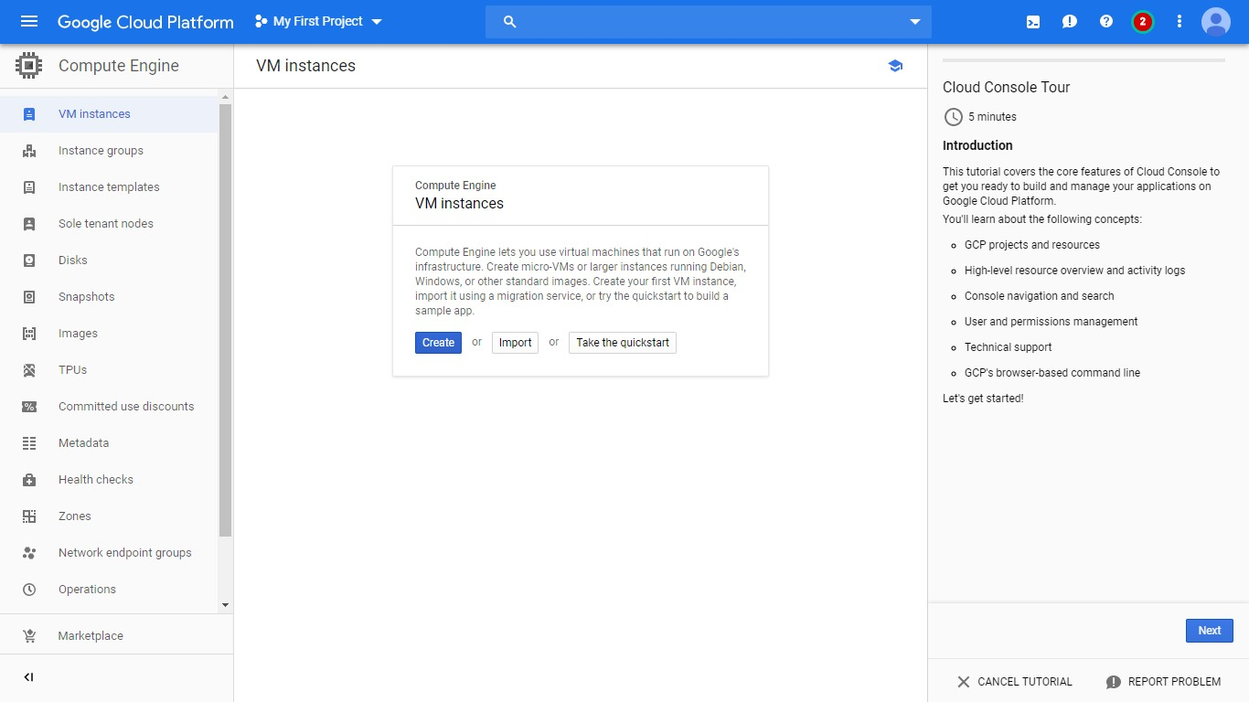

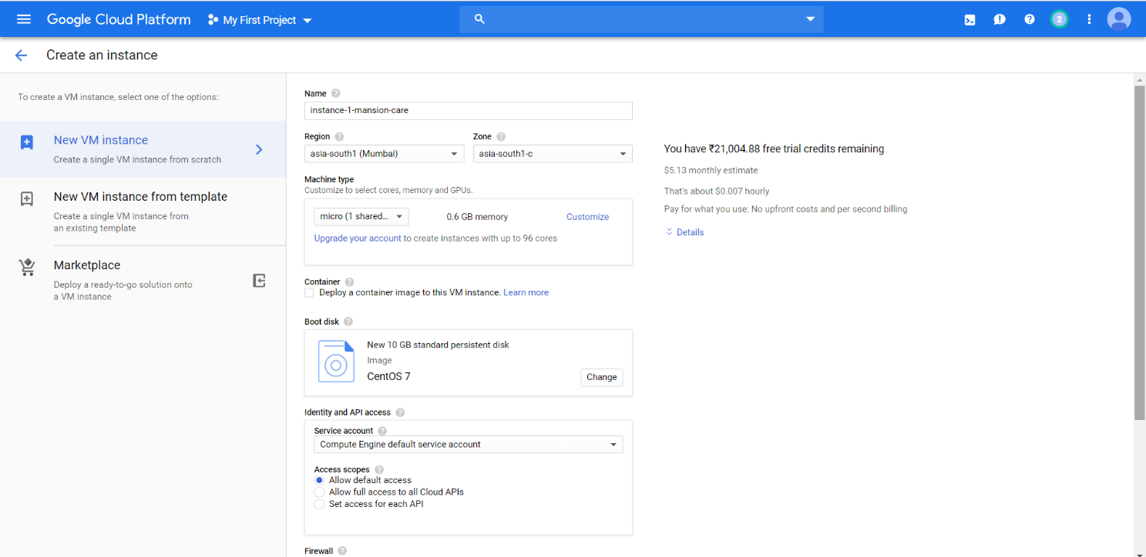

**Step 3: Create a New Instance (Give the Name You Like)**

**Step 4: Choose Cent OS 7 as your OS**

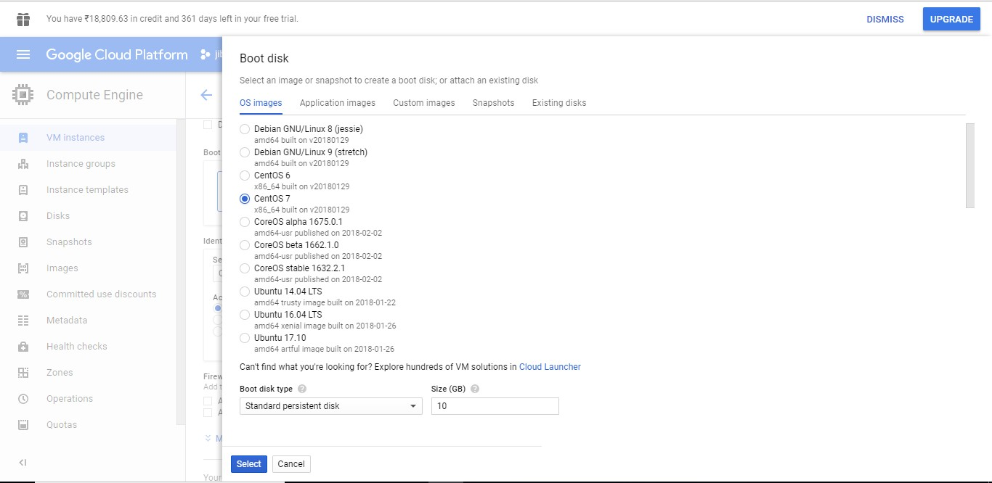

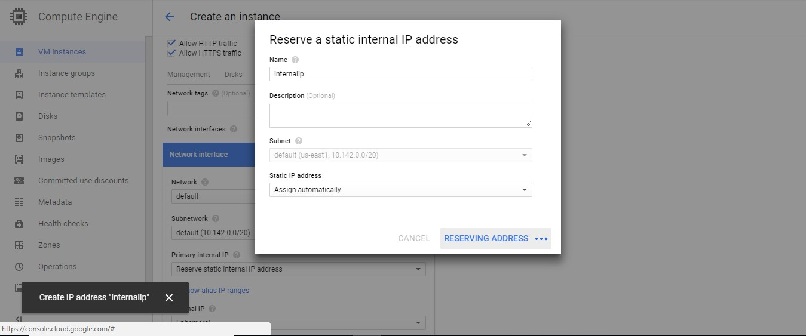**Step 5: From the Network Interface option, Reserve Static Internal and External IP address**

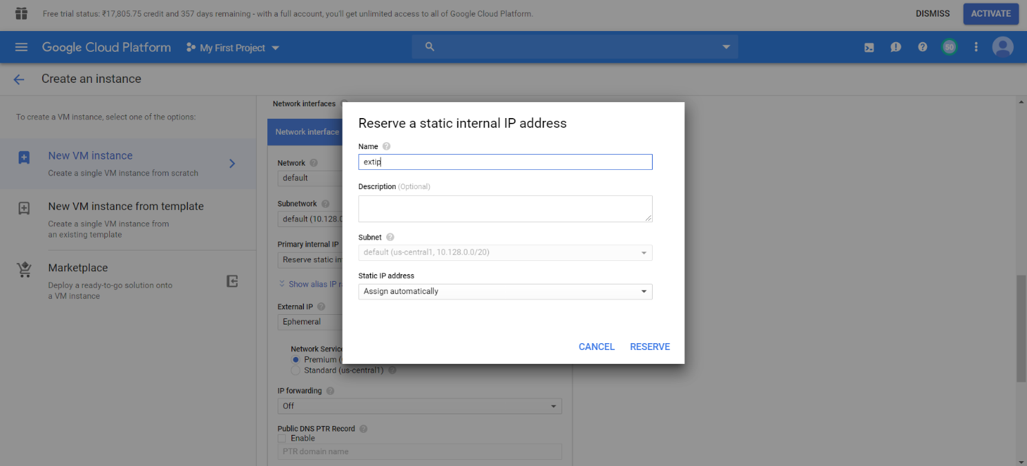

**Then Our Instance will be created**

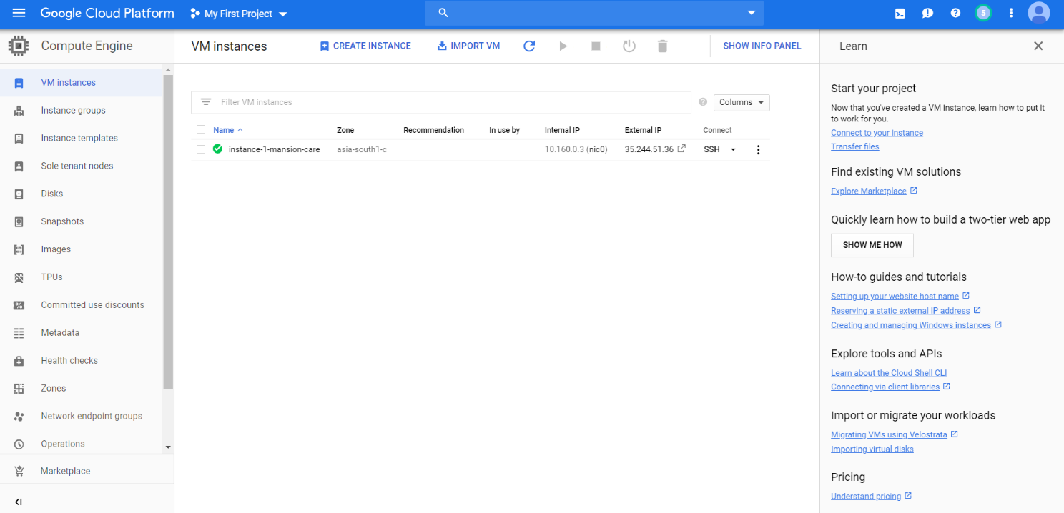

**Step 6: Open the Shell by Clicking the SSH drop down appears on the right side of our Instance.**

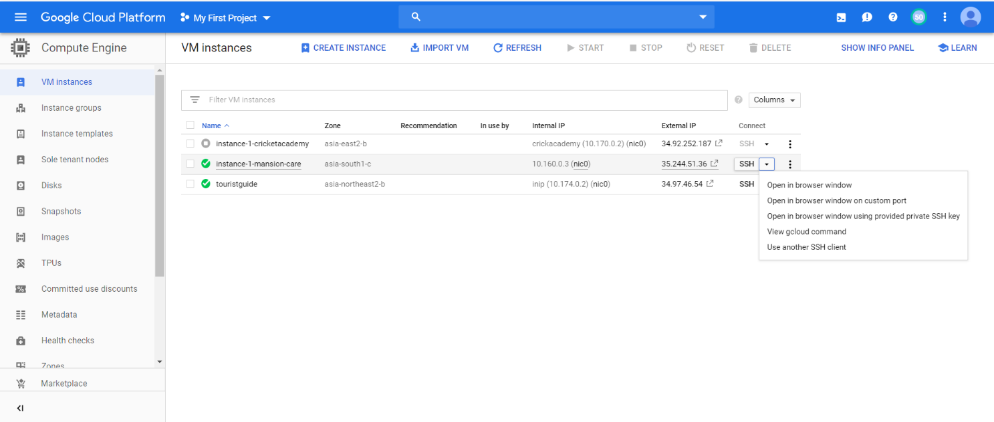

**Step 7: In the Shell**

Type in the following commands one by one

1. To get the Admin Privileges type the Command: sudo -s
2. For updating type: yum update -y
3. yum install -y perl
4. yum install -y wget
5. hostname centos.yourhostname.com
6. systemctl stop NetworkManager.service
7. systemctl disable NetworkManager.service
8. Then type the command for install cPanel and WHM

cd /home && curl -o latest -L <https://securedownloads.cpanel.net/latest>&& sh latest

1. Set password for WHM by typing the command ‘passwd’ on the shell

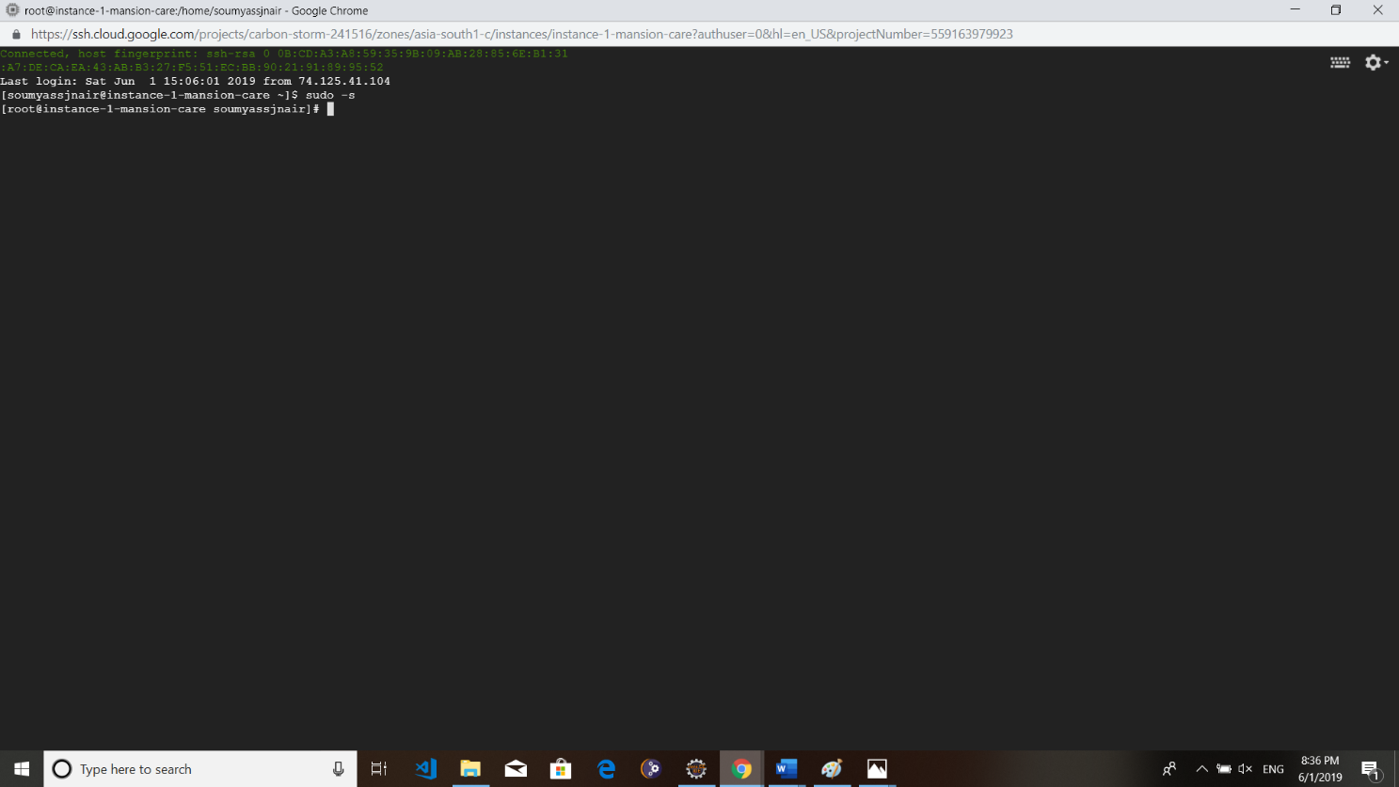

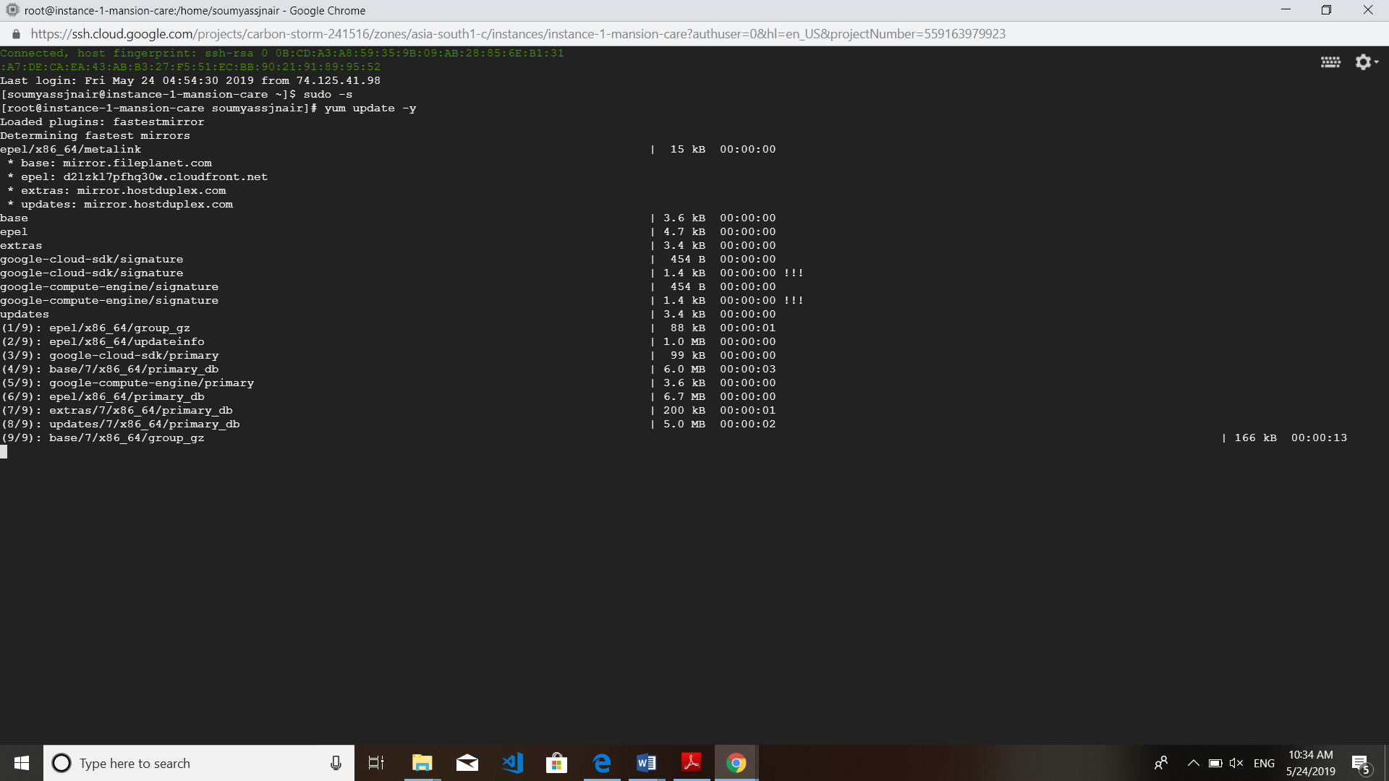

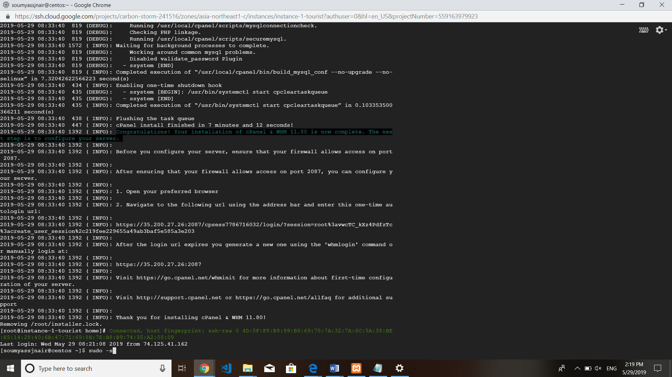

#### Step 8: Purchase a Domain from Freenom ([www.freenom.com](http://www.freenom.com/))

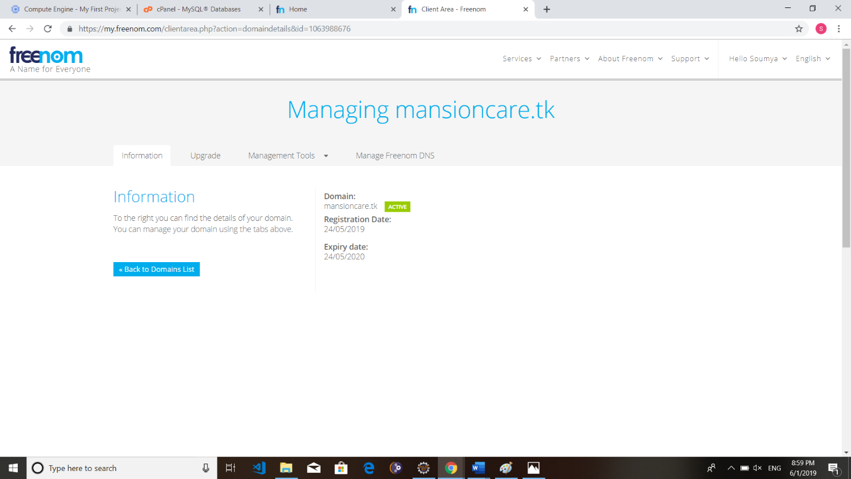

**Step 9: Create a Cloud DNS zone (Network Services -> Cloud DNS -> Create Zone).**

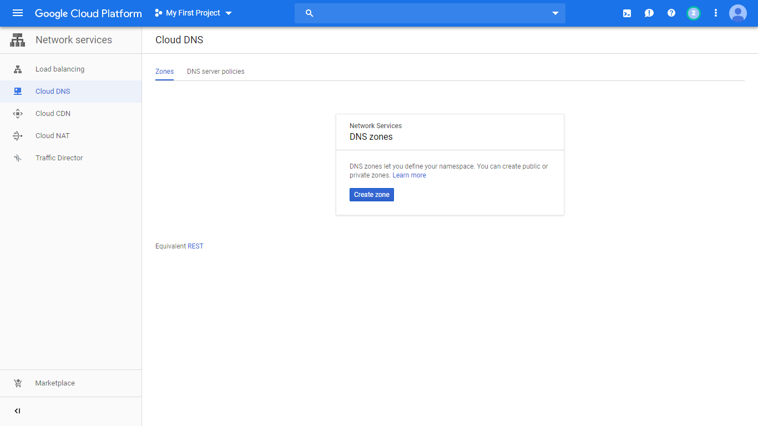

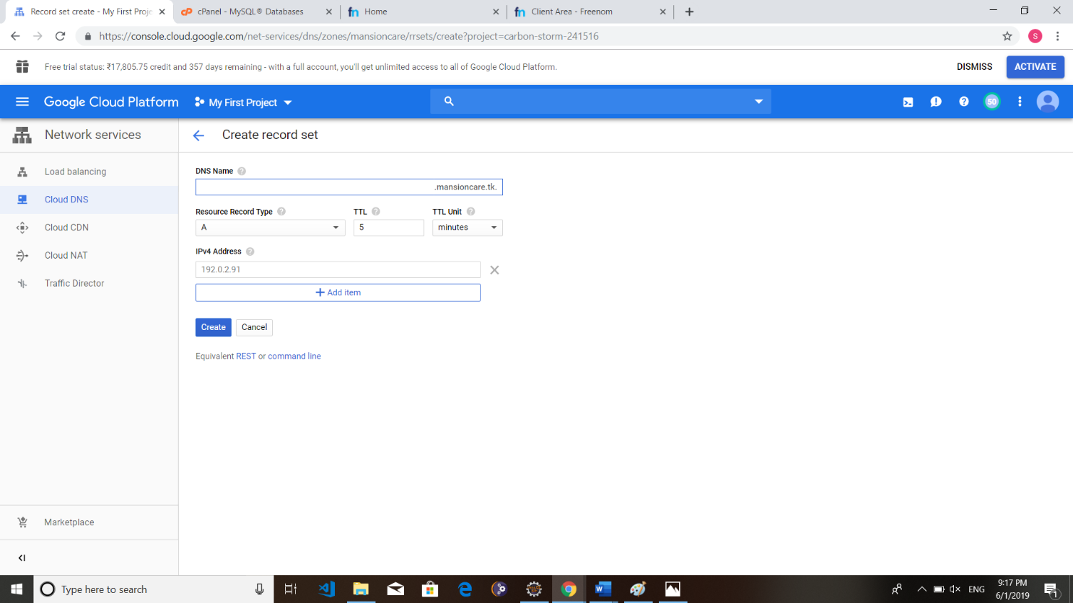

**Step 10: In the Newley Created zone, add two record sets A and CNAME. Provide the External IP address of our virtual machine in the IPV4 address field. Also provide the registered domain names.**

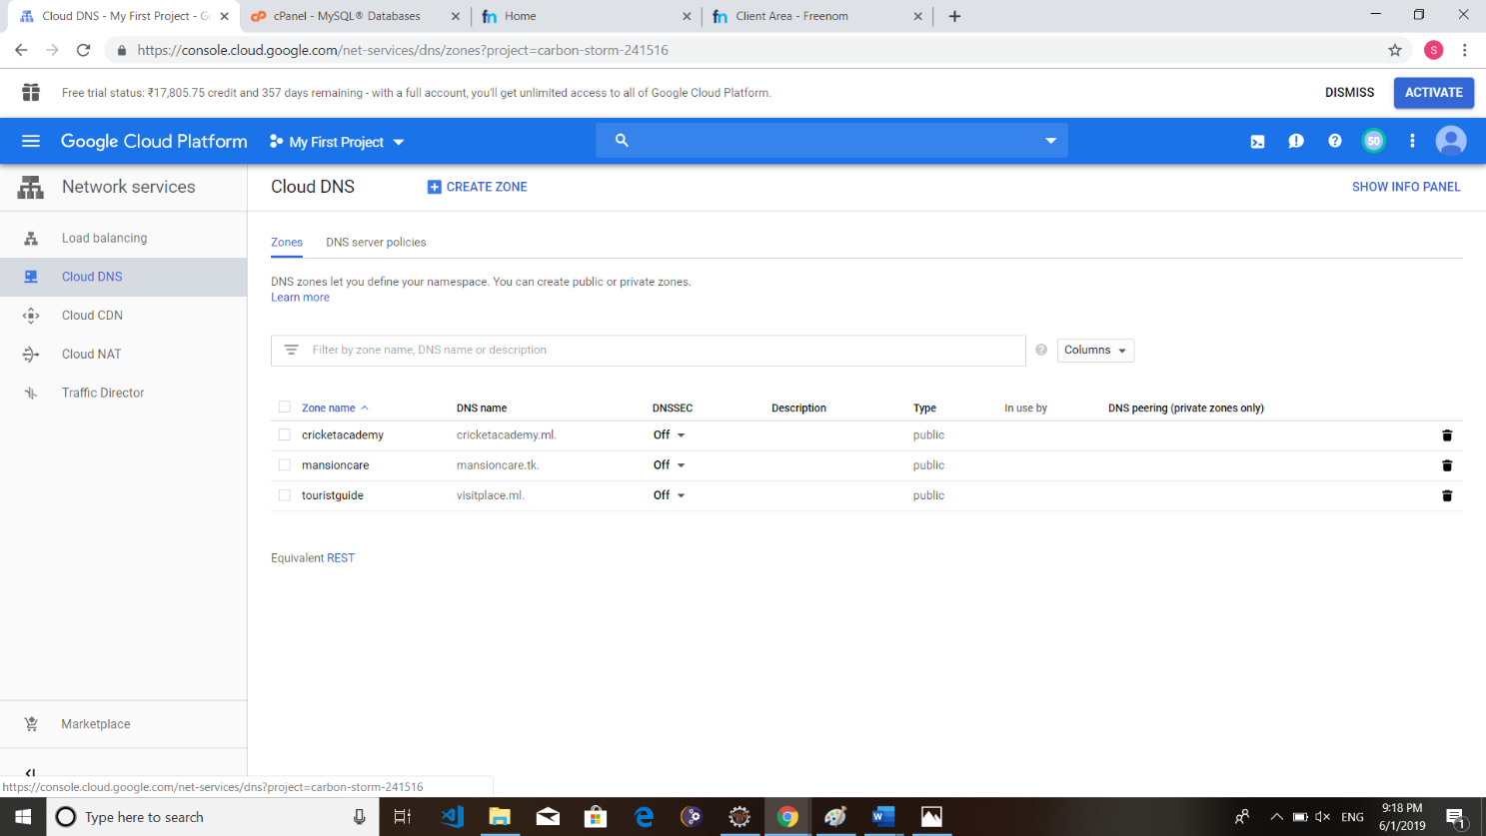

**Step 11: Create a Firewall rule. (Network services -> Firewall rules)**

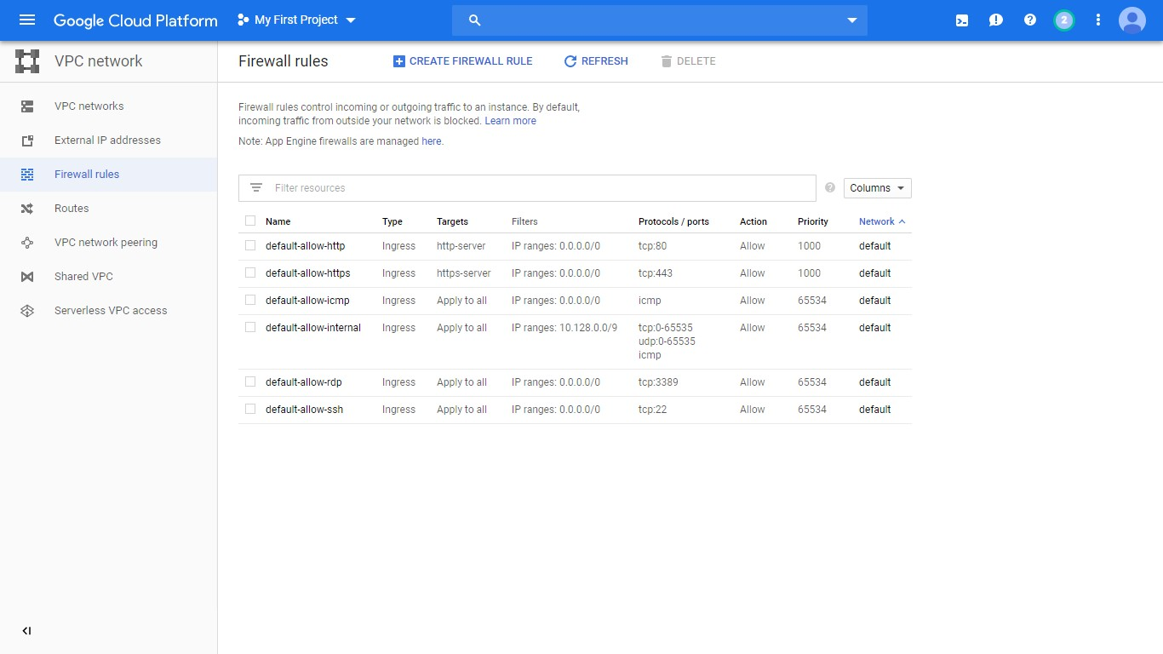

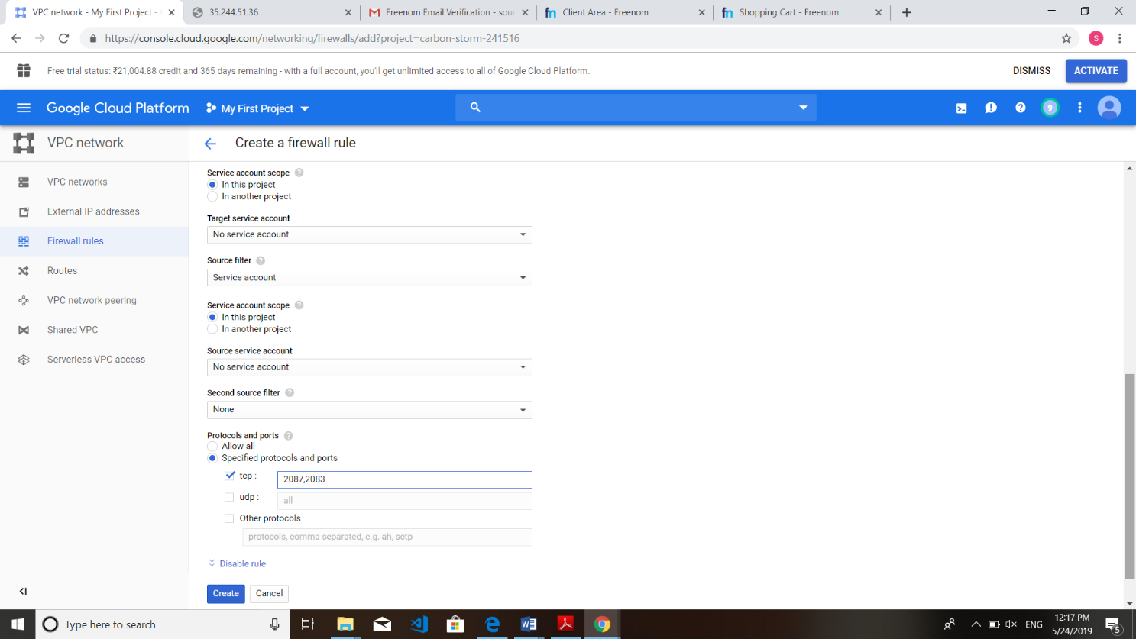

**Step 12: Set password for WHM by typing the command ‘passwd’ on the shell**

**Then open the WHM login page byhttps:// ipaddress/2087 Username: root and give the password**

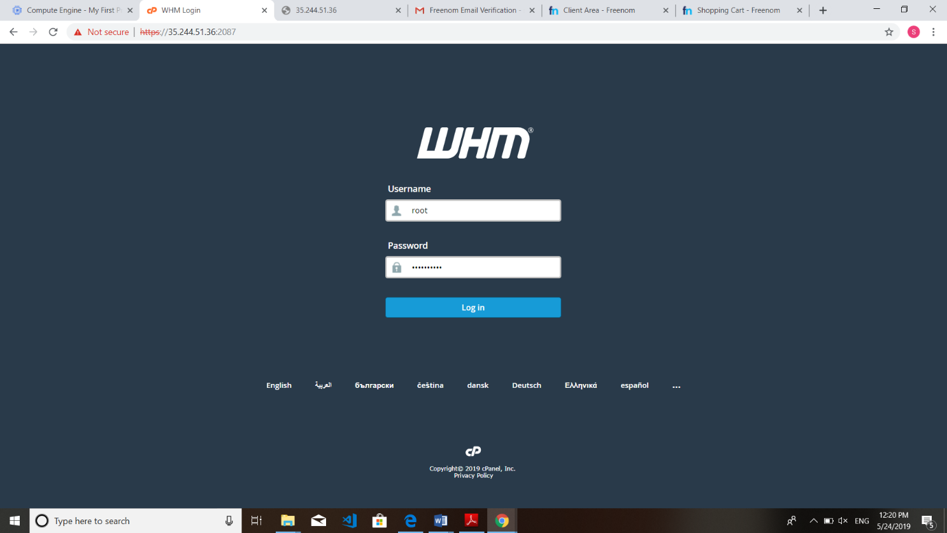

**Step 13: To create a new account go to Account Functions -> create a new account. (provide username, password and Email).**

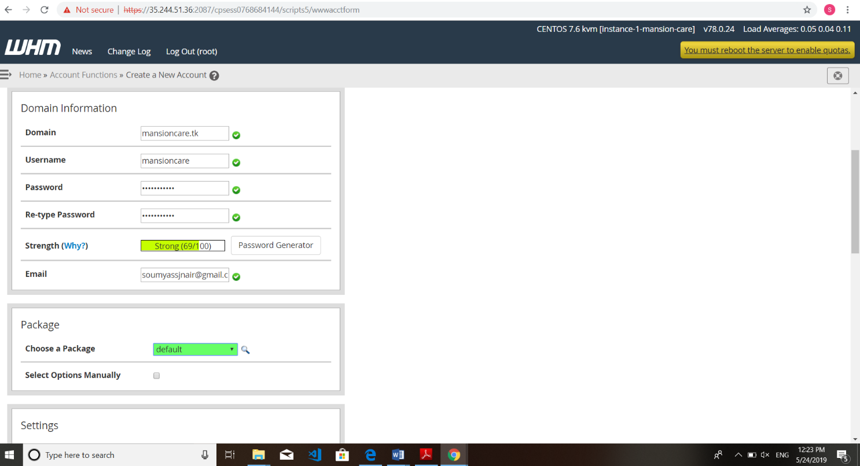

**Step 14: Log into the cPanel (**[**https://ipaddress/2083**](https://ipaddress/2083)**)**

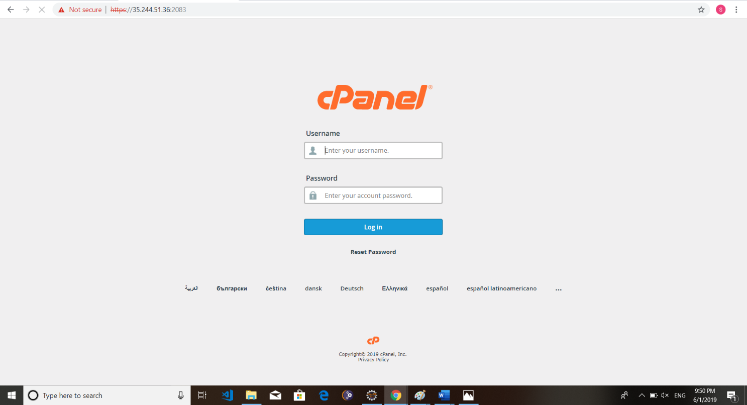

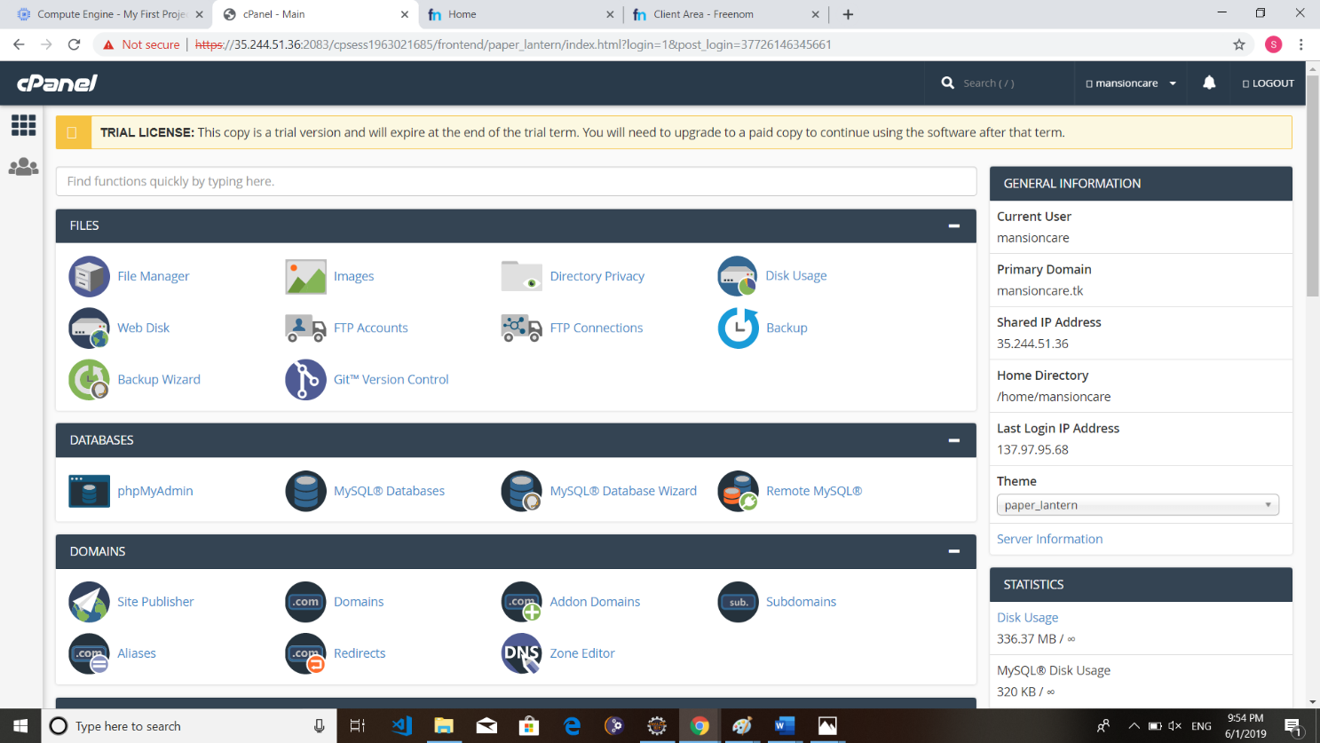

**Step 15: In the file manager, Upload the project to the public_html folder (.zip) format).**

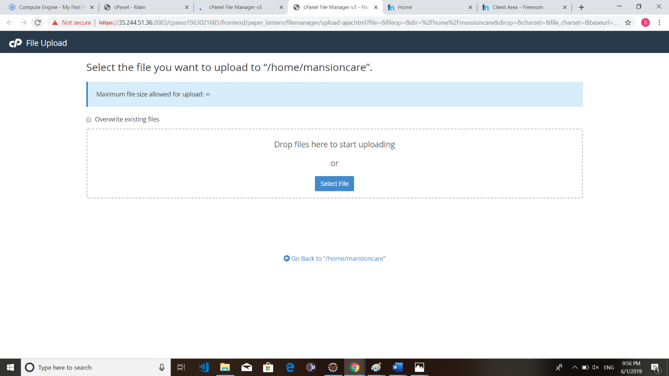

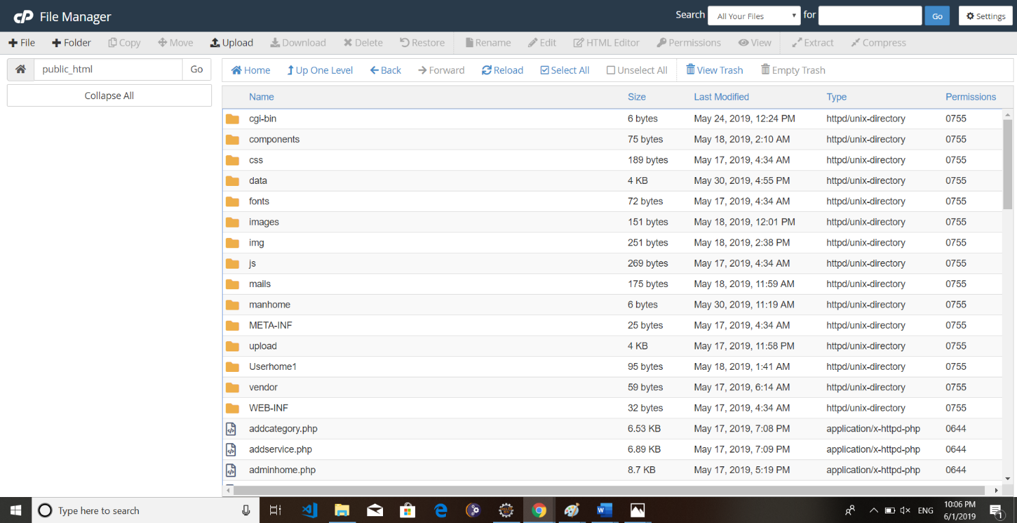

**Step 16: Open MySQL Databases icon and create new database and user. Then add the user to the database.**

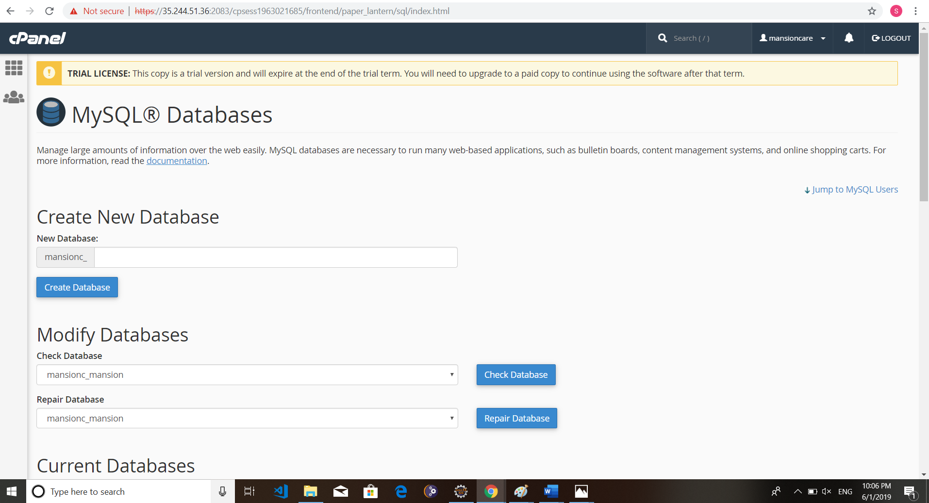

**Step 17: Open phpMyAdmin and import our database. (You can also create a new database).**

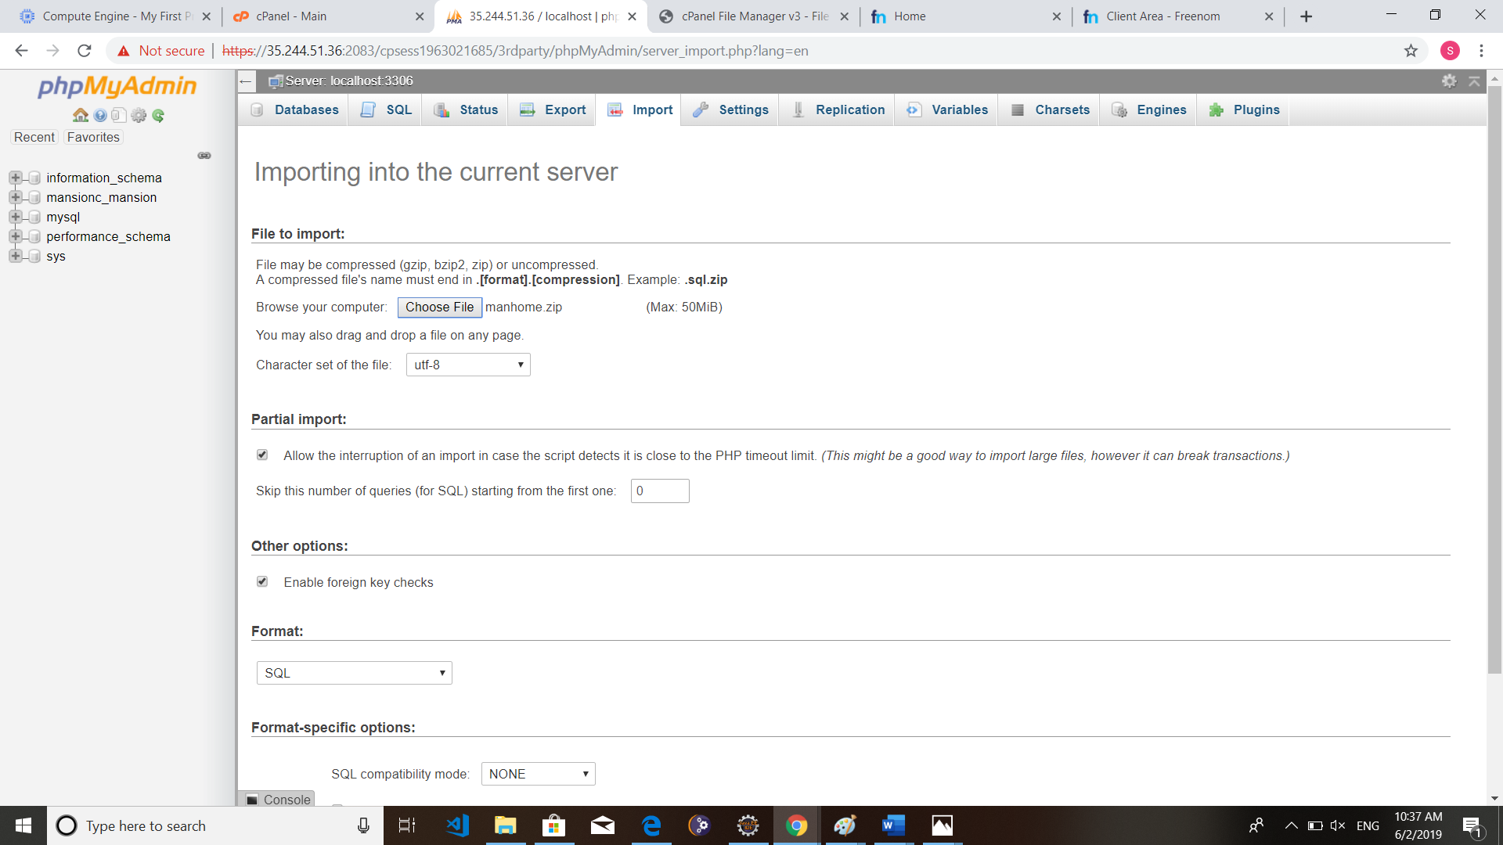

**Step 18: Then edit the database connection page.**

**Give the username, password and the database name**

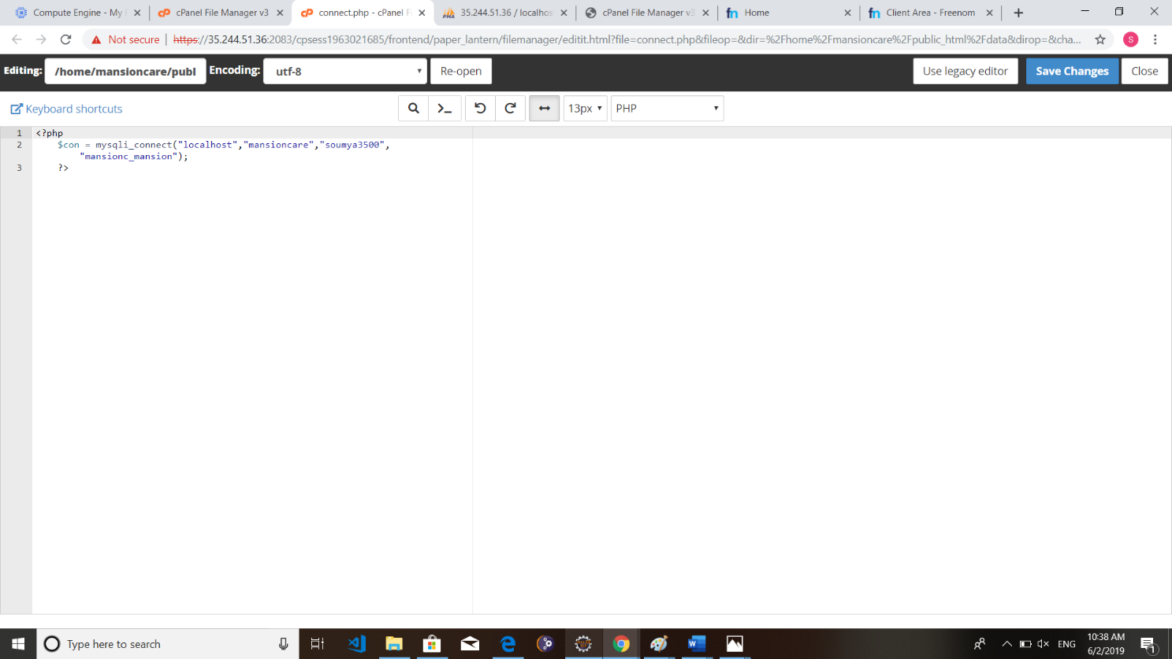

**Step 19: Our project is hosted in Google Cloud Platform.**

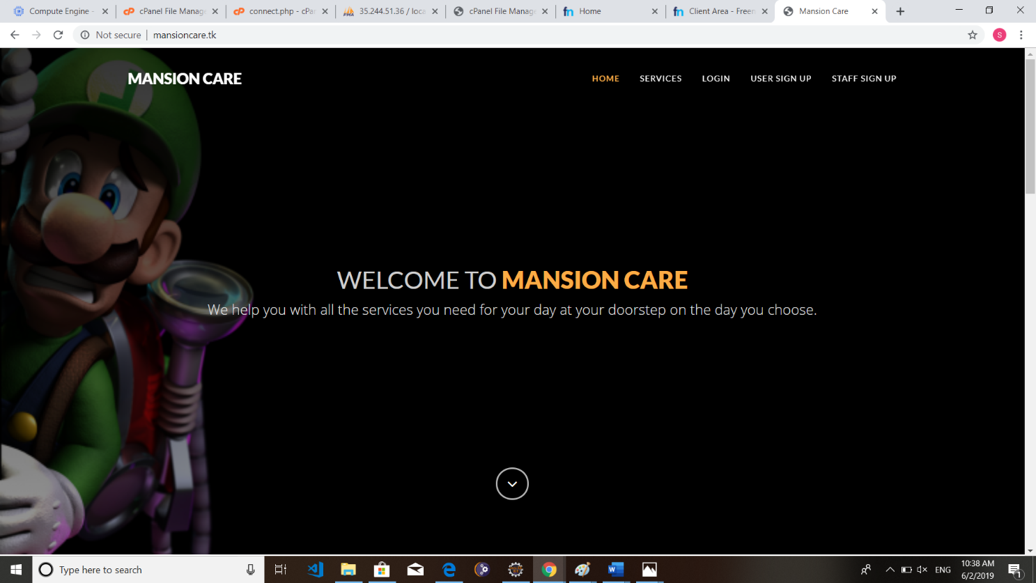

**P1.1.3 WEB HOST MANAGEMENT TOOLS**

**P1.1.3.1 Web Host Manager (WHM)**

Web Host Manager, or WHM, is a powerful program that allows administrative access to the back end of cPanel. There are two versions that Host Gator uses. Reseller accounts get basic WHM. Dedicated Servers and VPS accounts get root WHM (also called rWHM), which has features that require root access to the server enabled. Resellers cannot have rWHM. WHM gives you a lot more control and flexibility when managing either a few very popular and resource intensive sites, or large number of sites. On top of giving you the ability to sell hosting services to other people, WHM also gives you the option to create and manage multiple cPanels. There are lots of really good reasons, if you have business oriented or popular sites, to place them on separate cPanels. Here are a few of the more common reasons we see:

* If one of your sites is hacked or attacked, the odds that the hacker can get into your other sites is dramatically reduced, which increases your security.
* There is no way for someone to tell if accounts on different cPanels are attached to the same WHM account, which increases your privacy.
* If you have multiple sites that need to take credit cards, using WHM saves you a lot of time, stress, and money. To be able to process credit cards you need an SSL certificate.
* You have the ability to monitor and adjust your bandwidth and disk space, which can be key to keeping a quickly growing or popular site from being suspended or going down due to bandwidth overages.
* Managing a large number of domains in one cPanel can be frustrating, especially if you update the files regularly. While we allow unlimited domains on a shared cPanel account, that does not mean it is always pleasant to work on that many domains in one cPanel.
* You need to have several web sites that take credit cards, and each one needs its own cPanel for its own dedicated IP address.

WHM gives you a suite of tools to easily do the following things:

* Create, delete, and suspend your cPanel accounts.
* Manage and monitor your sites (password resets).
* Access to check and change all of your domains' DNS zones.
* The ability to configure your own customers' support requests through cPanel.
* Permission to check the server information and status.
* Ability to create your own default page when you create a new account.
* Access to customize your hosting and control panel with extensive branding.
* Ability to change your client domain names and user names.
* Hop between every cPanel on your account and access/change anything that does not require SQL access.

#### Step 1: Open WHM Panel then Signup

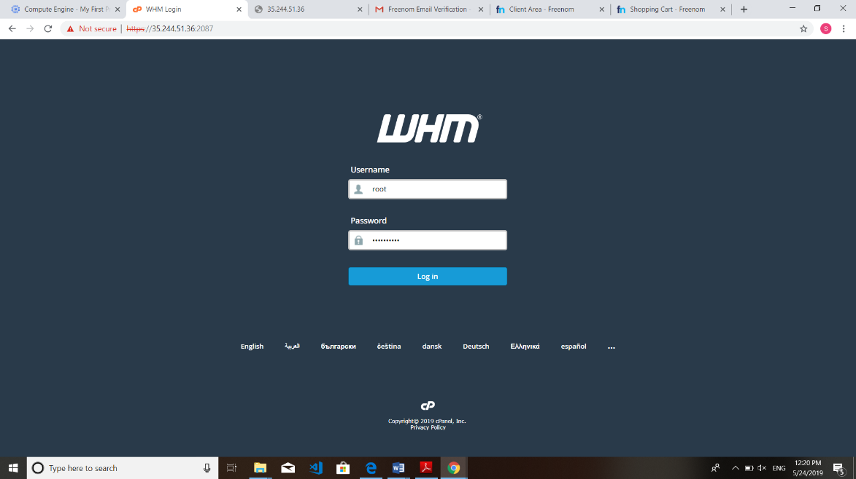

**Step 2: Create a cPanel Account for our Project**



**P1.1.3.2 Control Panel (cPanel)**

cPanel is an online Linux-based [web hosting control panel](https://en.wikipedia.org/wiki/Web_hosting_control_panel) that provides a graphical interface and automation tools designed to simplify the process of hosting a web site. cPanel utilizes a 3-tier structure that provides capabilities for administrators, resellers, and end-user website owners to control the various aspects of website and server administration through a standard web browser. In addition to the GUI, cPanel also has command line and API-based access that allows third party software vendors, [web hosting](https://en.wikipedia.org/wiki/Web_hosting) organizations, and developers to automate standard system administration processes.

cPanel is designed to function either as a [dedicated server](https://en.wikipedia.org/wiki/Dedicated_hosting_service) or [virtual private server](https://en.wikipedia.org/wiki/Virtual_private_server). The latest cPanel version supports installation on [CentOS](https://en.wikipedia.org/wiki/CentOS), [Red Hat Enterprise Linux](https://en.wikipedia.org/wiki/Red_Hat_Enterprise_Linux) (RHEL), and [CloudLinux OS](https://en.wikipedia.org/wiki/CloudLinux_OS). cPanel 11.30 is the last major version to support [FreeBSD](https://en.wikipedia.org/wiki/FreeBSD). Application- based support includes [Apache,](https://en.wikipedia.org/wiki/Apache_HTTP_Server) [PHP](https://en.wikipedia.org/wiki/PHP), [MySQL](https://en.wikipedia.org/wiki/MySQL), [PostgreSQL,](https://en.wikipedia.org/wiki/PostgreSQL) [Perl,](https://en.wikipedia.org/wiki/Perl) and [BIND](https://en.wikipedia.org/wiki/BIND) (DNS). Email based support includes [POP3](https://en.wikipedia.org/wiki/Post_Office_Protocol), [IMAP](https://en.wikipedia.org/wiki/Internet_Message_Access_Protocol), and [SMTP](https://en.wikipedia.org/wiki/Simple_Mail_Transfer_Protocol) services. cPanel is accessed via https on [port](https://en.wikipedia.org/wiki/Port_(computer_networking)) 2083.

Once installed, cPanel cannot be easily removed. cPanel's FAQ states that the best way to uninstall cPanel is by reformatting the server. However, uninstall guides are available online for expert server administrators who do not wish to reformat their server. Similarly, it should only be installed on a freshly installed operating system with minimal prior configuration.

The tools provided are designed to simplify running and controlling a website. It uses a tiered structure that allows different levels of access. Administrators and end users can control the different aspects of the server and the website directly through their browser. cPanel is generally accessed using https on port 2083 or simply by adding “/cPanel” to the end of the host name. Depending on the hosting provider the cPanel will generally have some sort of auto installer or package dedicated to content management systems like WordPress.

Some of the great features that cPanel includes are:

* Email: Within cPanel you can create new email accounts, view/modify your existing accounts, modify your MX records, change email passwords, set up mail box quotas and much more.
* Domains: Under the domains section of cPanel, you can configure new domains to your account, set up parked domains, create subdomains, setup redirects, and much more.
* File Management: In the files section of cPanel, you can back up your cPanel account, access/ modify files stored in your account, review your disk usage, and create/manage FTP accounts
* Databases: Here you can create new databases, set up remote access to MySQL, access the databases using phpMyAdmin, and much more

cPanel is very user friendly and is quite robust. There's numerous tools within cPanel to handle a wide variety of tasks. It contains a full help menu that is easy to use.

**Step 1:** Open cPanel



**Step 2:** Open file Manager and Upload the Project.



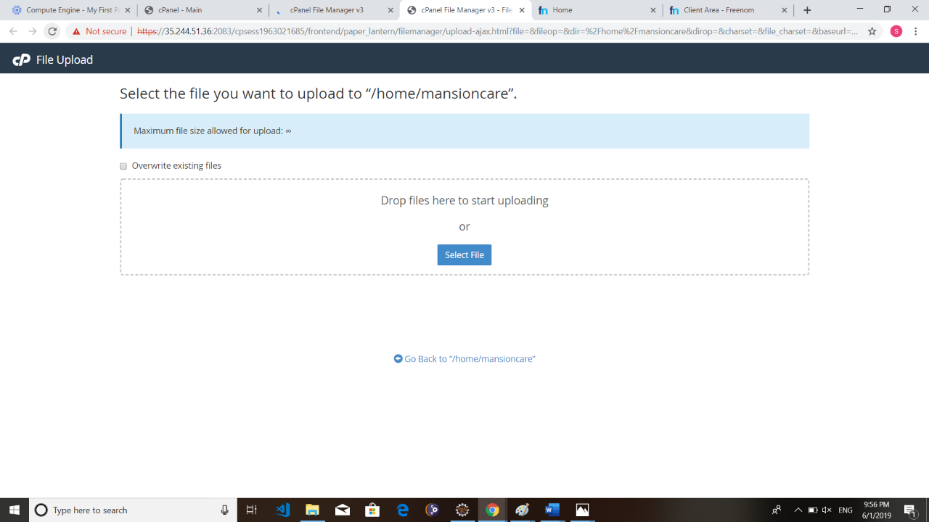

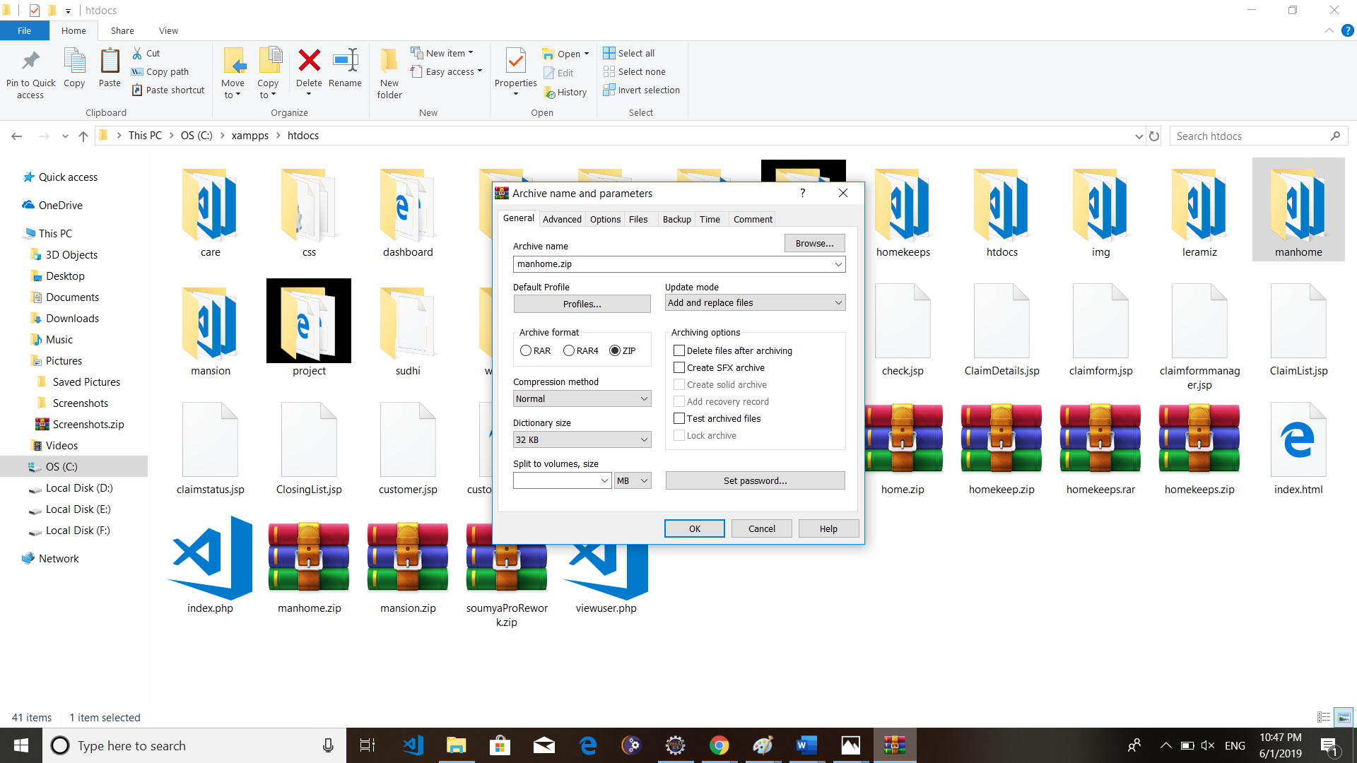

**Step 3:** Open PhpMyAdmin and Import the database

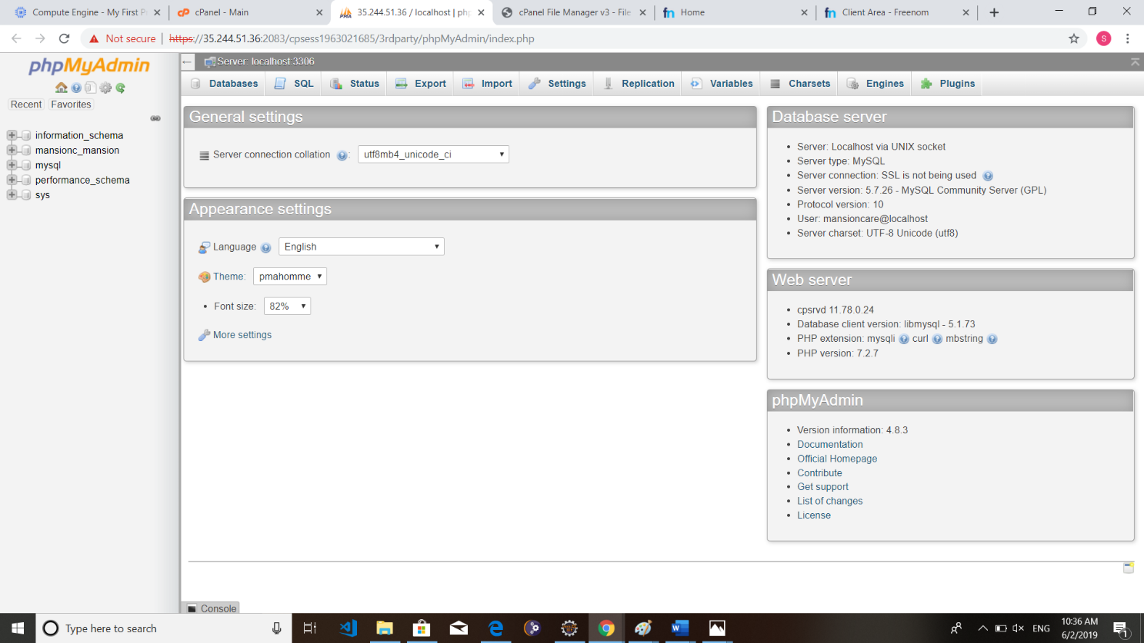

**Step 4:** Create new Database



**Step 5:** Import the Database



#### Step 6: : Then edit the database connection page(connect.php).



**Step 7: Project is hosted successfully.**



**P1.1.3.3 Plesk Panel**

Plesk is the leading WebOps hosting platform to run, automate and grow applications, websites and hosting businesses. Being the only OS-agnostic platform, Plesk is running on more than 380,000 servers, automating 11M+ websites and 19M mailboxes. Available in more than 32 languages across 140 countries, 50% of the top 100 service providers worldwide are partnering with Plesk today. Plesk has simplified the life of SysAdmins and SMBs since the early 2000’s and continues to add value across multiple cloud services. The Plesk hosting platform effectively enables application developers by providing access to a simple and more secure web infrastructure managed by web pros and hosting companies.

The worldwide developer market consists of over 20M cloud developers who are looking for access to faster, more secure and efficient infrastructures. The Plesk vision is to constantly elevate customer and partner profitability by providing them with a cloud platform that grants application developers a ready-to-code environment. Besides simplifying complexity, Plesk increases its efforts to enable customers and partners alike to extend and customize Plesk as an open hosting platform. The rich ecosystem of Plesk extensions not only provides access to even more relevant features targeted at specific audiences but also allows service providers of any size to generate unique upsell opportunities.

Plesk culture

As a team, we thrive on excellence, innovation, collaboration, and efficiency. We enjoy what we do, understand our customers and build a hosting platform that clients love and need. The relentless commitment of our team to accept new business challenges guarantees that we are creative and respectful of time and resources as well as the environment. We keep our actions and goals transparent, cultivate a culture of leadership, inclusion, execution, and respect. As a former member of the Parallels group of companies, our background is global, innovative and diverse. January 2016 was the right time for Plesk to become a separate business, enabling us to accelerate development cycles, drive innovation and focus on the needs of our partners, customers and employees.

#### IMPLEMENTATION

**IMPLEMENTATION**

**Step 1**: Use the Login credentials provided by the Deployment Manager to access the Admin panel. Use the Admin URL to log in, with Admin user and Admin password(temporary)

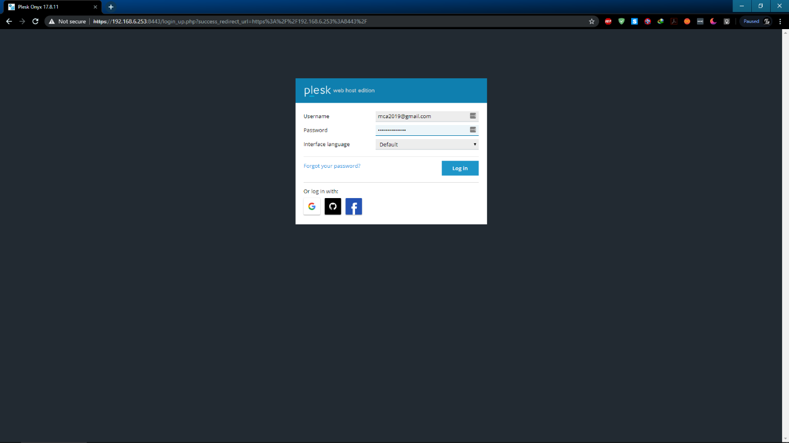

**Step 2:** Once you successfully logged in, you have to configure the web host, such as how you will use the product, user interface and etc. On the next step, you have to enter the hostname, if you already have a hostname use that one or create a new domain**.**

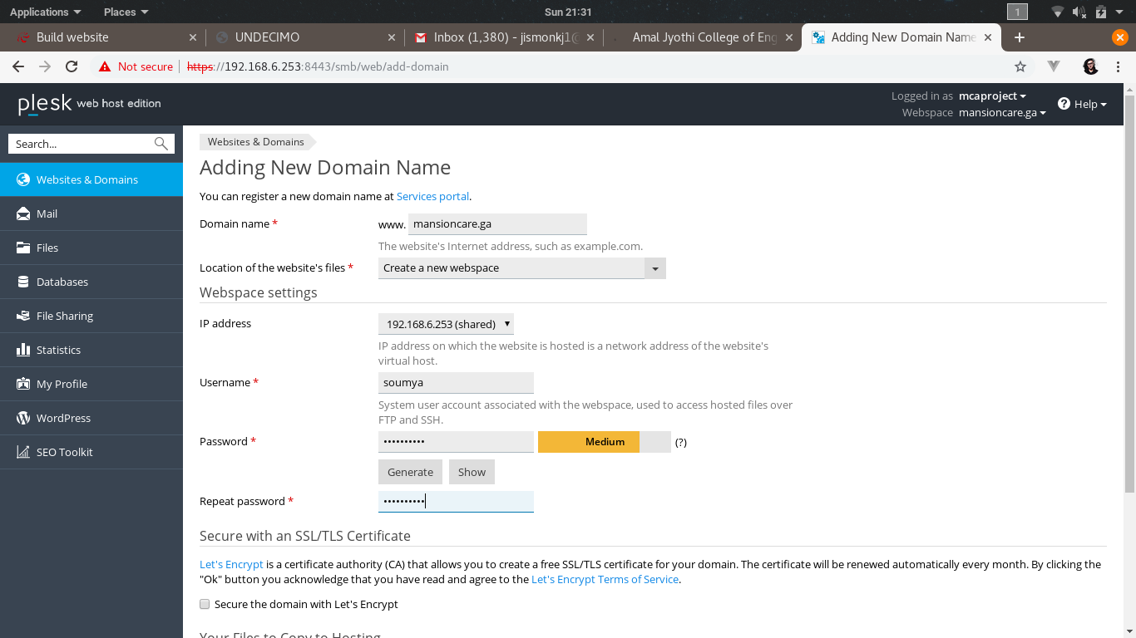

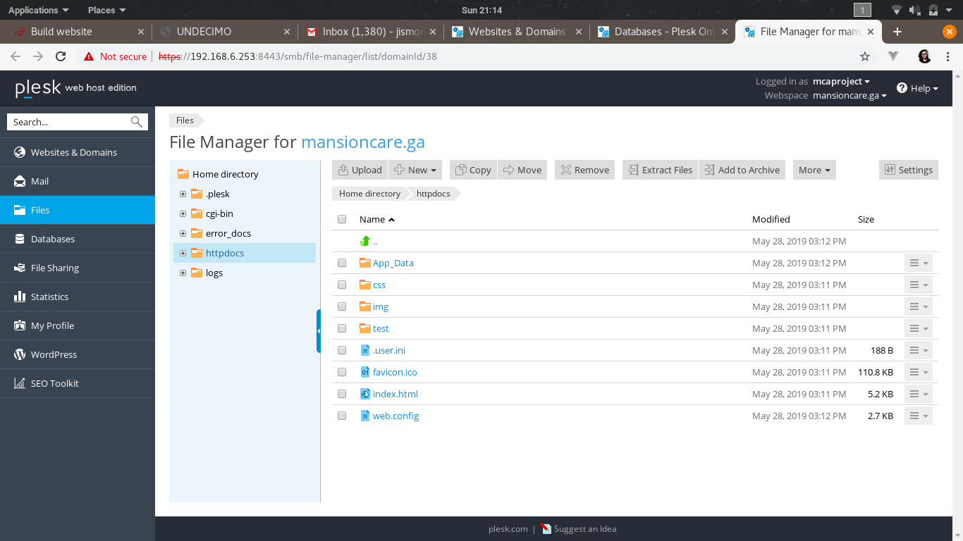

**Step 3:** Use a valid domain provider to register a domain. Here we are using ‘Freenom’to register

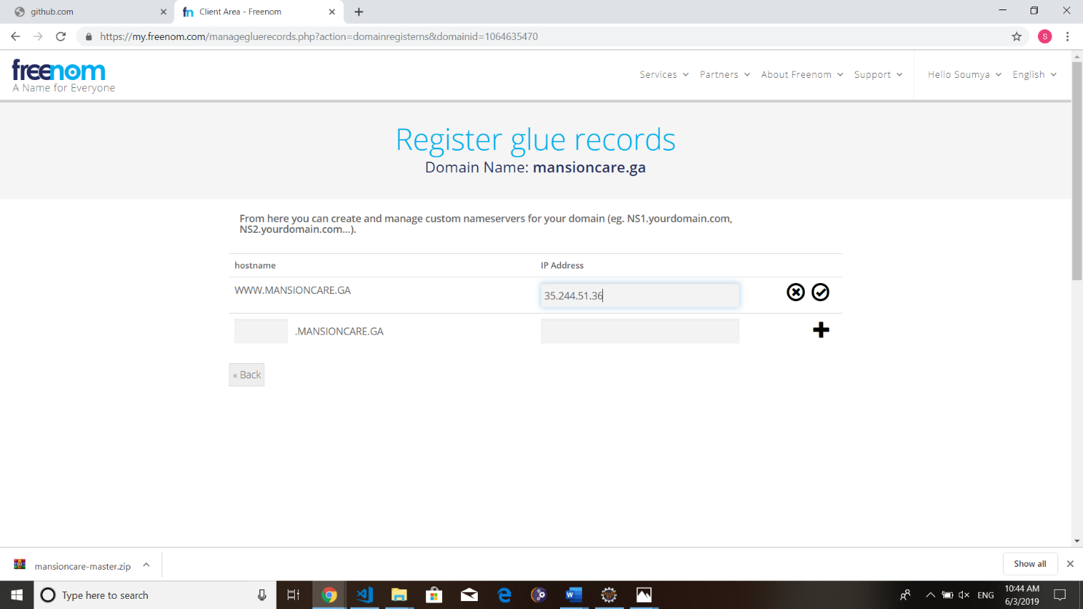

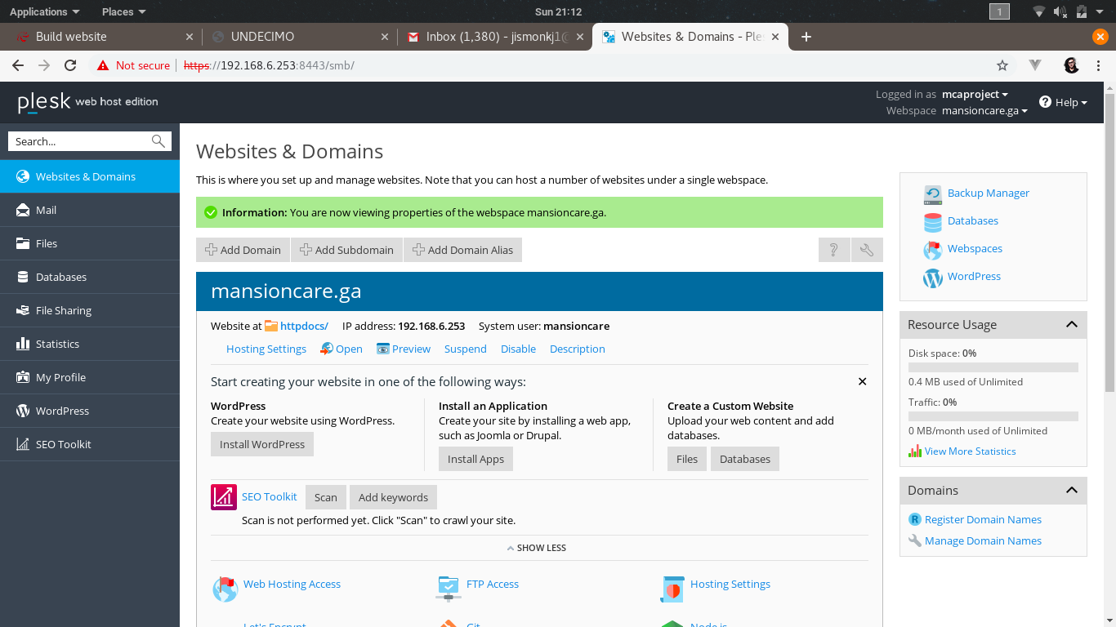

**Step 4:** Go to Menu > Databases. Choose database name, related site and create database user as well as password.

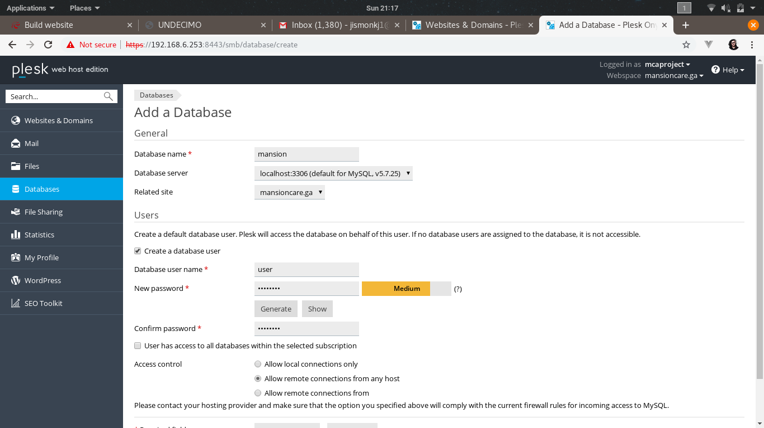

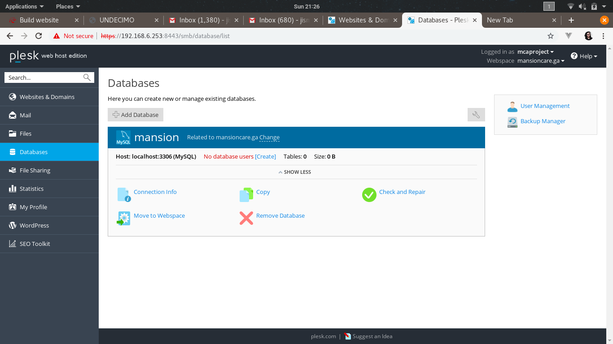



**Step 5:** In the File Manager, Upload the files



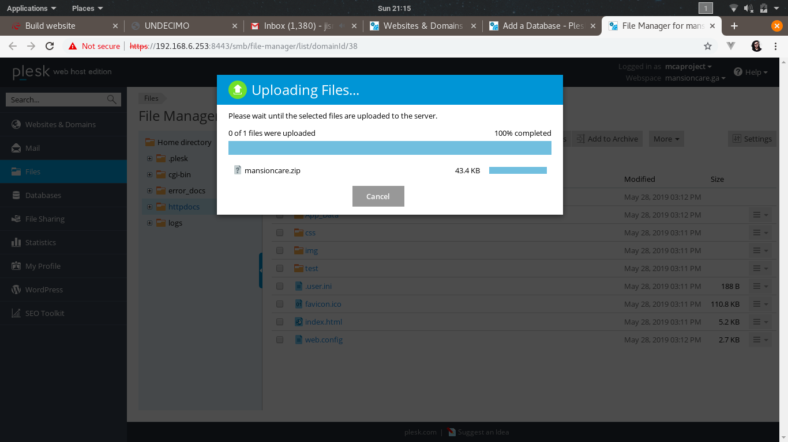

**Step 6:** Project is Hosted successfully.

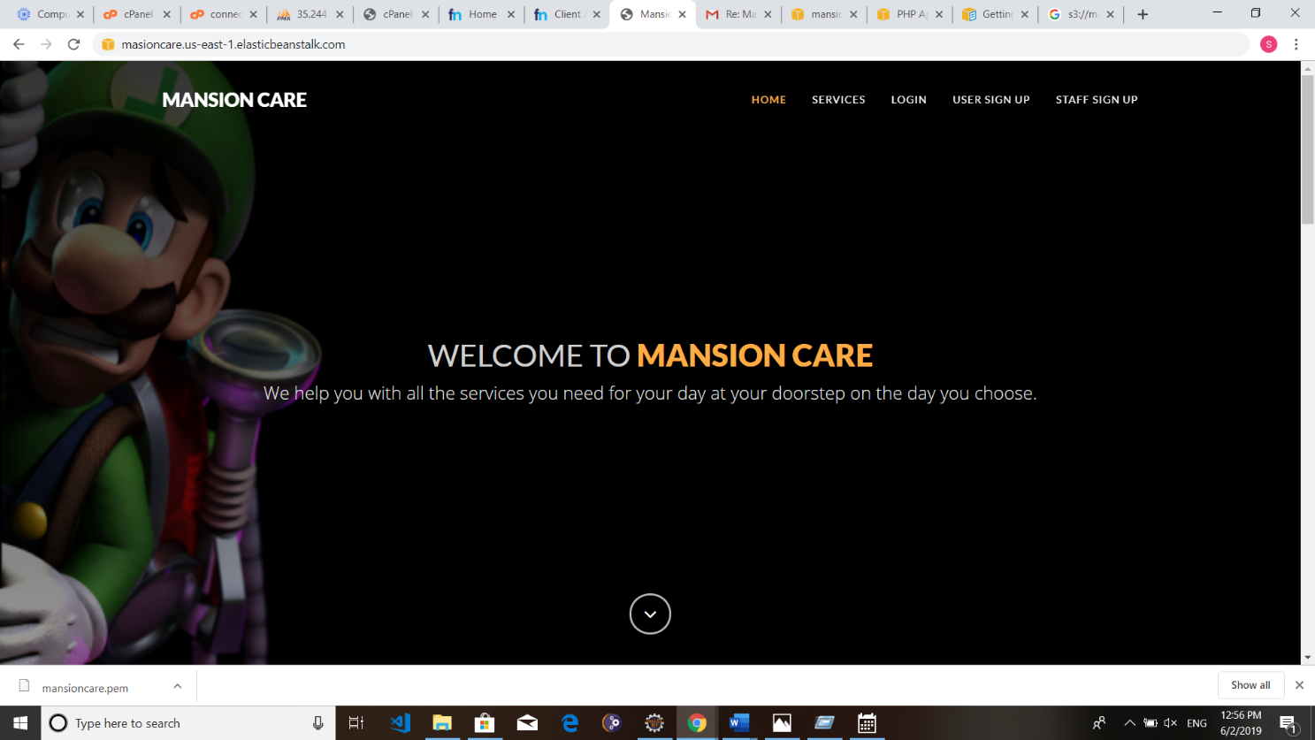

## P1.2 AWS (AMAZON WEB SERVICES)

### P1.2.1 INTRODUCTION AMAZON WEB SERVICES CLOUD

In 2006, Amazon Web Services (AWS) began offering IT infrastructure services to businesses in the form of web services -- now commonly known as cloud computing. One of the key benefits of cloud computing is the opportunity to replace up-front capital infrastructure expenses with low variable costs that scale with your business. With the Cloud, businesses no longer need to plan for and procure servers and other IT infrastructure weeks or months in advance. Instead, they can instantly spin up hundreds or thousands of servers in minutes and deliver results faster.

Today, Amazon Web Services provides a highly reliable, scalable, low-cost infrastructure platform in the cloud that powers hundreds of thousands of businesses in 190 countries around the world. With data center locations in the U.S., Europe, Brazil, Singapore, Japan, and Australia, customers across all industries are taking advantage of the following benefits:

Low Cost

AWS offers low, pay-as-you-go pricing with no up-front expenses or long-term commitments. We are able to build and manage a global infrastructure at scale and pass the cost saving benefits onto you in the form of lower prices. With the efficiencies of our scale and expertise, we have been able to lower our prices on 15 different occasions over the past four years. Visit the Economics Centre to learn more.

Agility and Instant Elasticity

AWS provides a massive global cloud infrastructure that allows you to quickly innovate, experiment and iterate. Instead of waiting weeks or months for hardware, you can instantly deploy new applications, instantly scale up as your workload grows, and instantly scale down based on demand. Whether you need one virtual server or thousands, whether you need them for a few hours or 24/7, you still only pay for what you use. Visit the Architecture Centre to learn more.

#### Open and Flexible

AWS is a language and operating system agnostic platform. You choose the development platform or programming model that makes the most sense for your business. You can choose which services you use, one or several, and choose how you use them. This flexibility allows

you to focus on innovation, not infrastructure. Download the AWS Overview Whitepaper.

#### Secure

AWS is a secure, durable technology platform with industry-recognized certifications and audits: PCI DSS Level 1, ISO 27001, FISMA Moderate, FedRAMP, HIPAA, and SOC 1 (formerly referred to as SAS 70 and/or SSAE 16) and SOC 2 audit reports. Our services and data centers have multiple layers of operational and physical security to ensure the integrity and safety of your data. Visit the Security Centre to learn more.

#### Solutions

The AWS cloud computing platform provides the flexibility to launch your application regardless of your use case or industry. Learn more about popular solutions customers are running on AWS.

[Application Hosting](https://aws.amazon.com/application-hosting/)

Use reliable, on-demand infrastructure to power your applications, from hosted internal applications to SaaS offerings.

[Websites](https://aws.amazon.com/websites/)

Satisfy your dynamic web hosting needs with AWS’s scalable infrastructure platform.

[Backup and Storage](https://aws.amazon.com/backup-recovery/)

Store data and build dependable backup solutions using AWS’s inexpensive data storage services.

[Enterprise IT](https://aws.amazon.com/enterprise-it/)

Host internal- or external-facing IT applications in AWS's secure environment.

[Content Delivery](https://aws.amazon.com/content-delivery/)

Quickly and easily distribute content to end users worldwide, with low costs and high data transfer speeds.

[Databases](https://aws.amazon.com/running_databases/)

Take advantage of a variety of scalable database solutions, from hosted enterprise database software or non-relational database solutions.

Get Started

* Sign up for AWS, by signing up for AWS, you have access to Amazon’s cloud computing services.

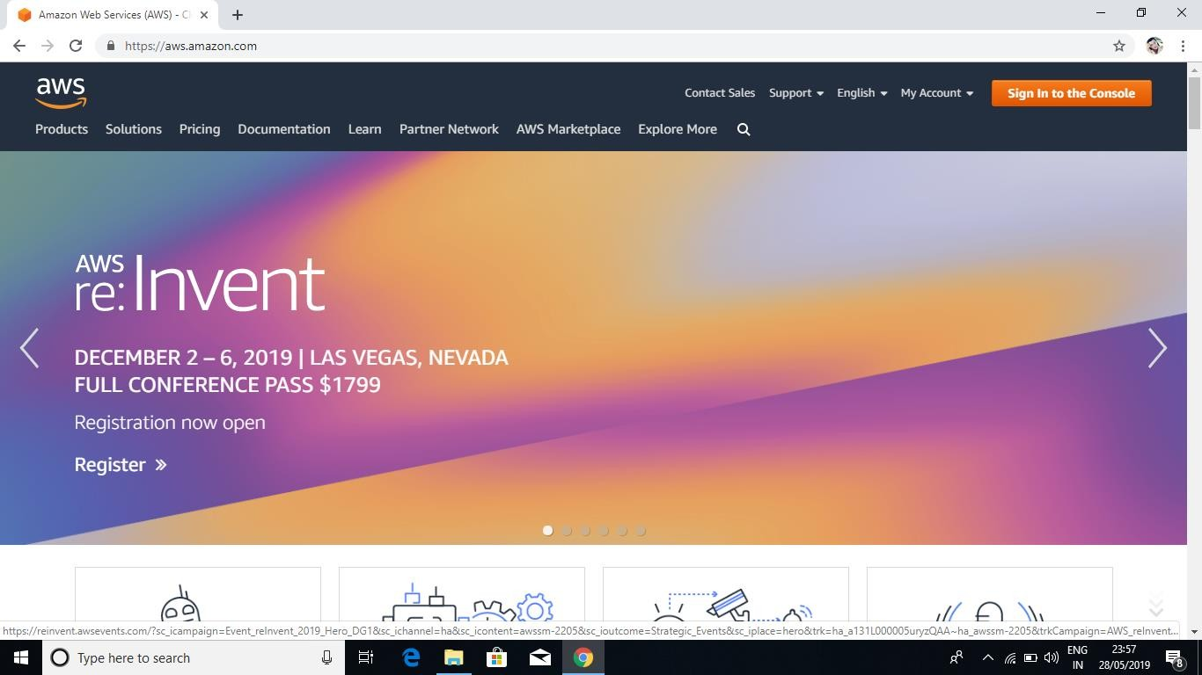

* Once you successfully logged in, you will be redirected to AWS Dashboard.

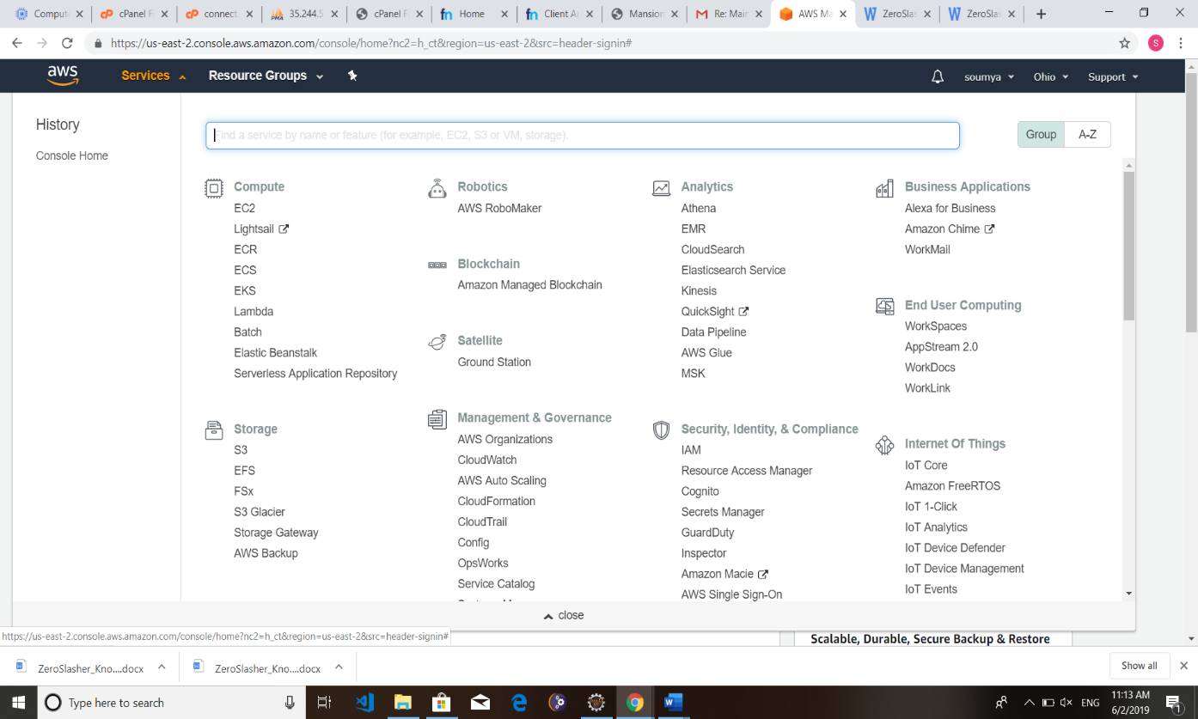

### P1.2.2 AMAZON ELASTIC COMPUTE CLOUD (EC2)

Amazon Elastic Compute Cloud (Amazon EC2) is a web service that provides secure, resizable compute capacity in the cloud. It is designed to make web-scale cloud computing easier for developers.

Amazon EC2’s simple web service interface allows you to obtain and configure capacity with minimal friction. It provides you with complete control of your computing resources and lets you run on Amazon’s proven computing environment. Amazon EC2 reduces the time required to obtain and boot new server instances to minutes, allowing you to quickly scale capacity, both up and down, as your computing requirements change. Amazon EC2 changes the economics of computing by allowing you to pay only for capacity that you actually use. Amazon EC2 provides developers the tools to build failure resilient applications and isolate them from common failure scenarios.

#### Step 1: Go to EC2 Console and then press ‘Launch Instance’

#### 

**Step 2: We are Creating a Windows Server Instance**

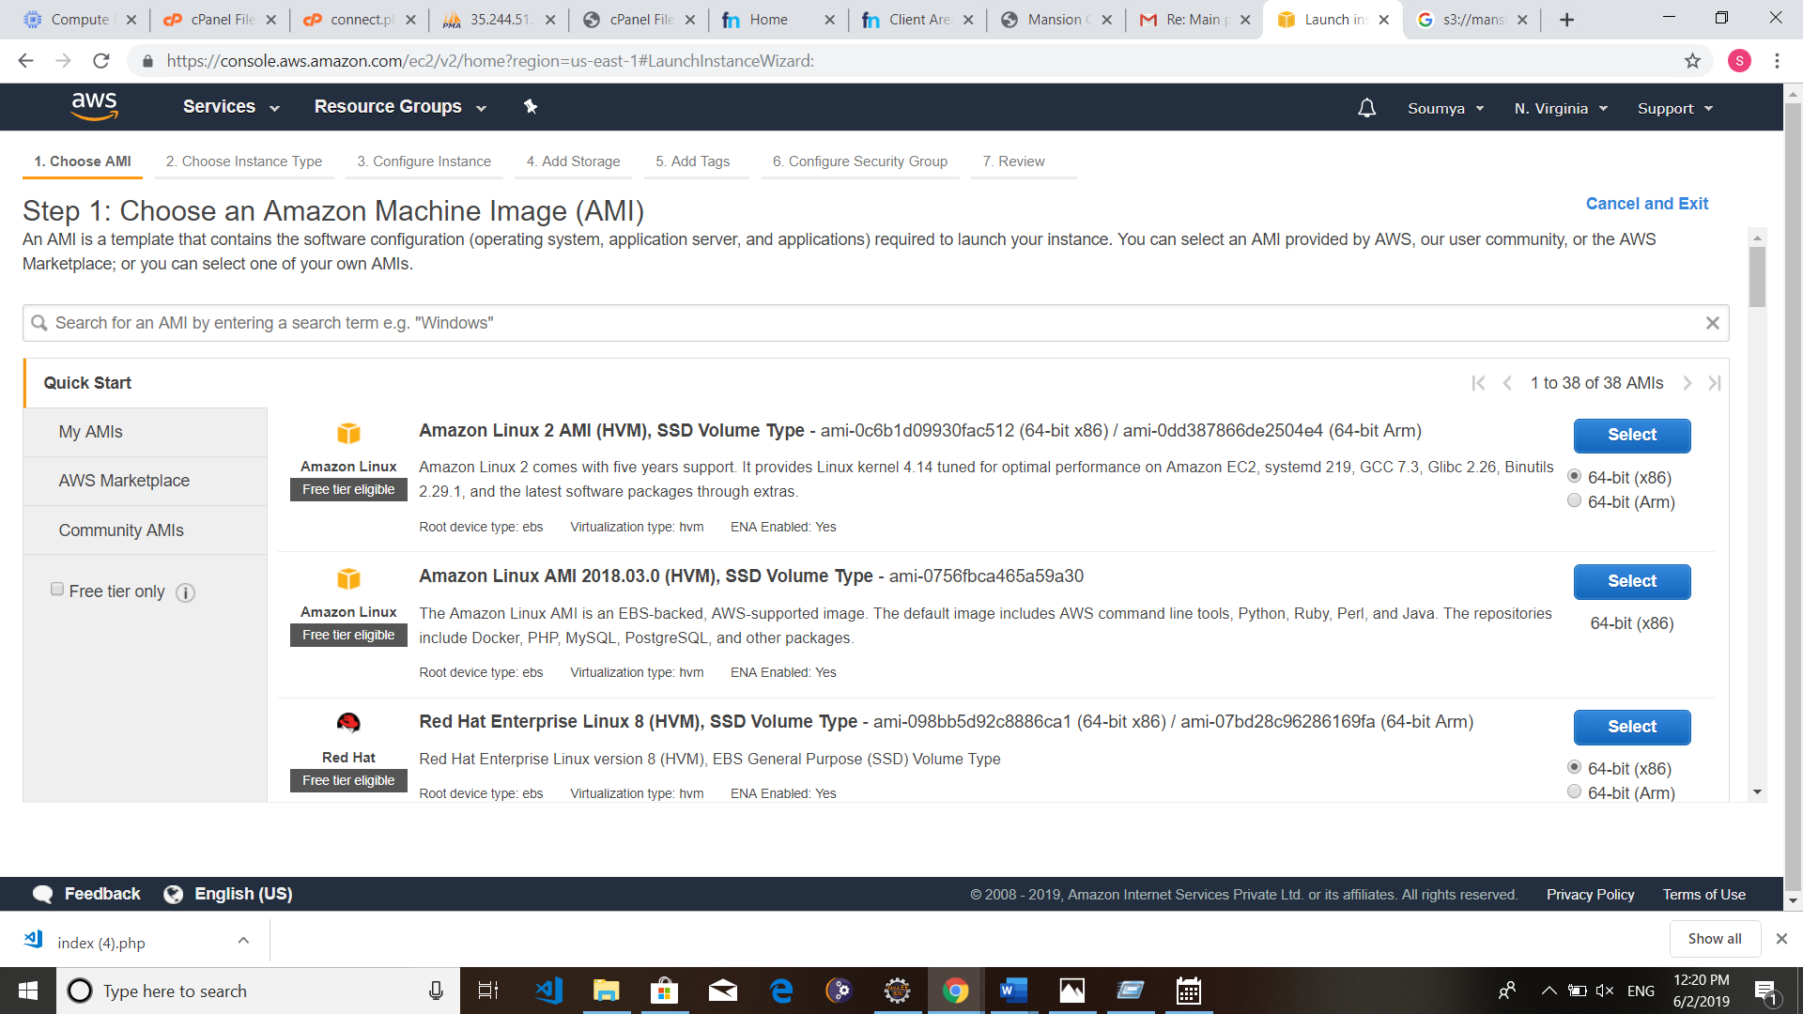

**Step 3: Continue the Installation Step as follows**

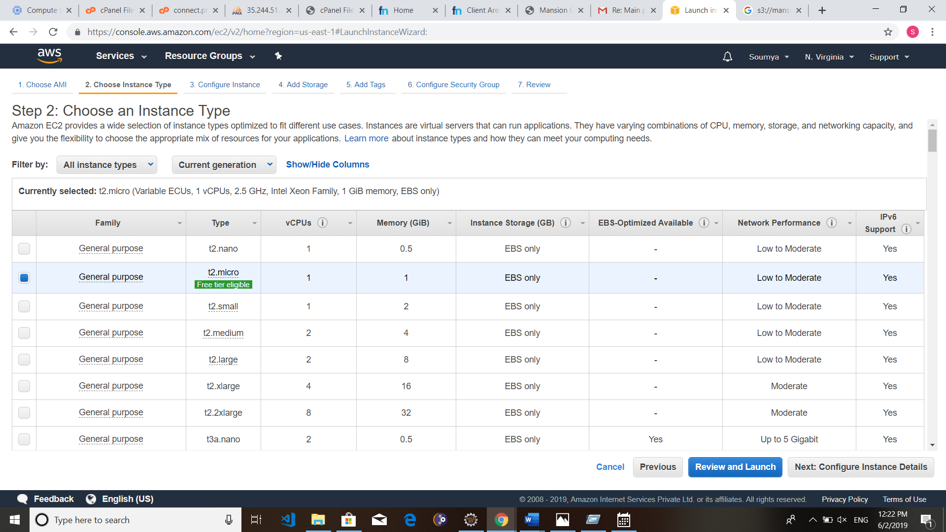

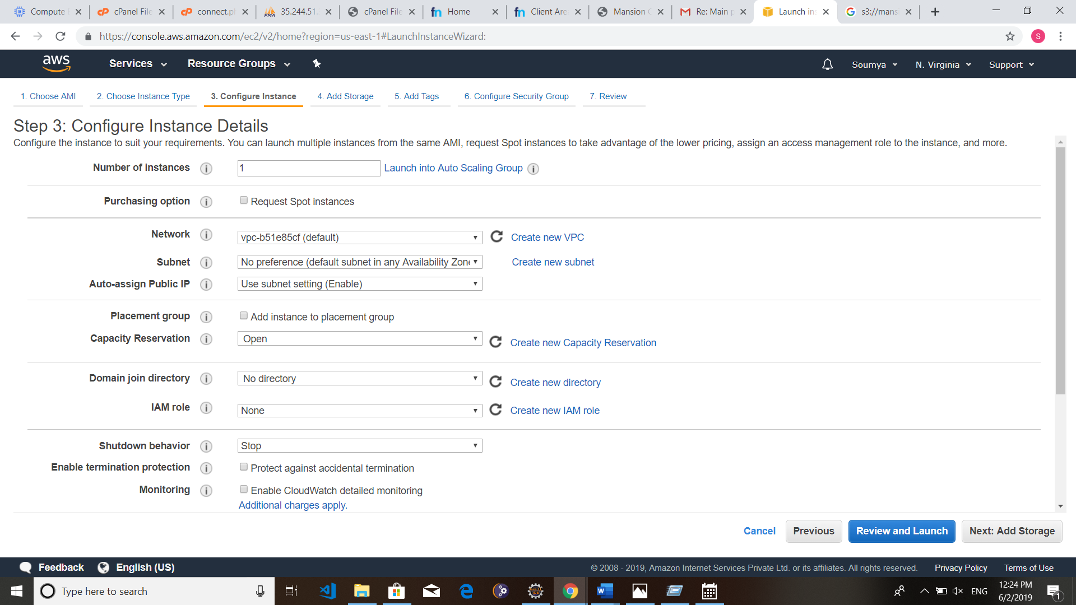

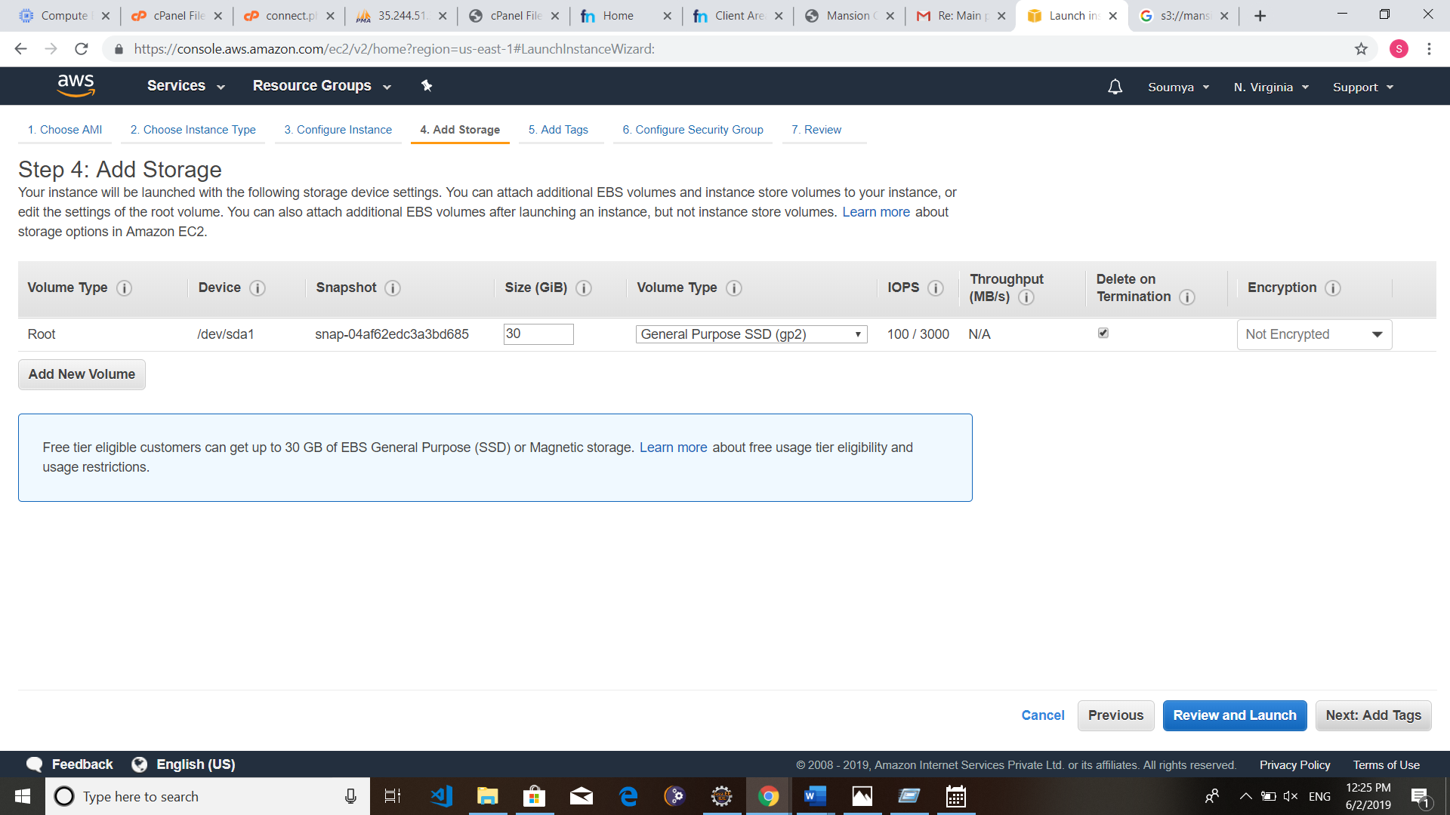

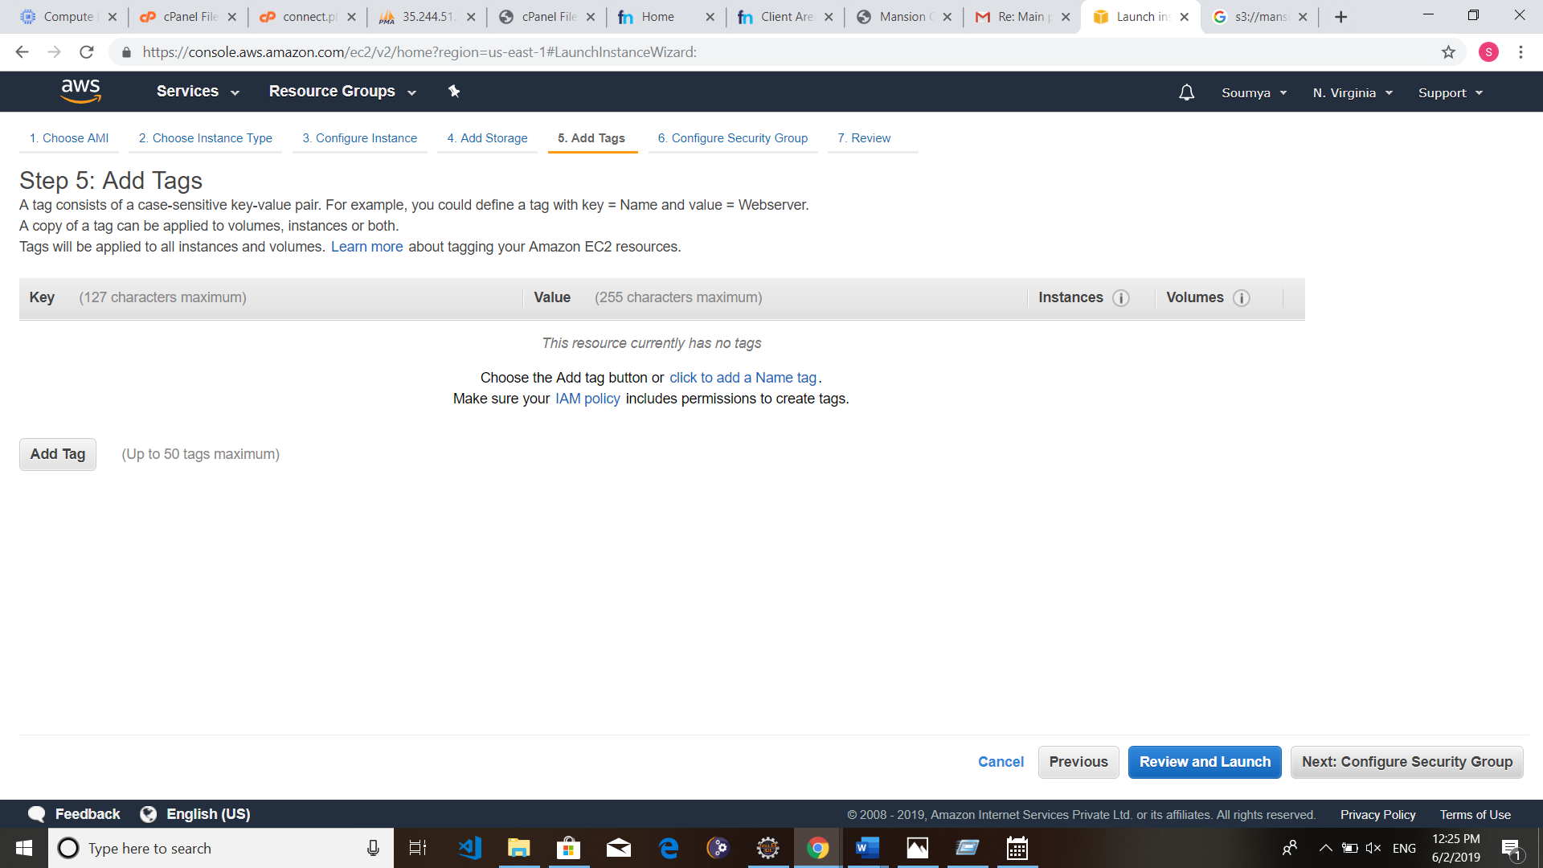

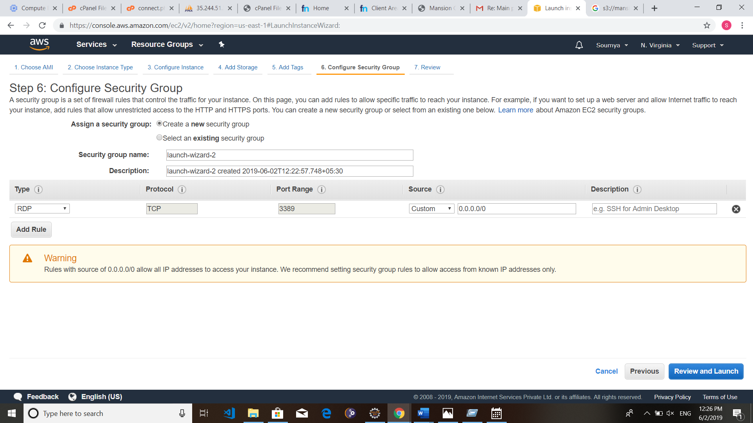

**Step 4: Create a New Key Pair**

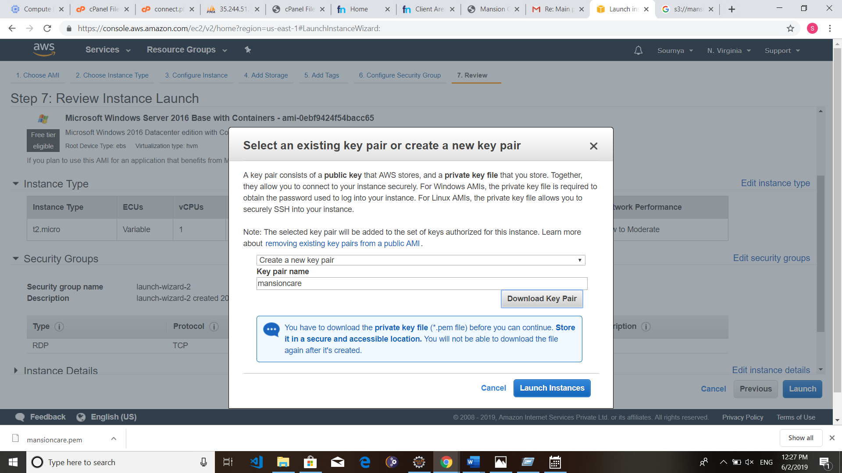

**Step 5: The Instance will be Created.**

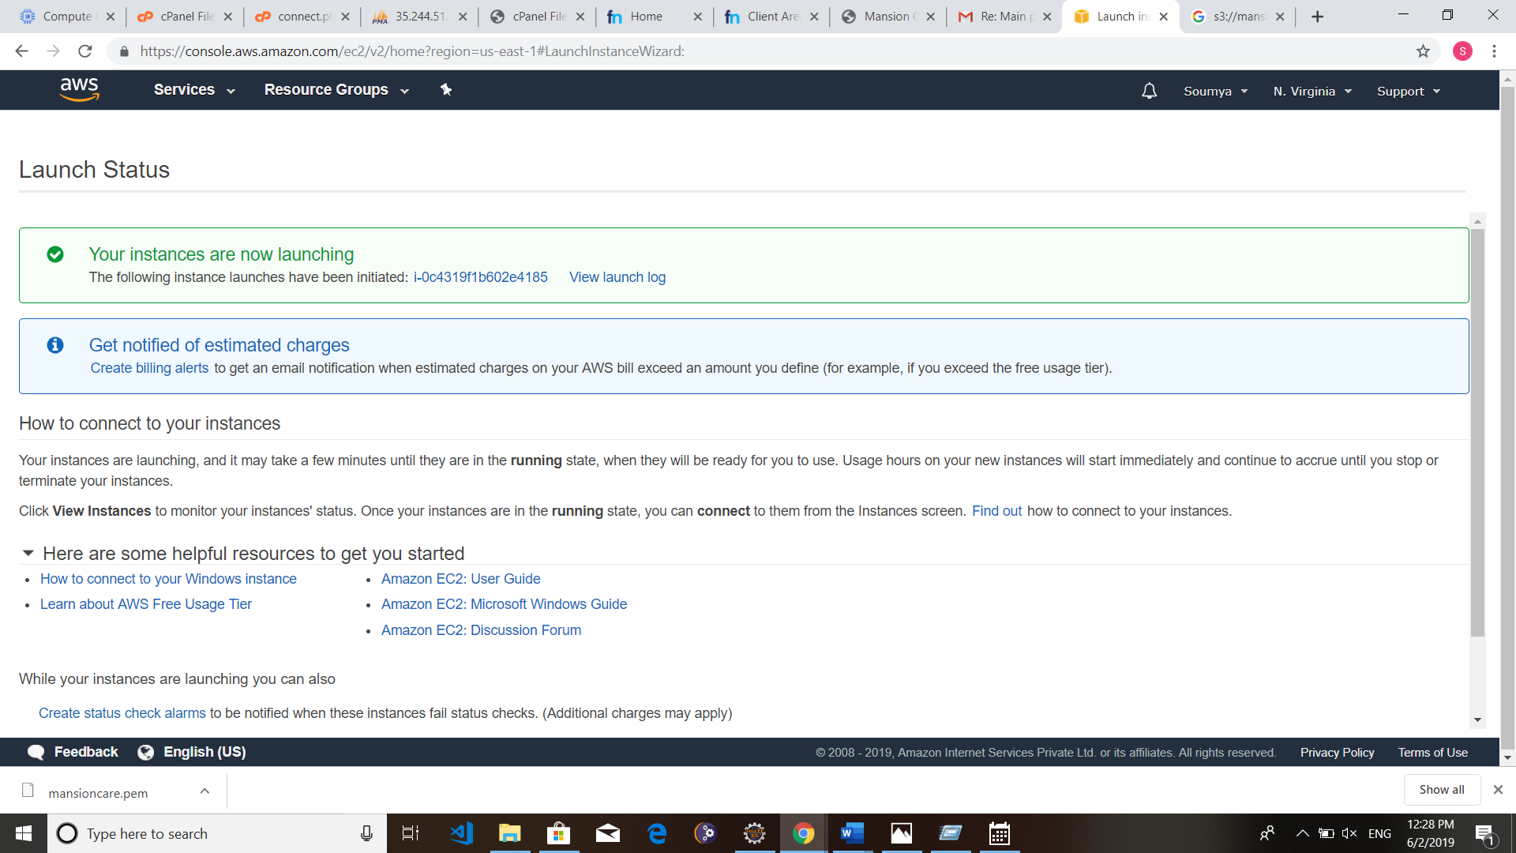

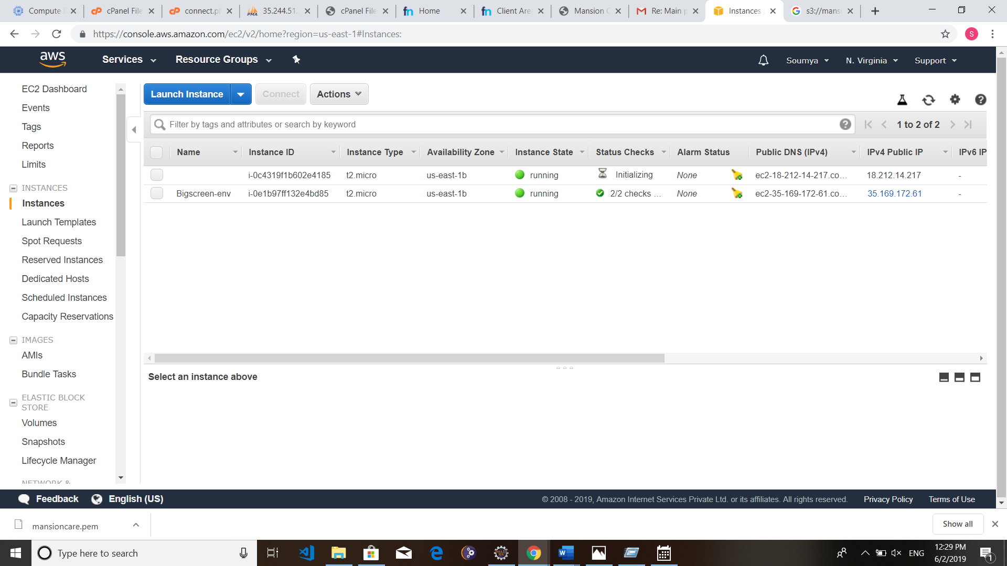

**You can remove the instance by selecting the instance and choose stop then terminate from instance state from dropdown.**

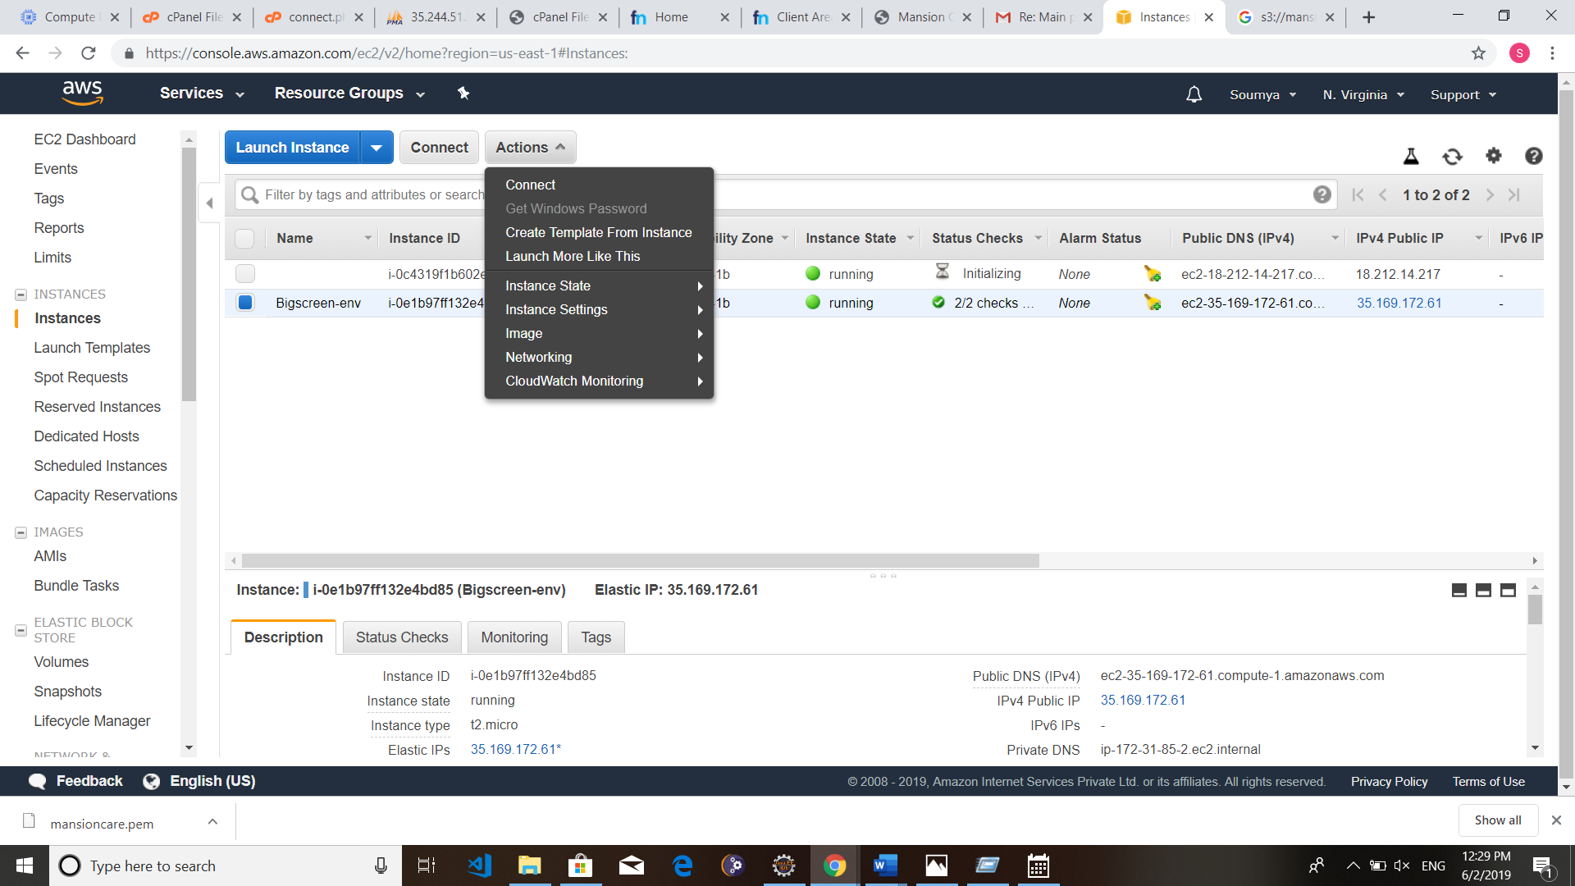

**P1.2.3 AMAZON SIMPLE STORAGE SERVICE (S3)**

Amazon S3 is a web service offered by Amazon Web Services. Amazon S3 provides storage through web services interfaces. S3 is a scalable, high-speed, low-cost, web-based cloud storage service designed for online [backup](http://searchdatabackup.techtarget.com/definition/backup) and [archiving](http://searchstorage.techtarget.com/definition/archive) of data and [application programs](http://searchsoftwarequality.techtarget.com/definition/application-program). S3 was designed with a minimal feature set and created to make web-scale computing easier for developers. Amazon S3 is an object storage service, which differs from block and file cloud storage. Each object is stored as a file with its metadata included and given an ID number. Applications use this ID number to access an object. Unlike file and block cloud storage, a developer can access an object via a rest API.

The S3 cloud storage service gives a subscriber access to the same systems that Amazon uses to run its own websites. S3 enables a customer to upload, store and download practically any file or object that is up to five [gigabytes](http://searchstorage.techtarget.com/definition/gigabyte) (5 GB) in size. Amazon S3 comes in two storage classes: S3 Standard and S3 Infrequent Access. S3 Standard is suitable for frequently accessed data that needs to be delivered with low latency and high throughput. S3 Standard targets applications, dynamic websites, content distribution and big data workloads. S3 Infrequent Access offers a lower storage price for backups and long-term data storage.

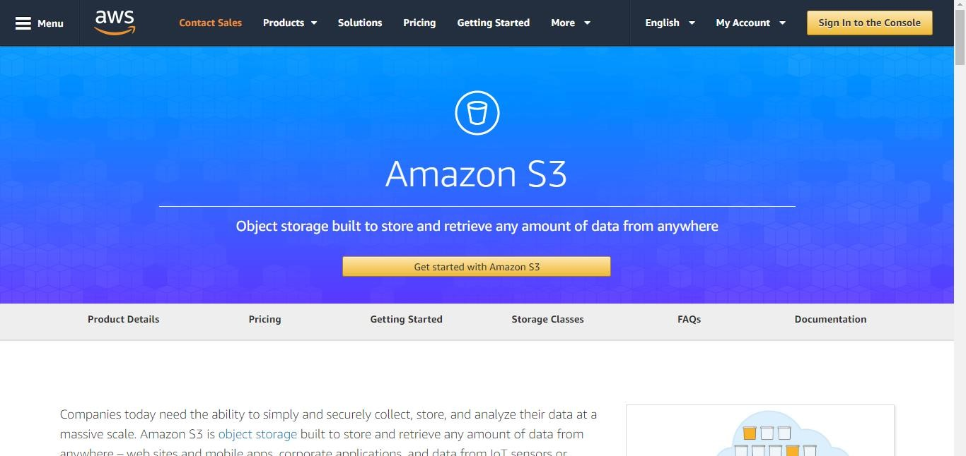

#### Step 1: Login into the AWS platform

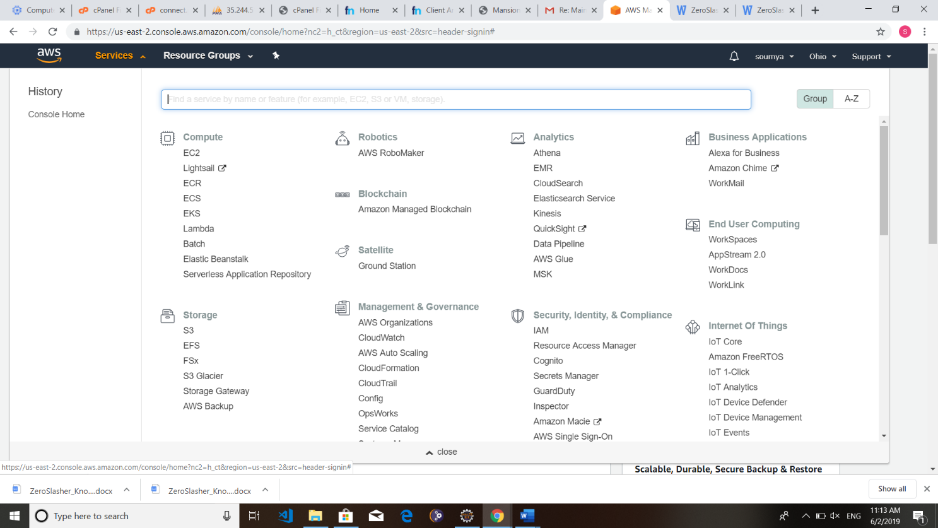

**Step 2: We are going to create an Amazon S3 Bucket**

1. **Provide Bucket name**

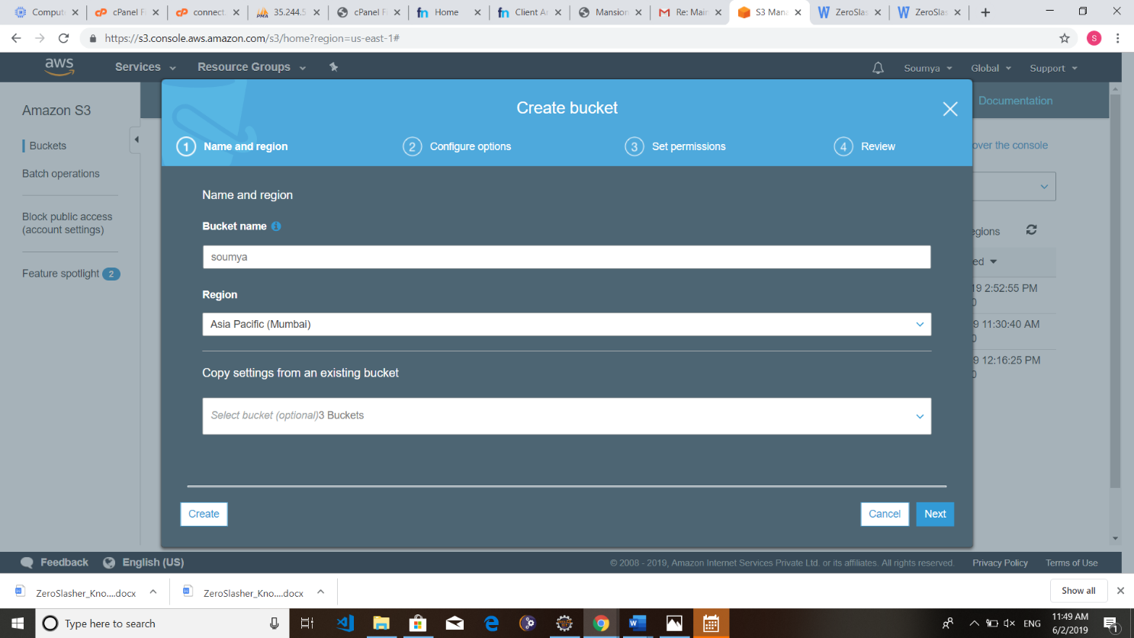

1. **Set Properties and permissions**

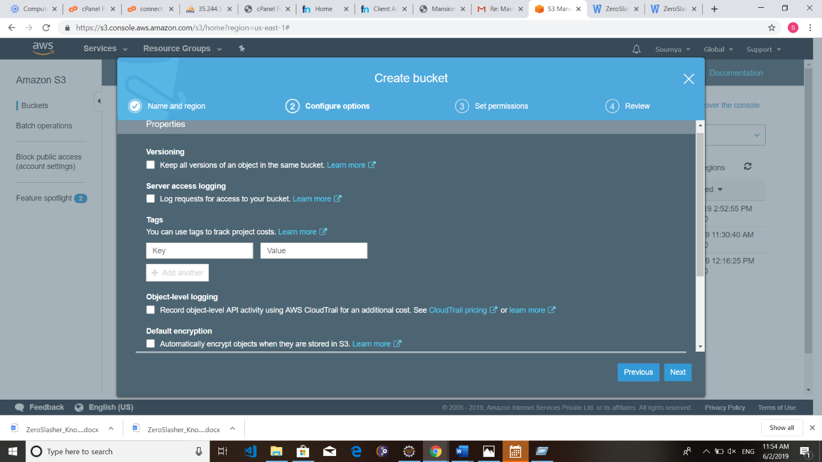

1. **Review the Changes**

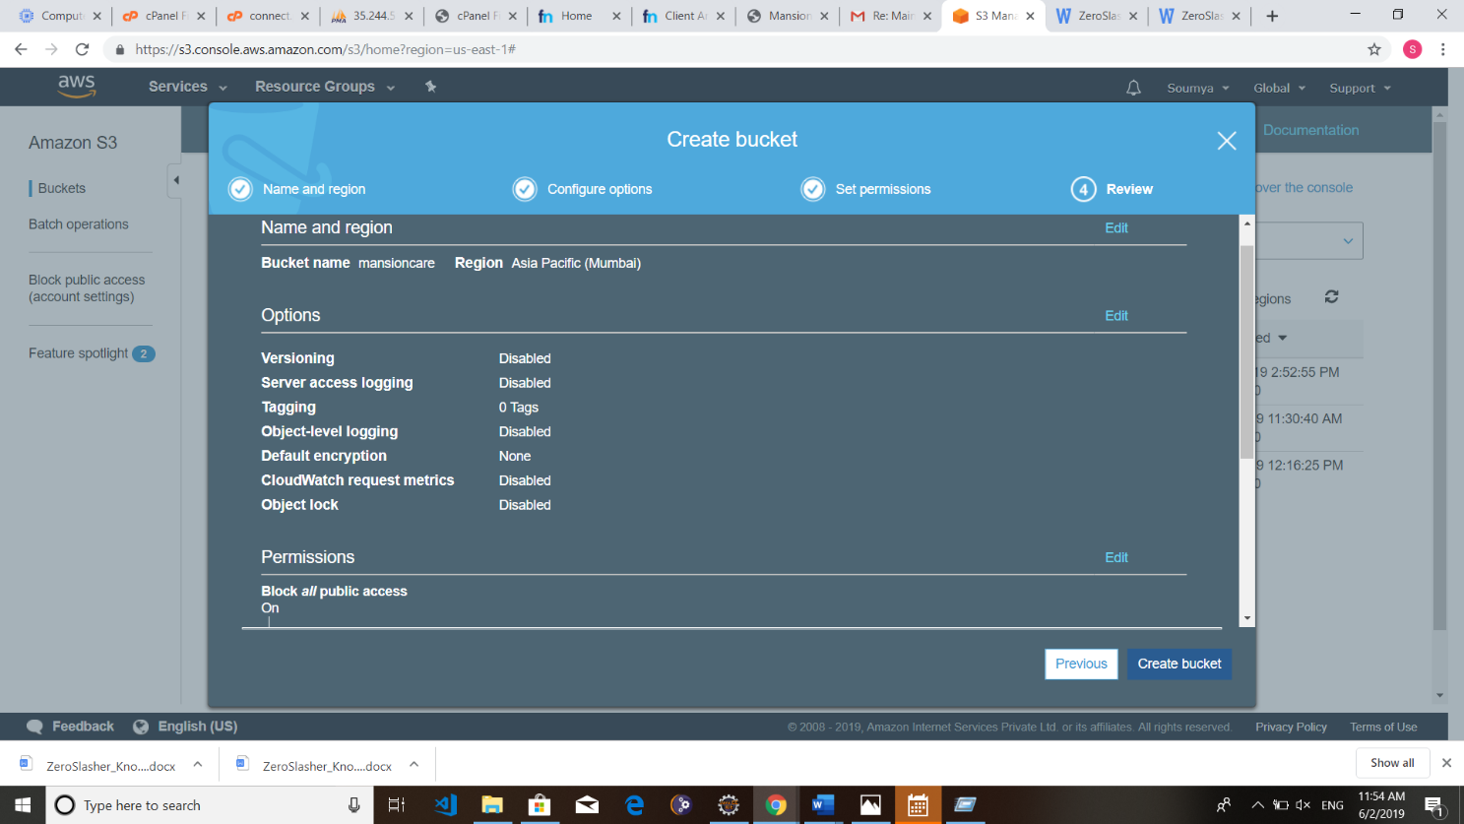

1. **Our Bucket has been created**

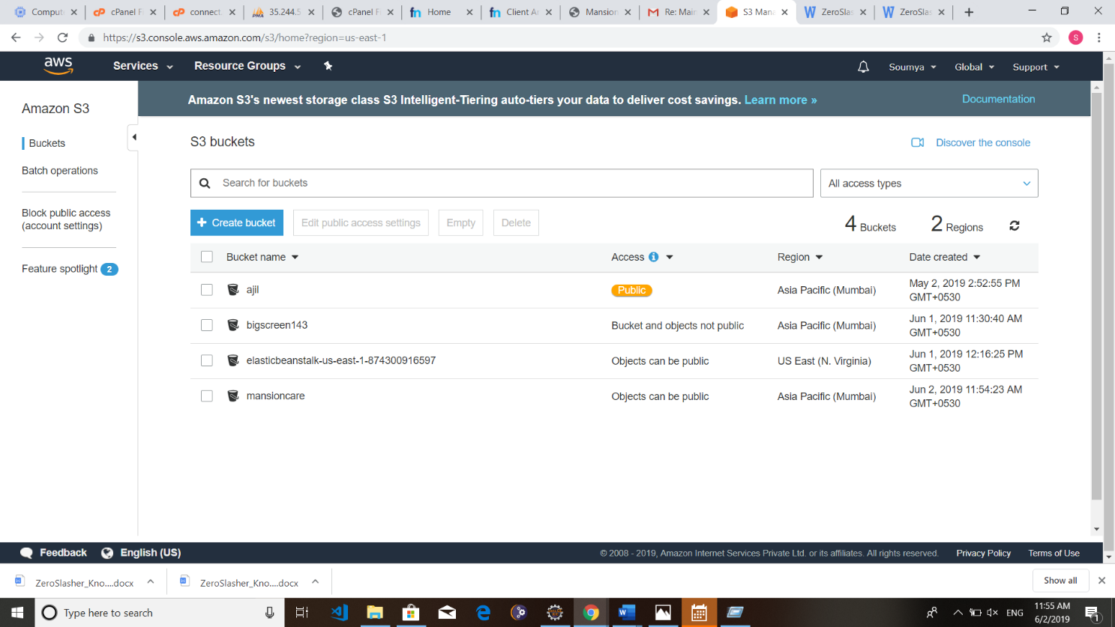

**Step 3: We can upload files to this Bucket.**

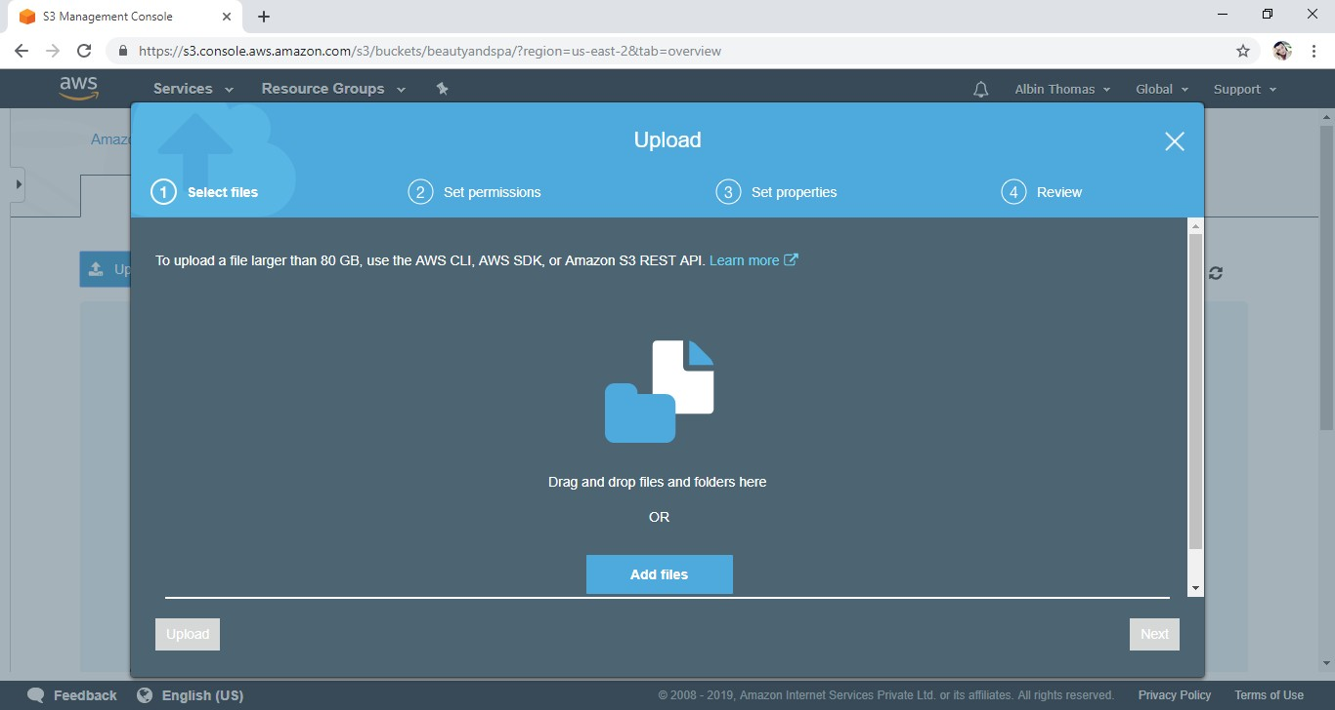

1. **Just drag and drop the files, that we need to upload.**

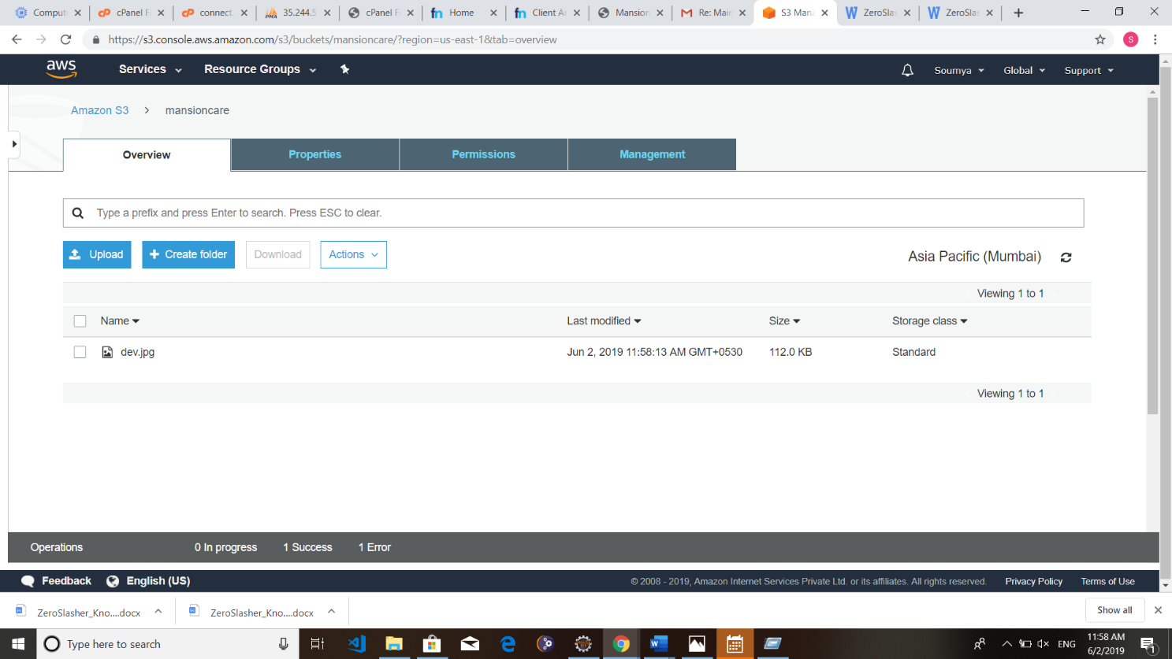

1. **We have to set the permissions. Otherwise it will not be publicly available.**

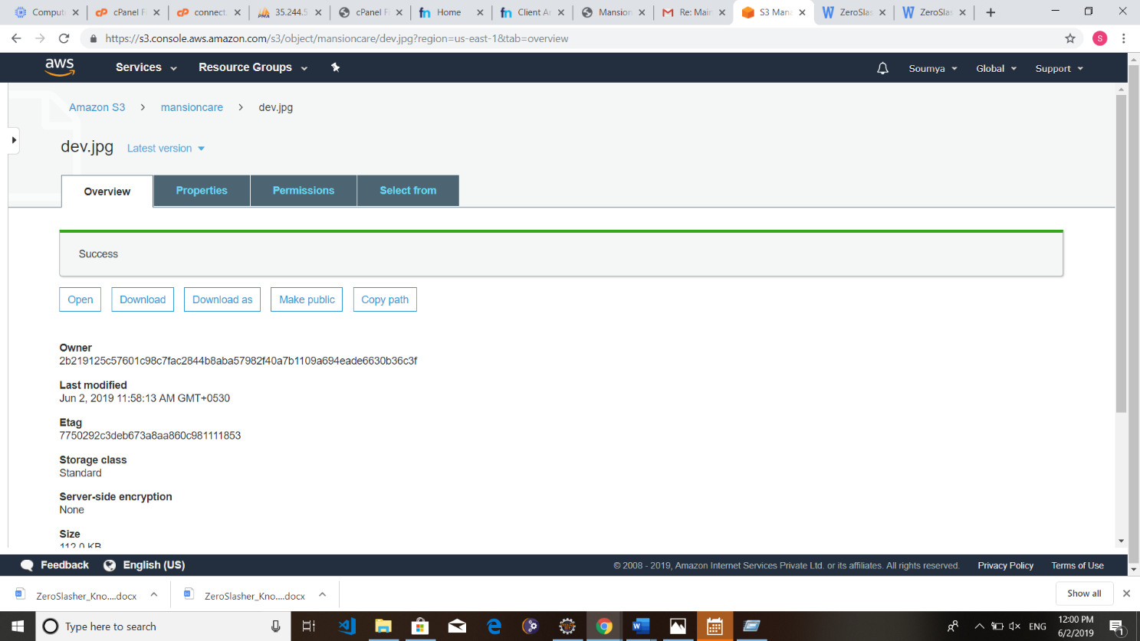

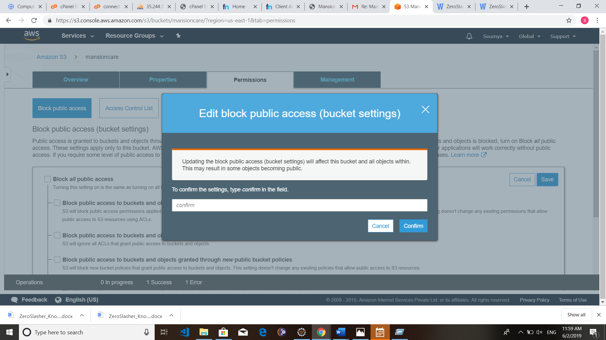

**Then the file will be publicly available.**

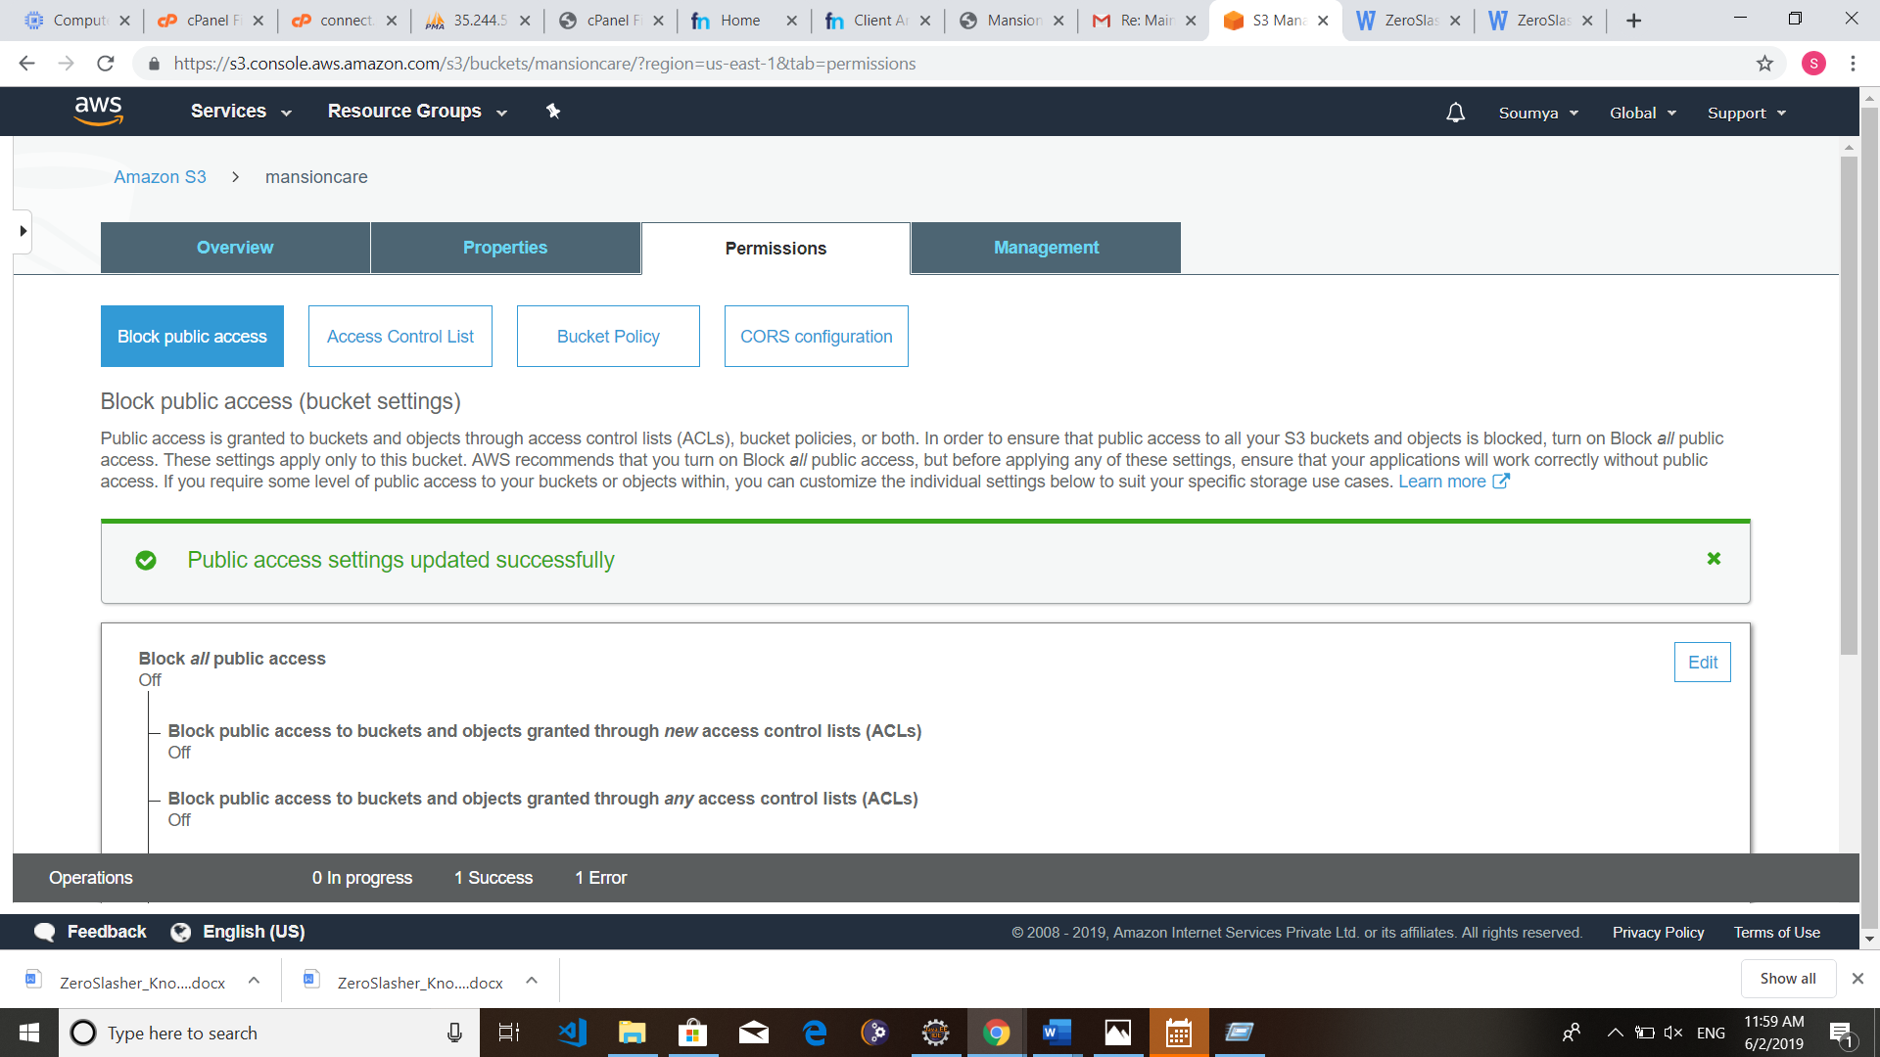

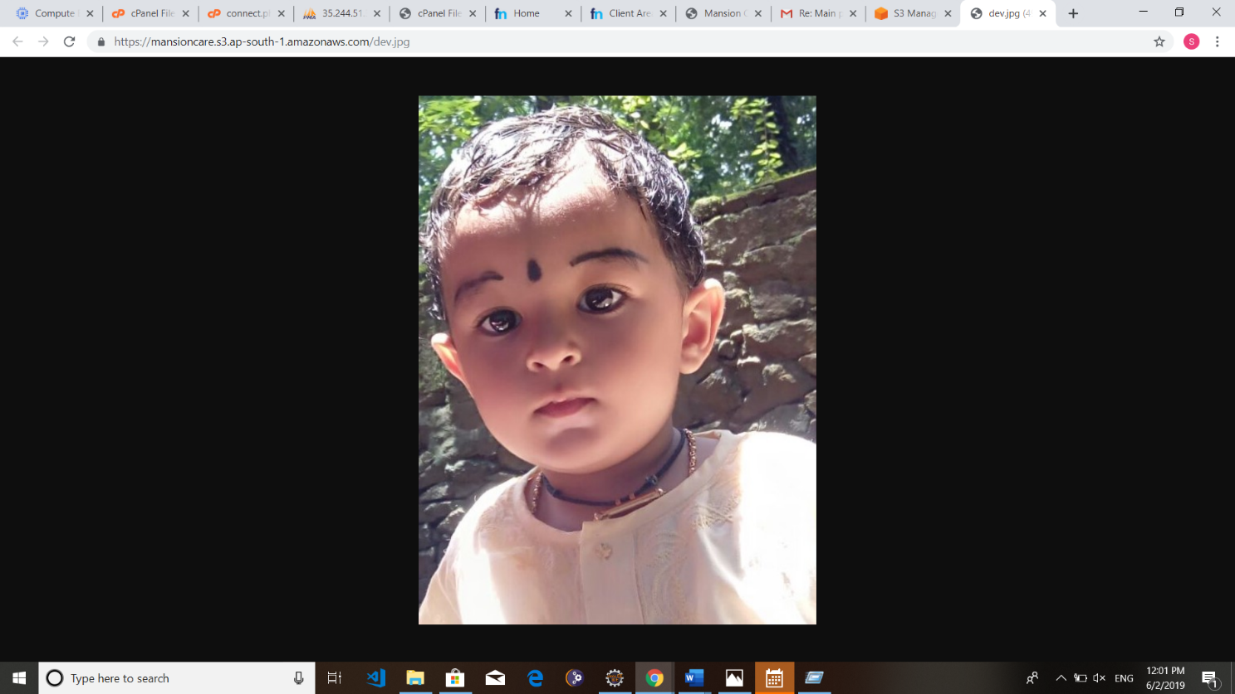

**Step 4: For the purpose of hosting a Website we create another Bucket**

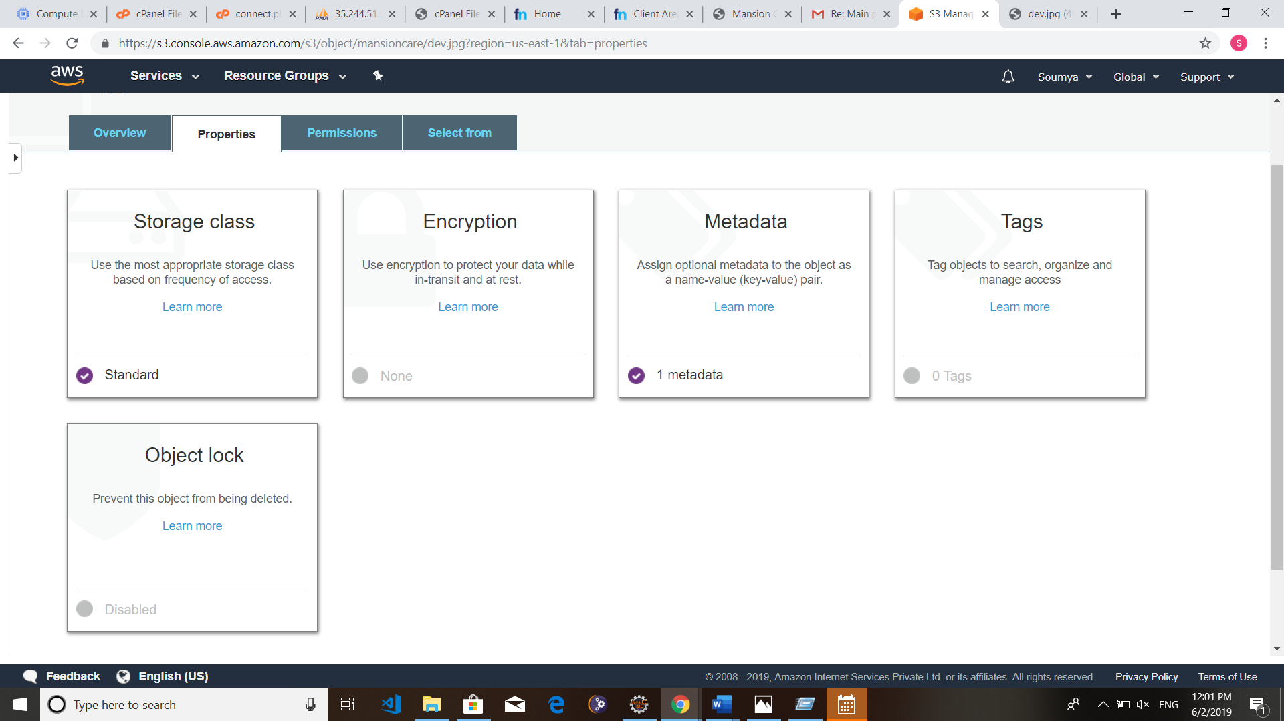

**Specify the name of the Index document and Error document. Save it.**

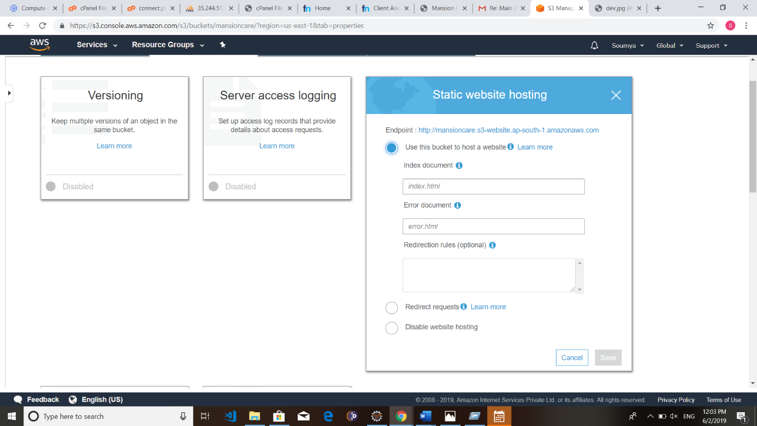

**Upload the Index document and Error Document.**

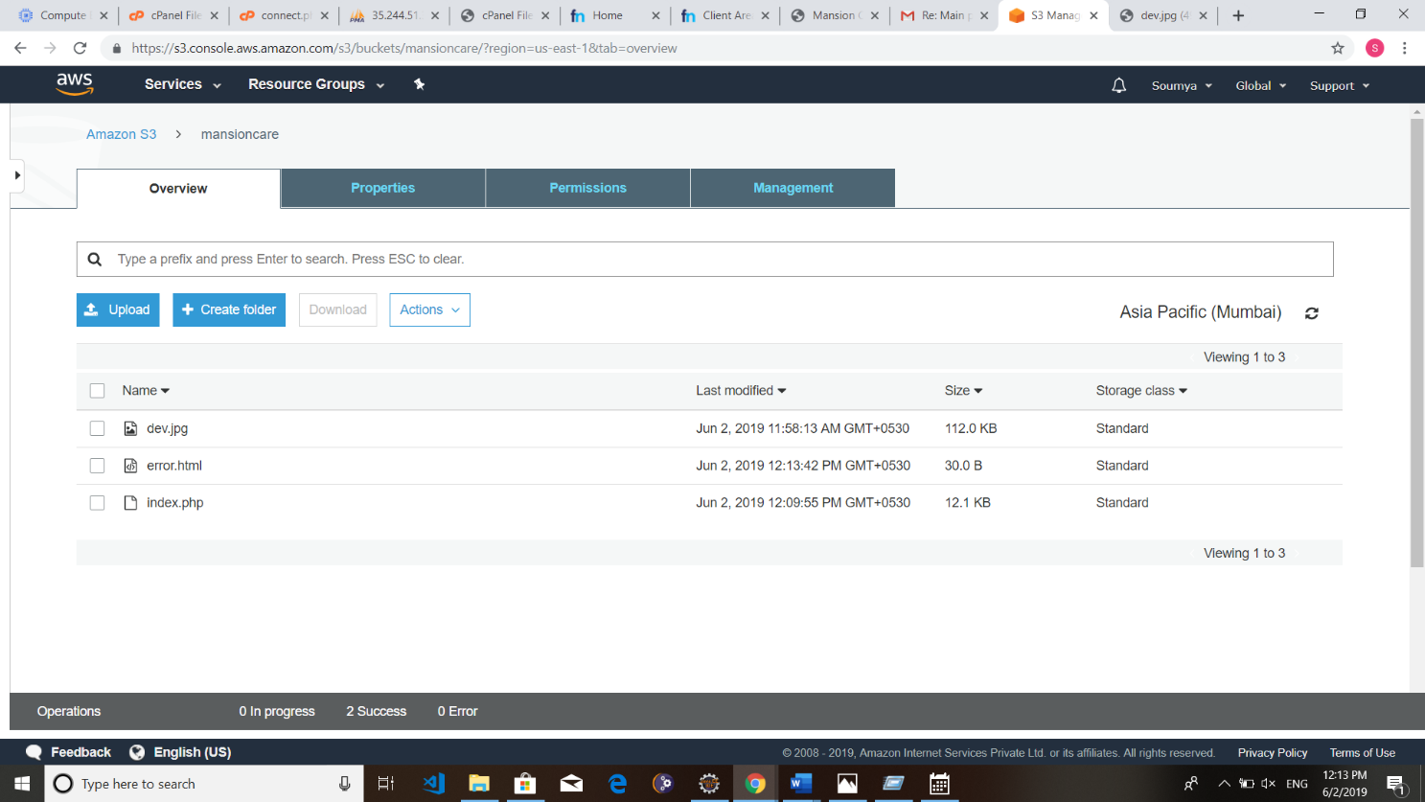

**Now you can access the static site by the url provided here:**

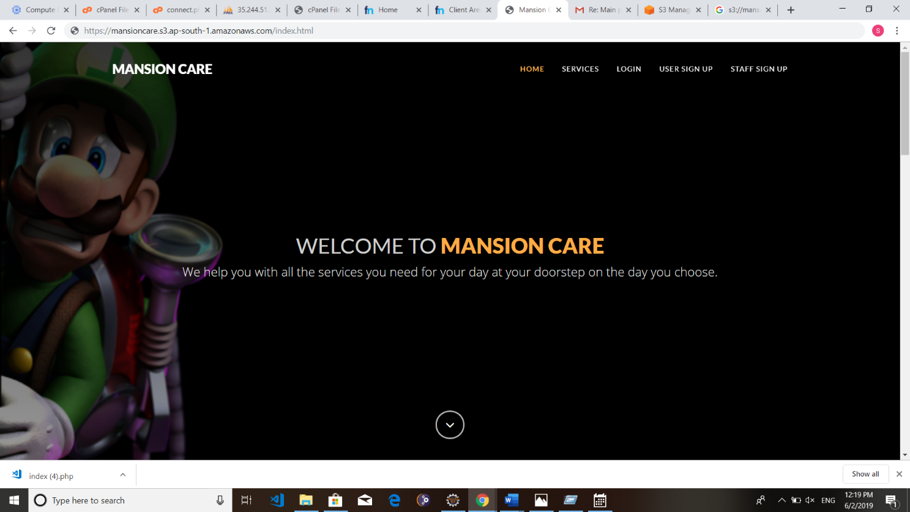

**P1.2.4 AWS ELASTIC BEANSTALK**

AWS Elastic Beanstalk is an easy-to-use service for deploying and scaling web applications and services developed with Java, .NET, PHP, Node.js, Python, Ruby, Go, and Docker on familiar servers such as Apache, Nginx, Passenger, and IIS.

You can simply upload your code and Elastic Beanstalk automatically handles the deployment, from capacity provisioning, load balancing, auto-scaling to application health monitoring. At the same time, you retain full control over the AWS resources powering your application and can access the underlying resources at any time.

There is no additional charge for Elastic Beanstalk - you pay only for the AWS resources needed to store and run your applications.

#### Benefits:

##### Fast and Simple to Begin

Elastic Beanstalk is the fastest and simplest way to deploy your application on AWS. You simply use the AWS Management Console, a Git repository, or an integrated development environment (IDE) such as Eclipse or Visual Studio to upload your application, and Elastic Beanstalk automatically handles the deployment details of capacity provisioning, load balancing, auto-scaling, and application health monitoring. Within minutes, your application will be ready to use without any infrastructure or resource configuration work on your part**.**

##### Impossible to Outgrow

Elastic Beanstalk automatically scales your application up and down based on your application's specific need using easily adjustable Auto Scaling settings. For example, you can use CPU utilization metrics to trigger Auto Scaling actions. With Elastic Beanstalk, your application can handle peaks in workload or traffic while minimizing your costs.

##### Developer Productivity

Elastic Beanstalk provisions and operates the infrastructure and manages the application stack (platform) for you, so you don't have to spend the time or develop the expertise. It will also keep the underlying platform running your application up-to-date with the latest patches and updates. Instead, you can focus on writing code rather than spending time managing and configuring servers, databases, load balancers, firewalls, and networks.

#### Step 1: Login to AWS and click Elastic Beanstalk

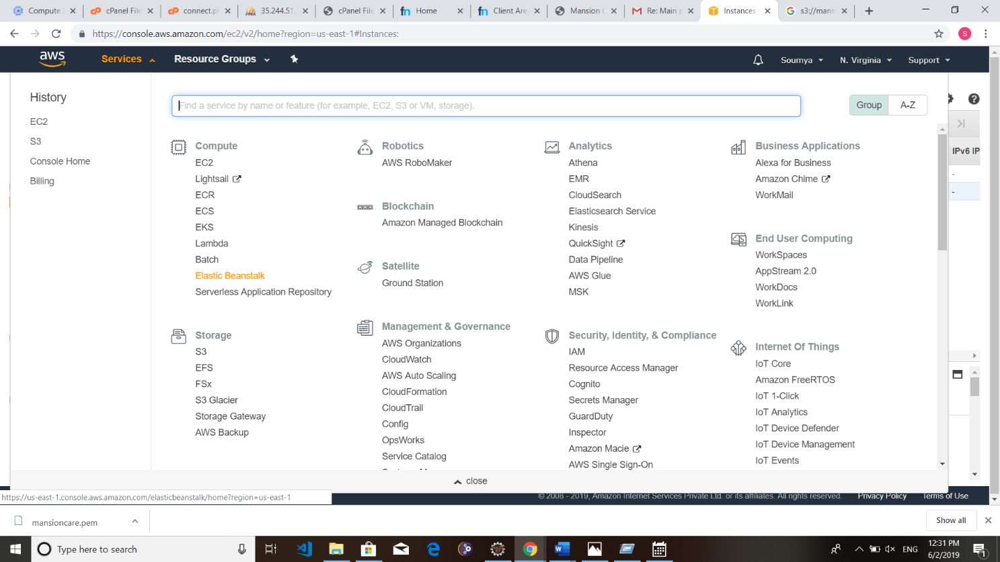

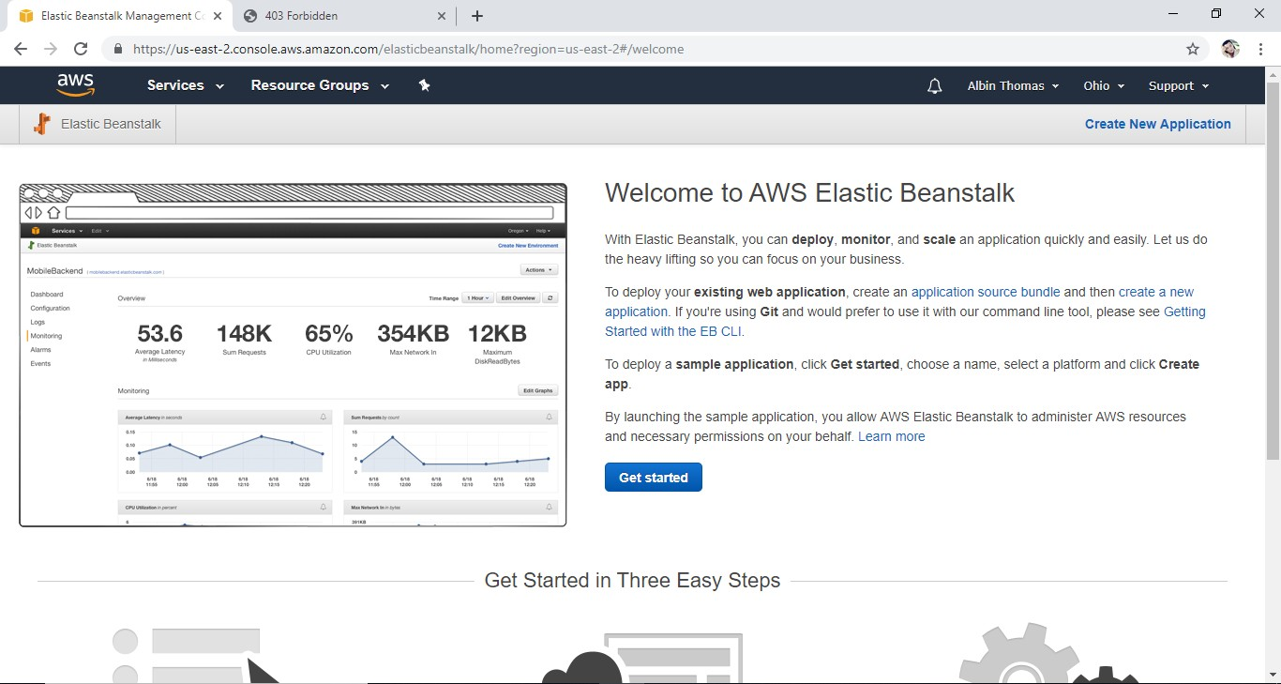

**Step 2: Create Web App with Elastic Beanstalk**

Choose the application name, select platform and you may upload the source code too.

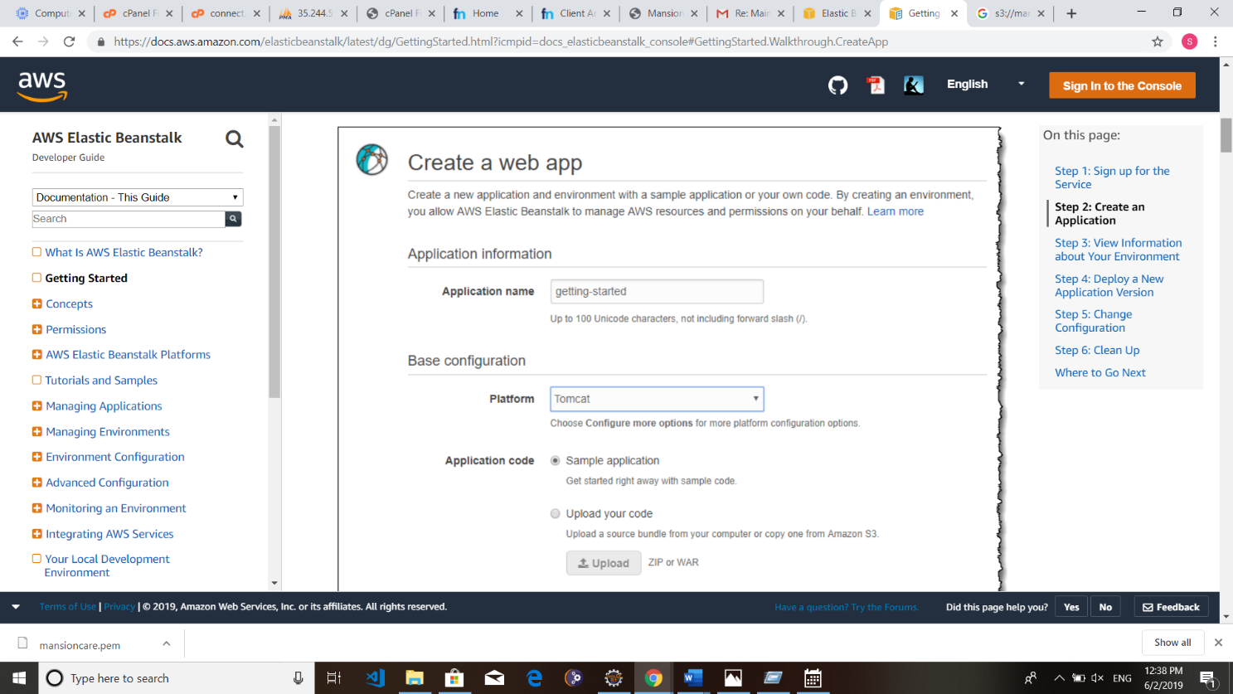

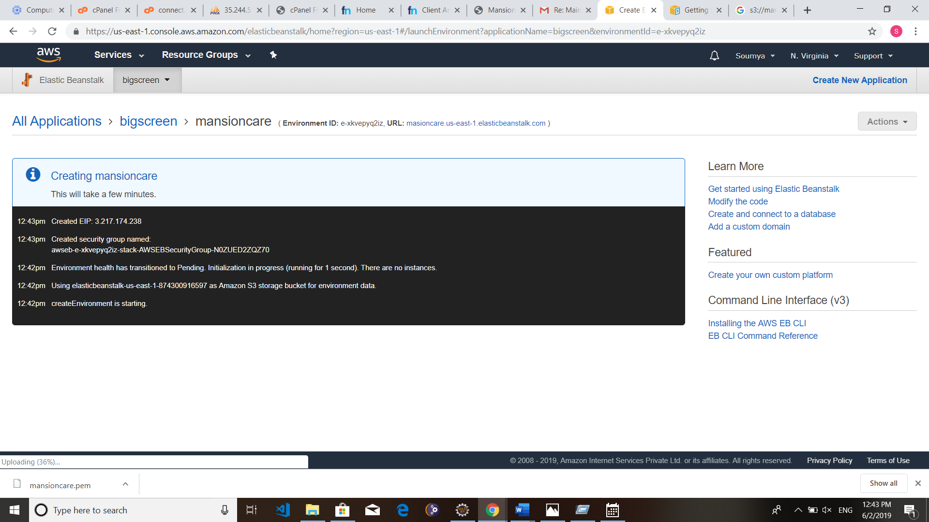

#### Beanstalk Web App has successfully created.

**–––**

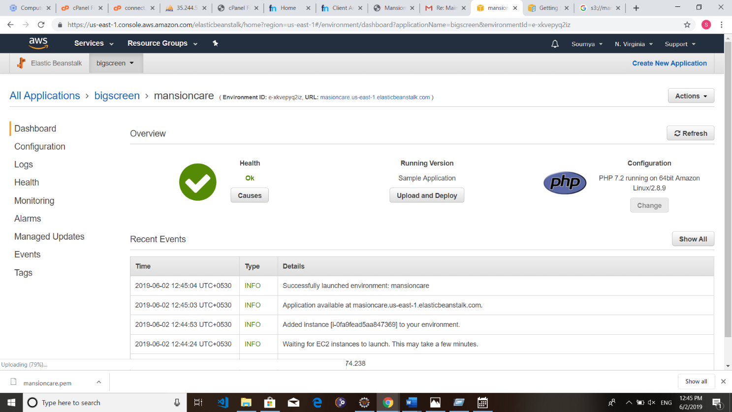

**Step 3: Create Web App with Elastic Beanstalk Click upload and deploy button on the dashboard.**

**Upload the source code for the web app.**

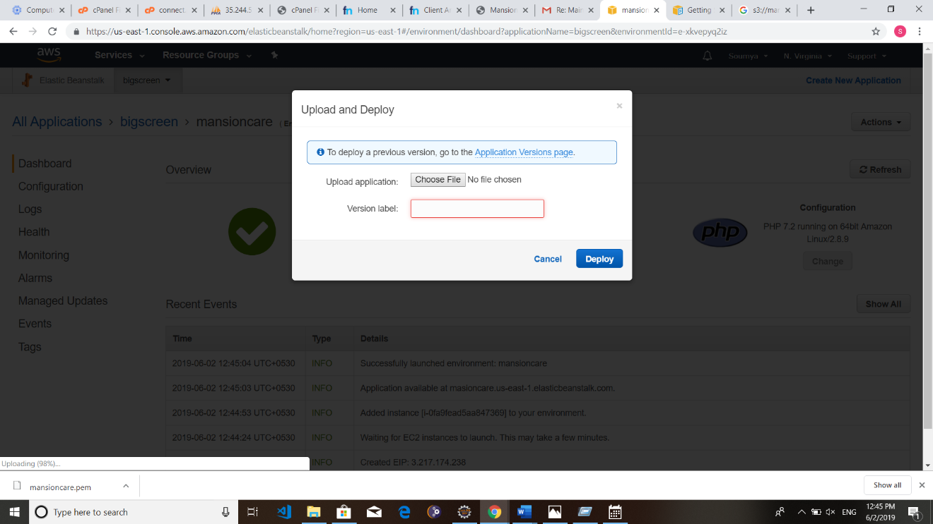

**Use the url displayed in the dashboard to access the beanstalk web app.**



**Beanstalk offers a number of options to configure the web app.**

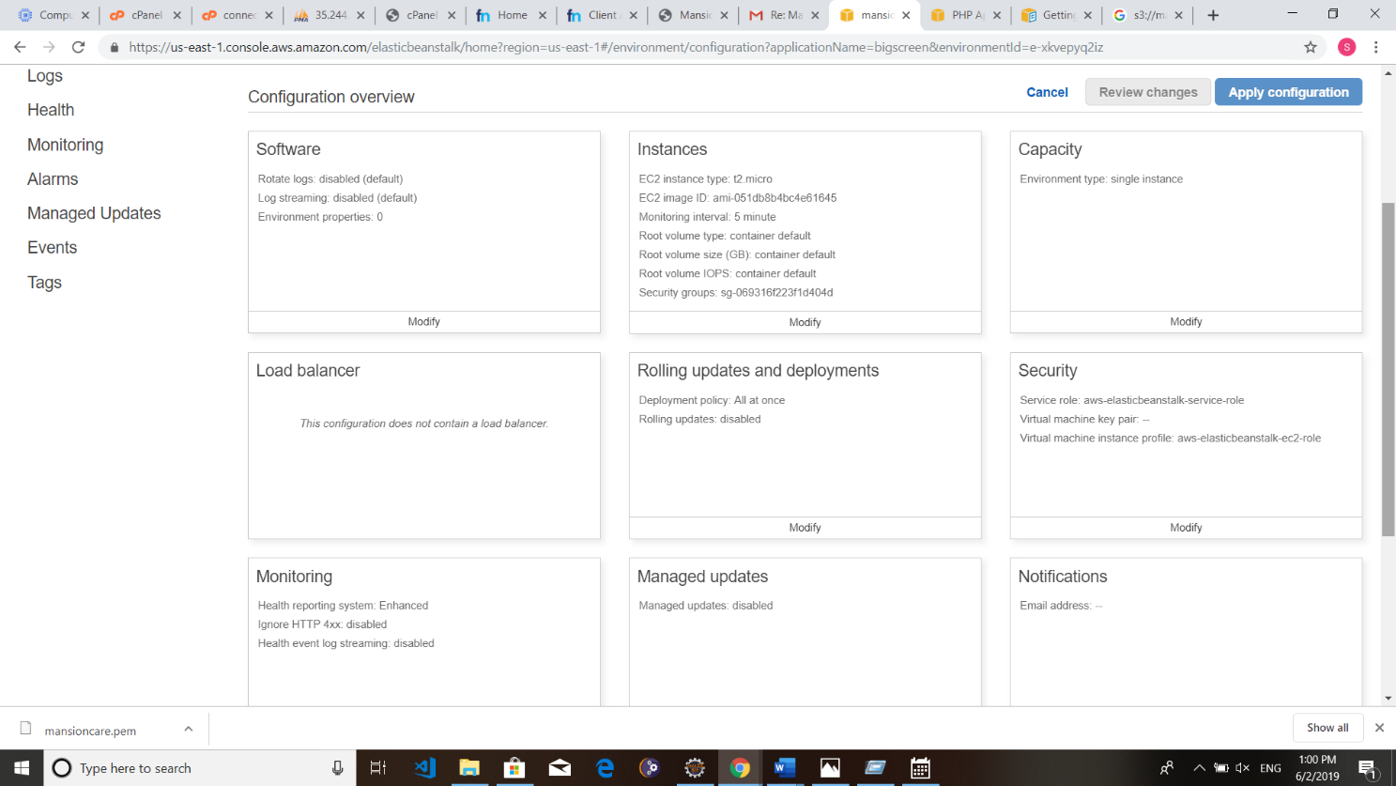

You may modify the instance capacity or more.

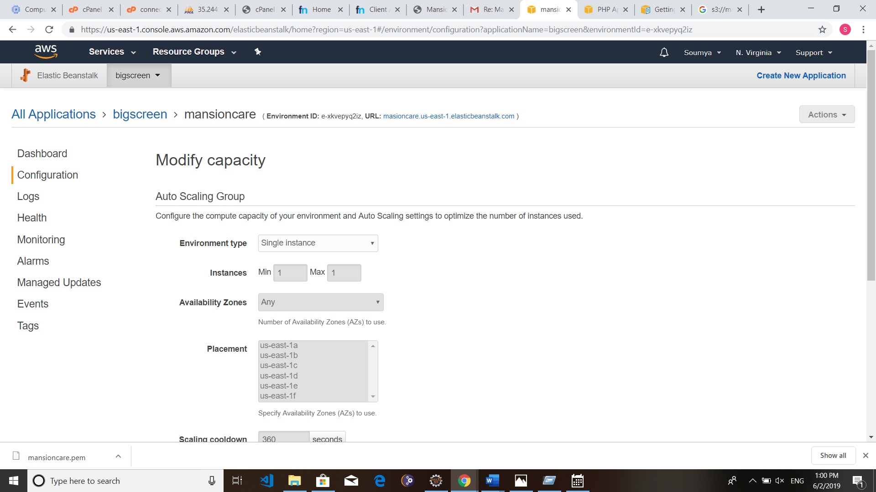

### P1.2.5 AWS DB PRODUCTS

**P1.2.5.1 Amazon Relational Database Service (RDS)**

Amazon Relational Database Service (Amazon RDS) is a web service that makes it easy to set up, operate, and scale a relational database in the cloud. It provides cost-efficient and resizable capacity while managing time-consuming database administration tasks, freeing you up to focus on developing your applications.

Amazon RDS gives you access to the capabilities of a familiar MySQL, PostgreSQL, Oracle or Microsoft SQL Server database engine. This means that the code, applications, and tools you already use today with your existing databases can be used with Amazon RDS. Amazon RDS automatically patches the database software and backs up your database, storing the backups for a user-defined retention period and enabling point-in-time recovery. You benefit from the flexibility of being able to scale the compute resources or storage capacity associated with your Database Instance (DB Instance) via a single API call.

### P1.2.5.2 Amazon DynamoDB

DynamoDB is a fast, fully managed NoSQL database service that makes it simple and cost- effective to store and retrieve any amount of data and serve any level of request traffic. All data items are stored on Solid State Drives (SSDs) for high availability and durability.

### P1.2.5.3 Amazon ElastiCache

ElastiCache is a web service that makes it easy to deploy, operate, and scale an in-memory cache in the cloud. The service improves the performance of web applications by allowing you to retrieve information from fast, managed, in-memory caches, instead of relying entirely on slower disk-based databases. ElastiCache supports two widely adopted open-source engines – Memcached and Redis. The service is protocol compliant with both engines, so popular tools that you use today with existing Memcached and Redis environments will work seamlessly with ElastiCache.

### P1.2.6 DEVOPS IN AWS

AWS provides a set of flexible services designed to enable companies to more rapidly and reliably build and deliver products using AWS and DevOps practices. These services simplify provisioning and managing infrastructure, deploying application code, automating software release processes, and monitoring your application and infrastructure performance. And it is the combination of cultural philosophies, practices, and tools that increase an organization’s ability to deliver applications and services at high velocity: evolving and improving products at a faster pace than organizations using traditional software development and infrastructure management processes. This speed enables organizations to better serve their customers and compete more effectively in the market.

Under a DevOps model, development and operations teams are no longer “siloed.” Sometimes, these two teams are merged into a single team where the engineers work across the entire application lifecycle, from development and test to deployment to operations, and develop a range of skills not limited to a single function. Quality assurance and security teams may also become more tightly integrated with development and operations and throughout the application lifecycle. These teams use practices to automate processes that historically have been manual and slow. They use a technology stack and tooling which help them operate and evolve applications quickly and reliably. These tools also help engineers independently accomplish tasks (for example, deploying code or provisioning infrastructure) that normally would have required help from other teams, and this further increases a team’s velocity.

## P1.3 MICROSOFT AZURE CLOUD

### P1.3.1 INTRODUCTION TO MICROSOFT AZURE CLOUD

Microsoft Azure (formerly Windows Azure is a [cloud computing](https://en.wikipedia.org/wiki/Cloud_computing) service created by [Microsoft](https://en.wikipedia.org/wiki/Microsoft) for building, testing, deploying, and managing applications and services through a global network of Microsoft-managed [data centers](https://en.wikipedia.org/wiki/Data_center). It provides [software as a service](https://en.wikipedia.org/wiki/Software_as_a_service) [(SaaS),](https://en.wikipedia.org/wiki/Software_as_a_service) [platform as a service (PaaS)](https://en.wikipedia.org/wiki/Platform_as_a_service) and [infrastructure as a service (IaaS)](https://en.wikipedia.org/wiki/Infrastructure_as_a_service) and supports many different [programming languages,](https://en.wikipedia.org/wiki/Programming_language) tools, and frameworks, including both Microsoft-specific and third-party software and systems. Windows Azure is designed to make IT management easier. The main purpose of developing Windows Azure was to minimize the overhead and personnel expenses associated with the creation, distribution, and upgrade of the Web applications.

The Windows Azure platform is considered a platform as a service, which is an imperative component of a cloud computing platform. It consists of various on-demand services hosted in Microsoft's data centers and is commoditized through three product brands. The services and applications developed using the Azure platform run on the Windows Azure operating system, which provides a runtime environment for Web applications along with an extensive set of services that facilitate the building, hosting and management of applications without requiring maintenance too expensive onsite resources. Windows Azure is designed to support both Microsoft and non-Microsoft platforms. The three main components that constitute Windows Azure are:

* Compute layer
* Storage layer
* Fabric layer

Windows Azure also includes an automated service management feature that allows the upgrading of applications without affecting their performance. Windows Azure is designed to support a number of platforms and programming languages. Some of the languages supported are extensible markup language (XML), representational state transfer (REST), Simple Object Access Protocol (SOAP), Ruby, Eclipse, Python, and PHP.

**Step 1: For Registration go to** [***http://imagine.microsoft.com***](http://imagine.microsoft.com/)

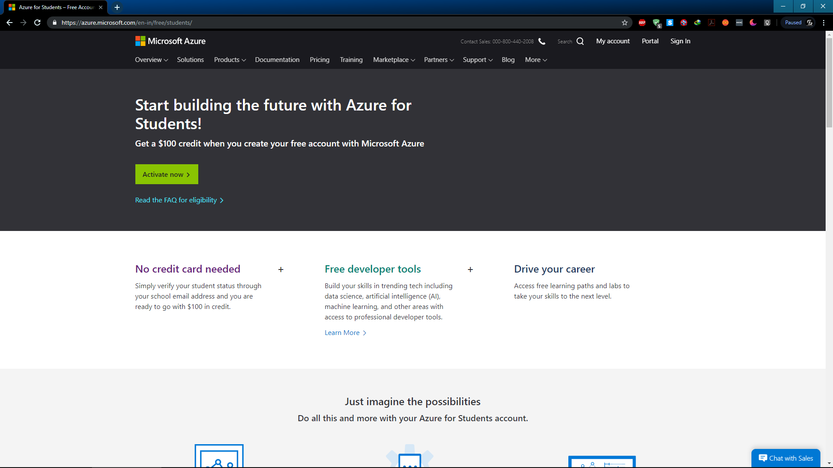

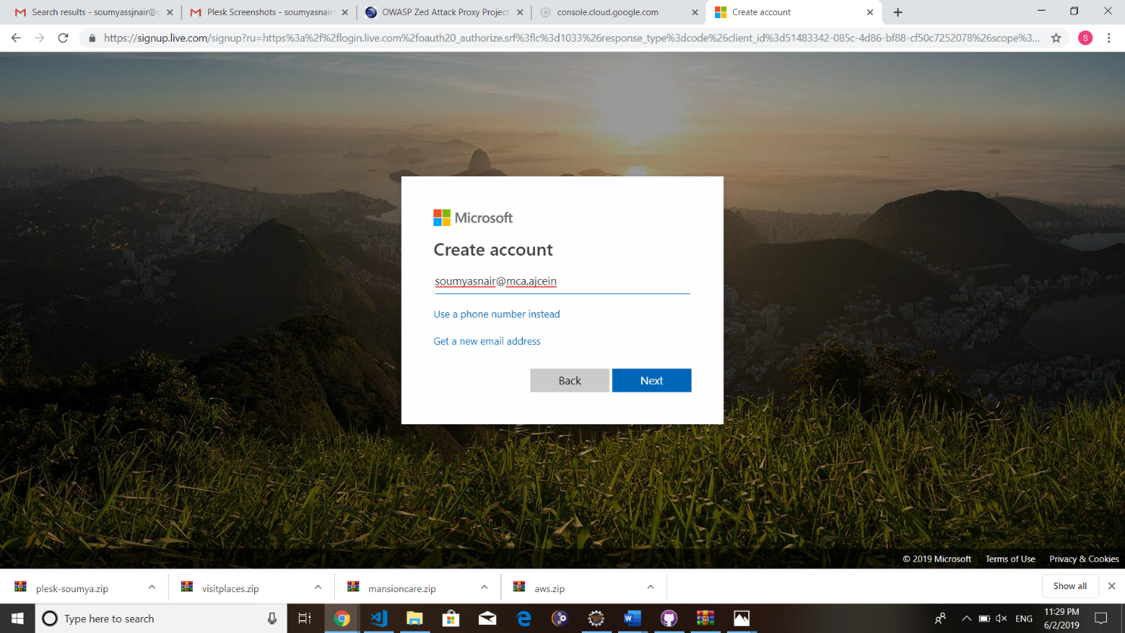

#### Step 2: After registration you will get Azure Dashboard

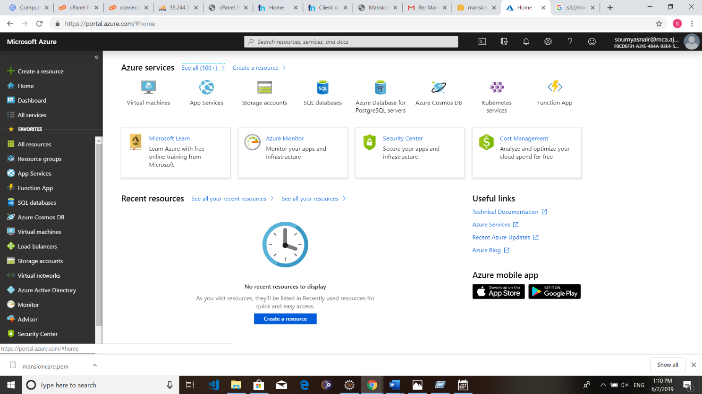

**Step 3: Create Resource Group: All Resources > Resource Group**

**Click Add Button > Select Subscription Model > Give Resource Group name**

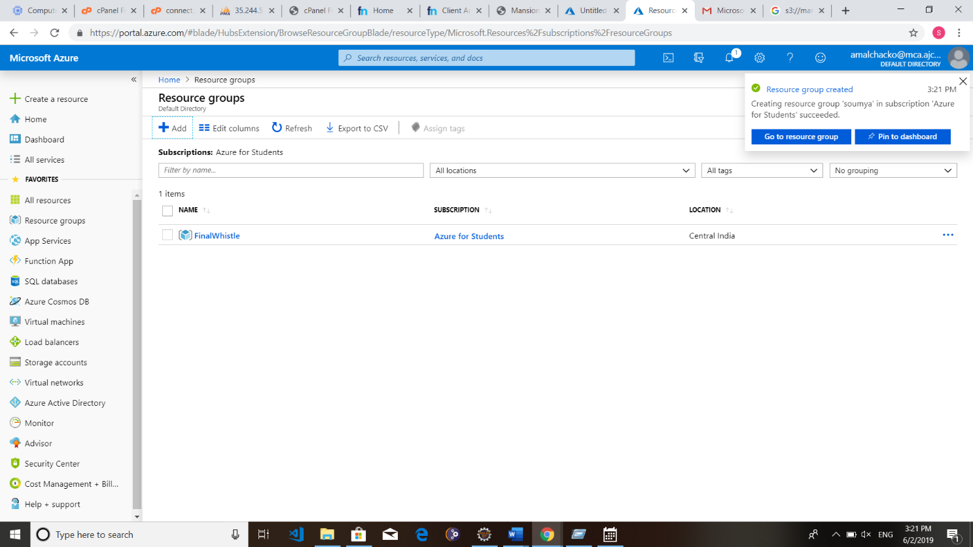

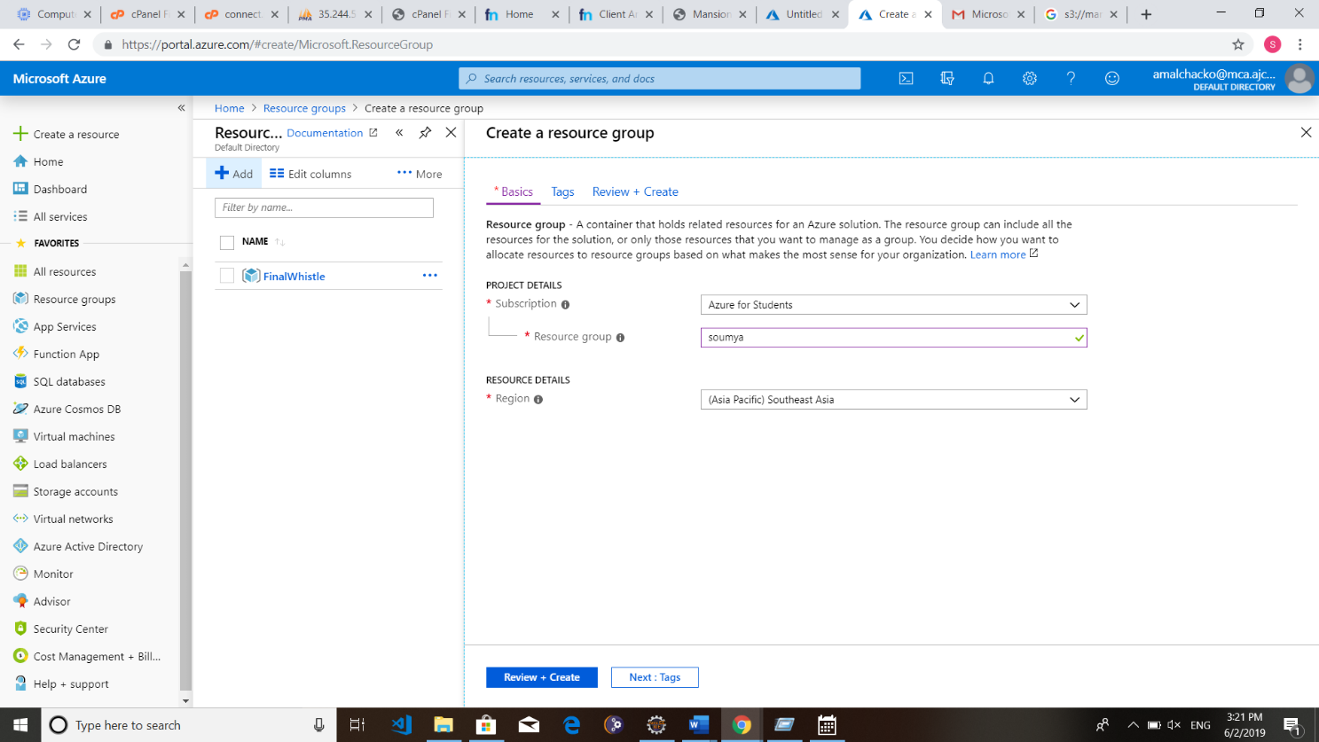

**Step 4: Select App Service**

**Create Instance and Configure It.**

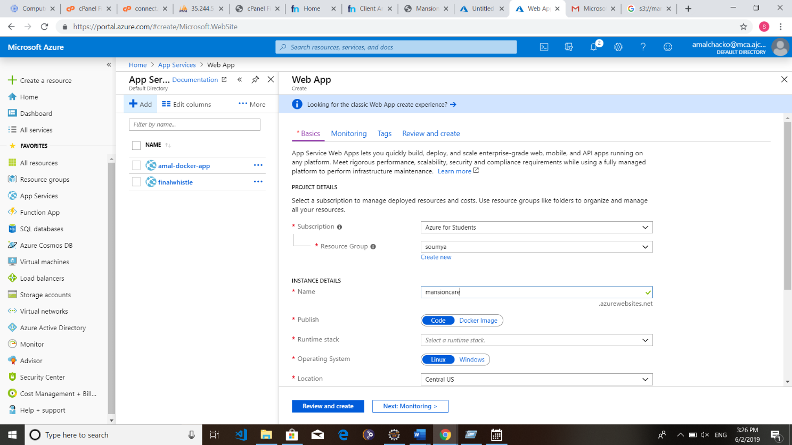

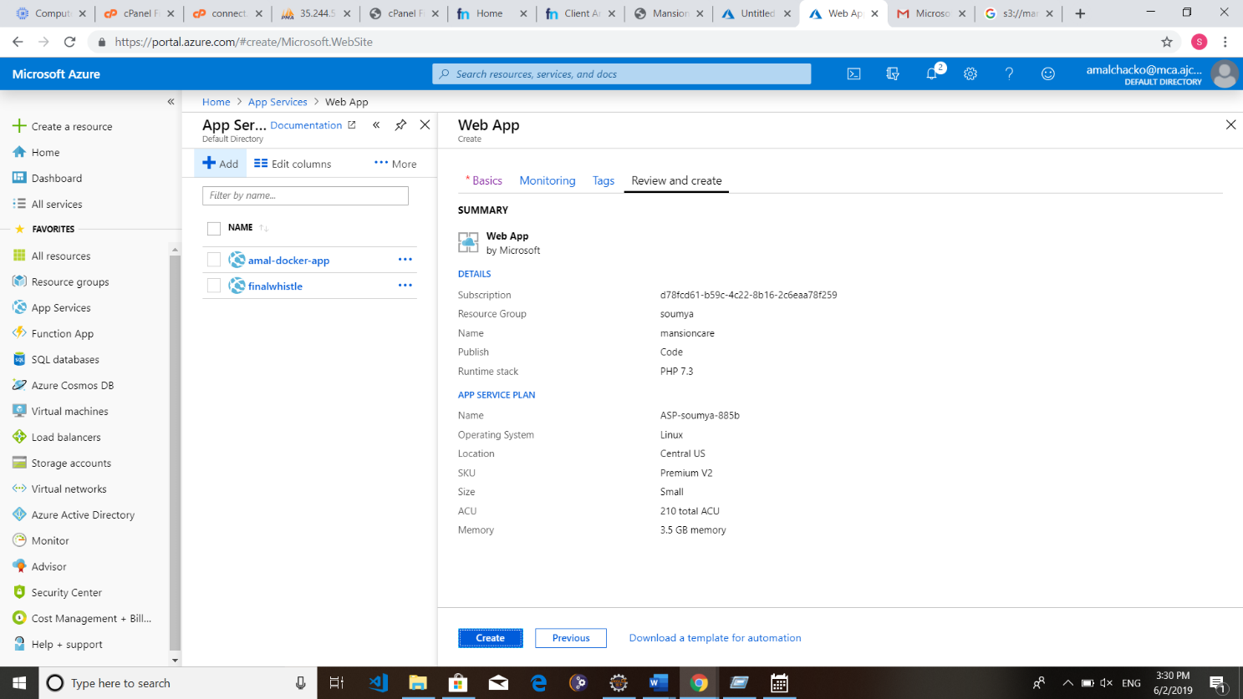

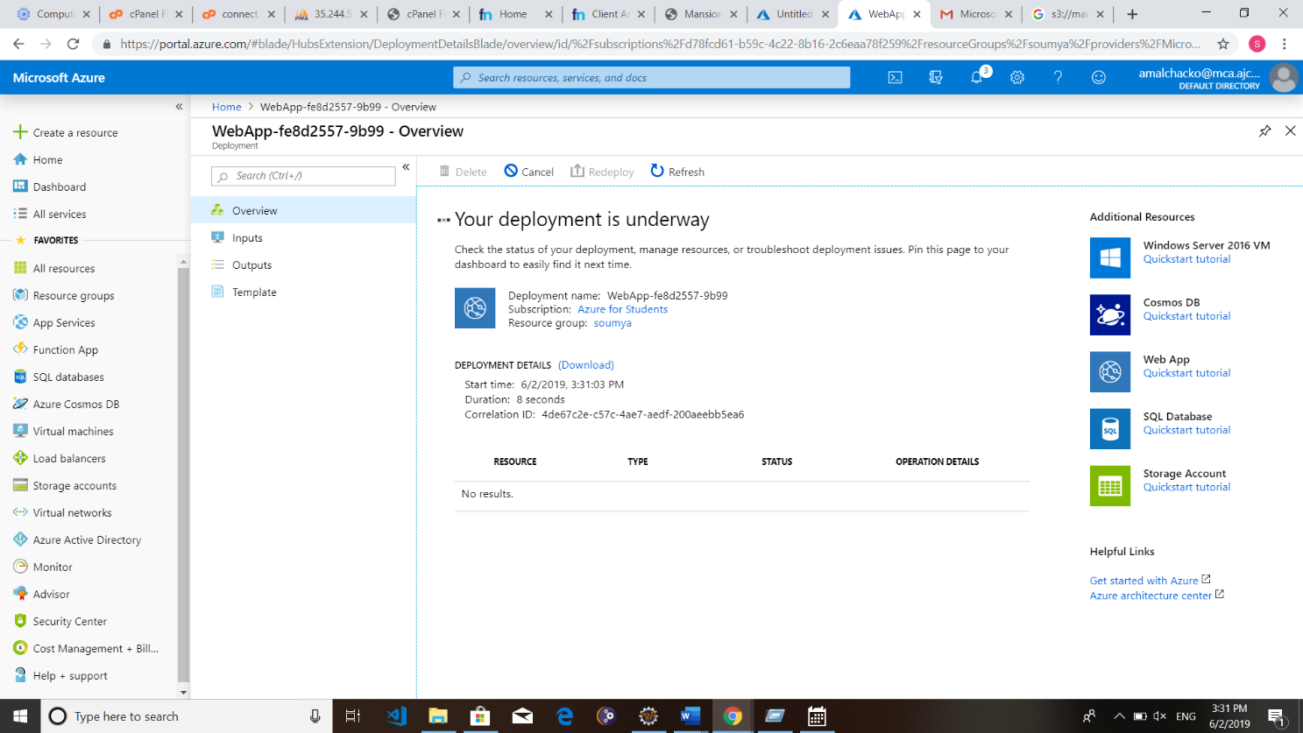

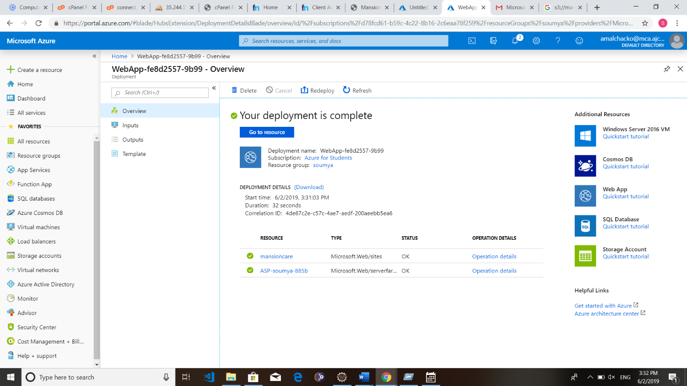

**After Deployment is Complete.**

**Step 5: Open Github account and create a new repository. Upload the source code to Github.**

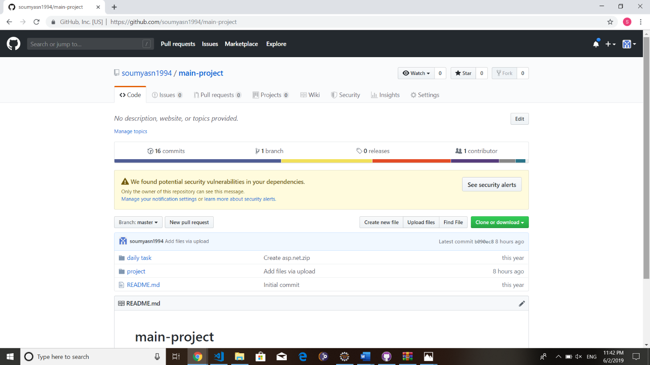

**Step 6: Select Deployment Center from Azure Dashboard.**

1. **Choose Github**

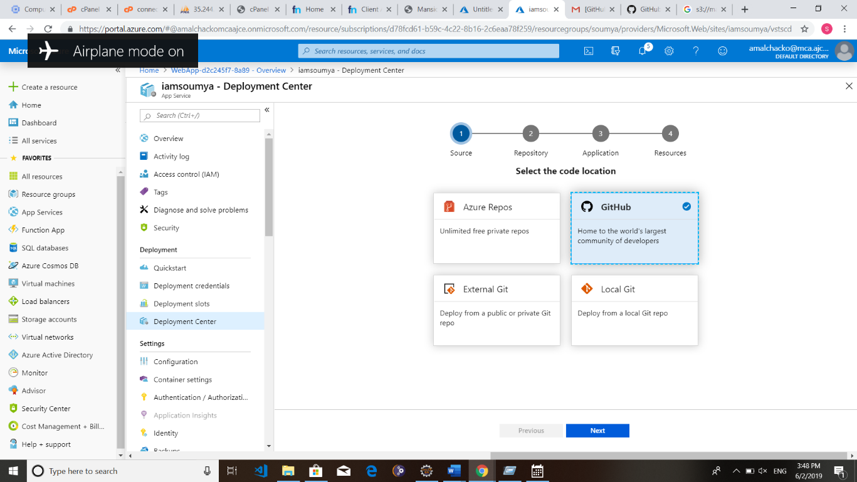

1. **Integration of Github Repository**

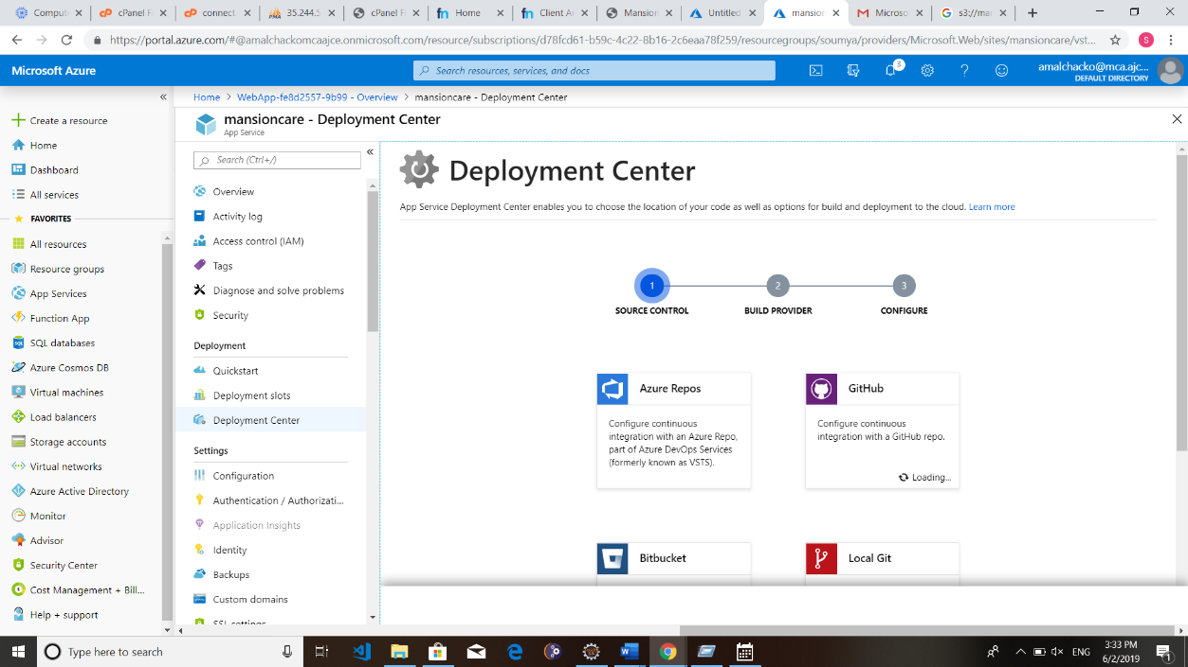

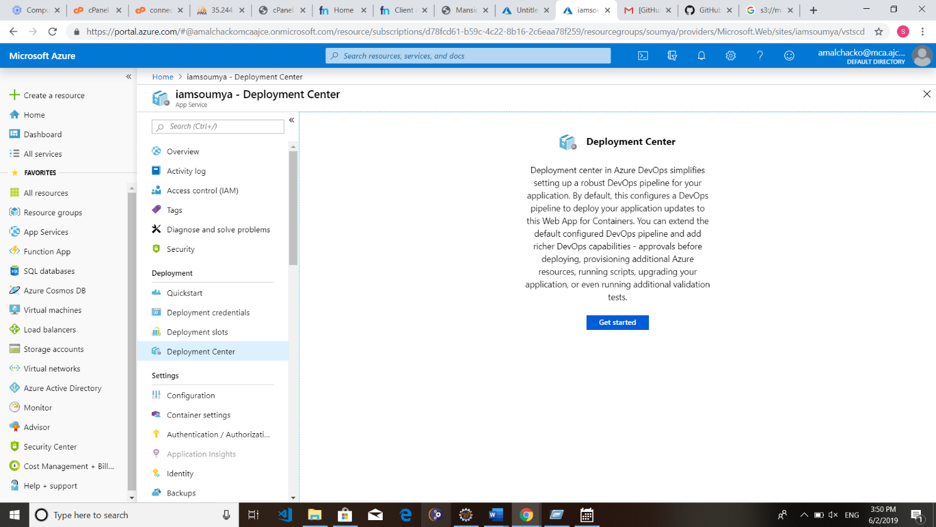

1. **Select Build Provider**

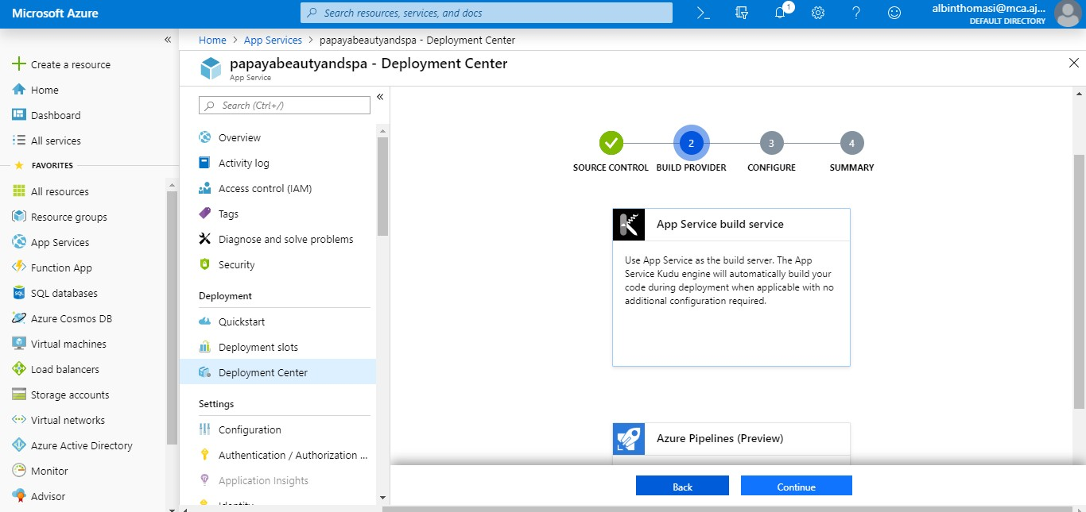

1. **complete other Configurations**

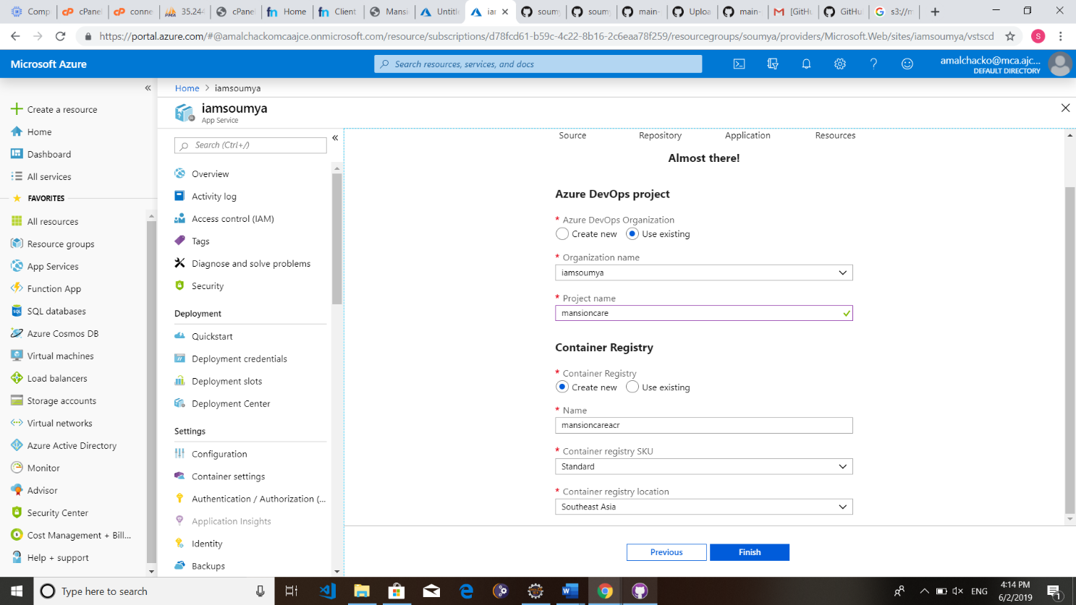

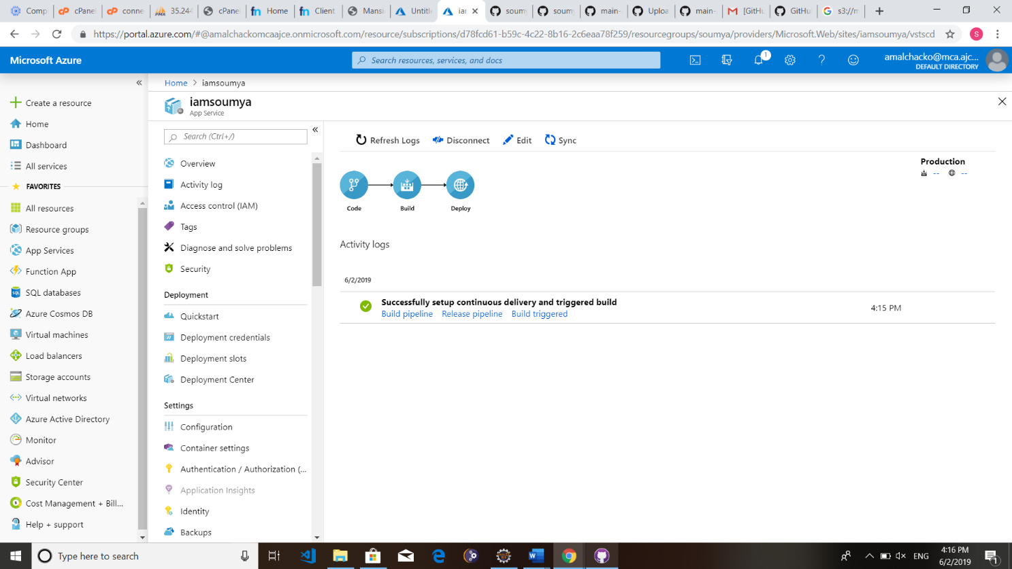

**Now the app is hosted and you can access it from the URL given in resource instance dashboard. (Dashboard > All Resources > instance-name)**

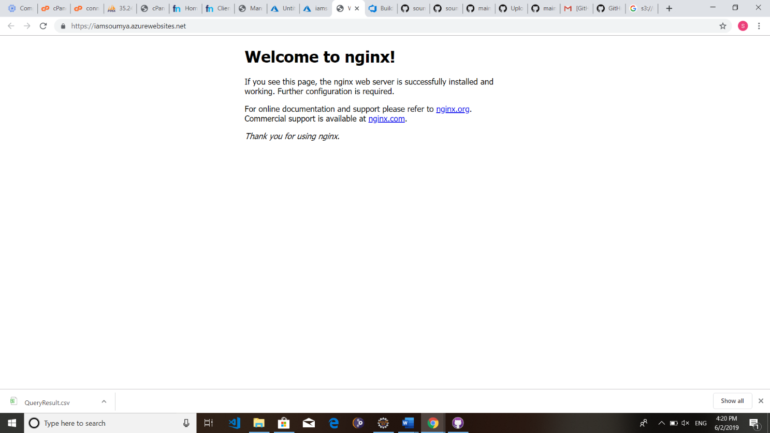

**P1.3.2 VIRTUAL MACHINES**

It is an operating system or application environment that is installed on software, which reproduces dedicated hardware. The end user has the same experience on a virtual machine as they would have on dedicated hardware. Azure Virtual Machines gives you the flexibility of virtualization for a wide range of computing solutions with support for Linux, Windows Server, SQL Server, Oracle, IBM, SAP, and more. All current generation Virtual Machines include load balancing and auto-scaling, for free. For optimal performance, we recommend pairing your Virtual Machines with [Managed Disks.](https://azure.microsoft.com/en-us/pricing/details/managed-disks/) Standard [egress](https://azure.microsoft.com/en-us/pricing/details/bandwidth/) charges apply.

#### Benefits

* Limits cost by reducing the need for physical hardware systems.
* Efficiently use hardware, which lowers the quantities of hardware and associated maintenance costs, and reduces power and cooling demand
* Ease of management because the virtual hardware does not fail.

#### Vendors?

* VMware - mature product portfolio, with many years of use in the IT industry
* Microsoft - a bit of late player to virtualization, Microsoft is showing considerable progress.

### P1.3.3 DEVOPS IN AZURE

In order to release quickly and have stable application environments with minimal errors, it is of vital importance that developers work well with IT operations people and vice versa. To do this, they need to communicate well and sometimes work on the same team.

Ideally, they work in the same environment. Makes sense, right? This is called [DevOps](https://stackify.com/what-is-devops/). DevOps is a hyped-up term, but it comes down to implementing common sense by working better together.One of the most important goals that DevOps helps to achieve is:

* Faster and more reliable releases of the application through [Continuous Integration (CI)* and Continuous Deployment (CD)](https://stackify.com/fundamentals-of-the-cd-ci-pipeline/)

Microsoft provides some awesome services and features that can help your team to achieve this goal. You’ll learn about them in this article.

* [Continuous Deployment of Azure App Services](https://docs.microsoft.com/azure/app-service/app-service-continuous-deployment)
* [Azure DevOps Projects](https://azure.microsoft.com/features/devops-projects/)
* [Visual Studio Team Services](https://www.visualstudio.com/team-services/)

#### Continuous deployment of Azure App Services

Azure App Services are services that you use to host your web application or API. When you have the source code of your application in source control somewhere, you can easily have it deployed automatically to the App Service, every time you push up a change.

You do this by configuring the Deployment Options feature in App Services. This is really simple to do.

* 1. In your App Service (like a Web App), go to the Deployment Options blade
  2. Here, it asks you to choose a source. So, choose where your source code lives
  3. When you’ve chosen your source code repository, you’ll need to authenticate so that Azure can use those credentials to access the source code
  4. Next, you can choose the details of your deployment, which can include setting up a performance test as part of the process. In my case, I have chosen GitHub as my source
  5. Once this is done, the process starts to run and builds and deploys your source code into the App Service

Once this is configured, every time that you commit changes to the source code repository, it will get built and deployed to the App Service automatically.

You can see the deployments in the Deployment Options blade in the App Service. This is a pretty cool feature and very useful. Especially when you work with a team of developers that are all checking in code to the same repository. However, the Deployment Options feature in App Service is pretty restricted. It is easy to set up, but that also means that you do not have a lot of configuration choices if you need to do more.

# PART 2

**USING GIT AS A VERSION CONTROL SYSTEM**

## P2.1 INTRODUCTION TO GITHUB

GitHub is a web-based version-control and collaboration platform for software developers. GitHub, which is delivered through a software-as-a-service ([SaaS](http://searchcloudcomputing.techtarget.com/definition/Software-as-a-Service)) business model, was started in 2008 and was founded on Git, an open source code management system created by [Linus Torvalds](http://whatis.techtarget.com/definition/Linus-Torvalds) to make software builds faster. And it is used to store the source code for a project and track the complete history of all changes to that code. It allows developers to collaborate on a project more effectively by providing tools for managing possibly conflicting changes from multiple developers. GitHub allows developers to change, adapt and improve software from its public repositories for free, but it charges for private repositories, offering various paid plans. Each public or private repository contains all of a project's files, as well as each file's revision history. Repositories can have multiple collaborators and can be either public or private.

GitHub facilitates [social coding](http://whatis.techtarget.com/definition/social-coding) by providing a web interface to the Git [code](http://whatis.techtarget.com/definition/code) [repository](http://searchoracle.techtarget.com/definition/repository) and management tools for collaboration. GitHub can be thought of as a serious [social](http://whatis.techtarget.com/definition/social-networking) [networking](http://whatis.techtarget.com/definition/social-networking) site for software developers. Members can follow each other, rate each other's work, receive updates for specific projects and communicate publicly or privately.

#### GitHub products and features

GitHub offers an on-premises version in addition to the well-known SaaS product. GitHub Enterprise supports integrated development environments and continuous integration tool integration, as well as a litany of third-party apps and services. It offers increased security and auditable than the SaaS version.

## P2.2 WORKING WITH GIT

#### Step 1: Sign in to GitHub

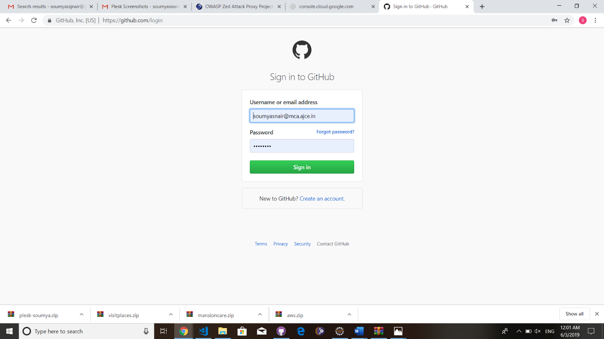

**Step 2: Once successfully sign in, set up personal account, create a repository.**

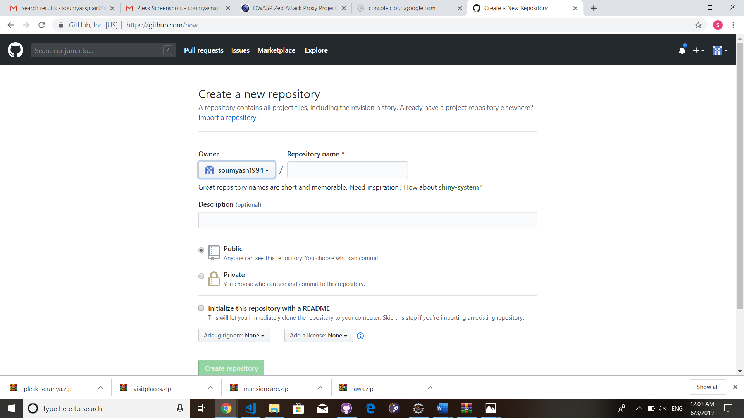

**Step 3: Once repository is completed, you can setup the repository**

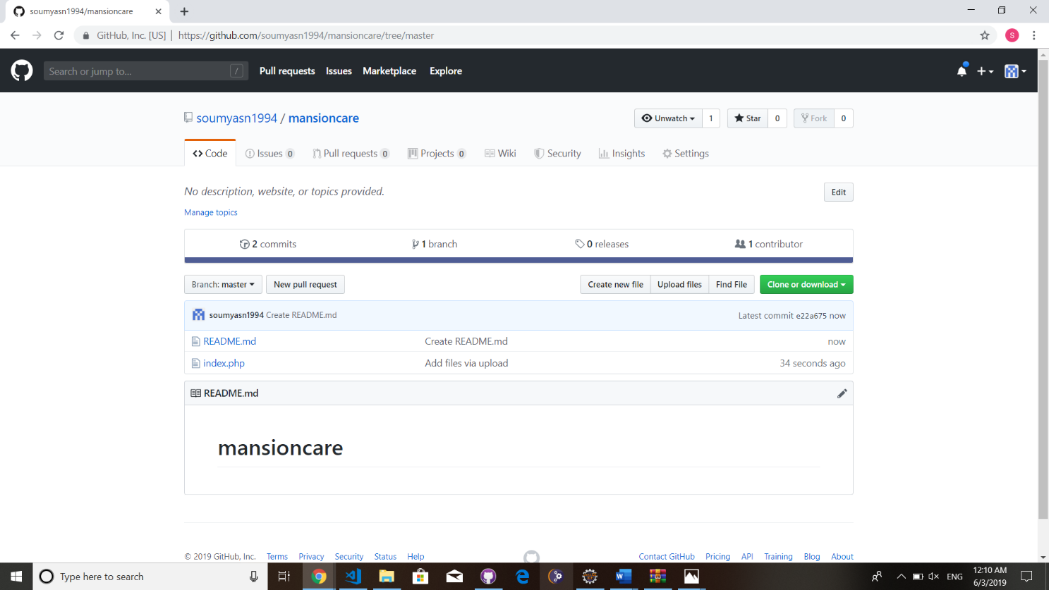

**Step 4: Download and install GitHub desktop application. Once installed Go to Repository > Clone repository, and select your repository which was created in GitHub.com or Select a local system folder**

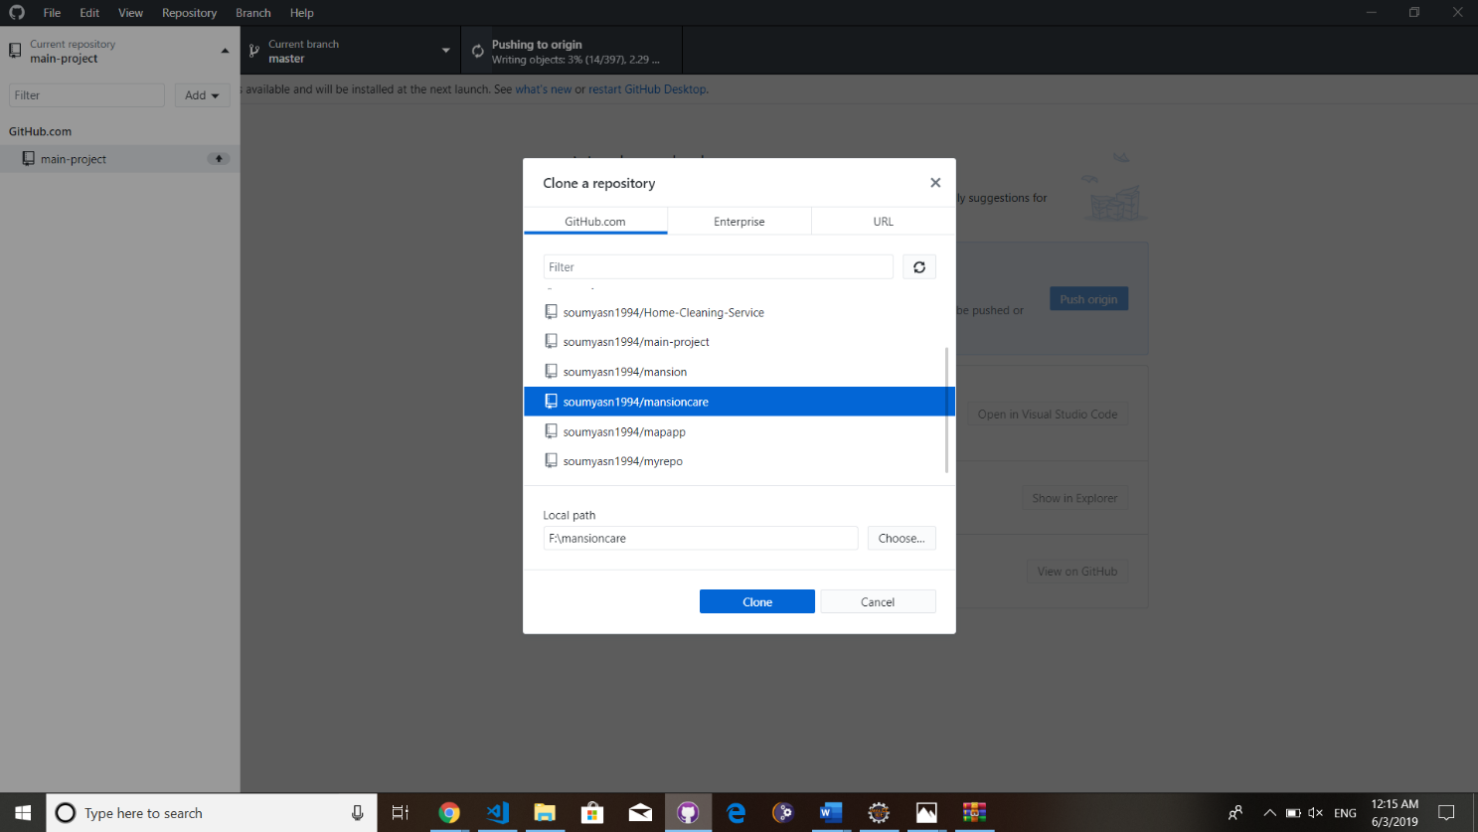

**Step 5: Once repository is created, make changes on the file which is stored inside the local repository and commit to master.**

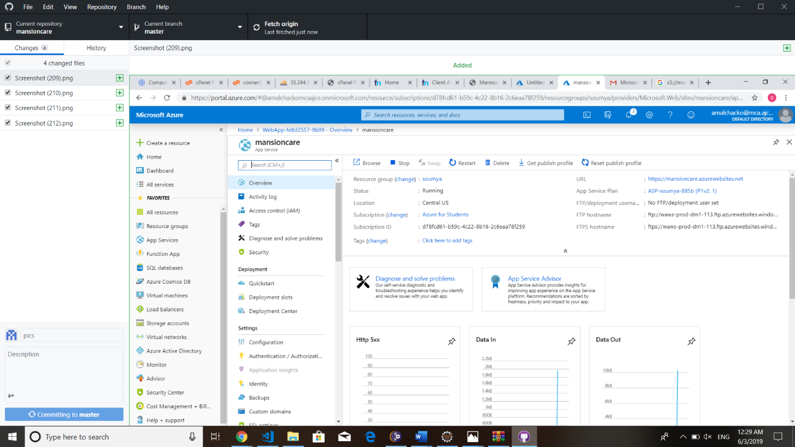

**Step 6: Push the local repository to origin. Refresh GitHub.com repository to fetch commits.**

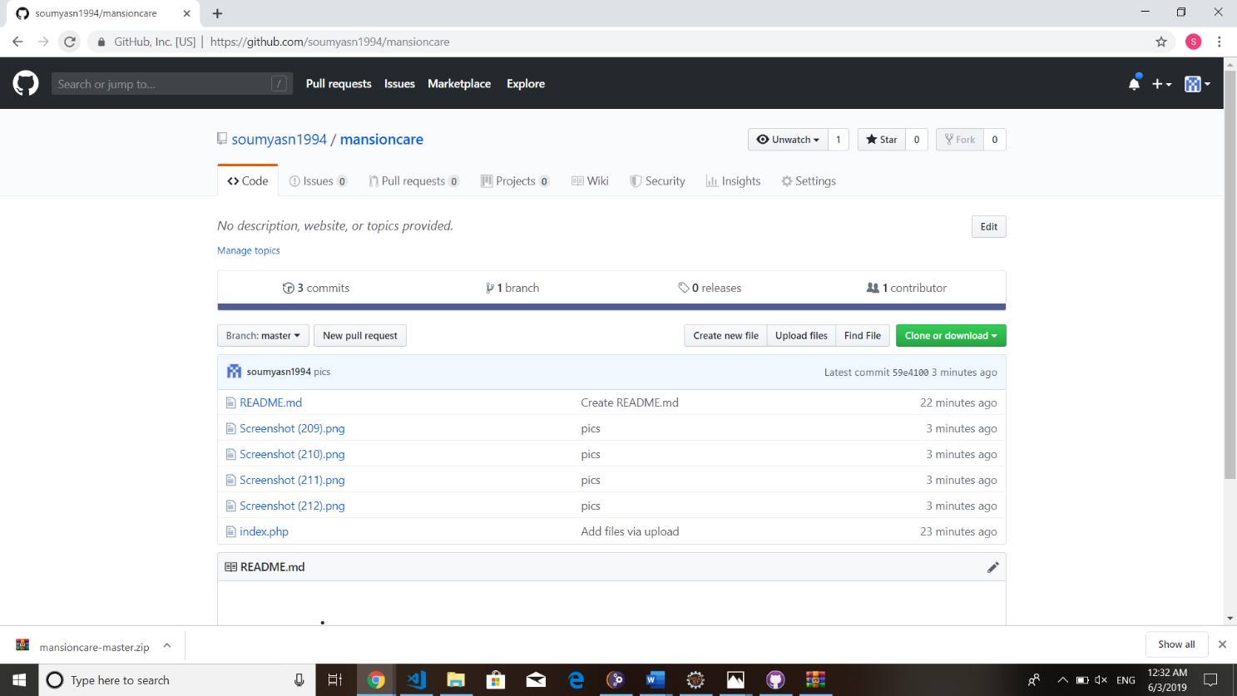

**PART 3**

**DATA DESIGN IN NOVEL TECHNOLOGIES**

**P3.1 MONGODB**

**P3.1.1 INTRODUCTION TO MONGODB**

MongoDB is an [open source](http://whatis.techtarget.com/definition/open-source) database that uses a document-oriented data model. And it is one of several [database](http://searchsqlserver.techtarget.com/definition/database) types to arise in the mid-2000s under the NoSQL banner. Instead of using [tables](http://searchmicroservices.techtarget.com/definition/table) and [rows](http://searchoracle.techtarget.com/definition/row) as in [relational databases](http://searchsqlserver.techtarget.com/definition/relational-database), MongoDB is built on an architecture of collections and documents. Documents comprise sets of [key-value pairs](http://searchenterprisedesktop.techtarget.com/definition/key-value-pair) and are the basic unit of data in MongoDB. Collections contain sets of documents and function as the equivalent of relational database tables. Like other NoSQL databases, MongoDB supports dynamic [schema](http://searchsqlserver.techtarget.com/definition/schema) design, allowing the documents in a collection to have different fields and structures. The database uses a document storage and data interchange format called BSON, which provides a [binary](http://whatis.techtarget.com/definition/binary) representation of [JSON](http://searchwindevelopment.techtarget.com/definition/JSON-Javascript-Object-Notation)-like documents. Automatic [sharding](http://searchcloudcomputing.techtarget.com/definition/sharding) enables data in a collection to be distributed across multiple systems for [horizontal scalability](http://searchcio.techtarget.com/definition/horizontal-scalability) as data [volumes](http://searchstorage.techtarget.com/definition/volume) increase.

MongoDB was created by Dwight Merriman and Eliot Horowitz, who had encountered development and scalability issues with traditional relational database approaches while building [Web applications](http://searchsoftwarequality.techtarget.com/definition/Web-application-Web-app) at DoubleClick, an Internet advertising company that is now owned by Google Inc.

**P3.1.2 IMPLEMENTATION OF MONGODB**

1. Download and Install MongoDB server for Windows. htt[ps://www.mongodb.c](http://www.mongodb.com/dr/fastdl.mongodb.org/win32/mongodb-win32-x86_64-)o[m/dr/fastdl.mongodb.org/win32/mongodb-win32-x86_64-](http://www.mongodb.com/dr/fastdl.mongodb.org/win32/mongodb-win32-x86_64-) 2008plusssl- 3.6.2-signed.msi/download

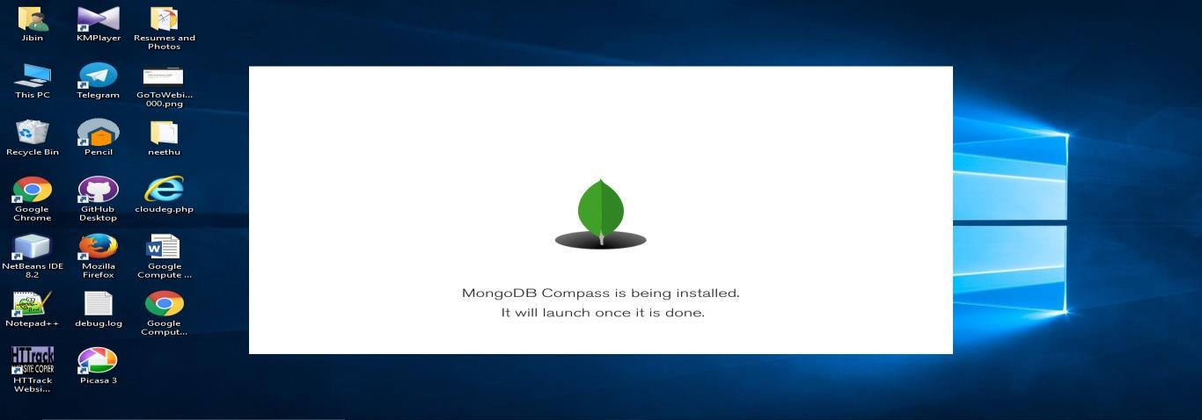

1. Download and extract MongoDB PHP driver https://s3.amazonaws.com/drivers.mongodb.org/php/php_mongo-1.6.8.zip
2. Rename any one file (Eg. php_mongo-1.6.8-5.6-vc11.dll) to php_mongo.dll and copy it to Extension directory known as ext directory. XAMPP: xampp\php\ext WAMPP: wamp\bin\php\php\ext
3. Add the following line to your php.ini extension=php_mongo.dll
4. Add Environment variable (Control Panel -> System and Security -> System -> Advanced system settings -> Environment variables) by editing PATH variable. C:\Program Files\MongoDB\Server\3.6\bin C:\xampp\php OR C:\wamp\bin\php
5. Create directory C:\data\db
6. Restart Apache server
7. Open CMD and start MongoDB server by using command Mongod

#### Working with MongoDB Server

1. Open the MongoDB Server (MongoDB Compass community: localhost)
2. Connect to localhost

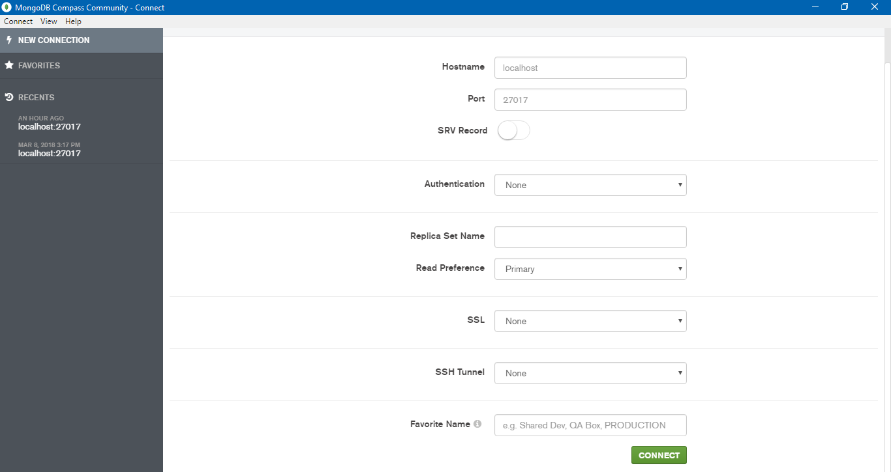

1. Once connected to the server, Create a database and collection as well. A collection in MongoDB is equivalent to RDBMS table

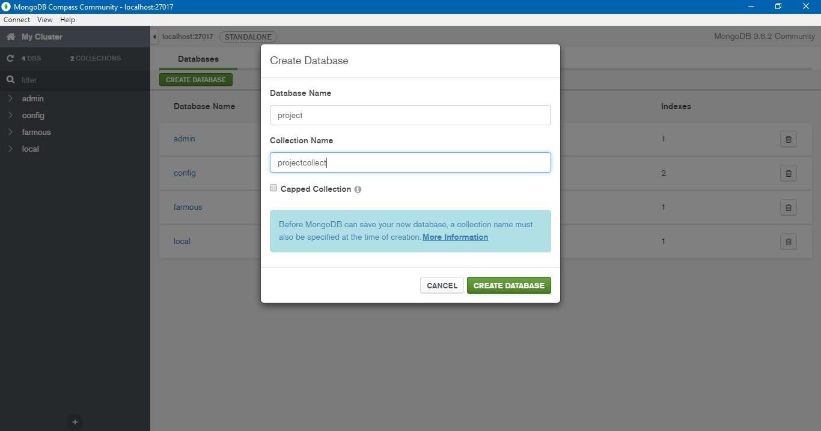

1. Once the database and collection are created, insert your documents into the collection. Documents in MongoDB is equivalent to the rows in RDBMS.

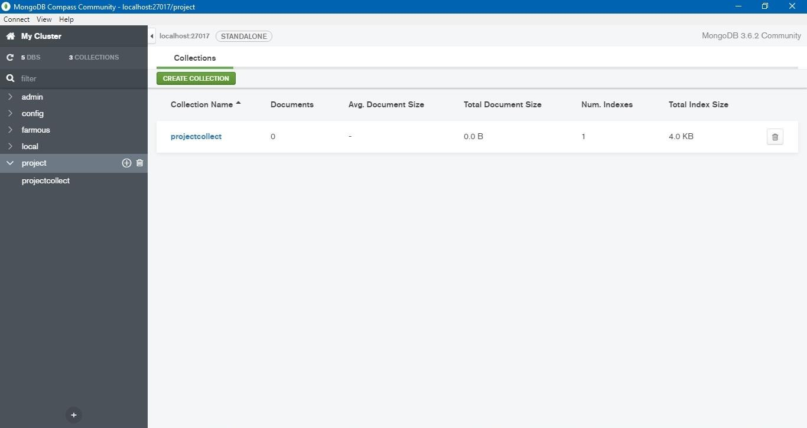

1. Document ID is the default and unique value provided by the MongoDB

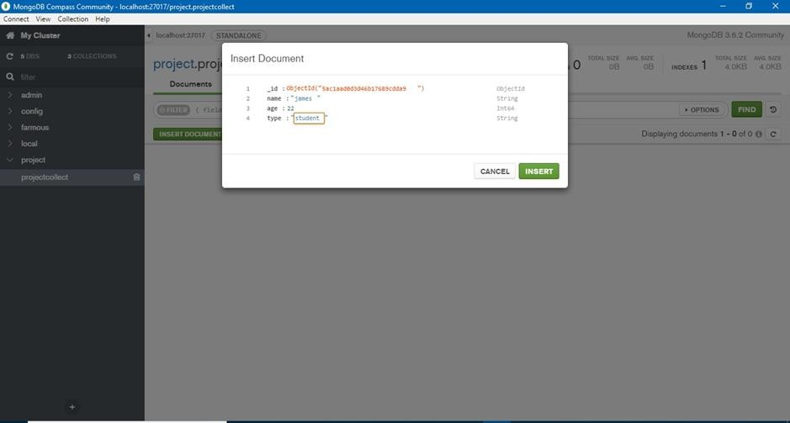

#### Basic queries to access your database

1. MongoDB Connection $con = new MongoClient ();
2. Selection or Creation of Database (MySQL: Database) $db = $con->database_name;
3. Collection Creation (MySQL: Table) $collection = $db-> createCollection("collection_name");
4. Document Insertion (MySQL: Insert - Row) $document = array (“key-1" => "value-1", "key-n" => "value-n”); $collection->insert($document);
5. View data (MySQL: Select) $cursor = $collection->find (); foreach ($cursor as

$document) {echo $document["key"];}

1. Updating data (MySQL: Update) $collection->update(array("key"=>"old-value"), array('$set'=>array("key"=>"new-value")));
2. Deletion of data (MySQL: Delete) $collection->remove(array("condition- key"=>"condition-value"));

## P3.2 BIGTABLE IN GCP

### P3.2.1 INTRODUCTION TO BIGTABLE

Google Bigtable is a distributed, column-oriented data store created by Google Inc. to handle very large amounts of structured data associated with the company's Internet search and Web services operations. And it was designed to support applications requiring massive scalability; from its first [iteration](http://searchsoftwarequality.techtarget.com/definition/iteration), the technology was intended to be used with [petabytes](http://searchstorage.techtarget.com/definition/petabyte) of data. The database was designed to be deployed on clustered systems and uses a simple data model that Google has described as "a sparse, distributed, persistent multidimensional sorted map." Data is assembled in order by row key and indexing of the map is arranged according to row, column keys, and timestamps. [Compression](http://searchstorage.techtarget.com/definition/compression) algorithms help achieves high capacity. Google Bigtable serves as the database for applications such as the Google App Engine Datastore, Google Personalized Search, Google Earth and [Google Analytics.](http://searchbusinessanalytics.techtarget.com/definition/Google-Analytics) Google has maintained the software as a proprietary, in-house technology. Nevertheless, Bigtable has had a large impact on [NoSQL](http://searchdatamanagement.techtarget.com/definition/NoSQL-Not-Only-SQL) database design. Google software developers publicly disclosed Bigtable details in a technical paper presented at the USENIX Symposium on Operating Systems and Design Implementation in 2006.

Google's thorough description of Bigtable's inner workings has allowed other organizations and open source development teams to create Bigtable derivatives, including the [Apache](http://searchdatamanagement.techtarget.com/definition/Apache-HBase) [HBase](http://searchdatamanagement.techtarget.com/definition/Apache-HBase) database, which is built to run on top of the Hadoop Distributed File System (HDFS). Other examples include [Cassandra,](http://whatis.techtarget.com/definition/Cassandra-Apache-Cassandra) which originated at Facebook Inc., and Hyper table, an open source technology that is marketed in a commercial version as an alternative to HBase.

### P3.2.2 IMPLEMENTATION OF BIGTABLE

#### Creating a Cloud Bigtable Instance through the [Google Cloud Platform Console](https://console.cloud.google.com/).

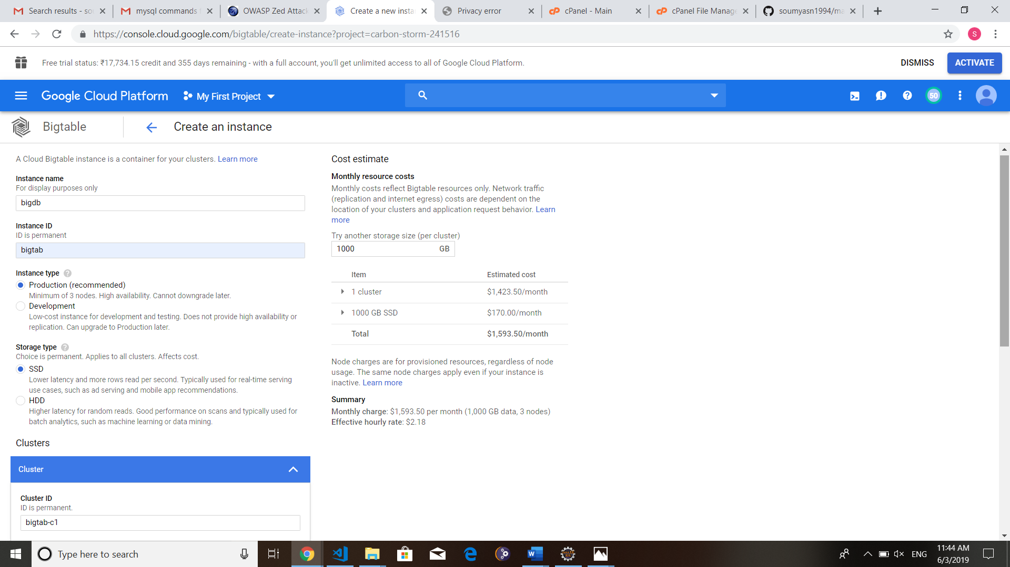

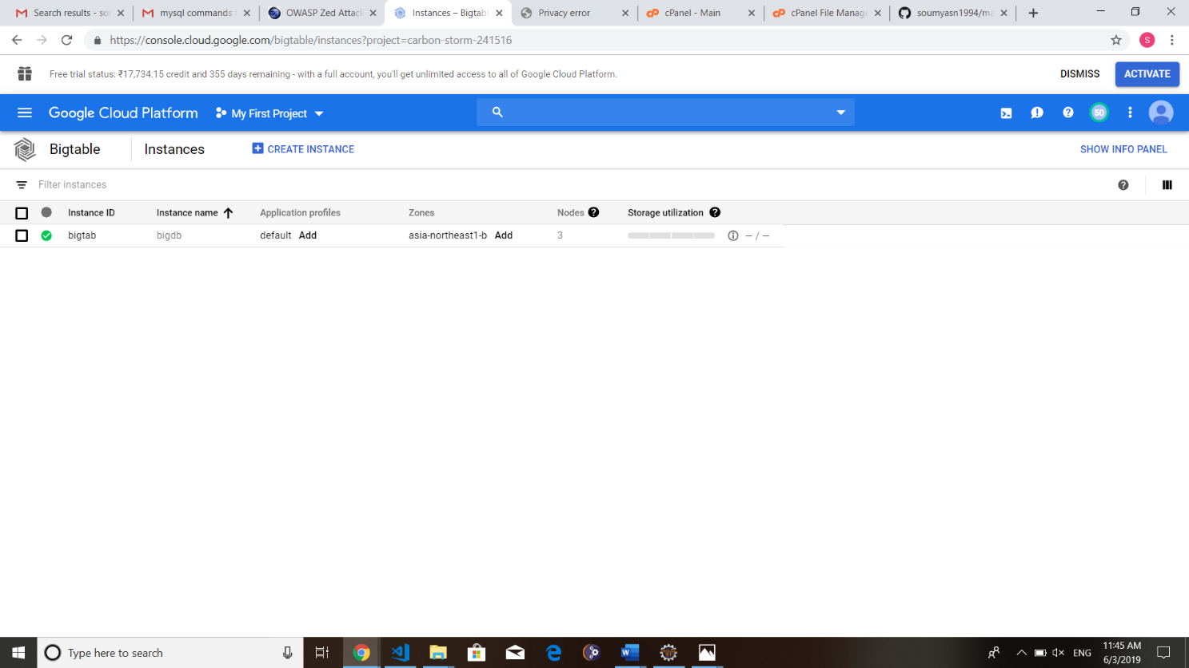

1. **Installing the Cloud SDK for Cloud Bigtable**

gcloud components update beta

gcloud config set project [PROJECT_ID]

gcloud beta Bigtable instances --help # help for all commands

gcloud beta bigtable instances create --help # help for the `create` command

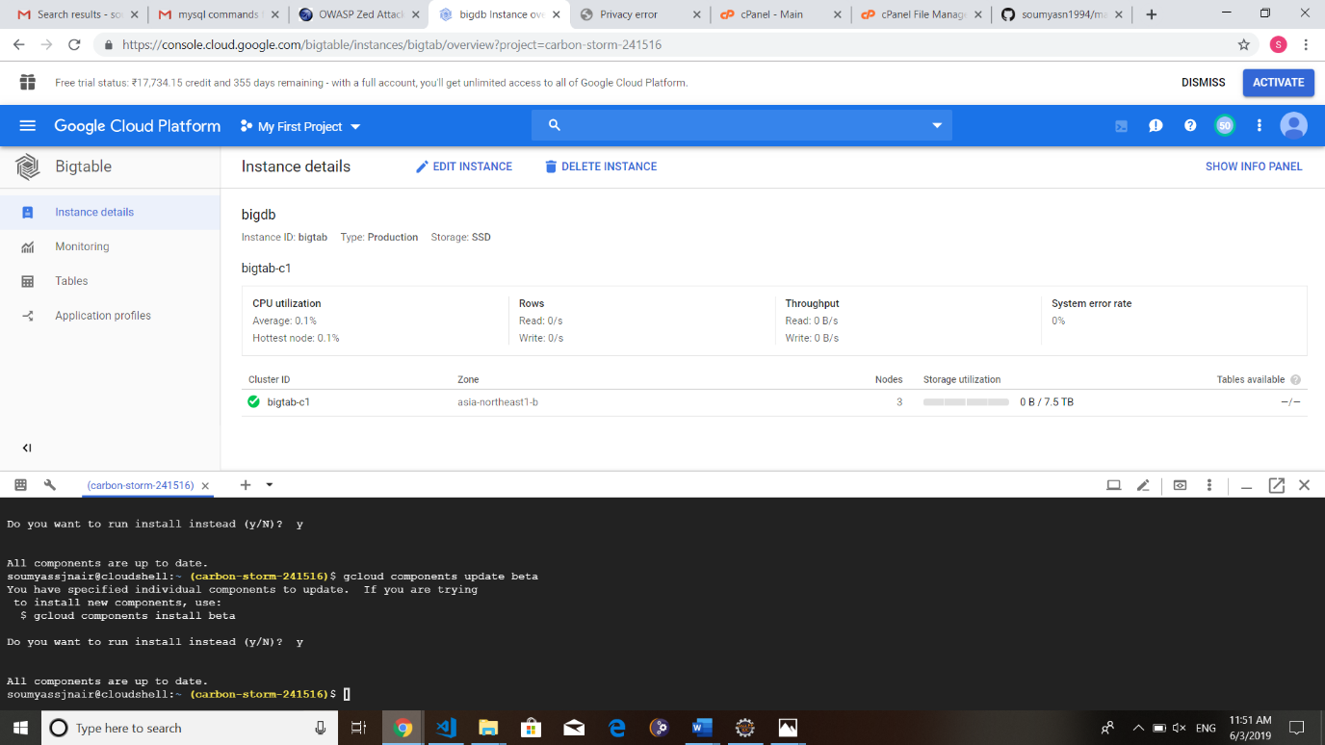

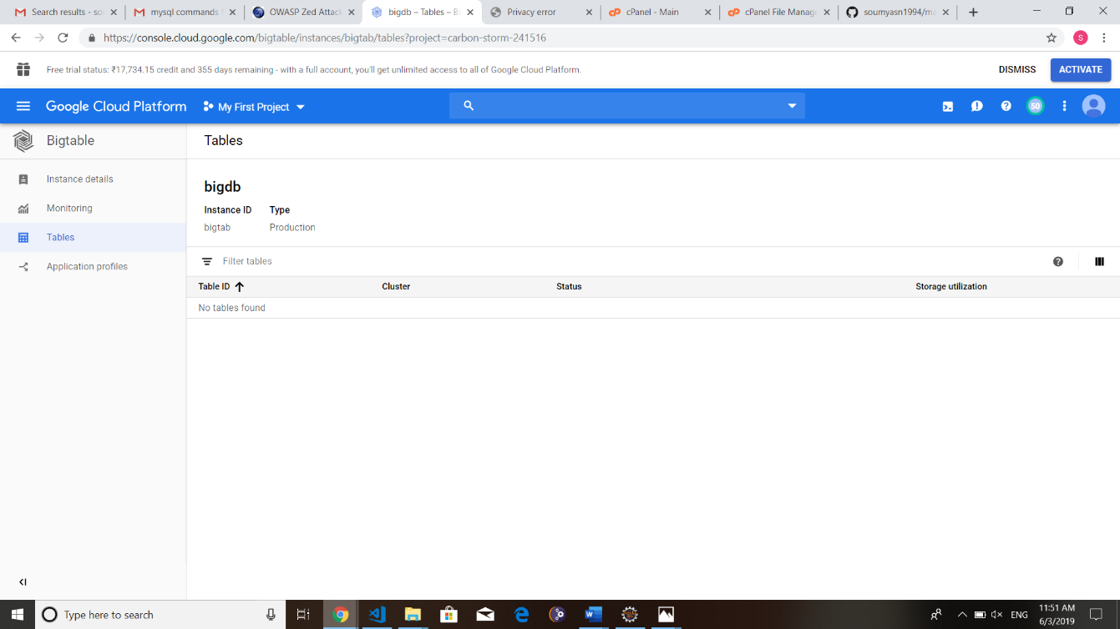

# PART 4

**SEARCH ENGINE OPTIMIZATION**

**Search engine optimization** is a methodology of strategies, techniques, and tactics or it is the process of getting traffic from the free, organic, editorial or natural search results on search engines used to increase the number of visitors to a [website](https://www.webopedia.com/TERM/W/web_site.html) by obtaining a high-ranking placement in the search results page of a [search engine](https://www.webopedia.com/TERM/S/search_engine.html) ([SERP](https://www.webopedia.com/TERM/S/SERP.html)) — including Google, Bing, Yahoo and other search engines.

## P4.1 GOOGLE ADWORDS

### P4.1.1 INTRODUCTION TO GOOGLE ADWORDS

AdWords (Google AdWords) is an [advertising](http://www.webopedia.com/Internet_and_Online_Services/Electronic_Commerce/Online_Advertising/) service by Google for businesses wanting to display ads on Google and its advertising network. The AdWords program enables businesses to set a budget for advertising and only pay when people click the ads. The ad service is largely focused on [keywords.](http://www.webopedia.com/keyword.html)

Businesses that use AdWords can create relevant ads using keywords that people who search the Web using the Google [search engine](http://www.webopedia.com/TERM/S/search_engine.html) would use. The keyword, when searched for triggers your ad to be shown. AdWords at the top ads that appear under the heading "Sponsored Links" found on the right-hand side or above Google search results. If your AdWords ad is clicked on, Google search users are then directed to your [website.](http://www.webopedia.com/TERM/W/web_site.html)

When choosing keywords for your AdWords campaigns different matching options are available. The two main keyword match options include the following:

* **Broad Match**: This reaches the most users by showing your ad whenever your keyword is searched for.
* **Negative Match**: This option prevents your ad from showing when a word or phrase you specify is searched for.
* **Phrase Match**: Your ad is shown for searches that match the exact phrase.
* **Exact Match**: Your ad is shown for searches that match the exact phrase exclusively. When using AdWords keywords are also used to determine your cost of advertising. Each keyword you choose will have a cost per click (CPC) bid amount. The bids specify the maximum amount you're willing to pay each time someone clicks your ad (the maximum [cost- per-click](http://www.webopedia.com/TERM/C/CPC.html)). A higher [CPC](http://www.webopedia.com/TERM/C/CPC.html) bid can allow your ad to show at a higher position on the page.

### P4.1.2 IMPLEMENTATION OF GOOGLE ADWORDS

#### Step 1: Go to Google AdWords Express and sign into your Google account

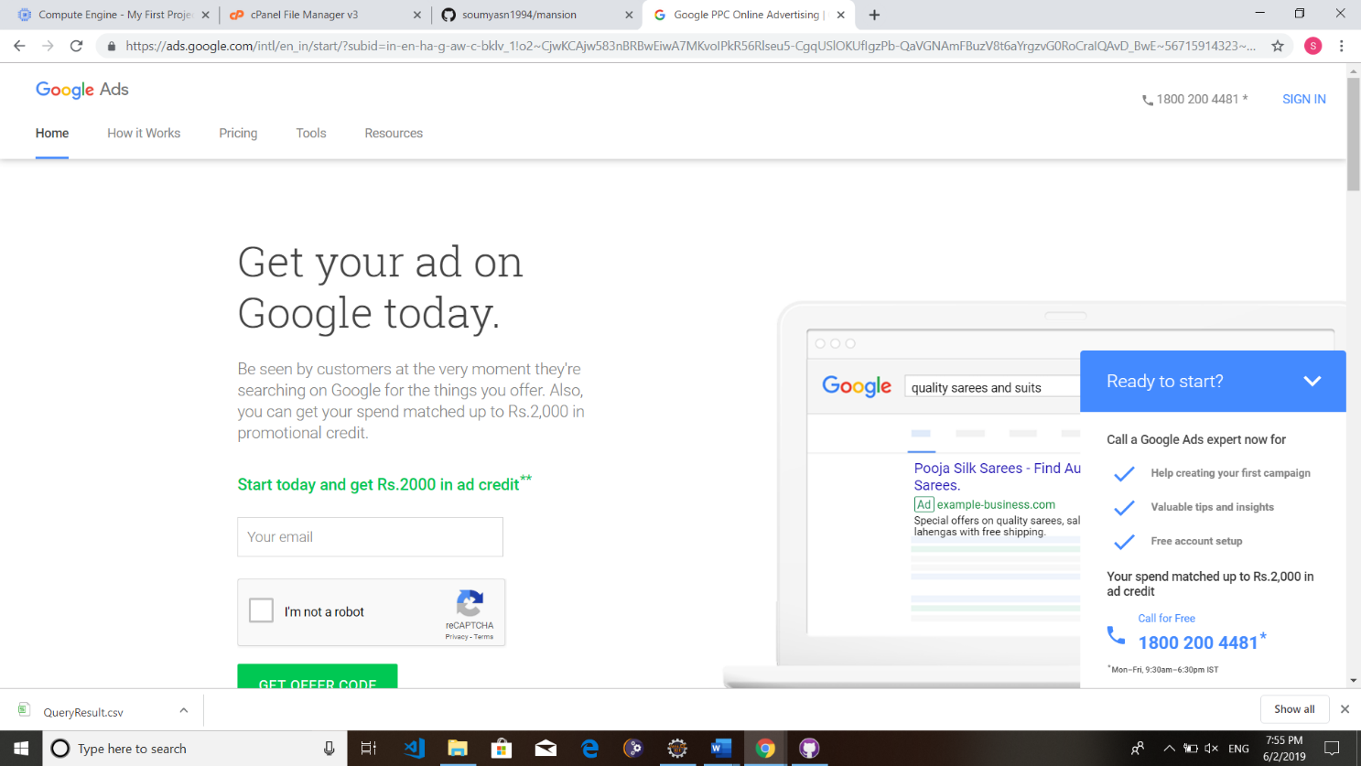

**Step 2: Describe your business and website URL.**

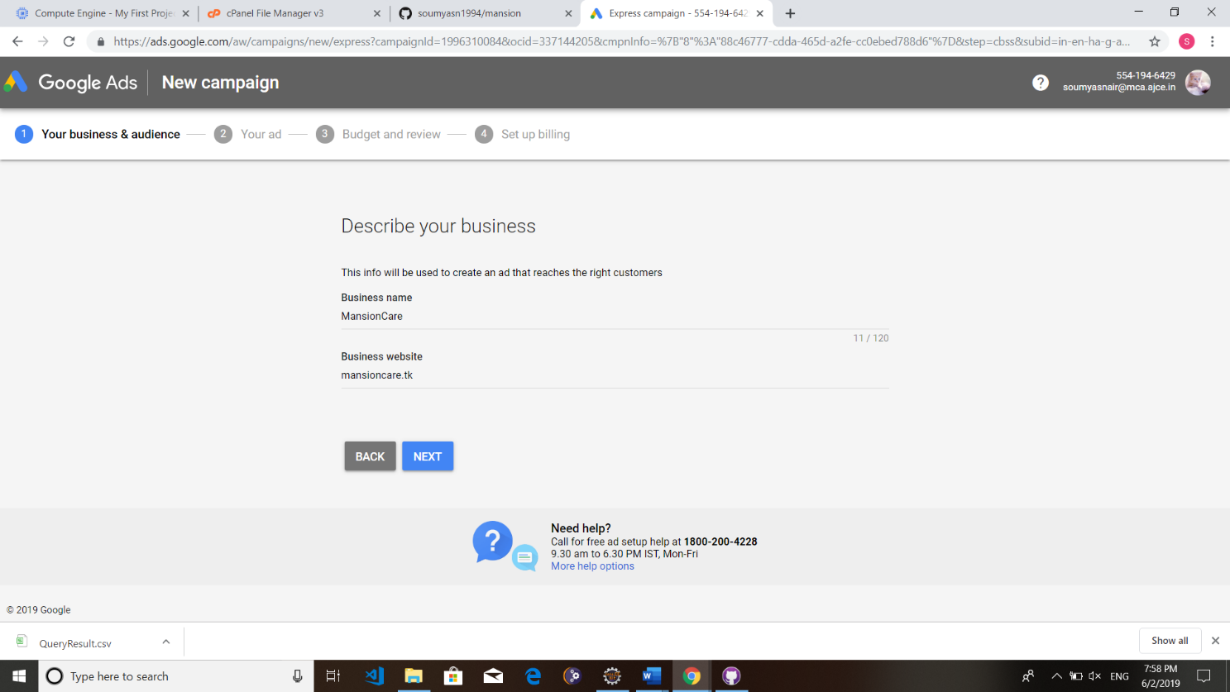

#### Step 3: Pick a goal for your ad, which means, what action do you most want customers to take?

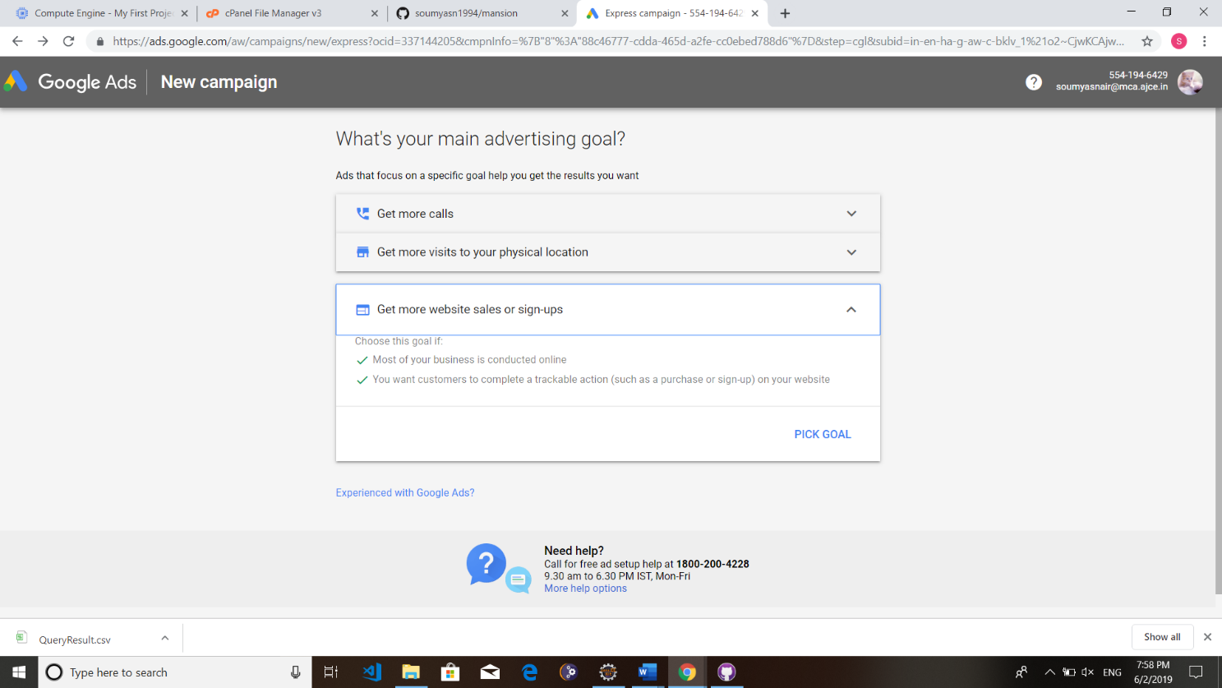

**Step 4: Pick an area to show your ad in, Here Google is providing two options, one is Near my business (Which allows you to specify the distance of area from your location) and second is in specific cities, states or countries.**

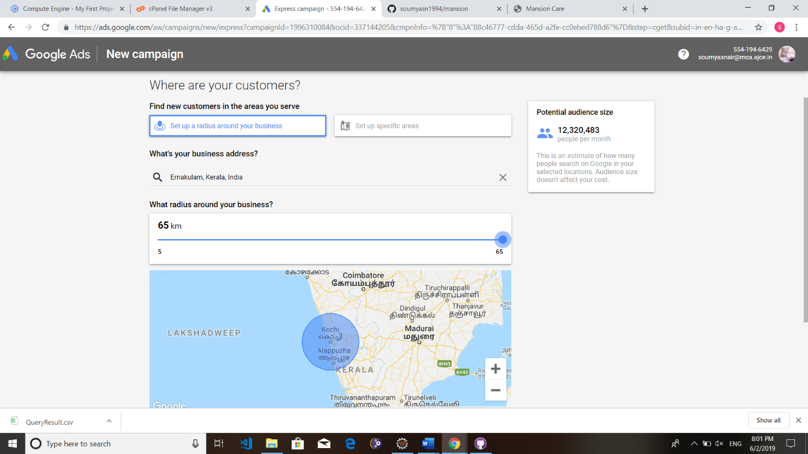

**Step 5: Define your products and services. Specifically, it aims for the business category.**

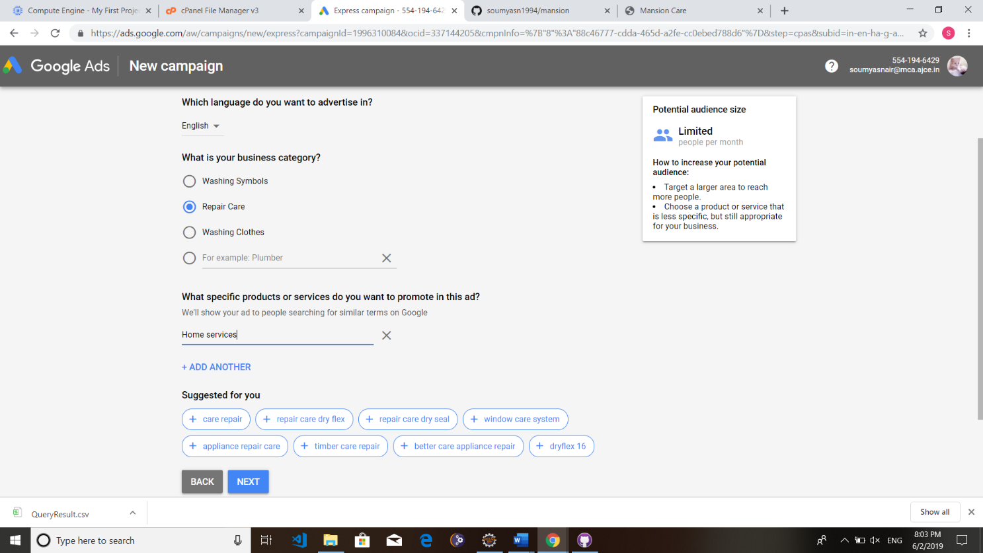

**Step 6: Create your Ad preview including Headline, Description, Ad URL**.

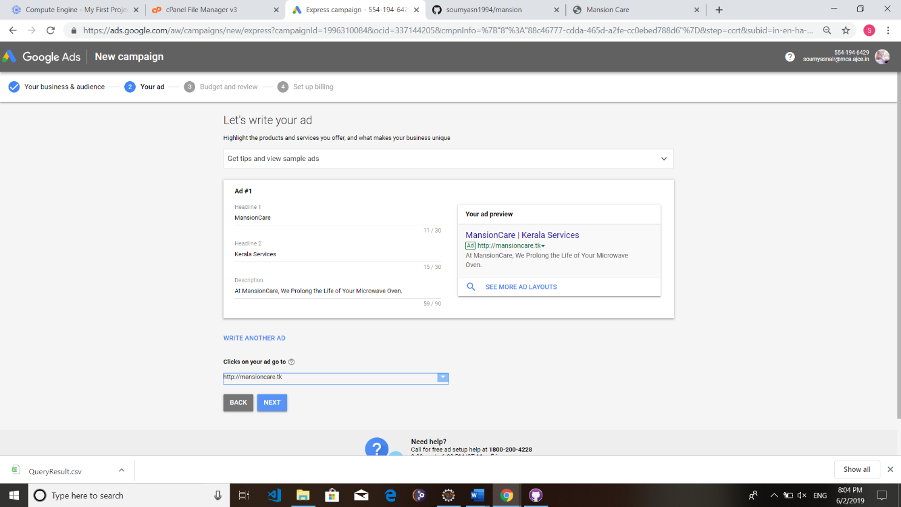

**Step 7: Review your Ad and settings.**

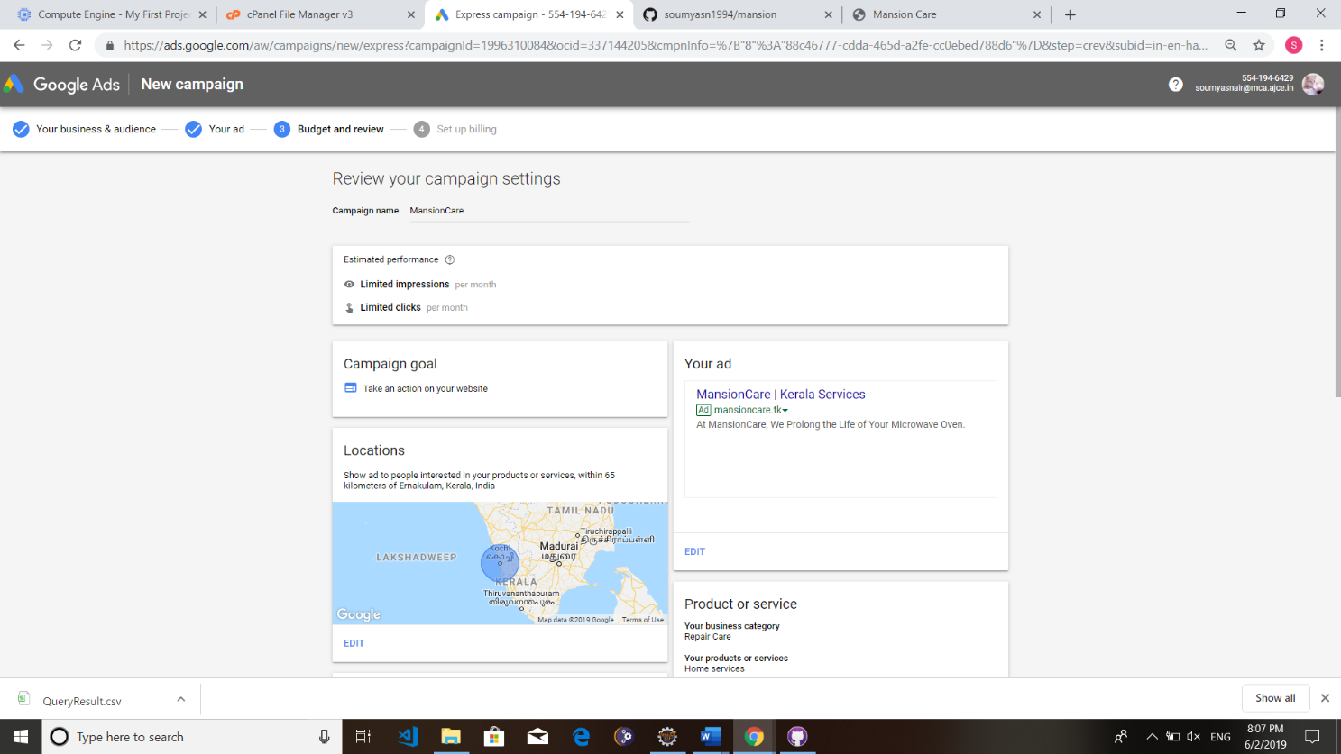

**P4.2 GOOGLE ADSENSE**

**P4.2.1 INTRODUCTION TO GOOGLE ADSENSE**

AdSense (*Google AdSense*) is an [advertising](http://www.webopedia.com/Internet_and_Online_Services/Electronic_Commerce/Online_Advertising/) placement service by Google. The program is designed for website publishers who want to display targeted [text](http://www.webopedia.com/TERM/T/text.html), video or [image](http://www.webopedia.com/TERM/I/image.html) advertisements on [website](http://www.webopedia.com/TERM/W/web_site.html) pages and earn money when site visitors view or click the ads. The advertisements are controlled and managed by Google and Web publishers simply need to create a free AdSense account and copy and paste provided code to display the ads. Revenue using AdSense is generated on a per-click or per-[impression](http://www.webopedia.com/TERM/I/impression.html) basis. It is free to become a verified website publisher in the Google AdSense program.

Google currently offers a number of different AdSense programs, depending on the type of content you will place the ads on (e.g. a webpage or RSS feed). Some of the more common programs include:

* AdSense for content: display ads on a website
* AdSense for search: display ads in search results on a website
* AdSense for mobile: display ads on a mobile site
* AdSense for feeds: display ads in RSS feeds
* AdSense for domains: display ads on unused domains

AdSense programs are also available to qualified publishers and developers. Qualified publishers may use AdSense to drive revenues for [iPhone](http://www.webopedia.com/TERM/I/iPhone.html) applications, video or Web [browser](http://www.webopedia.com/TERM/B/browser.html) games.

### P4.2.2 IMPLEMENTATION ON ADSENSE

**Signin wth google account**

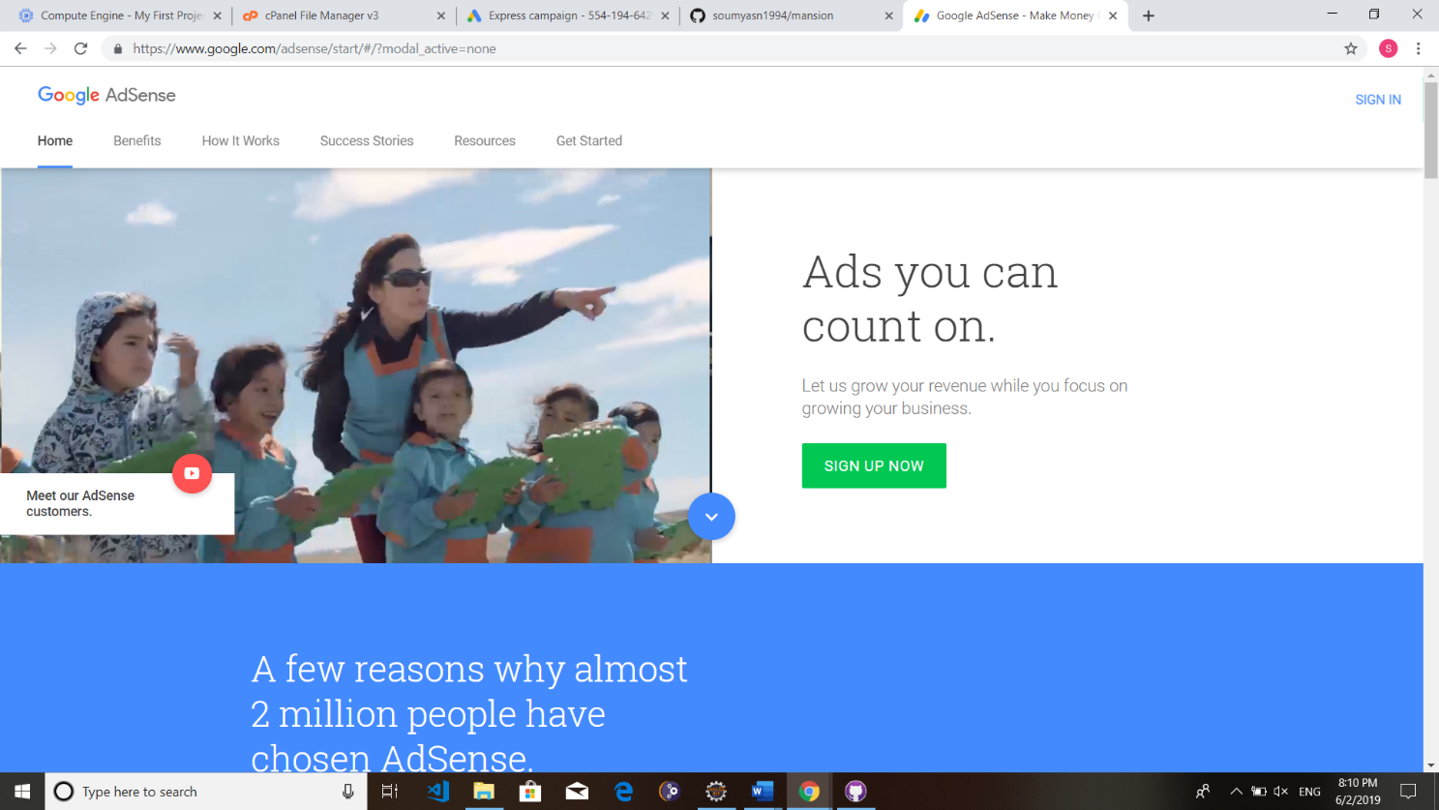

**Enter Website details**

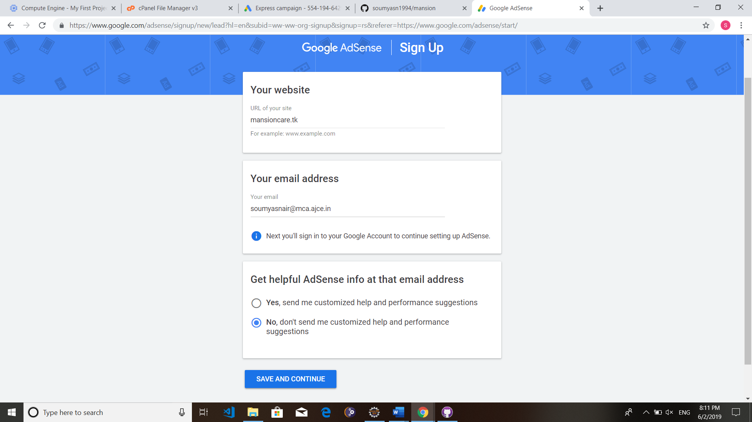

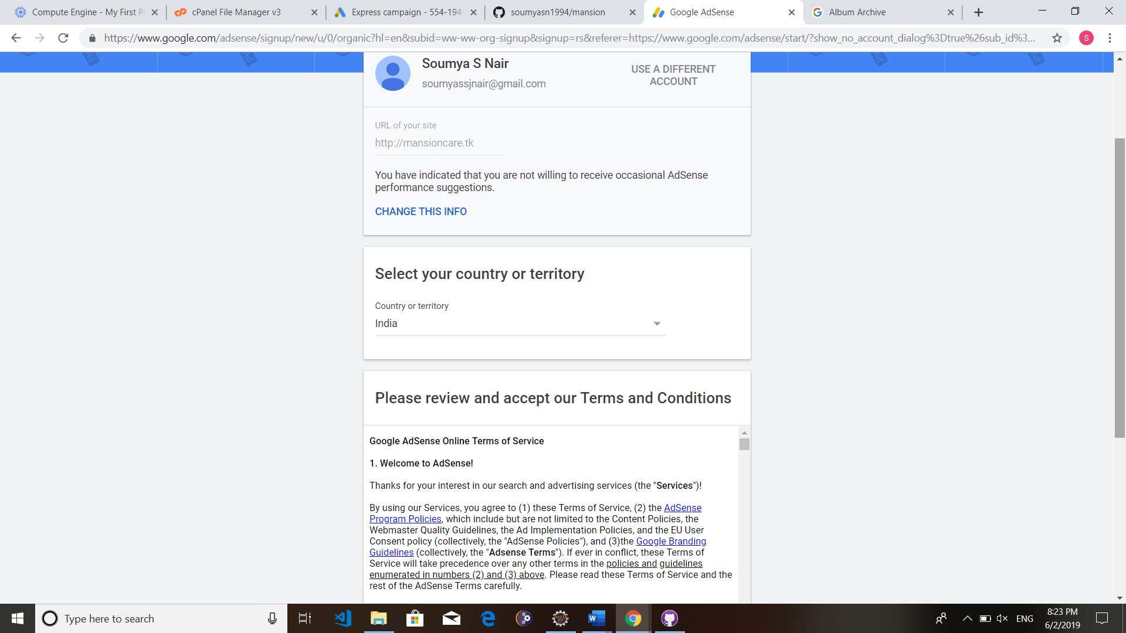

**Submit billing details**

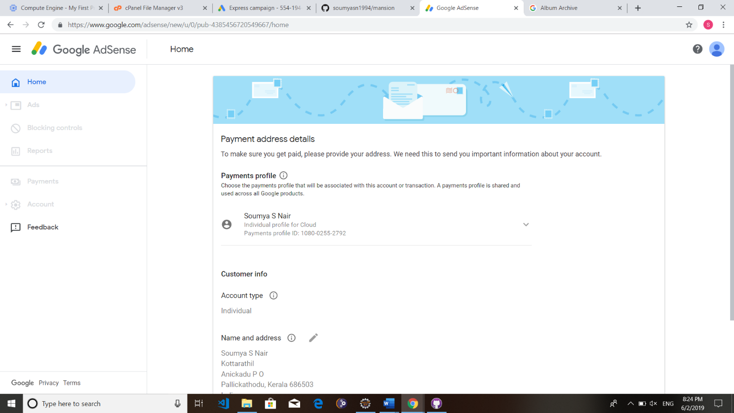

**Paste the given code in project’s index file**

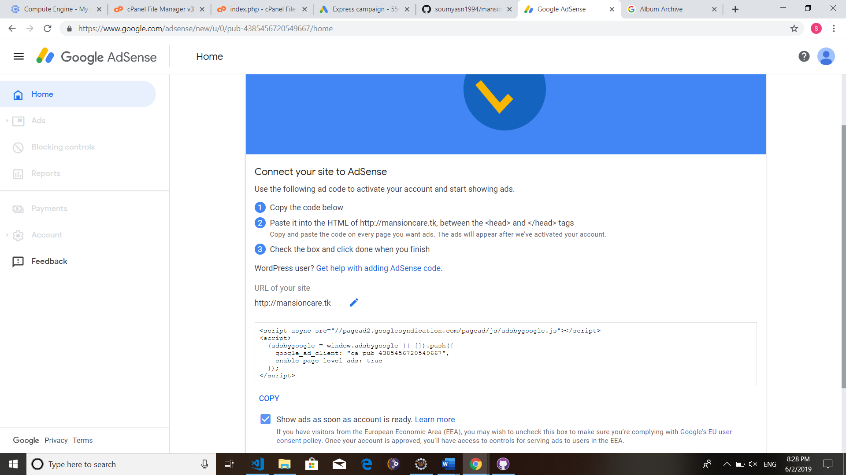

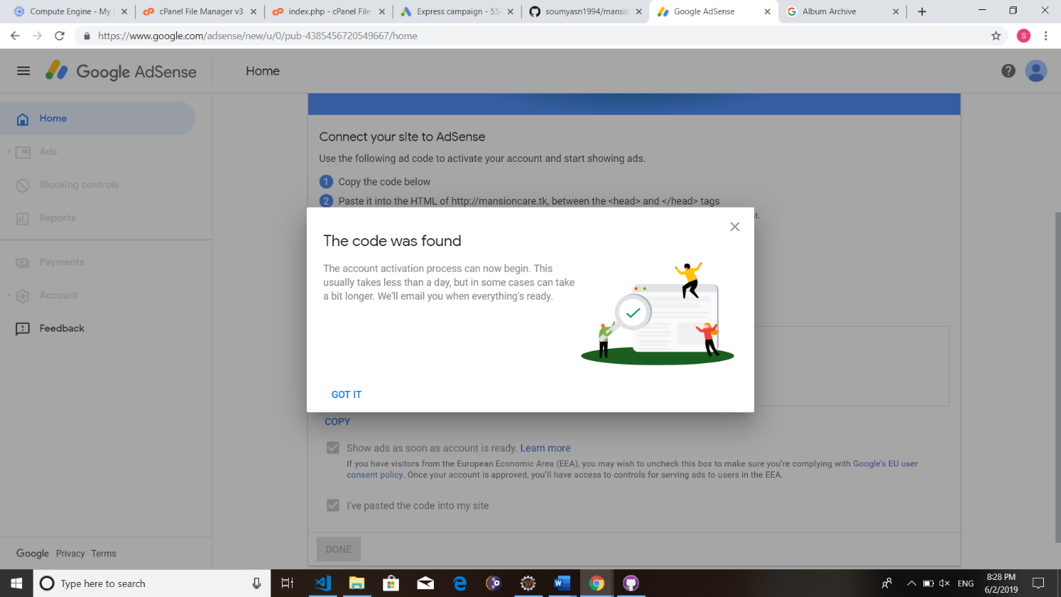

**Adsese will check for the code in our site**

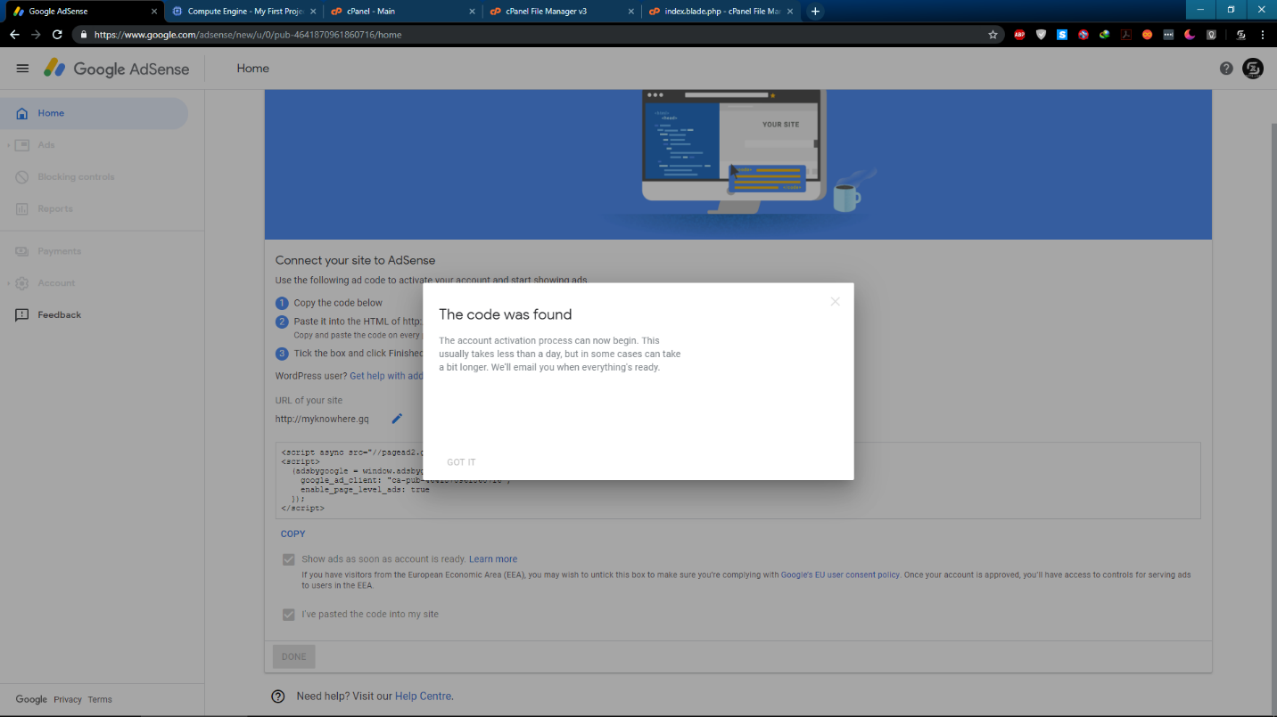

**Activate Adsense**

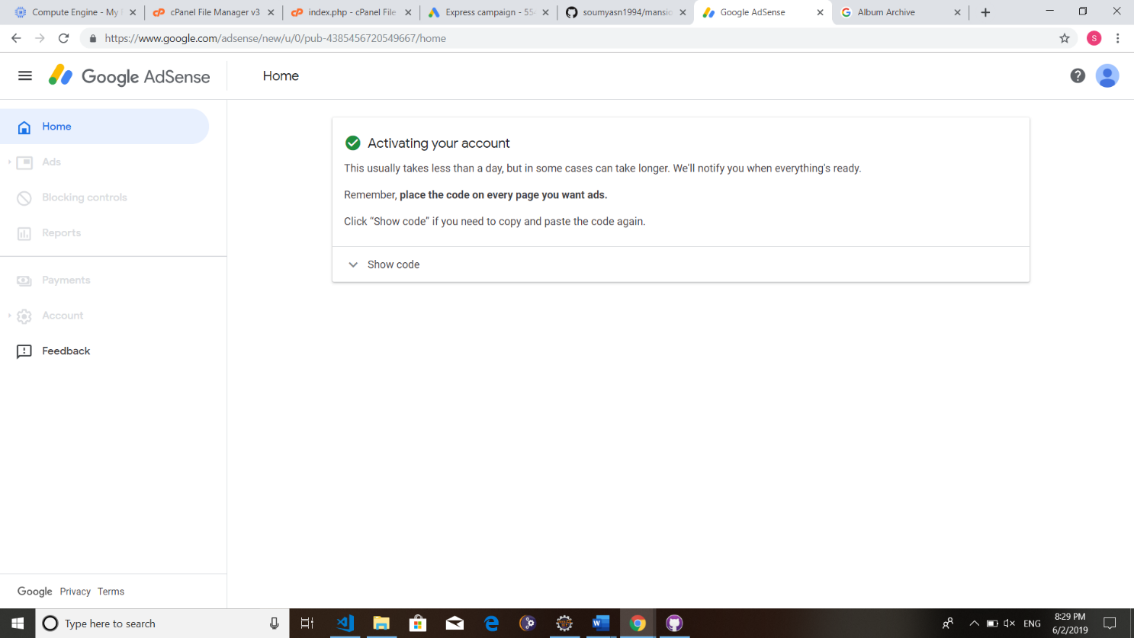

**P4.3 GOOGLE WEBMASTERS**

**P4.3.1 INTRODUCTION TO GOOGLE WEBMASTERS**

Google Webmaster Tools (GWT) is the primary mechanism for Google to communicate with webmasters. Google Webmaster Tools helps you to identify issues with your site and can even let you know if it has been infected with malware (not something you ever want to see, but if you haven’t spotted it yourself, or had one of your users tweet at you to let you know, it’s invaluable). And also, GWT let you evaluate and maintain your website's performance in search results Offered as a free service to anyone who owns a website, Google Webmaster Tools (GWT) is a conduit of information from the largest search engine in the world to you, offering insights into how it sees your website and helping you uncover issues that need fixing. You do not need to use GWT for your website to appear in search results, but it can offer you valuable information that can help with your marketing efforts.

#### How GWT can help monitor your website's performance

1. It verifies that Google can access the content on your website.
2. GWT makes it possible to submit new pages and posts for Google to crawl and remove content you don't want search engine users to discover.
3. It helps you deliver and evaluate content that offers users a more visual experience.
4. You can maintain your website without disrupting its presence in search results.
5. It allows you to discover and eliminate malware or spam problems that may not be easily found through other means.

### P4.3.2 IMPLEMENTATION OF ROBOTS.TXT

Robots.txt is a text (not html) file you put on your site to tell search robots which pages you would like them not to visit. Robots.txt is by no means mandatory for search engines but generally search engines obey what they are asked not to do. It is important to clarify that robots.txt is not a way from preventing search engines from crawling your site (i.e. it is not a firewall, or a kind of password protection) and the fact that you put a robots.txt file is something like putting a note “Please, do not enter” on an unlocked door – e.g. you cannot prevent thieves from coming in but the good guys will not open to door and enter. That is why we say that if you have really sensitive data, it is too naïve to rely on robots.txt to protect it from being

indexed and displayed in search results.

The location of robots.txt is very important. It must be in the main directory because otherwise user agents (search engines) will not be able to find it – they do not search the whole site for a file named robots.txt. Instead, they look first in the main directory (i.e. <http://mydomain.com/robots.txt)>and if they don't find it there, they simply assume that this site does not have a robots.txt file and therefore they index everything they find along the way.

#### Structure of a Robots.txt File

The structure of a robots.txt is pretty simple (and barely flexible) – it is an endless list of user agents and disallowed files and directories. Basically, the syntax is as follows:

User-agent:

Disallow:

“*User-agent”* are search engines' crawlers and *disallow:* lists the files and directories to be excluded from indexing. In addition to “user-agent:” and “disallow:” entries, you can include comment lines – just put the # sign at the beginning of the line:

# All user agents are disallowed to see the /temp directory. User-agent: *

Disallow: /temp/

## P4.4 BING WEBMASTER TOOL

### P4.4.1 INTRODUCTION TO BING WEBMASTER TOOL

**Bing Webmaster Tools** (previously the Bing Webmaster Centre) is a free service as part of [Microsoft](https://en.wikipedia.org/wiki/Microsoft)'s [Bing](https://en.wikipedia.org/wiki/Bing_(search_engine)) search engine which allows webmasters to add their websites to the [Bing](https://en.wikipedia.org/wiki/Bing_(search_engine)) index crawler. The service also offers tools for webmasters to troubleshoot the crawling and indexing of their website, Sitemap creation, submission and ping tools, website statistics, consolidation of content submission, and new content and community resources. Bing has generally been great to SEOs and webmasters, and nowhere is this more apparent than with Bing Webmaster Tools. In many ways, Bing Webmaster Tools is actually more advanced — and caters more to SEO professionals — than its Google counterpart, [Google](https://searchengineland.com/google-webmaster-tools-rebrands-to-google-search-console-221282) [Search Console.](https://searchengineland.com/google-webmaster-tools-rebrands-to-google-search-console-221282) For this, I give them a round of applause. I mean, would we have a [Google](https://searchengineland.com/google-launches-disavow-links-tool-136826) [Disavow Links Tool](https://searchengineland.com/google-launches-disavow-links-tool-136826) if Bing hadn’t [released one first](https://searchengineland.com/bing-launches-way-to-disavow-links-but-why-126262)? Maybe; but I still applaud Bing for catering to SEOs.

#### Step 1: Sign in to Bing webmaster

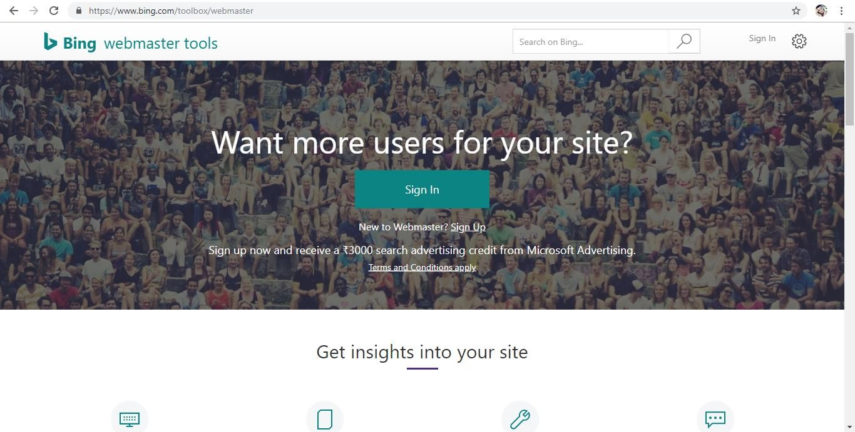

**Step 2: Add a website and Provide the details about the site.**

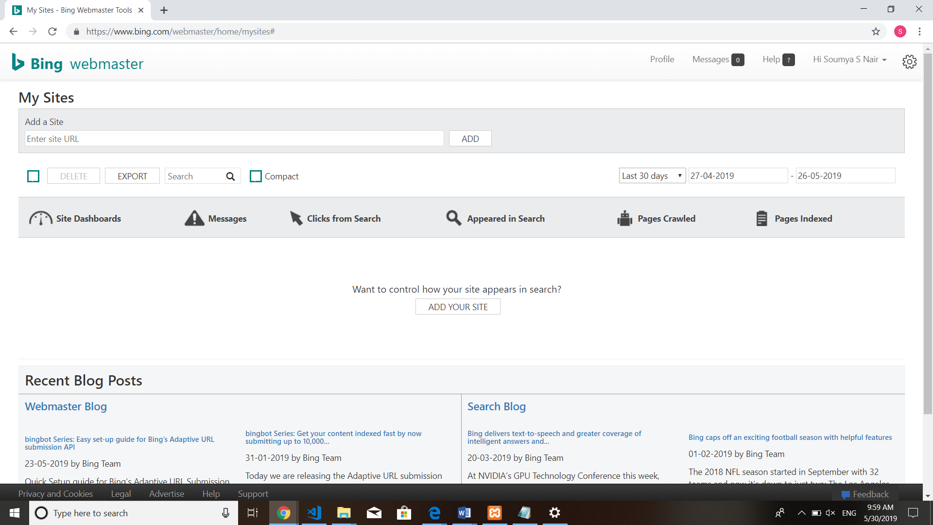

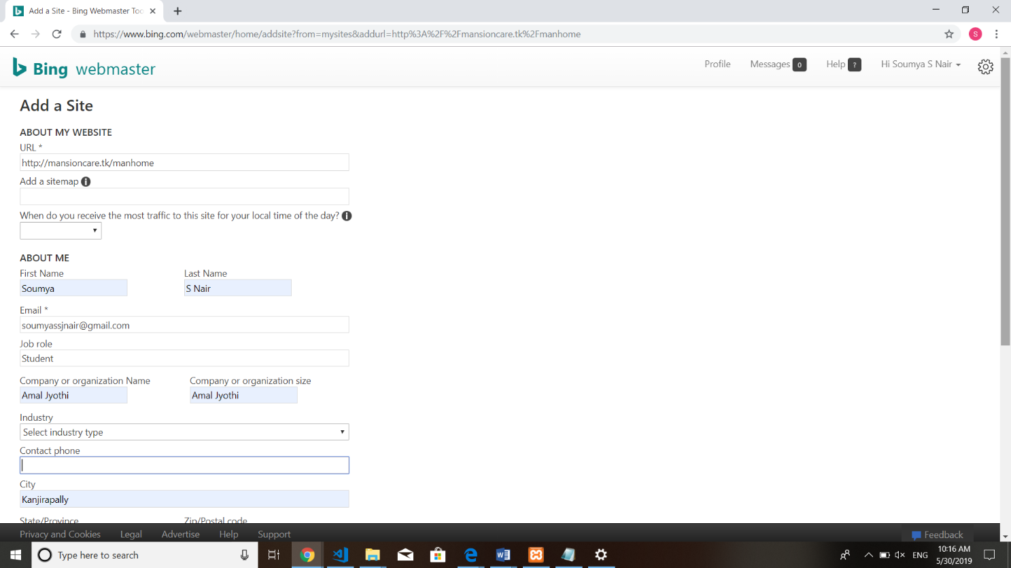

**Step 3: Verify ownership of your site.**

* Download and Upload BingSiteAuth.xml the file to your root directory.
* Confirm successful upload by visiting your URL/BingSiteAuth.xml in your browser
* Copy and paste a <meta> tag in your default webpage

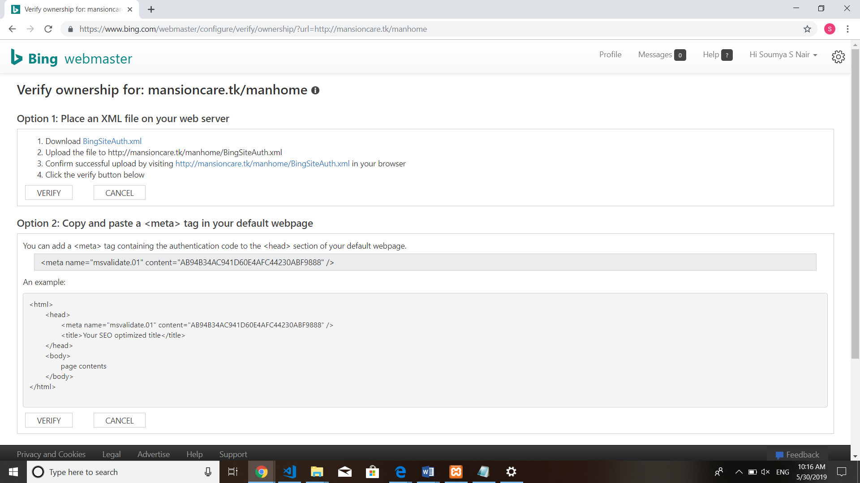

#### Step 4: Upload the BingSiteAuth.xml file into the root directory.

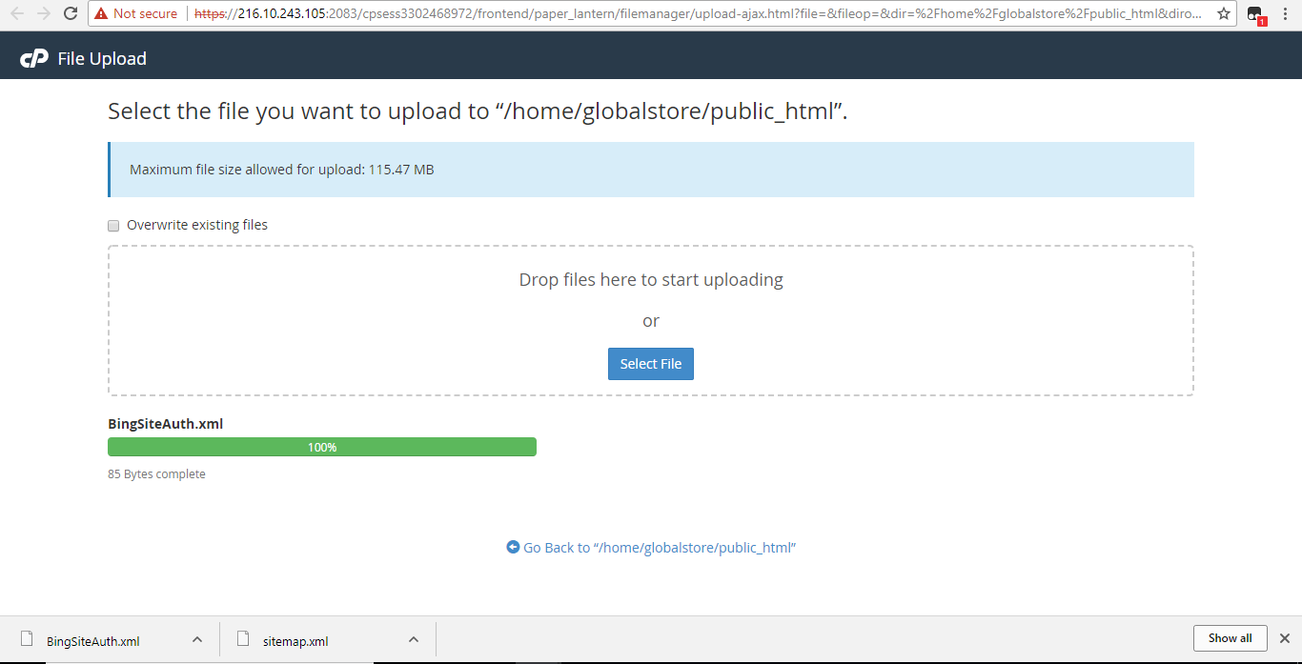

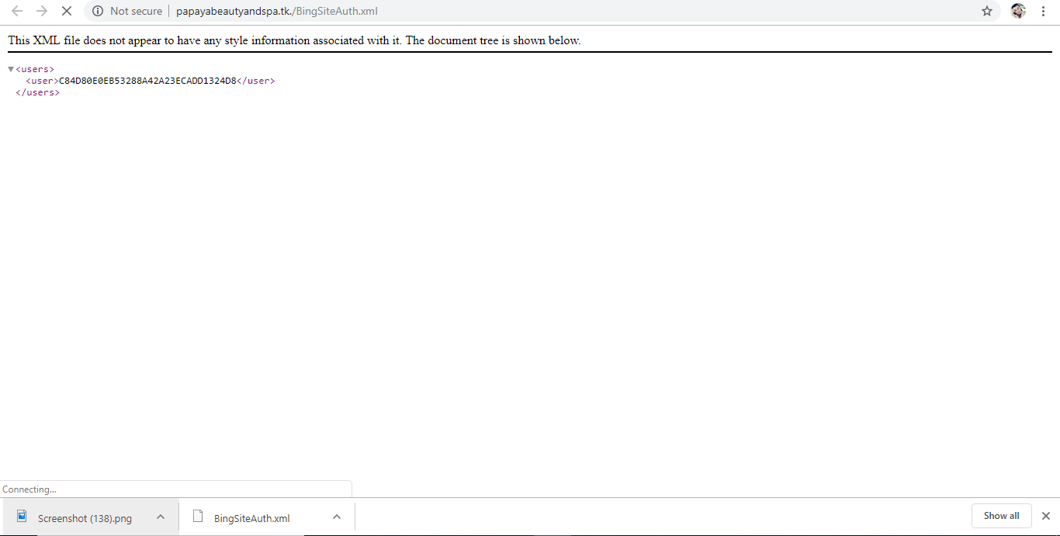

**Step 5: Site is verified and we get access to the dashboard.**

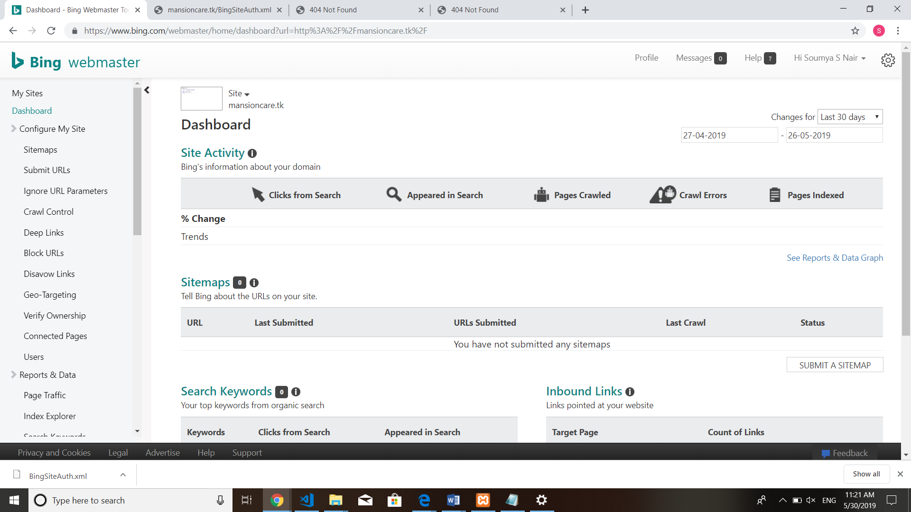

**PART 5**

**SERVER SECURITY AND PENETRATION TESTING**

**P5.1 DATA SECURITY**

Data security refers to protective digital privacy measures that are applied to prevent unauthorized access to computers, databases, and websites. Data security also protects data from corruption. Data security is an essential aspect of IT for organizations of every size and type. Examples of data security technologies include backups, data masking, and data erasure. The core of the data security technology is encryption, where digital data, software/hardware, and hard drives are encrypted and therefore rendered unreadable to unauthorized users and hackers.

#### Different Ways to Enhance Data Security

* 1. Limit Data Access
  2. Identify Sensitive Data
  3. Pre-planned Data Security Policy

### P5.2 SERVER HARDENING

Server Hardening is the process of enhancing server security through a variety of means which results in a much more secure server operating environment. This is due to the advanced security measures that are put in place during the server hardening process.

The term "hardening," in the general sense, implies taking a soft surface or material and making changes to it which result in that surface becoming stronger and more resistant to damage. That is exactly how server hardening impacts server security. Hardened servers are more resistant to security issues than non-hardened servers. * In a time when nearly every computing resource is online and susceptible to attack, server hardening is a near absolute must to perform on your servers. * The Internet has vastly altered the complexion of the server hardening industry over the last decade. Much of the applications and system software that is now developed is intended for use on the Internet, and for connections to the Internet. * Many servers online today are attacked thousands of times per hour, tens and sometimes hundreds of thousands of times each and every day. The best defense against such attacks is to ensure that server hardening is a well- established practice within your organization or to outsource this task to an experienced & established server hardening agency.

Server Hardening, probably one of the most important tasks to be handled on your servers, becomes more understandable when you realize all the risks involved. The default config of most operating systems is not designed with security as the primary focus. Instead, default

setups focus more on usability, communications and functionality. To protect your servers, you must establish solid and sophisticated server hardening policies for all servers

in your organization. Developing a server hardening checklist would likely be a great first step in increasing your server and network security. Make sure that your checklist includes minimum security practices that you expect of your staff. If you go with a consultant you can provide them with your server hardening checklist to use as a baseline.

Server Hardening Tips & Tricks: Every server security conscious organization will have their own methods for maintaining adequate system and network security. Often you will find that server hardening consultants can bring your security efforts up a notch with their specialized expertise. Some common server hardening tips & tricks include: - Use Data Encryption for your Communications - Avoid using insecure protocols that send your

information or passwords in plain text. - Minimize unnecessary software on your servers. - Disable Unwanted SUID and SGID Binaries - Keep your operating system up to date, especially security patches. - Using security extensions is a plus. - When using Linux, SELinux should be considered. Linux server hardening is a primary focus for the web hosting industry, however in web hosting SELinux is probably not a good option as it often causes issues when the server is used for web hosting purposes. - User Accounts should have very strong passwords - Change passwords on a regular basis and do not reuse them - Lock accounts after too many login failures. Often these login failures are illegitimate attempts to gain access to your system. - Do not permit empty passwords. - SSH Hardening --- Change the port from default to a non- standard one --- Disable direct root logins. Switch to root from a lower level account only when necessary. - Unnecessary services should be disabled. Disable all instances of IRC - BitchX, bnc, eggdrop, generic-sniffers, guardservices, ircd, psyBNC, ptlink. - Securing /tmp /var/tmp

/dev/shm

## P5.3 KALI LINUX TOOLS

### P5.3.1 INTRODUCTION TO KALI LINUX TOOLS

Kali Linux is the world’s most powerful and popular penetration testing platform, used by security professionals in a wide range of specializations, including penetration testing, forensics, reverse engineering, and vulnerability assessment. It is the culmination of years of refinement and the result of a continuous evolution of the platform, from WHoppiX to WHAX, to BackTrack, and now to a complete penetration testing framework leveraging many features of Debian GNU/Linux and the vibrant open source community worldwide. Kali contains several hundred tools which are geared towards various information security tasks, such as Penetration Testing, Security research, Computer Forensics and Reverse Engineering. Kali Linux was released on the 13th March 2013 as a complete, top-to-bottom rebuild of [Backtrack](http://www.backtrack-linux.org/) [Linux](http://www.backtrack-linux.org/), adhering completely to [Debian](http://www.debian.org/) development standards.

#### Major Kali Linux Penetration Testing tools

* **Sqlmap**

sqlmap is an open source penetration testing tool that automates the process of detecting and exploiting SQL injection flaws and taking over of database servers. It comes with a powerful detection engine, many niche features for the ultimate penetration tester and a broad range of switches lasting from database fingerprinting, over data fetching from the database.

#### Metasploit Framework

Metasploit is a penetration testing platform that enables you to find, exploit, and validate vulnerabilities. It provides the infrastructure, content, and tools to perform penetration tests and extensive security auditing and thanks to the open source community and Rapid7’s own hard-working content team, new modules are added on a regular basis.

#### Hashcat

hashcat is the world’s fastest and most advanced password recovery utility, supporting five unique modes of attack for over 200 highly-optimized hashing algorithms. hashcat currently supports CPUs, GPUs, and other hardware accelerators on Linux, Windows, and OSX, and has facilities to help enable distributed password cracking.

### P5.3.2 IMPLEMENTATIONTION OF KALI LINUX TOOLS

#### Testing with The Mole

Mole is a programmed automatic SQL Injection exploitation tool. Just by giving a vulnerable URL and a substantial string on the site it can recognize the injection and exploit it, either by utilizing the union method or a Boolean question-based system. The Mole utilizes a command- based interface, permitting the client to show the activity he needs to perform effectively. The CLI likewise gives auto-completion on both commands and command arguments, making the user sort as less as could be expected under the possibilities.

* Download and open themole.exe file
* Once a command-line interface is opened, use the following commands
* url <http://www.yourwebsite.com/page.php?id=numeric_value>
* Now find out any keywords available on the website, it may anything means any word find you on this site, I'm using classmates.
* needle classmates 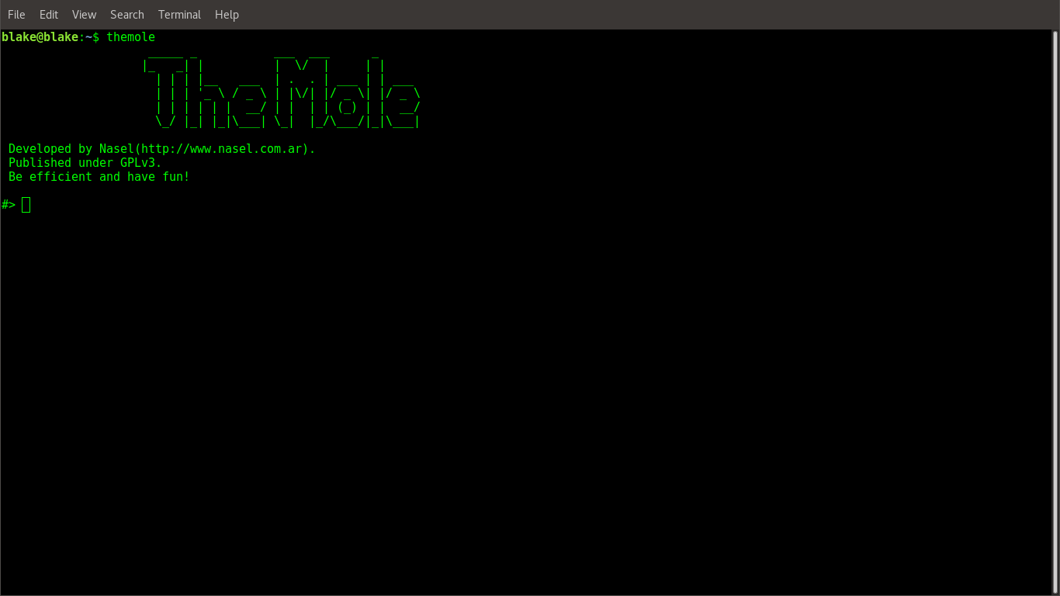

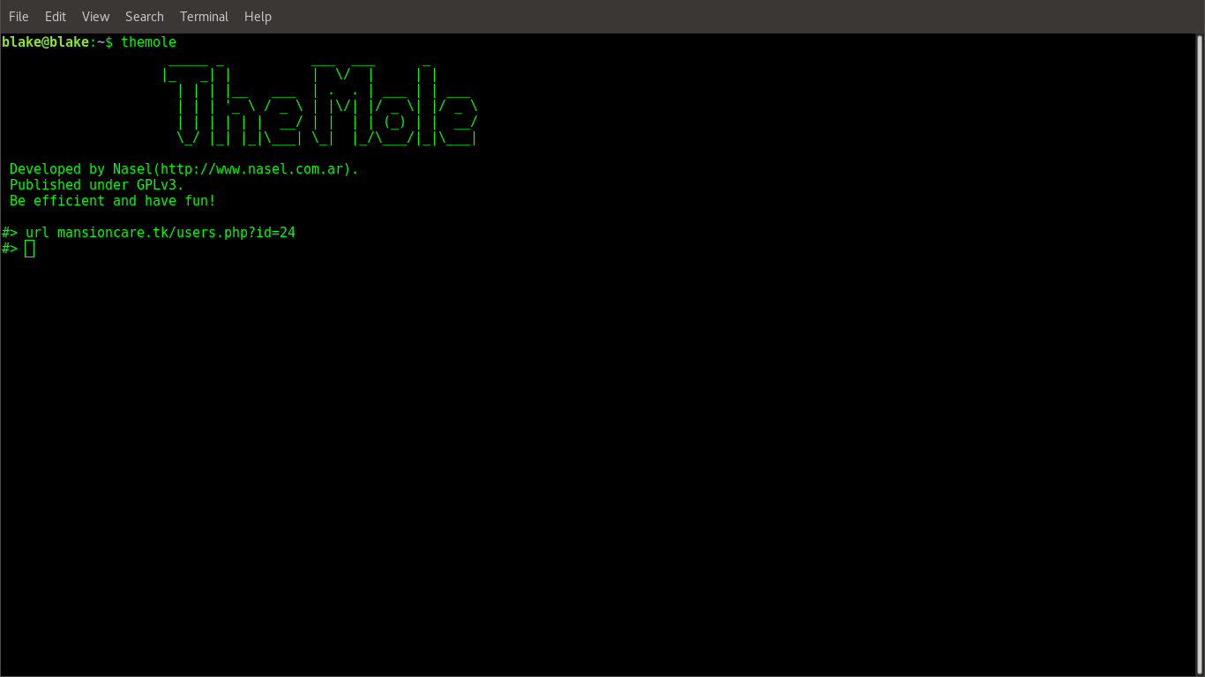

* finally, use command schemas to fetch tables

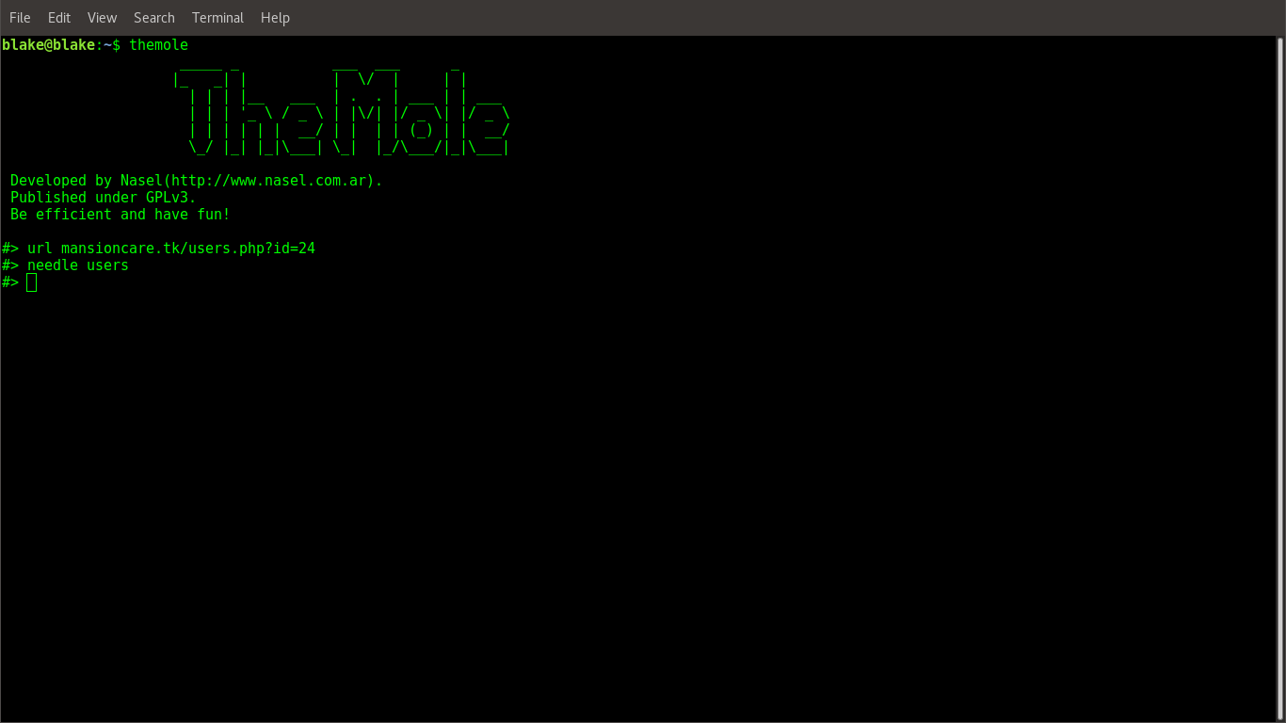

Output:

Could not Exploit SQL Injection

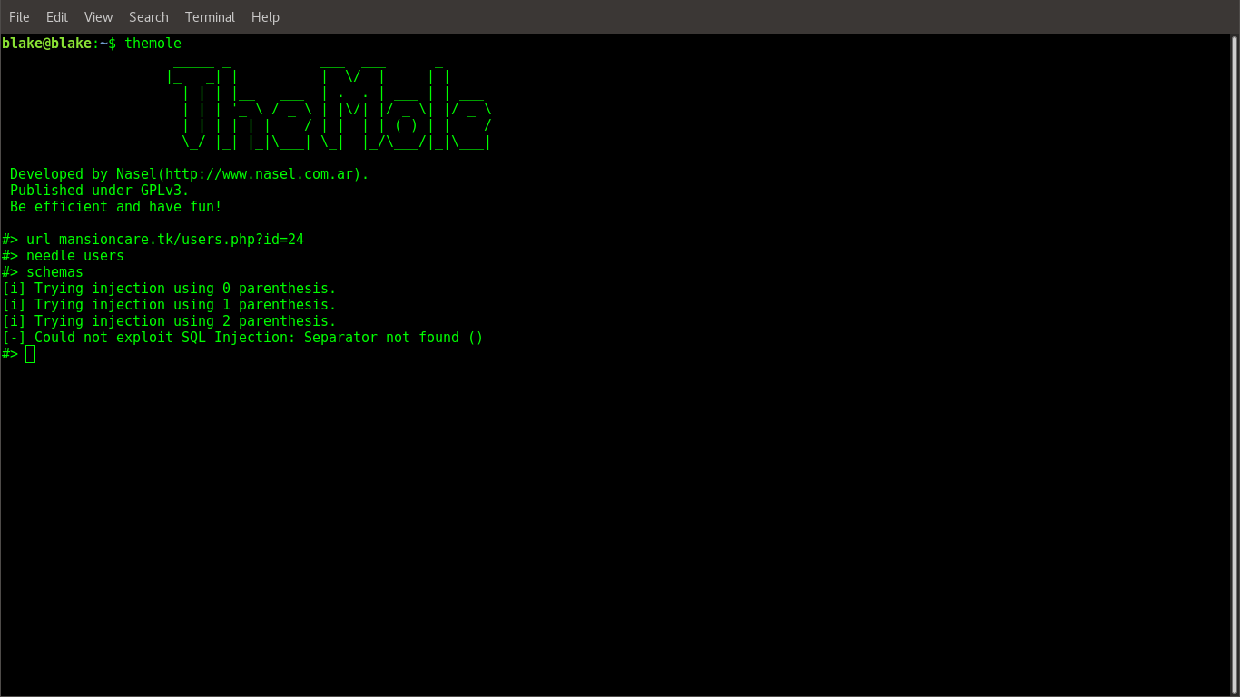

# PART 6 TECHNOLOGY FRAMEWORKS

## P6.1 ASP.NET MVC

### P6.1.1 Introduction

ASP.NET MVC is an open-source software from Microsoft. Its web development framework combines the features of MVC (Model-View-Controller) architecture, the most up-to-date ideas and techniques from Agile development and the best parts of the existing ASP.NET platform. ASP.NET MVC is basically a web development framework from Microsoft, which combines the features of MVC (Model-View-Controller) architecture, the most up-to-date ideas and techniques from Agile development, and the best parts of the existing ASP.NET platform.

ASP.NET MVC is not something, which is built from ground zero. It is a complete alternative to traditional ASP.NET Web Forms. It is built on the top of ASP.NET, so developers enjoy almost all the ASP.NET features while building the MVC application.

The MVC architectural pattern separates the user interface (UI) of an application into three main parts.

* **The Model** − A set of classes that describes the data you are working with as well as the business logic.
* **The View** − Defines how the application’s UI will be displayed. It is a pure HTML, which decides how the UI is going to look like.
* **The Controller** − A set of classes that handles communication from the user, overall application flow, and application-specific logic.

**Implementation of ASP.Net MVC**

* Download and install Microsoft Visual Studio 2012 and onwards
* Create an ASP.Net MVC Application. Open the Visual Studio. Click File>New > Project menu option. A new Project dialog opens.
* From the left pane, select Templates → Visual C# → Web.
* In the middle pane, select ASP.NET Web Application.
* Enter the project name, MVCApplication2, in the Name field and click ok to continue. You will see the following dialog which asks you to set the initial content for the ASP.NET project.

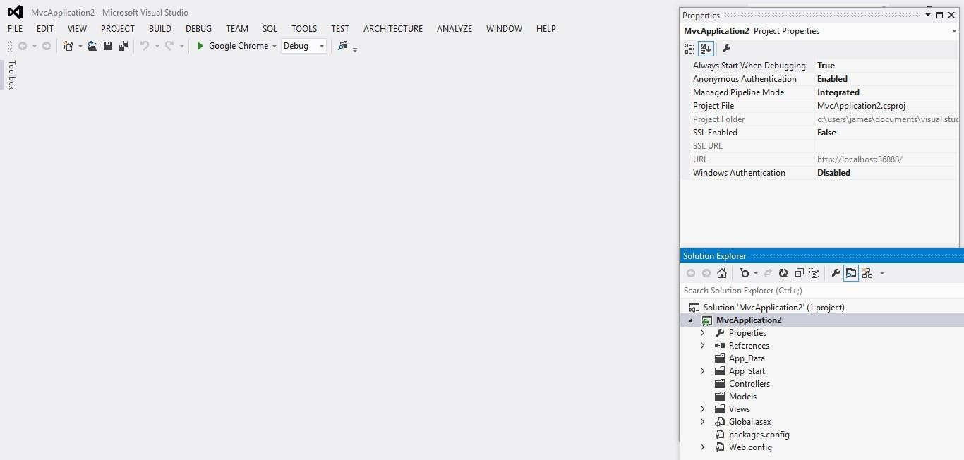

* Run this application from Debug > Start Debugging menu option and you will see a **404 Not Found** Error.

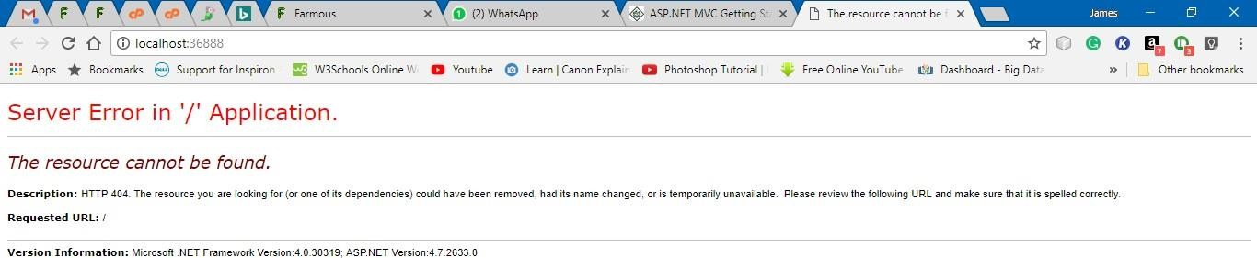

**Add Controller**

* To remove the 404 Not Found error, we need to add a controller, which handles all the incoming requests.
* To add a controller, right-click on the controller folder in the solution explorer and select Add > Controller.
* Select the MVC 5 Controller – Empty option and click ‘Add’ button. The Add Controller dialog will appear.
* Set a name to Controller and click the Add button.
* To make this a working example, let’s modify the controller class by changing the action method called **Index** using the following code.

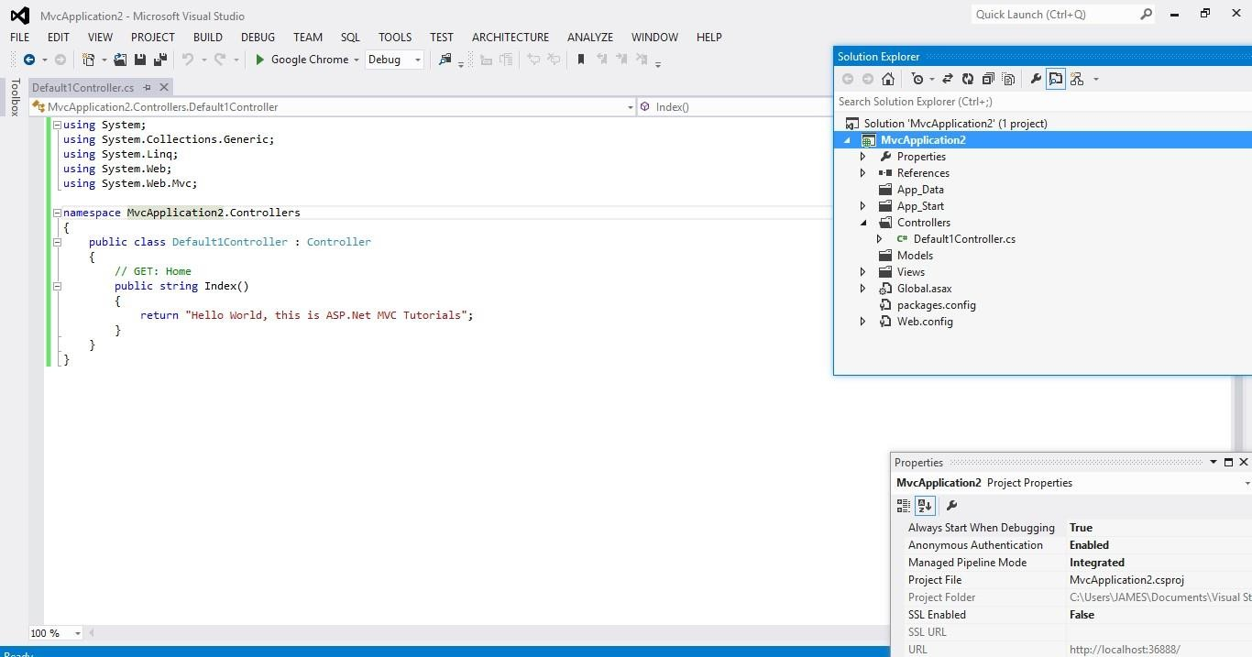

* Run this application from Debug

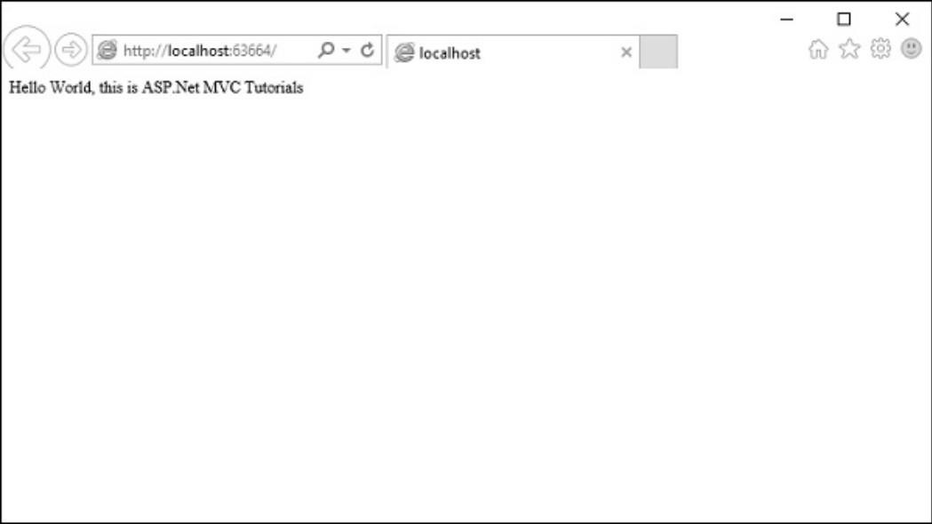

## P6.2 LARAVEL

**Laravel** is a free, open-source PHP web framework, created by Taylor Otwell and intended for the development of web applications following the model–view–controller (MVC) architectural pattern. It has a very rich set of functionalities, which will increase the speed of website development work.

If you know PHP well, then Laravel will make your task easier. It has a very rich set of libraries and helpers. By using Laravel, you will save a lot of time, if you are developing a website from scratch. Not only that, a website built in Laravel is secure too, as it has the ability to prevent various attacks that take place through websites.

It is very easy to install Laravel. Just follow the steps given below –

* First, download the Laravel installer using Composer: Composer global require laravel/installer
* Once installed, the laravel new command will create a fresh Laravel installation in the directory you specify

Laravel new helloworld

* Via Composer Create-Project

composer create-project laravel/laravel hello-world

* Local Development Server

If you have PHP installed locally and you would like to use PHP's built-in development server to serve your application, you may use the serve Artisan command. This command will start a development server at http://localhost:8000.

php artisan serve

Laravel is based on the Model-View-Controller (MVC) development pattern. MVC is a software approach that separates application logic from presentation. In practice, it permits your web pages to contain minimal scripting since the presentation is separate from the PHP scripting.

* The Model represents your data structures. Typically, your model classes will contain functions that help you retrieve, insert and update information in your database.
* The View is information that is being presented to a user. A View will normally be a web page, but in Laravel, a view can also be a page fragment like a header or footer. It can also be an RSS page or any other type of “page”.
* The Controller serves as an intermediary between the Model, the View, and any other resources needed to process the HTTP request and generate a web page.

Example

1. Create a Laravel application:

Composer create-project laravel/laravel hello-world

1. Navigate to the project folder, e.g. D:\laravel\hello-world
2. Create a controller:

php artisan make:controller HelloController

1. Register a route to HelloController's index method. Add this line or routes/web.php Route::get(‘hello’,HelloController@index’);
2. Create a Blade template in the views directory: resources/views/hello.blade.php:

<html>

<body>

<h1>HelloWorld</h1>

</body>

</html>

1. Now we tell index method to display the hello.blade.php template: app/Http/Controllers/HelloController.php

<?php

namespace App\Http\Controllers; use Illuminate\Http\Request;

use App\Http\Requests;

class HelloController extends Controller

{

public function index ()

{

return view('hello');

}

}

// ... other resources are listed below the index one above

1. You can serve your app using the following PHP Artisan Command: php artisan serve;

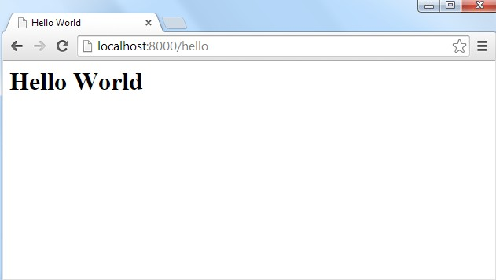

## P6.3 ANGULAR

Angular 6 is a JavaScript framework for building web applications and apps in JavaScript, html, and TypeScript, which is a superset of JavaScript. Angular provides built-in features for animation, http service, and materials which in turn has features such as auto-complete, navigation, toolbar, menus, etc. The code is written in TypeScript, which compiles to JavaScript and displays the same in the browser.

#### Step 1: Install the Angular CLI

Install the Angular CLI globally.

To install the CLI using npm, open a terminal/console window and enter the following command:



#### Step 2: Create a workspace and initial application

You develop apps in the context of an Angular workspace. A workspace contains the files for one or more projects. A project is the set of files that comprise an app, a library, or end- to-end (e2e) tests.

To create a new workspace and initial app project:

1. Run the CLI command ng new and provide the name my-app, as shown here:



The ng new command prompts you for information about features to include in the initial app project. Accept the defaults by pressing the Enter or Return key.

The Angular CLI installs the necessary Angular npm packages and other dependencies. This can take a few minutes.

It also creates the following workspace and starter project files:

* A new workspace, with a root folder named my-app
* An initial skeleton app project, also called my-app (in the src subfolder)
* An end-to-end test project (in the e2e subfolder)
* Related configuration files
* The initial app project contains a simple Welcome app, ready to run.

#### Step3: Serve the Application

Angular includes a server, so that you can easily build and serve your app locally. Go to the workspace folder (my-app).

Launch the server by using the CLI command ng serve, with the --open option.



The ng serve command launches the server, watches your files, and rebuilds the app as you make changes

to those files.

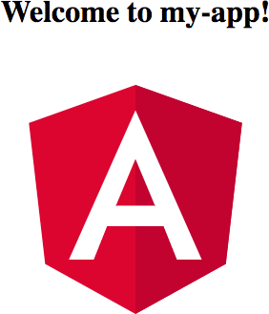The --open (or just -o) option automatically opens your browser to http://localhost:4200/. Your app greets you with a message:

**Step 4: Edit your first Angular component**

Components are the fundamental building blocks of Angular applications. They display data on the screen, listen for user input, and take action based on that input.

As part of the initial app, the CLI created the first Angular component for you. It is the root component, and it is named app-root.

Open ./src/app/app.component.ts.

Change the title property from 'my-app' to 'My First Angular App'. src/app/app.component.ts

@Component({ selector: 'app-root',

templateUrl: './app.component.html', styleUrls: ['./app.component.css']

})

export class AppComponent { title = 'My First Angular App!';

}

The browser reloads automatically with the revised title. That's nice, but it could look better. Open ./src/app/app.component.css and give the component some style.

src/app/app.component.css h1 {

color: #369;

font-family: Arial, Helvetica, sans-serif; font-size: 250%;

}

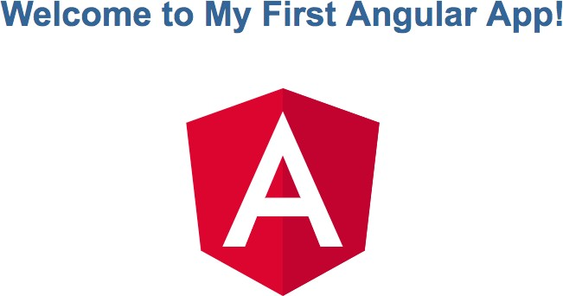

## P6.4 ANDROID

Android is a software package and linux based operating system for mobile devices such as tablet computers and smart phones. It is developed by Google and later the OHA (Open Handset Alliance). Java language is mainly used to write the android code even though other languages can be used. The goal of android project is to create a successful real-world product that improves the mobile experience for end users. There are many code names of android such as Lollipop, Kitkat, Jelly Bean, Ice cream Sandwich, Froyo, Ecliar, Donut etc .

#### Creating Android Application

The first step is to create a simple Android Application using Android studio. When you click on Android studio icon, it will show screen as shown below

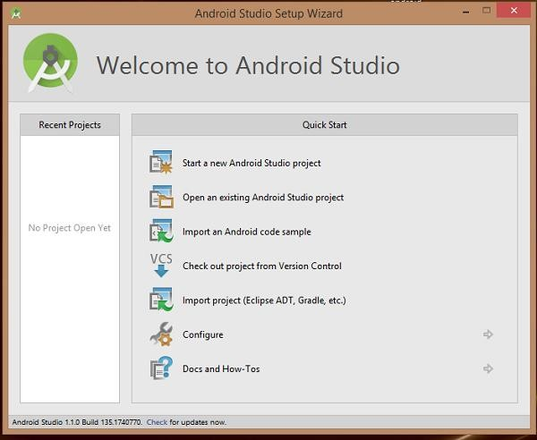

You can start your application development by calling start a new android studio project. in a new installation frame should ask Application name, package information and location of the project.−

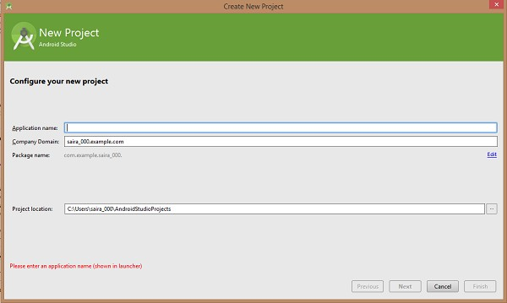

After entered application name, it going to be called select the form factors your application runs on, here need to specify Minimum SDK, in this example, I have declared as API23: Android 6.0(Marshmallow) –

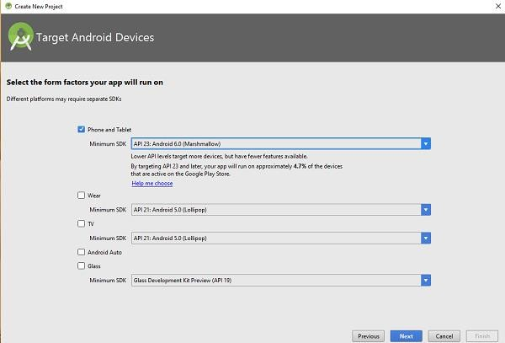

The next level of installation should contain selecting the activity to mobile, it specifies the default layout for Applications

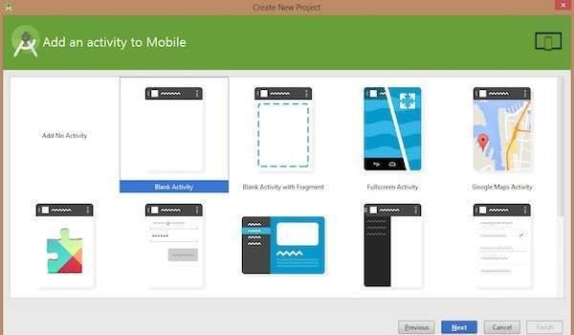

At the final stage it going to be open development tool to write the application code.

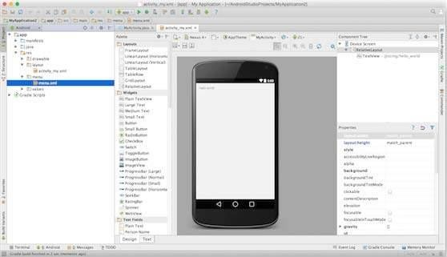

#### Anatomy of Android Application

Before you run your app, you should be aware of a few directories and files in the Android

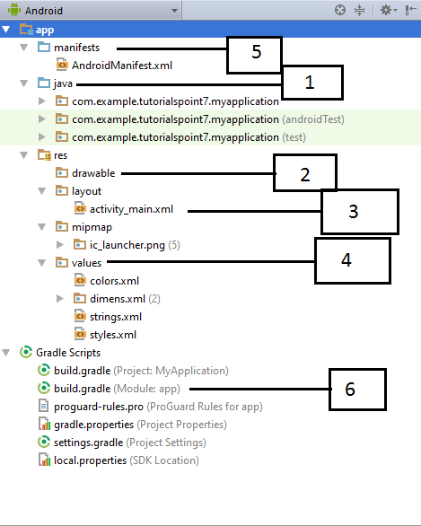

Following section will give a brief overview of the important application files.

#### The Main Activity File

The main activity code is a Java file **MainActivity.java**. This is the actual application file which ultimately gets converted to a Dalvik executable and runs your application. Following is the default code generated by the application wizard for *Hello World!* application −

package com.example.helloworld;

import android.support.v7.app.AppCompatActivity;

import android.os.Bundle;

public class MainActivity extends AppCompatActivity { @Override

protected void onCreate(Bundle savedInstanceState) { super.onCreate(savedInstanceState); setContentView(R.layout.activity_main);

}

}

Here, *R.layout.activity_main* refers to the *activity_main.xml* file located in the *res/layout* folder. The *onCreate()* method is one of many methods that are figured when an activity is loaded.

#### The Manifest File

Whatever component you develop as a part of your application, you must declare all its components in a *manifest.xml* which resides at the root of the application project directory. This file works as an interface between Android OS and your application, so if you do not declare your component in this file, then it will not be considered by the OS. For example, a default manifest file will look like as following file −

<?xml version="1.0" encoding="utf-8"?>

<manifest xmlns:android="<http://schemas.android.com/apk/res/android>" package="com.example.albin7.myapplication">

<application android:allowBackup="true" android:icon="@mipmap/ic_launcher" android:label="@string/app_name" android:supportsRtl="true" android:theme="@style/AppTheme">

<activity android:name=".MainActivity">

<intent-filter>

<action android:name="android.intent.action.MAIN" />

<category android:name="android.intent.category.LAUNCHER" />

</intent-filter>

</activity>

</application>

</manifest>

Here <application>...</application> tags enclosed the components related to the application. Attribute *android:icon* will point to the application icon available under *res/drawable-hdpi*. The application uses the image named ic_launcher.png located in the drawable folders

The <activity> tag is used to specify an activity and *android:name* attribute specifies the fully qualified class name of the *Activity* subclass and the *android:label* attributes specifies a string to use as the label for the activity. You can specify multiple activities using <activity> tags.

The **action** for the intent filter is named *android.intent.action.MAIN* to indicate that this activity serves as the entry point for the application. The **category**for the intent-filter is named *android.intent.category.LAUNCHER* to indicate that the application can be launched from the device's launcher icon.

The *@string* refers to the *strings.xml* file explained below. Hence, *@string/app_name* refers to the *app_name* string defined in the strings.xml file, which is "HelloWorld". Similar way, other strings get populated in the application.

Following is the list of tags which you will use in your manifest file to specify different Android application components −

* <activity>elements for activities
* <service> elements for services
* <receiver> elements for broadcast receivers
* <provider> elements for content providers

#### The Strings File

The **strings.xml** file is located in the *res/values* folder and it contains all the text that your application uses. For example, the names of buttons, labels, default text, and similar types of strings go into this file. This file is responsible for their textual content. For example, a default strings file will look like as following file −

<resources>

<string name="app_name">HelloWorld</string>

<string name="hello_world">Hello world!</string>

<string name="title_activity_main">MainActivity</string>

</resources>

#### The Layout File

The **activity_main.xml** is a layout file available in *res/layout* directory, that is referenced by your application when building its interface. You will modify this file very frequently to change the layout of your application. For your "Hello World!" application, this file will have following content related to default layout −

<RelativeLayout xmlns:android="[http://schemas.android.com/apk/res/android"](http://schemas.android.com/apk/res/android) xmlns:tools="[http://schemas.android.com/tools"](http://schemas.android.com/tools) android:layout_width="match_parent" android:layout_height="match_parent" >

<TextView android:layout_width="wrap_content" android:layout_height="wrap_content" android:layout_centerHorizontal="true" android:layout_centerVertical="true" android:padding="@dimen/padding_medium" android:text="@string/hello_world"

tools:context=".MainActivity" />

</RelativeLayout>

This is an example of simple RelativeLayout which we will study in a separate chapter. The TextView is an Android control used to build the GUI and it have various attributes like android:layout_width, android:layout_height etc which are being used to set its width and height etc.. The @string refers to the strings.xml file located in the res/values folder. Hence, @string/hello_world refers to the hello string defined in the strings.xml file, which is "Hello World!".

#### Running the Application

Let's try to run our **Hello World!** application we just created. I assume you had created your **AVD** while doing environment set-up. To run the app from Android studio, open one of your project's activity files and click Run  icon from the tool bar. Android studio installs the app on your AVD and starts it and if everything is fine with your set-up and application, it will display following Emulator window –

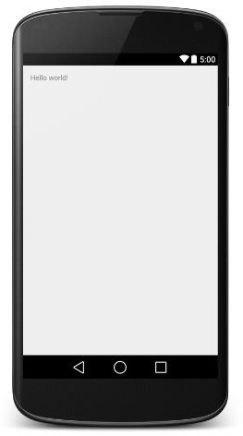

## P6.5 JAVA SPRING

The **Spring Framework** is an application framework and inversion of control container for the Java platform. The framework's core features can be used by any Java application, but there are extensions for building web applications on top of the Java EE (Enterprise Edition) platform. Although the framework does not impose any specific programming model, it has become popular in the Java community as an addition to, or even replacement for the Enterprise JavaBeans (EJB) model. The Spring Framework is open source.

#### Program Implementation

**Step1:** Install JDK 1.8 and set Tomcat server

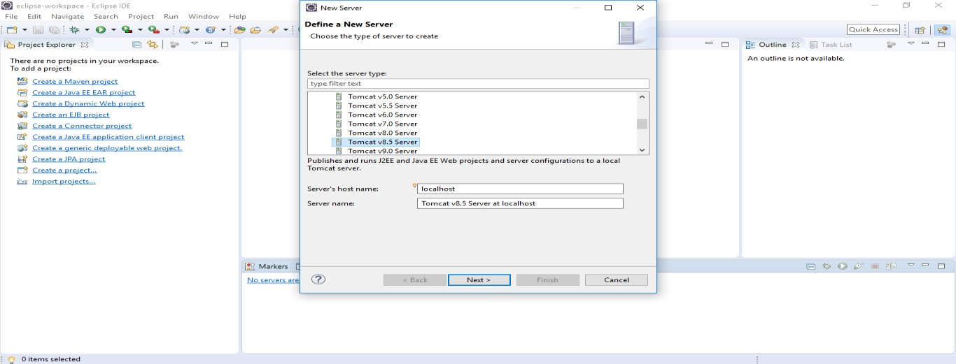

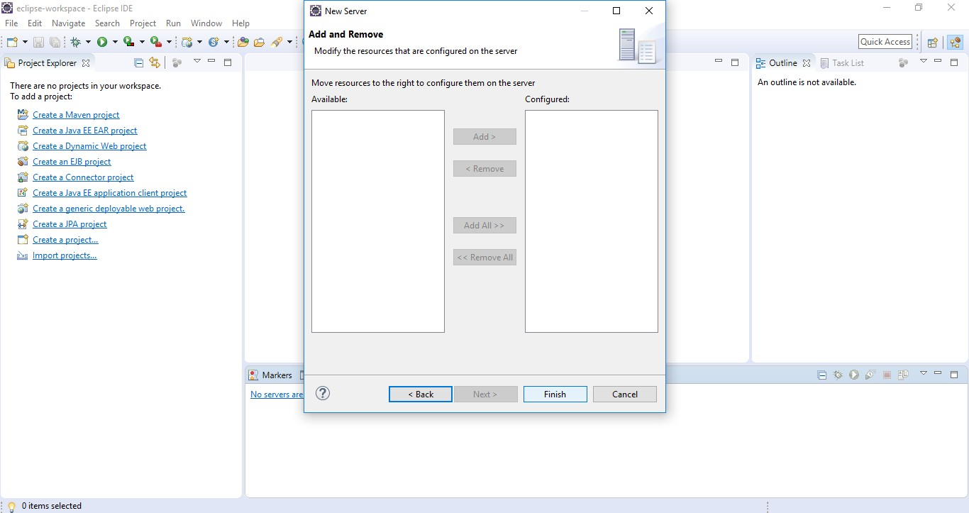

**Step2:** Start Maven project **–** file-> new -> maven

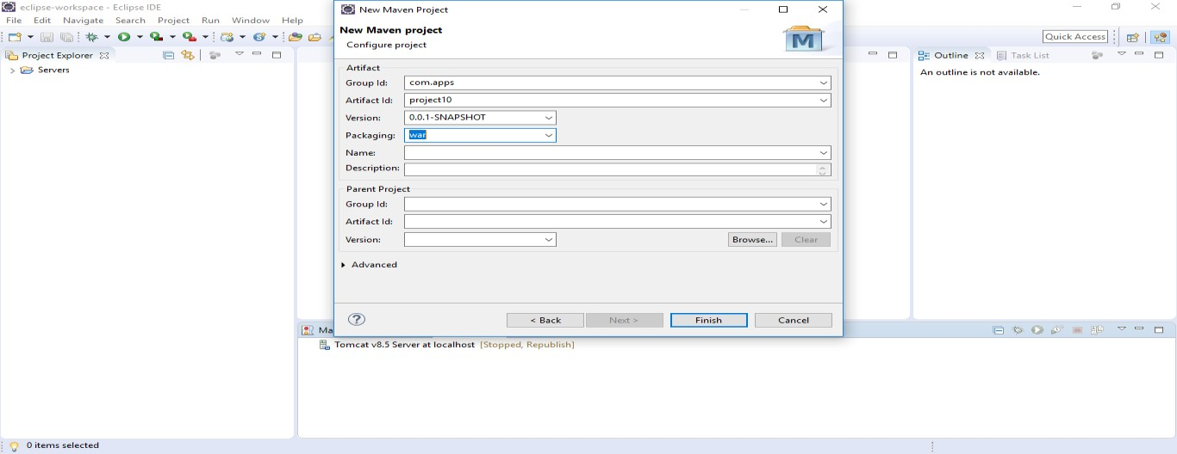

**Step3:** Build your maven project

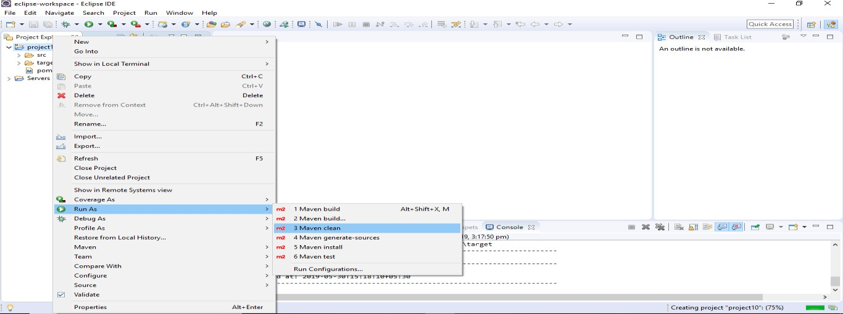

**Step4:** Add a folder in webapp and the folder name is WEB-INF

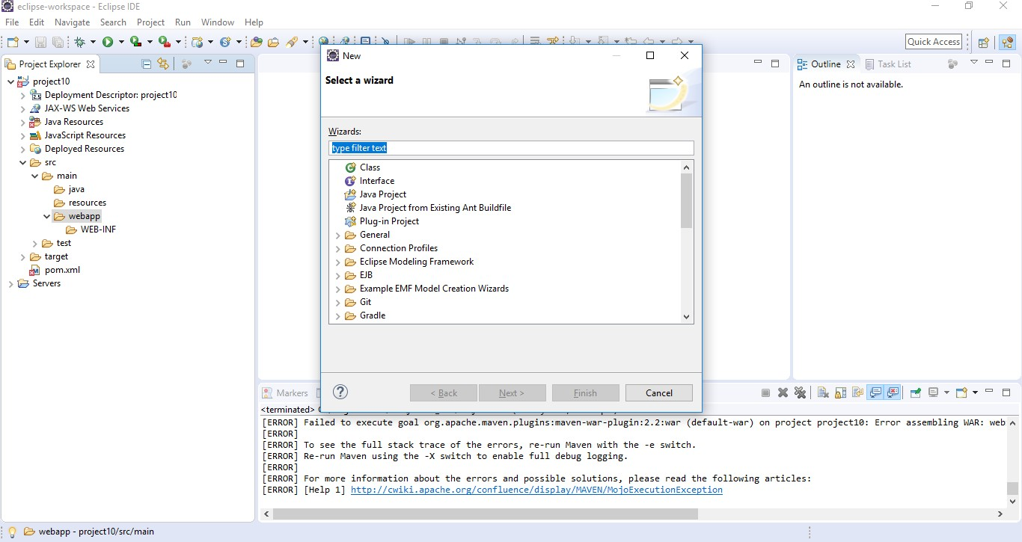

**Step5:** Click WEB-INF -> Ctrl+N -> select jsp file -> name the file with index.jsp

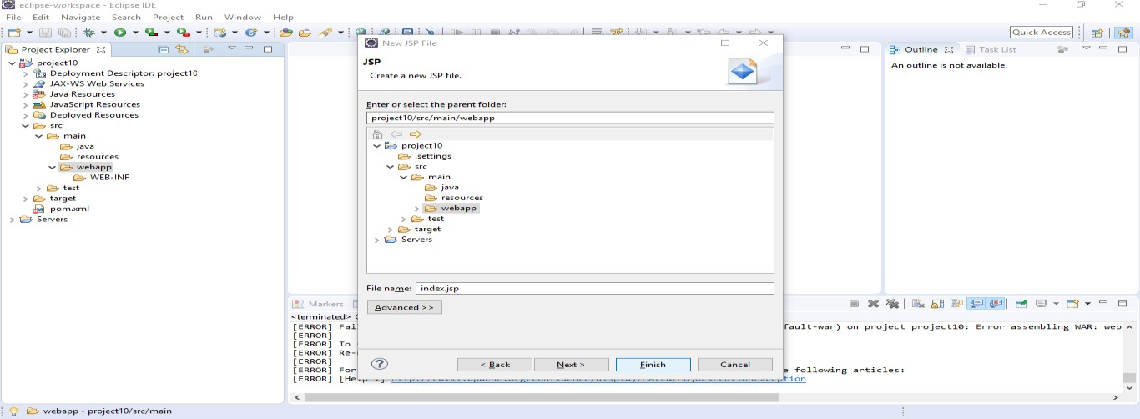

**Step6:** Set Pom file

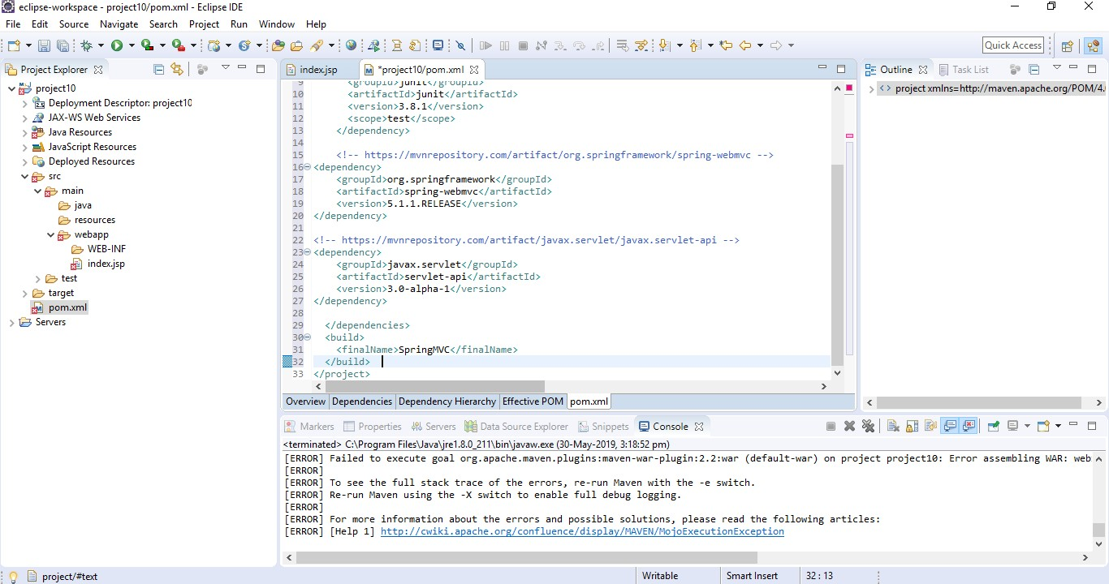

**Step7:** Create java packages

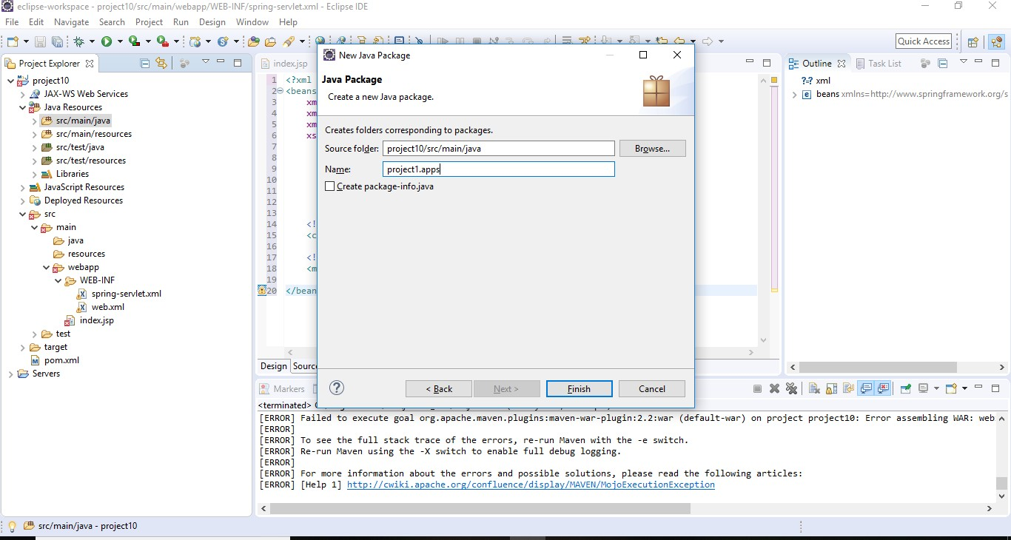

**Step:8** Create java class

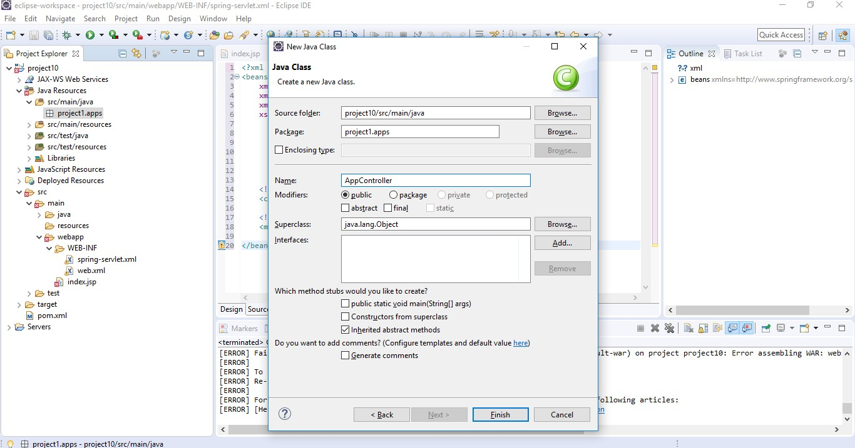

**Step:9** Set AppController

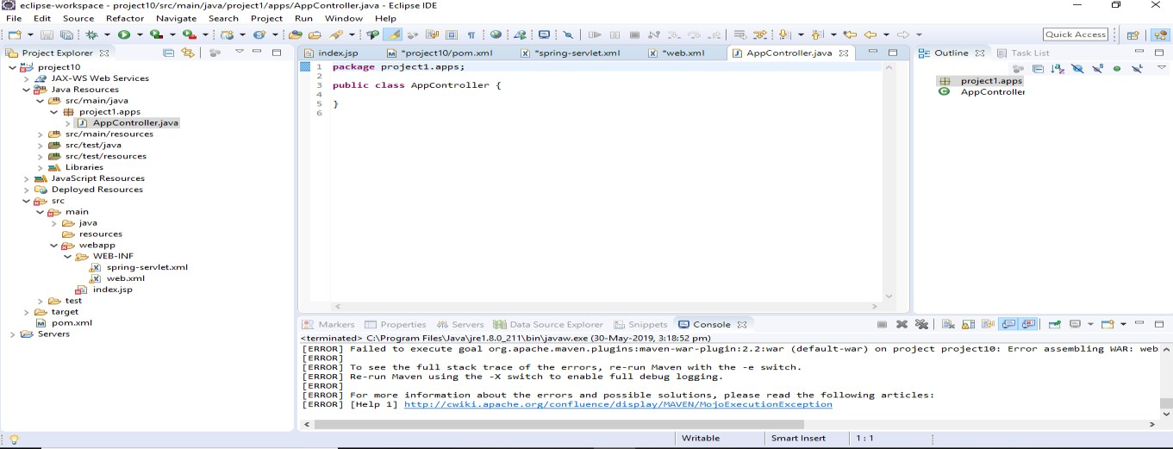

**Step:10** Run your project

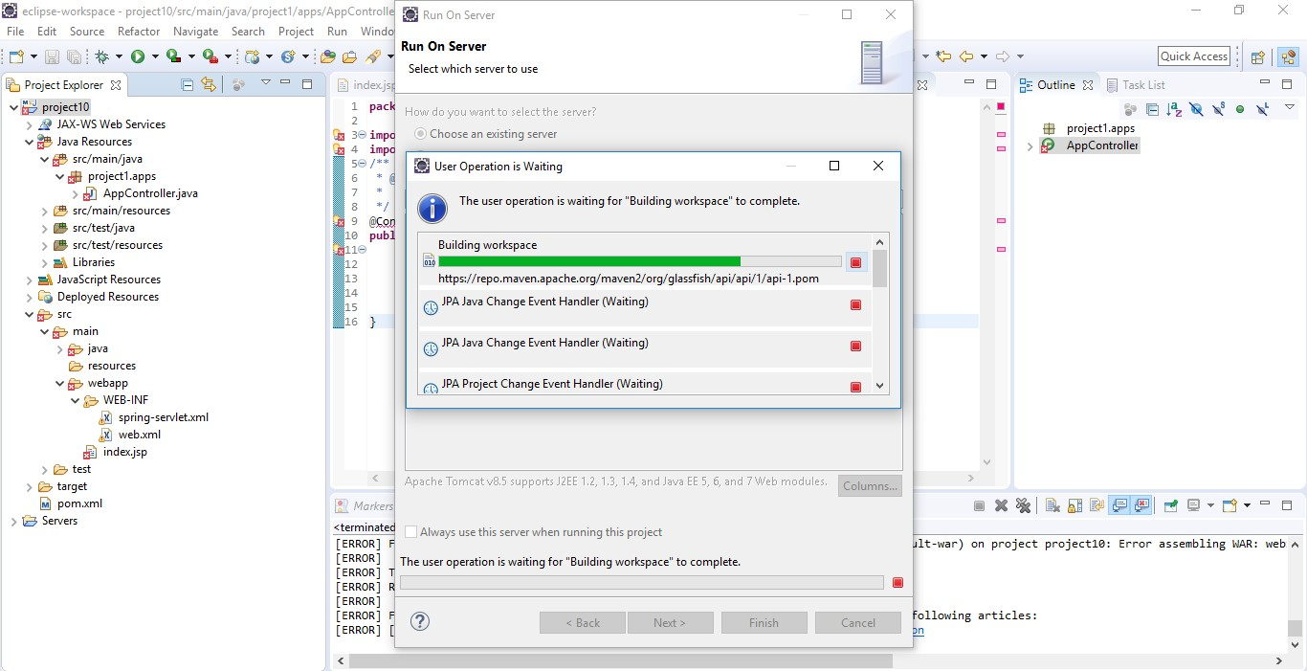

#### Output

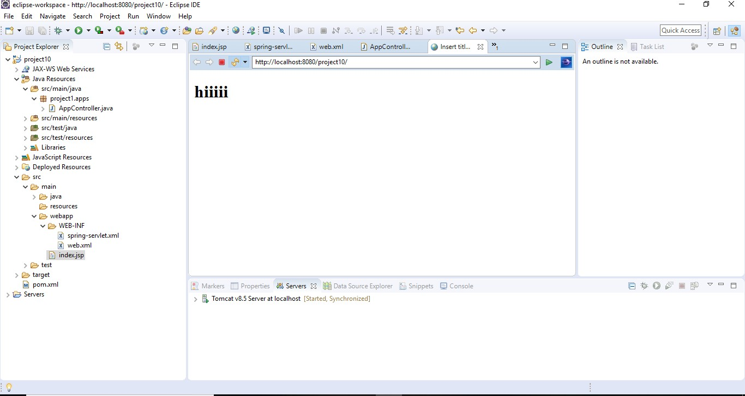

**PART 7**

**PROJECT DOCUMENTATION**

**P7.1 INTRODUCTION**

**P7.1.1 Project Overview**

Mansion Care System is a simple platform for users to access services for their huge needs. It provides the services to the users who are searching for service providers like cleaning, plumbers, post-party cleaning, servants, daily wages people etc. This is a website in which we will get the services of several service providers. Once the user register, he/she want to book the service of our system. This system provides registration too. After the registration, the user can login and he/she can book the services and a job oppourunity are added for users/people you are willing to work. The system also provides facility for posting a feedback and hence it will reach to all viewers. The system also provides users an efficient cleaning mechanism at their door step.

**P7.1.2 Project Specification**

Mansion Care System provides interior and exterior cleaning services on a local area. This services directly came to your venue at minimal cost at any time. This service has specific charge and are paid after the work or credit card payment. Online home services provide professional and efficient cleaning employees with experience .This also provide a job opportunity to the people who are willing to work .The services are deep cleaning, furniture and furnishings, post party cleaning, floor scrubbing & polishing, general cleaning (manual cleaning), sweeping, vacuum cleaning, mat cleaning etc.These services provides it all in a single click. Once the user wishes to checkout with our services he/she must register on the site first. Cleaning to your surrounding keeps you Healthy-wealthy and Prosperous.

These system include they are:

1. **Admin Module**

The admin is the overall controller of the system. Admin can manage employees, job categories and sub categories .

**2 .Registered User Module**

Registered user can search for service and can able to book his/her service, and also able to edit,update registration details and view profile etc.

**3. Employee Registered Module**

People can registered for the job that are suitable for them and are willing to work in any place.

**4. Booking Module**

A registered user can book for services and check for the availability for our team members at a particular date.

#### The main features of the project:

##### Service booking facility

Users can find a service based on their needs. After that users can choose to book on their preferred services.

##### Product review and rating

The registered users can make reviews and rating for the employees.

##### Product search

### Users can have facility to search services on the basis of service categories.

##### Employee leave management

Employee can request for leaves from admin and view the leave status.

##### Adding employees

Admin is responsible for adding employees to the application when they join. Their login credentials are forwarded to their email.

##### Online payment

Users can make online payment for services. . After the payment users are acknowledged through both email notification.

##### Service recommendation for users

Sometimes users may be searching for a service for a specific problem and they may find it difficult to choose a specific one. Service recommendation feature is able to suggest them a service that best suit their needs.

##### Appointment reschedule facility

Users can reschedule their appointments if the employee will takes leave on user’s appointment date.

### P7.2 SYSTEM STUDY

**P7.2.1 Introduction**

System analysis is a process of gathering and interpreting facts, diagnosing problems and the information to recommend improvements on the system. It is a problem solving activity that requires intensive communication between the system users and system developers. System analysis or study is an important phase of any system development process. The system is studied to the minute‟s detail and analysed. The system analyst plays the role of the interrogator and dwells deep into the working of the present system. The system is viewed as a whole and the input to the system are identified. The outputs from the organizations are traced to the various processes. System analysis is concerned with becoming aware of the problem, identifying the relevant and decisional variables, analysing and synthesizing the various factors and determining an optimal or at least a satisfactory solution or program of action.

A detailed study of the process must be made by various techniques like interviews, questionnaires etc. The data collected by these sources must be scrutinized to arrive to a conclusion. The conclusion is an understanding of how the system functions. This system is called the existing system. Now the existing system is subjected to close study and problem areas are identified. The designer now functions as a problem solver and tries to sort out the difficulties that the enterprise faces. The solutions are given as proposals. The proposal is then weighed with the existing system analytically and the best one is selected. The proposal is presented to the user for an endorsement by the user. The proposal is reviewed on user request and suitable changes are made. This is loop that ends as soon as the user is satisfied with proposal.

Preliminary study is the process of gathering and interpreting facts, using the information for further studies on the system. Preliminary study is problem solving activity that requires intensive communication between the system users and system developers. It does various feasibility studies. In these studies, a rough figure of the system activities can be obtained, from which the decision about the strategies to be followed for effective system study and analysis can be taken.

can be take.

#### System Study Questionnaire

1. Do we have a search option in our application and how it will be implemented?

Ans: Yes. We have the option like that. If someone search for a service he can search the particular employee on particular location he wants. Ana also he can search different services and the corresponding employee for the service on the basis of the location as their wish.

1. What all services offers you?

Ans: We provide all type of home services like cleaning, washing, carpentry works,

electrical work, home maintainace, etc…

1. How users are supposed to verify in this system?

Ans: In our system the users are verified by their Aadhar Number. While registering to our site the should give their Aadhar number and upload a copy of that. Then we will check and verify by using that Aadhar number that the user is valid or not.

1. How application ensures the services delivered on time to the users?

Ans: By providing feedback message through the site or mobile by the users they can ensures that the services are delivered on time.

1. What are the procedures for booking?

* + First, we search which type of service as we wants.
  + Then choose the employees corresponding to the service as they want, on the basis of their location.
  + After that we book the employee there should a option for booking an employee…

1. What all ways we can done the payment?

Ans: It provides both online payment and credit card payments.

1. List out some of the best App available in the market for home care?
   * + Hubstaff
     + FCS Housekeeping
     + ZendMaid Software
     + Brilion
     + MaidEasy Software
     + Claensure
     + CleanSweep

1. How can I create wallet in my c2c market place website?

Ans: Wallet System is an awesome module which allows customers to make the online payment from their Wallet System. In this module, customer/User can use Wallet Cash during the checkout and money will be deducted from their Wallet Cash. They can easily add credit to their wallet system. Admin can set the limit for the Wallet System. Admin can also refund the customer amount through the wallet system.

1. How can I ensure the availability of a particular employee? Ans: We provides an availability calendar for each employee, from that we check the availability of each employee…

1. Is there any feedback facilities for the customer and employees and how it will be implemented?

Ans: Yes. After the service is complete the customer can give feedback about the employee. Employees can also give their opinion and suggestions through feedback.

### P7.2.2 Proposed system

Online home cleaning service provides interior and exterior cleaning services on a local area. This services directly came to your venue at minimal cost at any time. This also provide a job opportunity to the people who are willing to work .The services are deep cleaning, furniture and furnishings, post party cleaning, floor scrubbing & polishing, general cleaning (manual cleaning), sweeping, vacuum cleaning, mat cleaning etc. These services provides it all in a single click. It will be a simple platform for users to access services for their huge needs. It provides the services to the users who are searching for service providers like coconut tree climbers, plumbers, drivers, servants, daily wages people etc. This is a website in which we will get the services of several service providers.

ADVANTAGES OF PROPOSED SYSTEM

The system is very simple in design and to implement. The system requires very low system resources and the system will work in almost all configurations. It has got following features:

* *Better Search options:*

Users can go through available and add them view the available employess from there they can choose one they imant and pay for them on the go. Search offers much flexibility while selecting employees.

* *Email verifications and notifications:-*

User will be asked for his email address at the time of registration. User receives an verification email. Once the user complete the verification of the email it can be used to login to the site. And also the user get email notifications when they book a service after pay for service from the website.

* *Online Payments:-*

Users can make online payment for booked services. After the payment users are acknowledged through both email notification.

* *Service recommendation for users:-*

Sometimes users may be searching for a service for a specific problem and they may find it difficult to choose a specific one. Service recommendation feature is able to suggest them a service that best suit their needs.

* *Better security: -*

For data to remain secure measures must be taken to prevent unauthorized access. Security means that data are protected from various forms of destruction. The system security problem can be divided into four related issues: security, integrity, privacy and confidentiality. Username and password requirement to sign in ensures security. It will also provide data security as we are using the secured databases for maintaining the documents.

* *Ensure data accuracy: -*

The proposed system eliminates the manual errors while entering the details of the users during the registration.

* *Better service: -*

The product will avoid the burden of hard copy storage. We can also conserve the time and human resources for doing the same task. The data can be maintained for longer period with no loss of data.

* *User friendliness and interactive: -*

The proposed system will help the user to reduce the workload and provides user friendly environment so that they can easily do their jobs. The system alerts the users for each activity to be carried out, through notification.

* *Minimum time required: -*

The data are management is in such a way that a particular registered user can search service provider very easily.

## P7.3 REQUIREMENT ANALYSIS

### P7.3.1 Feasibility Study

A feasibility study is carried out to select the best system that meets performance requirements. Feasibility is the determination of whether or not a project is worth doing. The process followed in making this determination is called a feasibility study. This type of study determines if a project can and should be taken. Since the feasibility study may lead to the commitment of large resources, it becomes necessary that it should be conducted competently and that no fundamental errors of judgment are made. Depending on the results of the initial investigation, the survey is expanded to a more detailed feasibility study.

Feasibility study is a test of system proposal according to its workability, impact on the organization, ability to meet user needs, and effective use of resources. The objective of the feasibility study is not to solve the problem but to acquire a sense of its scope. During the study, the problem definition is crystallized and aspects of the problem to be included in the system are determined. All projects are feasible given unlimited resources and infinite time. Unfortunately the development of computer-based system in many cases is more likely to be plagued by scarcity of resources and delivery date. The document provides the feasibility of the project that is being designed and lists various areas that were considered very carefully during the feasibility study of this project such as Economic, Technical, Resource, Operational and Behavioral feasibilities.

* How would the organization cope if this system was not implemented?

The organization will be working in manual. The customers will need to visit the spa and book for the Appointment. Staffs have to perform these appointment scheduling manually. This takes more time and process overhead.

* What direct contributions will the system make to the business objectives and requirements? The system is going to make things a lot simpler. Customers can find an appointment from anywhere easily with few clicks. The system will make appointment and scheduling automated thus reducing the overhead. The spa will be able to present theirs offers and services more meaningfully.
* Does the system require technology that has not previously been used in the organization? The system will be using data mining techniques to provide user a better experience.
* What must be supported by the system and what need not to be supported?

System will support online appointments and payments. System will not be supporting credit processes.

### P7.3.1.1 Economic Feasibility

* Cost incurred on software development to produce long-term gains for an organization
* Cost required to conduct software investigation (such as requirements elicitation and requirement analysis)
* Cost of hardware software development teams and training

The software will be economically feasible. The hardware is already installed, so the hardware cost of the project is low. Software cost will be under budget. As the technical requirements will be met with the estimated budget so there will not be any issues in finance.

Mansion Care will be a simple platform for users to access services for their huge needs. It is completely free. Using this system large number of people can solve their problems with free of cost. Inventory Management System only needs a basically configured personal computer. So that the system is economically feasible to the users.

### P7.3.1.2 Technical Feasibility

* Does the organization have the technical capabilities and resources to undertake the project? Yes. The system will be implemented as a web app. We already have been developing websites. We have already acquired the capabilities and resources to work on such projects.
* Analyses the technical skills and capabilities of the software development team members We have 3 members in our software development team. A UX/UI designer to work on the design and experience on the application. 2 Core php developers with similar applications. We have adequate experience and skills in the team. Having that our team is capable of developing the software with a month.
* Determine whether the relevant technology is stable and establishes

We use php 7.2 as the backend of the software. PHP is a well-established server side scripting technology. As the dbms we use MySQL and front end will be powered by bootstrap making the website mobile friendly.

### P7.3.1.3 Behavioral Feasibility

People are inherently resistant to change, and computers have been known to facilitate change. An estimate should be made of how strong a reaction the common user is likely to have toward the development of a new service discovery application. Therefore, it is understandable that the introduction of a new application requires a lot of efforts to let it reach to the potential users. The software that is being developed is user friendly and easy to learn. In this way, the developed software is truly efficient and can work on any circumstances, tradition, locales.

### P7.3.1.4 Operational Feasibility

Proposed projects are beneficial only if they can be turned into information systems that will meet the operating requirements of the organization. Some of the important questions that are useful to test the operational feasibility of a project are given below is there sufficient support for the project from the management? From users? If the present system is well liked and used to the extent that people would not be able to see reasons for a change, there may be a resistance are current methods acceptable to the users? If they are not, users may welcome a change that will bring about a more operational and useful system. Have the users been involved in the planning and development of the project, and then the changes of resistance can be possibly reduced. Issues that appear to be quite minor at the early stage can grow into major problems after implementation.

* Determine whether the solution suggested by the software development is acceptable.

Yes. Our solution is going to be implemented as a web application. It is convenient for both users and staffs to access the application. It is portable. If hosted on a public server, can be accessed anywhere.

* Analyses whether users will apt to a new software

The user will apt to the new software. The reason is that it saves time and makes it more onvenient to go the spa and get the services.

## P7.4 REQUIREMENT MODELING

### P7.4.1 UML Use Case Diagram

A UML use case diagram is the primary form of system/software requirements for a new software program under developed. Use cases specify the expected behavior (what), and not the exact method of making it happen (how). Use cases once specified can be denoted both textual and visual representation (such as UML). A key concept of use case modeling is that it helps us design a system from end user's perspective. It is an effective technique for communicating system behavior in the user's terms by specifying all externally visible system behavior. The purpose of a use case diagram in UML is to demonstrate the different ways that a user might interact with a system.

In the Unified Modeling Language (UML), a use case diagram can summarize the details of your system's users (also known as actors) and their interactions with the system. To build one, you'll use a set of specialized symbols and connectors. An effective use case diagram can help your team discuss and represent:

* Scenarios in which your system or application interacts with people, organizations, or external systems
* Goals that your system or application helps those entities (known as actors) achieve
* The scope of your system

A use case diagram doesn't go into a lot of detail—for example, don't expect it to model the order in which steps are performed. Instead, a proper use case diagram depicts a high-level overview of the relationship between use cases, actors, and systems. Experts recommend that use case diagrams be used to supplement a more descriptive textual use case.

UML is the modeling toolkit that you can use to build your diagrams. Use cases are represented with a labelled oval shape. Stick figures represent actors in the process, and the actor's participation in the system is modelled with a line between the actor and use case. To depict the system boundary, draw a box around the use case itself.

* UML use case diagrams are ideal for:
* Representing the goals of system-user interactions
* Defining and organizing functional requirements in a system
* Specifying the context and requirements of a system
* Modeling the basic flow of events in a use case
* Specify the context of a system
* Capture the requirements of a system
* Validate a systems architecture
* Drive implementation and generate test cases
* Developed by analysts together with domain experts

Basic Use Case Diagram Symbols and Notations

#### System

Draw your system's boundaries using a rectangle that contains use cases. Place actors outside the system's boundaries.

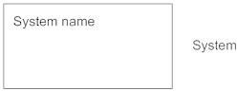

#### Use Case

Draw use cases using ovals. Label the ovals with verbs that represent the system's functions.

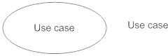

#### Actors

Actors are the users of a system. When one system is the actor of another system, label the actor system with the actor stereotype.

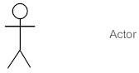

#### Relationships

Illustrate relationships between an actor and a use case with a simple line. For relationships among use cases, use arrows labeled either "uses" or "extends." A "uses" relationship indicates that one

use case is needed by another in order to perform a task. An "extends" relationship indicates alternative options under a certain use case.

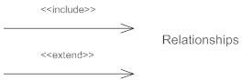

#### How to Create a Use Case Diagram

* **Identifying Actors**

Actors are external entities that interact with your system. It can be a person, another system or an organization. In a banking system, the most obvious actor is the customer. Other actors can be bank employee or cashier depending on the role you’re trying to show in the use case.

#### Identifying Use Cases

A good way to do this is to identify what the actors need from the system. In a banking system, a customer will need to open accounts, deposit and withdraw funds, request check books and similar functions. So, all of these can be considered as use cases. Top level use cases should always provide a complete function required by an actor. You can extend or include use cases depending on the complexity of the system. Once you identify the actors and the top-level use case you have a basic idea of the system. Now you can fine tune it and add extra layers of detail to it.

#### Look for Common Functionality to use Include

Look for common functionality that can be reused across the system. If you find two or more use cases that share common functionality you can extract the common functions and add it to a separate use case. Then you can connect it via the include relationship to show that it’s always called when the original use case is executed.

#### Is it Possible to Generalize Actors and Use Cases?

There may be instances where actors are associated with similar use cases while triggering few use cases unique only to them. In such instances, you can generalize the actor to show the inheritance of functions. You can do a similar thing for use case as well.

#### Optional Functions or Additional Functions

There are some functions that are triggered optionally. In such cases, you can use the extend relationship and attach an extension rule to it. In the below banking system example “Calculate Bonus” is optional and only triggers when a certain condition is matched.

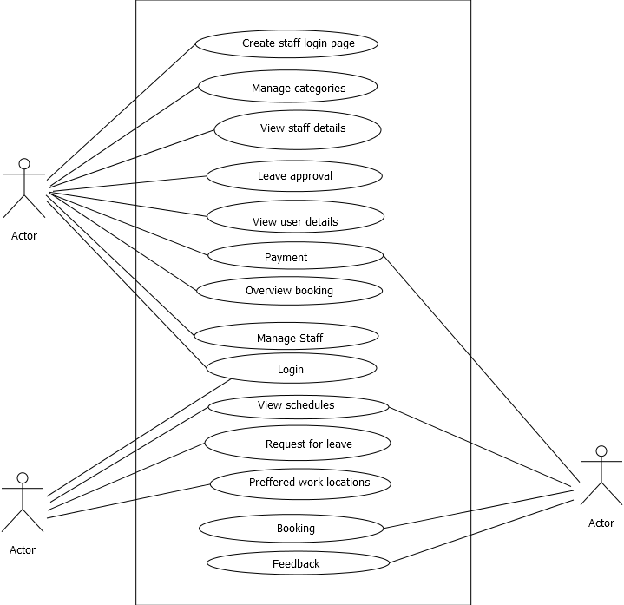

Figure 7.1: Use case diagram for Mansion Care

### P7.4.2 UML Sequence Diagram

A sequence diagram is [an interaction diagram](https://en.wikipedia.org/wiki/Interaction_diagram) that shows how objects operate with one another and in what order. It is a construct of a [message sequence chart.](https://en.wikipedia.org/wiki/Message_sequence_chart) A sequence diagram is a type of interaction diagram because it describes how—and in what order—a group of objects works together. These diagrams are used by software developers and business professionals to understand requirements for a new system or to document an existing process. Sequence diagrams are sometimes known as event diagrams or event scenarios.

A sequence diagram shows object interactions arranged in time sequence. It depicts the objects and classes involved in the scenario and the sequence of messages exchanged between the objects needed to carry out the functionality of the scenario. Sequence diagrams are typically associated with use case realizations in the Logical View of the system under development. Sequence diagrams are sometimes called event diagrams or event scenarios. A sequence

diagram shows, as parallel vertical lines (*lifelines*), different processes or objects that live simultaneously, and, as horizontal arrows, the messages exchanged between them, in the order in which they occur. This allows the specification of simple runtime scenarios in a graphical manner.

Sequence diagrams can be useful references for businesses and other organizations. Sequence diagram helps to:

* Represent the details of a UML use case.
* Model the logic of a sophisticated procedure, function, or operation.
* See how objects and components interact with each other to complete a process.
* Plan and understand the detailed functionality of an existing or future scenario.



Figure 7.2: Sequence diagram for Bea

## P7.5 SYSTEM SPECIFICATION

### P7.5.1 Hardware Specification

Processor - Pentium IV/AMD Dual core

RAM - 1 GB

Hard disk - 500 GB

### P7.5.2 Software Specification

Front End - PHP

Backend - MYSQL

Client on PC - Windows 10

Technologies used - JavaScript, HTML5, AJAX, JQuery, PHP, Laravel, CSS, Bootstrap

## P7.6 SOFTWARE DESCRIPTION

### P7.6.1 PHP

PHP is a server side scripting language designed for web development but also used as a general purpose programming language PHP is now installed on more than 244 million websites and

2.1 million web servers. Originally created by Rasmus Ledorf in 1995, the reference implementation of PHP is now produced by the PHP group. While PHP originally stood for personal Home page ,it now stands for PHP: Hypertext Preprocessor, a recursive acronym.

PHP is a server side scripting language that is embedded in HTML. It is used to manage dynamic content, databases, session tracking, even build entire e-commerce sites. It is integrated with a number of popular databases, including MySQL, PostgreSQL, Oracle, Sybase, Informix, and Microsoft SQL Server. PHP is pleasingly zippy in its execution, especially when compiled as an Apache module on the Unix side. The MySQL server, once started, executes even very complex queries with huge result sets in record-setting time. PHP supports a large number of major protocols such as POP3, IMAP, and LDAP. PHP4 added support for Java and distributed object architectures (COM and CORBA), making n-tier development a possibility for the first time.

PHP code is interpreted by a web server with a PHP processor module which generates the resulting web page. PHP commands can be embedded directly into a HTML source document rather than calling an external file to process data. It has also evolved to include a command- line interface capability and can be used in standalone incompatible with the GNU General Public License (GPL) due to restrictions on the usage of the term PHP.PHP can be deployed on most web servers and also as a standalone shell on almost every operating system and platform, free of charge.

### P7.6.2 MySQL

MySQL, the most popular Open Source SQL database management system, is developed, distributed, and supported by Oracle Corporation.

#### MySQL is a database management system.

A database is a structured collection of data. It may be anything from a simple shopping list to a picture gallery or the vast amounts of information in a corporate network. To add, access, and

process data stored in a computer database, you need a database management system such as MySQL Server. Since computers are very good at handling large amounts of data, database management systems play a central role in computing, as standalone utilities, or as parts of other applications.

#### MySQL databases are relational.

A relational database stores data in separate tables rather than putting all the data in one big storeroom. The database structures are organized into physical files optimized for speed. The logical model, with objects such as databases, tables, views, rows, and columns, offers a flexible programming environment. You set up rules governing the relationships between different data fields, such as one-to-one, one-to-many, unique, required or optional, and “pointers” between different tables. The database enforces these rules, so that with a well-designed database, your application never sees inconsistent, duplicate, orphan, out-of-date, or missing data.

The SQL part of “MySQL” stands for “Structured Query Language”. SQL is the most common standardized language used to access databases. Depending on your programming environment, you might enter SQL directly (for example, to generate reports), embed SQL statements into code written in another language,

or use a language- specific API that hides the SQL syntax. SQL is defined by the ANSI/ISO SQL Standard. The SQL standard has been evolving since 1986 and several versions exist. In this manual, “SQL92” refers to the standard released in 1992, “SQL:1999” refers to the standard released in 1999, and “SQL:2003” refers to the current version of the standard. We use the phrase “the SQL standard” to mean the current version of the SQL Standard at any time.

#### MySQL software is Open Source.

Open Source means that it is possible for anyone to use and modify the software. Anybody can download the MySQL software from the Internet and use it without paying anything. If you wish, you may study the source code and change it to suit your needs. The MySQL software uses the GPL (GNU General Public License), to define what you may and may not do with the software in different situations. The MySQL Database Server is very fast, reliable, scalable, and easy to use.

MySQL Server can run comfortably on a desktop or laptop, alongside your other applications, web servers, and so on, requiring little or no attention. If you dedicate an entire machine to MySQL, you can adjust the settings to take advantage of all the memory, CPU power, and I/O

capacity available. MySQL can also scale up to clusters of machines, networked together.

MySQL Server was originally developed to handle large databases much faster than existing solutions and has been successfully used in highly demanding production environments for several years. Although under constant development, MySQL Server today offers a rich and useful set of functions. Its connectivity, speed, and security make MySQL Server highly suited for accessing databases on the Internet.

#### MySQL Server works in client/server or embedded systems*.*

The MySQL Database Software is a client/server system that consists of a multi-threaded SQL server that supports different back ends, several different client programs and libraries, administrative tools, and a wide range of application programming interfaces (APIs).

We also provide MySQL Server as an embedded multi-threaded library that you can link into your application to get a smaller, faster, easier-to-manage standalone product.

#### A large amount of contributed MySQL software is available.

MySQL Server has a practical set of features developed in close cooperation with our users. It is very likely that your favorite application or language supports the MySQL Database Server.

## P7.7 SYSTEM DESIGN

Design is the first step into the development phase for any engineered product or system. Design is a creative process. A good design is the key to effective system. The term “design” is defined as “the process of applying various techniques and principles for the purpose of defining a process or a system in sufficient detail to permit its physical realization”. It may be defined as a process of applying various techniques and principles for the purpose of defining a device, a process or a system in sufficient detail to permit its physical realization. Software design sits at the technical kernel of the software engineering process and is applied regardless of the development paradigm that is used. The system design develops the architectural detail required to build a system or product. As in the case of any systematic approach, this software too has undergone the best possible design phase fine tuning all efficiency, performance and accuracy levels. The design phase is a transition from a user oriented document to a document to the programmers or database personnel. System design goes through two phases of development: Logical and Physical Design

### P7.7.1 Architectural Design

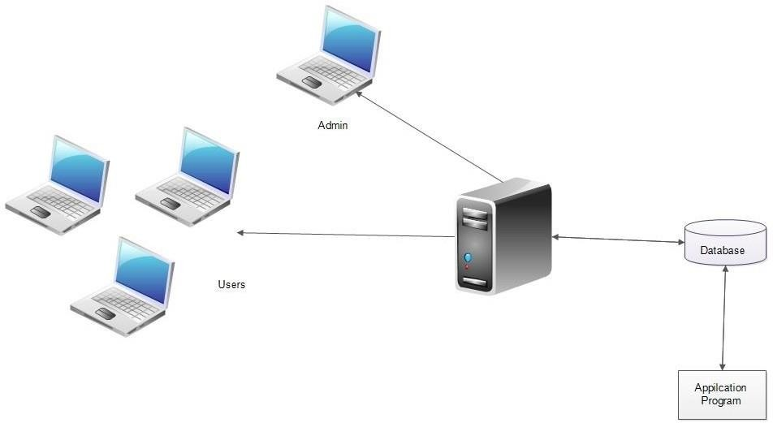

Figure 7.3: Architectural design for system design

The registered user, admin, service provider can accesses Mansion Care through internet using their Laptop, Smart Phone, Tablet or Desktop Computer. The System’s application program processes the user’s request and provides the required services by taking data from the system database.

### P7.7.2 Module Design

**Admin Module**

The administrator of the mansion care is allowed to access all the services in the system. User management, Employee management, Job Requests, Service bookings.

* Manager and controller of the entire system.
* Add employee profiles
* Complete user management
* Adding services for users
* Add coupon for users
* Manage Leave Requests
* Manage service bookings

### Employee Module

In the employee module they can request for leaves from admin and they can view bookings made by the users. Employees can also update the information about themselves through the application.

* Edit their own profiles
* Apply leaves
* View their own bookings
* View services
* Book for a service

### Registered User Module

* In this module the registered customer can book for different home services, and they get a approval mail notification. Sometimes users may be searching for a service and wants to choose a employee as they like. Service recommendation feature is able to suggest them a service that best suit their needs through predictions. Guest User or unregistered users, can view our services.
* Users can go through available services and employees nearby them and pay for them on the go. Our site offers much flexibility while selecting employees. They can search the employees on their locality and also in the same district of the user and find the total costs for the services. Carts helps users to finalize their bookings before payment.
* After the payment users are acknowledged through email notification.
* Edit their own profiles
* View employees and services
* View coupon rating
* View employes reviews and create their own reviews and also give rating

### Guest User Module

* Guest users can view services
* Guest users can view services and their reviews
* View employees

### P7.7.3 UML diagrams

UML is an acronym that stands for Unified Modeling Language. Simply put, UML is a modern approach to modeling and documenting software. In fact, it’s one of the most popular business process modeling techniques.

It is based on diagrammatic representations of software components. By using visual representations, we are able to better understand possible flaws or errors in software or business processes.

UML was created as a result of the chaos revolving around software development and documentation. In the 1990s, there were several different ways to represent and document software systems. The need arose for a more unified way to visually represent those systems and as a result, in 1994-1996, the UML was developed by three software engineers working at Rational Software. It was later adopted as the standard in 1997 and has remained the standard ever since.

Mainly, UML has been used as a general-purpose modeling language in the field of software engineering. However, it has now found its way into the documentation of several business processes or workflows.

There are several types of UML diagrams and each one of them serves a different purpose regardless of whether it is being designed before the implementation or after (as part of documentation).

The two most broad categories that encompass all other types are Behavioral UML diagram and Structural UML diagram. As the name suggests, some UML diagrams try to analyze and depict the structure of a system or process, whereas other describe the behavior of the system, its actors, and its building components. The different types are broken down as follows:

#### Structural Diagrams

The structural diagrams represent the static aspect of the system. These static aspects represent those parts of a diagram, which forms the main structure and are therefore stable. The structural diagrams are −

* Class diagram
* Object diagram
* Component diagram
* Deployment diagram

#### Behavioral Diagrams

Behavioral diagrams basically capture the dynamic aspect of a system. Dynamic aspect can be further described as the changing/moving parts of a system. UML has the following types of behavioral diagrams −

* Use case diagram
* Sequence diagram
* State chart diagram
* Activity diagram

#### Class Diagram

Class diagrams are the most common diagrams used in UML. Class diagram consists of classes, interfaces, associations, and collaboration. Class diagrams basically represent the object- oriented view of a system, which is static in nature.

Class diagram represents the object orientation of a system. Hence, it is generally used for development purpose. This is the most widely used diagram at the time of system construction.

##### Benefits of class diagrams

* Illustrate data models for information systems, no matter how simple or complex.
* Better understand the general overview of the schematics of an application.
* Visually express any specific needs of a system and disseminate that information throughout the business.
* Create detailed charts that highlight any specific code needed to be programmed and implemented to the described structure.
* Provide an implementation-independent description of types used in a system that are later passed between its components.

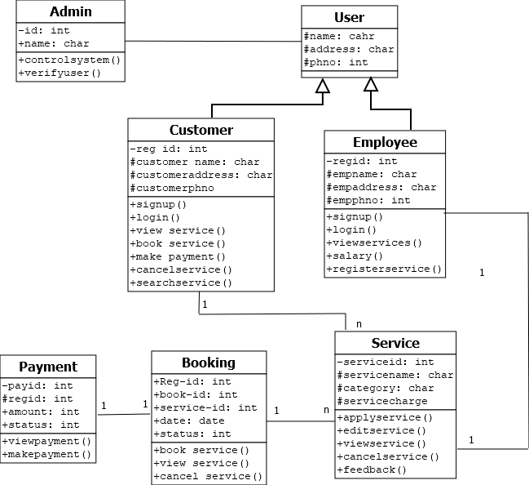

Figure 7.4: Class Diagram for Mansion Care management

#### Object Diagram

Object diagrams can be described as an instance of class diagram. Thus, these diagrams are more close to real-life scenarios where we implement a system. Object diagrams are a set of objects and their relationship is just like class diagrams. They also represent the static view of the system.

The usage of object diagrams is similar to class diagrams but they are used to build prototype of a system from a practical perspective.

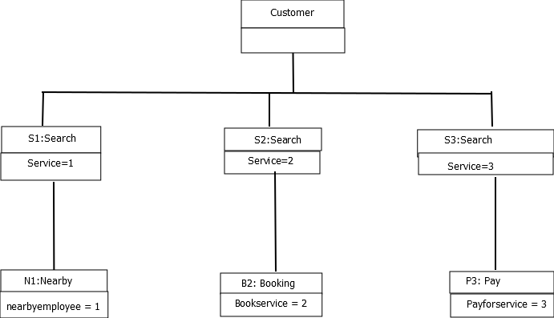

Figure 7.5: Object diagram for Mansion Care management

#### Deployment diagram

Deployment diagrams are used to visualize the topology of the physical components of a system, where the software components are deployed. Deployment diagrams are used to describe the static deployment view of a system. Deployment diagrams consist of nodes and their relationships.

The term Deployment itself describes the purpose of the diagram. Deployment diagrams are used for describing the hardware components, where software components are deployed. Component diagrams and deployment diagrams are closely related.

Component diagrams are used to describe the components and deployment diagrams shows how they are deployed in hardware. UML is mainly designed to focus on the software artifacts of a system. However, these two diagrams are special diagrams used to focus on software and hardware components.

Most of the UML diagrams are used to handle logical components but deployment diagrams are made to focus on the hardware topology of a system. Deployment diagrams are used by the system engineers.

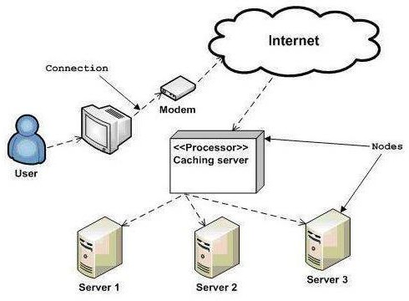

Figure 7.6:Deployment diagram

#### State chart Diagram

Any real-time system is expected to be reacted by some kind of internal/external events. These events are responsible for state change of the system.Statechart diagram is used to represent the event driven state change of a system. State chart diagram is used to visualize the reaction of a system by internal/external factors.

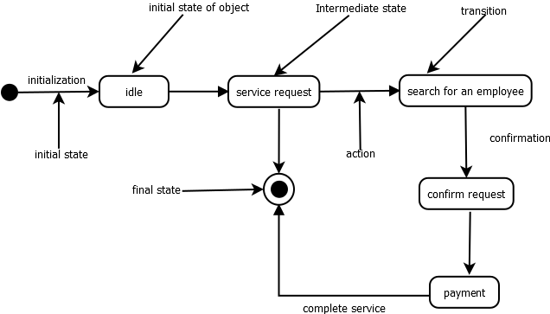

Figure 7.7: State chart diagram for Mansion Care home services

#### Collaboration diagram

A collaboration diagram, also called a communication diagram or interaction diagram, is an illustration of the relationships and interactions among [software](https://searchmicroservices.techtarget.com/definition/software) [object](https://searchmicroservices.techtarget.com/definition/object)s in the Unified Modeling Language (UML). The concept is more than a decade old although it has been refined as modeling paradigms have evolved.

A collaboration diagram resembles a [flowchart](https://whatis.techtarget.com/definition/flowchart) that portrays the roles, functionality and behavior of individual objects as well as the overall operation of the system in [real time](https://whatis.techtarget.com/definition/real-time). Objects are shown as rectangles with naming labels inside. These labels are preceded by colons and may be underlined. The relationships between the objects are shown as lines connecting the rectangles. The [message](https://whatis.techtarget.com/definition/message)s between objects are shown as arrows connecting the relevant rectangles along with labels that define the message sequencing.

Collaboration diagrams are best suited to the portrayal of simple interactions among relatively small numbers of objects. As the number of objects and messages grows, a collaboration diagram can become difficult to read. Several vendors offer software for creating and editing collaboration diagrams.

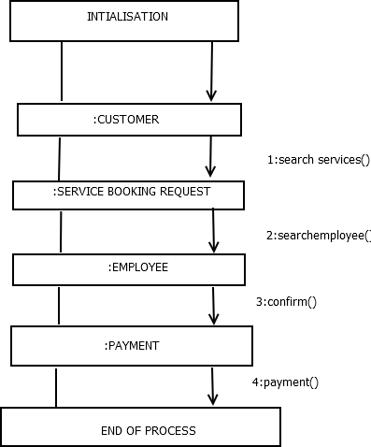

Figure 7.8: Collaboration diagram for Mansion Care management

#### Activity diagram

Activity diagram describes the flow of control in a system. It consists of activities and links. The flow can be sequential, concurrent, or branched. Activities are nothing but the functions of a system. Numbers of activity diagrams are prepared to capture the entire flow in a system. Activity diagrams are used to visualize the flow of controls in a system. This is prepared to have an idea of how the system will work when executed.

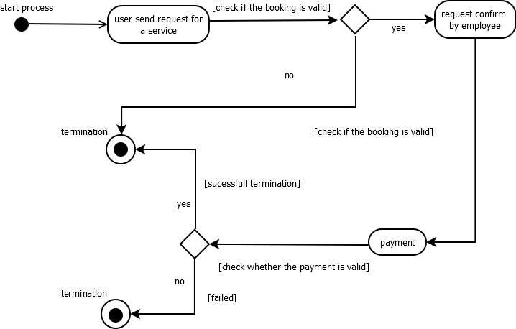

Figure 7.9: Activity diagram for Mansion Care management

### P7.7.4 Database Design

A database is an organized mechanism that has the capability of storing information through which a user can retrieve stored information in an effective and efficient manner. The data is the purpose of any database and must be protected. The database design is a two level process. In the first step, user requirements are gathered together and a database is designed which will meet these requirements as clearly as possible. This step is called Information Level Design and it is taken independent of any individual DBMS.

In the second step, this Information level design is transferred into a design for the specific

DBMS that will be used to implement the system in question. This step is called Physical Level Design, concerned with the characteristics of the specific DBMS that will be used. A database design runs parallel with the system design. The organization of the data in the database is aimed to achieve the following two major objectives.

#### Data Integrity:

Data integrity refers to the accuracy, consistency, and reliability of data that is stored in the database. Both database designers and database developers are responsible for implementing data integrity within one or a set of related databases.

* Domain integrity rules
* Entity integrity rules
* Referential integrity rules

#### Data independence:

Data independence is the type of data transparency that matters for a centralized DBMS. It refers to the immunity of user applications to changes made in the definition and organization of data. Application programs should not, ideally, be exposed to details of data representation and storage. The DBMS provides an abstract view of the data that hides such details.

* Physical data independence
* Logical data independence

#### Relational Database Management System (RDBMS)

A relational model represents the database as a collection of relations. Each relation resembles a table of values or file of records. In formal relational model terminology, a row is called a tuple, a column header is called an attribute and the table is called a relation. A relational database consists of a collection of tables, each of which is assigned a unique name. A row in a tale represents a set of related values.

#### Relations, Domains & Attributes

A table is a relation. The rows in a table are called tuples. A tuple is an ordered set of n elements. Columns are referred to as attributes. Relationships have been set between every table in the database. This ensures both Referential and Entity Relationship Integrity. A domain D is a set of atomic values. A common method of specifying a domain is to specify a data type from

which the data values forming the domain are drawn. It is also useful to specify a name for the domain to help in interpreting its values. Every value in a relation is atomic, that is not decomposable.

#### Relationships

* Table relationships are established using Key. The two main keys of prime importance are Primary Key & Foreign Key. Entity Integrity and Referential Integrity Relationships can be established with these keys.
* Entity Integrity enforces that no Primary Key can have null values.
* Referential Integrity enforces that no Primary Key can have null values.
* Referential Integrity for each distinct Foreign Key value, there must exist a matching Primary Key value in the same domain. Other key are Super Key and Candidate Keys.

#### Normalization

Data are grouped together in the simplest way so that later changes can be made with minimum impact on data structures. Normalization is formal process of data structures in manners that eliminates redundancy and promotes integrity. Normalization is a technique of separating redundant fields and breaking up a large table into a smaller one. It is also used to avoid insertion, deletion, and updating anomalies. Normal form in data modelling use two concepts, keys and relationships. A key uniquely identifies a row in a table. There are two types of keys, primary key and foreign key. A primary key is an element or a combination of elements in a table whose purpose is to identify records from the same table. A foreign key is a column in a table that uniquely identifies record from a different table. All the tables have been normalized up to the third normal form.

As the name implies, it denotes putting things in the normal form. The application developer via normalization tries to achieve a sensible organization of data into proper tables and where names can be easily correlated to the data by the user. Normalization eliminates repeating groups and thereby avoids data redundancy which proves to be a great burden on the computer resources. These include:

* Normalize the data.
* Choose proper names for the tables and columns.
* Choose the proper name for the data.

#### First Normal Form

The First Normal Form states that the domain of an attribute must include only atomic values and that the value of any attribute in a tuple must be a single value from the domain of that attribute. In other words 1NF disallows “relations within relations” or “relations as attribute values within tuples”. The only attribute values permitted by 1NF are single atomic or indivisible values. The first step is to put the data into First Normal Form. This can be donor by moving data into separate tables where the data is of similar type in each table. Each table is given a Primary Key or Foreign Key as per requirement of the project. In this we form new relations for each non-atomic attribute or nested relation. This eliminated repeating groups of data. A relation is said to be in first normal form if only if it satisfies the constraints that contain the primary key only.

#### Second Normal Form

According to Second Normal Form, for relations where primary key contains multiple attributes, no non-key attribute should be functionally dependent on a part of the primary key. In this we decompose and setup a new relation for each partial key with its dependent attributes. Make sure to keep a relation with the original primary key and any attributes that are fully functionally dependent on it. This step helps in taking out data that is only dependent on a part of the key. A relation is said to be in second normal form if and only if it satisfies all the first normal form conditions for the primary key and every non-primary key attributes of the relation is fully dependent on its primary key alone.

#### Third Normal Form

According to Third Normal Form, Relation should not have a non-key attribute functionally determined by another non-key attribute or by a set of non-key attributes. That is, there should be no transitive dependency on the primary key. In this we decompose and set up relation that includes the non-key attributes that functionally determines other non-key attributes. This step is taken to get rid of anything that does not depend entirely on the Primary Key. A relation is said to be in third normal form if only if it is in second normal form and more over the non key attributes of the relation should not be depend on other non-key attribute.

### TABLES

**Table No. : 1**

**Table name : tb_login**

**Primary Key: Log-id Foreign Key: roleid**

|  |  |  |  |
| --- | --- | --- | --- |
| **Field** | **Data type** | **Size** | **Description** |
| Username | varchar | 20 | Email |
| Password | varchar | 50 | Password |
| Log_id | int | 11 | User login id primary key |
| roleid | int | 11 | login role (admin, customer,employee) |
| Status | int | 2 | Valid/invalid |

**Table No. : 2**

**Table name : tb_ category**

**Primary Key : cat_id**

|  |  |  |  |
| --- | --- | --- | --- |
| **Field** | **Data type** | **Size** | **Description** |
| cat_id | int | 11 | Primary key |
| cat_name | varchar | 30 | Category Name |
| description | varchar | 100 | Description |
| Status | int | 11 | Valid/invalid |

**Table No. : 3**

**Table name : tb_regsuser**

**Primary Key : Log_id Foreign Key: Pid,**

|  |  |  |  |
| --- | --- | --- | --- |
| **Field** | **Data type** | **Size** | **Description** |
| Log_id | int | 11 | Primary key |
| First_name | varchar | 20 | First Name |
| last_name | varchar | 20 | Last Name |
| hname | varchar | 30 |  |
| Pid | int | 11 | Foreign key |
| Mobile | int | 50 | Mobile Number |
| Pin | int | 20 | Foreign key |
| Gender | varchar | 30 | Gender |
| DOB | date |  | Date of birth |
| Photo | varchar | 30 | Photo |
| Category | varchar | 30 | Category |
| Aadhar | varchar | 30 | Aadhar |
| Aadhar_pic | varchar | 30 | Aadhar Picture |
| Status | int | 2 | Status of the Employe |

**Table No. : 4**

**Table name : tb_ role**

**Primary Key : roleid**

|  |  |  |  |
| --- | --- | --- | --- |
| **Field** | **Data type** | **Size** | **Description** |
| roleid | int | 11 | Primary key |
| role | varchar | 30 | Role Name |

**Table No. : 5**

**Table name : tb_payment**

**Primary Key : pay_id**

**Foreign Key : bid, Log_id**

|  |  |  |  |
| --- | --- | --- | --- |
| **Field** | **Data type** | **Size** | **Description** |
| pay_id | int | 11 | Primary key |
| Log_id | int | 11 | Foreign key (Registration of user) |
| Bid | int | 11 | Foreign key(tb_bookings) |
| Amount | int | 11 | Payment amount |
| cu_date | date |  | Booked date |
| Status | int | 2 | Status of payment |

**Table No. : 6**

**Table name : tbl_service**

**Primary Key: service-id**

**Foreign Key: cat_id**

|  |  |  |  |
| --- | --- | --- | --- |
| **Field** | **Data type** | **Size** | **Description** |
| service_id | int | 11 | Primary key |
| cat_id | int | 11 | Foreign Key  (Category) |
| service_name | varchar | 20 | Service Name |
| Service_charge | int | 11 | Charge of the service per day |
| Image | varchar | 30 | Photo |

**Table No. : 7**

**Table name : tb_bookings**

**Primary Key : bid Foreign Key: Log_id**

|  |  |  |  |
| --- | --- | --- | --- |
| **Field** | **Data type** | **Size** | **Description** |
| Bid | int | 11 | Primary key |
| Log-id | int | 11 | Foreign key |
| Fdate | date | 2 | Starting date |
| Todate | date | 11 | End date |
| Eid | int | 11 | Employee Id |
| cu_date | date |  | Date of booking |
| Status | int | 2 | Status of booking |

**Table No. : 8**

**Table name : tbl_coupon**

**Primary Key : coid**

|  |  |  |  |
| --- | --- | --- | --- |
| **Field** | **Data type** | **Size** | **Description** |
| Coid | int | 11 | Primary key |
| card_num | int | 11 | Charge |
| Amount | int | 11 | Amount For the coupon |
| Expi | int | 11 | Time of expiry |
| Status | int | 11 | Valid/invalid |

**Table No. : 9**

**Table name : tb_place**

**Primary Key : Pid**

**Foreign Key: Did**

|  |  |  |  |
| --- | --- | --- | --- |
| **Field** | **Data type** | **Size** | **Description** |
| Pid | int | 11 | Primary key |
| Did | int | 11 | Foreign Key |
| Place | varchar | 30 | Place |

**Table No. : 10**

**Table name : tb_district**

**Primary Key : Did**

|  |  |  |  |
| --- | --- | --- | --- |
| **Field** | **Data type** | **Size** | **Description** |
| Did | int | 11 | Primary Key |
| District | varchar | 30 | District |

**Table No. : 11**

**Table name : tb_paymentdetails**

**Primary Key: rid Foreign Key: service_id, bid**

|  |  |  |  |
| --- | --- | --- | --- |
| **Field** | **Data type** | **Size** | **Description** |
| Rid | int | 11 | Primary key |
| Bid | int | 11 | Foreign Key  (Booking) |
| service_id | int | 11 | Foreign Key  (Service) |
| Amount | int | 11 | Amount for the service |
| Date | date | 30 | Date of payment |

**Table No. : 12**

**Table name : tbl_bookingdetails**

**Primary Key: boid**

**Foreign Key: bid**

|  |  |  |  |
| --- | --- | --- | --- |
| **Field** | **Data type** | **Size** | **Description** |
| Boid | int | 11 | Primary key |
| Bid | int | 11 | Foreign Key  (Booking) |
| Total | int | 11 | Total charge of the service |
| Date | date | 30 | Date of payment |

**Table No. : 13**

**Table name : tbl_ empserve**

**Primary Key : Log_id Foreign Key: cat_id**

|  |  |  |  |
| --- | --- | --- | --- |
| **Field** | **Data type** | **Size** | **Description** |
| Log_id | int | 11 | Primary key |
| cat_id | varchar | 30 | Offer type |

**Table No. : 14**

**Table name : tb_leave**

**Primary Key : lid Foreign Key: Log_id**

|  |  |  |  |
| --- | --- | --- | --- |
| **Field** | **Data type** | **Size** | **Description** |
| lid | int | 11 | Primary key |
| ldate | date |  | Apply Date |
| log_id | int | 11 | Foreign Key(registration) |
| reason | varchar | 100 | Reason for leave |
| status | int | 11 | Valid/invalid |

**Table No. : 15**

**Table name : tb_ rating**

**Primary Key : rid Foreign Key: Log_id**

|  |  |  |  |
| --- | --- | --- | --- |
| **Field** | **Data type** | **Size** | **Description** |
| rid | int | 11 | Primary key |
| Log_id | int | 11 | Foreign key(registration) |
| eid | int | 11 | Employee Id |
| msg | varchar | 500 | Message |
| rate | int | 11 | Rating |

**Table No. : 16**

**Table name : tb_ bank**

**Primary Key :** acc_num

|  |  |  |  |
| --- | --- | --- | --- |
| **Field** | **Data type** | **Size** | **Description** |
| acc_num | int | 11 | Primary key |
| cvv | int | 11 | Foreign key(registration) |
| h_name | varchar | 50 | Employee Id |
| balance | varchar | 30 | Meassage |

**Table No. : 17**

**Table name : wallet**

**Primary Key : w_id Foreign Key: Log_id**

|  |  |  |  |
| --- | --- | --- | --- |
| **Field** | **Data type** | **Size** | **Description** |
| w_id | int | 11 | Primary key |
| Log_id | int | 11 | Foreign key(registration) |
| w_acc_no | varchar | 50 | Account number |
| Cvv | varchar | 30 | CVV |
| bank_name | varchar | 30 | Bank name |
| balance | int | 60 | A/c balance |
| w_passwd | varchar | 30 | password |
| Status | int | 11 | Valid/invalid |

**Table No. : 18**

**Table name : otp**

**Primary Key : oid**

|  |  |  |  |
| --- | --- | --- | --- |
| **Field** | **Data type** | **Size** | **Description** |
| oid | int | 11 | Primary key |
| Username | varchar | 50 | Foreign key(Login) |
| otp | varchar | 20 | OTP Number |
| count | int | 11 | Count |
| status | int | 11 | Valid/invalid |

## P7.8 SYSTEM TESTING

### P7.8.1 Introduction

Software Testing is the process of executing software in a controlled manner, in order to answer the question - Does the software behave as specified? Software testing is often used in association with the terms verification and validation. Validation is the checking or testing of items, includes software, for conformance and consistency with an associated specification. Software testing is just one kind of verification, which also uses techniques such as reviews, analysis, inspections, and walkthroughs. Validation is the process of checking that what has been specified is what the user actually wanted.

Validation **:** Are we doing the right job? Verification **:** Are we doing the job right?

Software testing should not be confused with debugging. Debugging is the process of analyzing and localizing bugs when software does not behave as expected. Although the identification of some bugs will be obvious from playing with the software, a methodical approach to software testing is a much more thorough means for identifying bugs. Debugging is therefore an activity which supports testing, but cannot replace testing.

Other activities which are often associated with software testing are static analysis and dynamic analysis. Static analysis investigates the source code of software, looking for problems and gathering metrics without actually executing the code. Dynamic analysis looks at the behavior of software while it is executing, to provide information such as execution traces, timing profiles, and test coverage information.

Testing is a set of activity that can be planned in advanced and conducted systematically. Testing begins at the module level and work towards the integration of entire computers based system. Nothing is complete without testing, as it vital success of the system testing objectives, there are several rules that can serve as testing objectives. They are:

Testing is a process of executing a program with the intent of finding an error.

* A good test case is one that has high possibility of finding an undiscovered error.
* A successful test is one that uncovers an undiscovered error.

If a testing is conducted successfully according to the objectives as stated above, it would uncover errors in the software. Also testing demonstrate that the software function appear to be working according to the specification, that performance requirement appear to have been met.

There are three ways to test program.

* For correctness
* For implementation efficiency
* For computational complexity

Test for correctness are supposed to verify that a program does exactly what it was designed to do. This is much more difficult than it may at first appear, especially for large programs.

### P7.8.2 Test Plan

A test plan implies a series of desired course of action to be followed in accomplishing various testing methods. The Test Plan acts as a blue print for the action that is to be followed. The software engineers create a computer program, its documentation and related data structures. The software developers is always responsible for testing the individual units of the programs, ensuring that each performs the function for which it was designed. There is an independent test group (ITG) which is to remove the inherent problems associated with letting the builder to test the thing that has been built. The specific objectives of testing should be stated in measurable terms. So that the mean time to failure, the cost to find and fix the defects, remaining defect density or frequency of occurrence and test work-hours per regression test all should be stated within the test plan.

* Unit testing
* Integration Testing
* Data validation Testing
* Output Testing

### P7.8.2.1 Unit Testing

Unit testing focuses verification effort on the smallest unit of software design – the software component or module. Using the component level design description as a guide, important control paths are tested to uncover errors within the boundary of the module.

The relative complexity of tests and uncovered scope established for unit testing. The unit testing is white-box oriented, and step can be conducted in parallel for multiple components. The modular interface is tested to ensure that information properly flows into and out of the program unit under test. The local data structure is examined to ensure that data stored temporarily maintains its integrity during all steps in an algorithm’s execution. Boundary conditions are tested to ensure that all statements in a module have been executed at least once.

Finally, all error handling paths are tested.

Tests of data flow across a module interface are required before any other test is initiated. If data do not enter and exit properly, all other tests are moot. Selective testing of execution paths is an essential task during the unit test. Good design dictates that error conditions be anticipated and error handling paths set up to reroute or cleanly terminate processing when an error does occur. Boundary testing is the last task of unit testing step. Software often fails at its boundaries.

Unit testing was done by treating each module as separate entity and testing each one of them with a wide spectrum of test inputs. Some flaws in the internal logic of the modules were found and were rectified. After coding each module is tested and run individually. All unnecessary code where removed and ensured that all modules are working, and gives the expected result.

### P7.8.2.2 Integration Testing

Integration testing is systematic technique for constructing the program structure while at the same time conducting tests to uncover errors associated with interfacing. The objective is to take unit tested components and build a program structure that has been dictated by design. The entire program is tested as whole. Correction is difficult because isolation of causes is complicated by vast expanse of entire program. Once these errors are corrected, new ones appear and the process continues in a seemingly endless loop After performing unit testing in the System all the modules were integrated to test for any inconsistencies in the interfaces. Moreover differences in program structures were removed and a unique program structure was evolved.

### P7.8.2.3 Validation Testing

This is the final step in testing. In this the entire system was tested as a whole with all forms, code, modules and class modules. This form of testing is popularly known as Black Box testing or System tests.

Black Box testing method focuses on the functional requirements of the software. That is, Black Box testing enables the software engineer to derive sets of input conditions that will fully exercise all functional requirements for a program.

Black Box testing attempts to find errors in the following categories; incorrect or missing functions, interface errors, errors in data structures or external data access, performance errors and initialization errors and termination errors.

### P7.8.2.4 User Acceptance Testing

The system considered is tested for user acceptance; here it should satisfy the firm’s need. The software should keep in touch with perspective system; user at the time of developing and making changes whenever required. This done with respect to the following points:

* Input Screen Designs,
* Output Screen Designs,

The above testing is done taking various kinds of test data. Preparation of test data plays a vital role in the system testing. After preparing the test data, the system under study is tested using that test data. While testing the system by which test data errors are again uncovered and corrected by using above testing steps and corrections are also noted for future use.

## P7.9 IMPLEMENTATION

Implementation is the stage of the project where the theoretical design is turned into a working system. It can be considered to be the most crucial stage in achieving a successful new system gaining the users confidence that the new system will work and will be effective and accurate. It is primarily concerned with user training and documentation. Conversion usually takes place about the same time the user is being trained or later. Implementation simply means convening a new system design into operation, which is the process of converting a new revised system design into an operational one.

At this stage the main work load, the greatest upheaval and the major impact on the existing system shifts to the user department. If the implementation is not carefully planned or controlled, it can create chaos and confusion.

Implementation includes all those activities that take place to convert from the existing system to the new system. The new system may be a totally new, replacing an existing manual or automated system or it may be a modification to an existing system. Proper implementation is essential to provide a reliable system to meet organization requirements. The process of putting the developed system in actual use is called system implementation. This includes all those activities that take place to convert from the old system to the new system. The system can be implemented only after through testing is done and if it is found to be working according to the specifications. The system personnel check the feasibility of the system. The more complex the system being implemented, the more involved will be the system analysis and design effort required to implement the three main aspects: education and training, system testing and changeover.

The implementation state involves the following tasks:

* Careful planning.
* Investigation of system and constraints.
* Design of methods to achieve the changeover. Training of the staff in the changeover phase

### P7.9.1 Implementation Procedure

Implementation of software refers to the final installation of the package in its real environment, to the satisfaction of the intended uses and the operation of the system. In many organizations someone who will not be operating it, will commission the software development project. In the initial stage people doubt about the software but we have to ensure that the resistance does not build up, as one has to make sure that:

* The active user must be aware of the benefits of using the new system. Their confidence in the software is built up.
* Proper guidance is imparted to the user so that he is comfortable in using the application. Before going ahead and viewing the system, the user must know that for viewing the result, the server program should be running in the server. If the server object is not up running on the server, the actual process won’t take place

### P7.9.2 User Training

User training is designed to prepare the user for testing and converting the system. To achieve the objective and benefits expected from computer based system, it is essential for the people who will be involved to be confident of their role in the new system. As system becomes more complex, the need for training is more important. By user training the user comes to know how to enter data, respond to error messages, interrogate the database and call up routine that will produce reports and perform other necessary functions.

### P7.9.3 Operational Document

After providing the necessary basic training on computer awareness the user will have to be trained on the new application software. This will give the underlying philosophy of the use of the new system such as the screen flow, screen design type of help on the screen, type of errors while entering the data, the corresponding validation check at each entry and the ways to correct the date entered. It should then cover information needed by the specific user/ group to use the system or part of the system while imparting the training of the program on the application. This training may be different across different user groups and across different levels of hierarchy.

### P7.9.4 System Maintenance

Maintenance is the enigma of system development. The maintenance phase of the software cycle is the time in which a software product performs useful work. After a system is successfully implemented, it should be maintained in a proper manner. System maintenance is an important aspect in the software development life cycle. The need for system maintenance is for it to make adaptable to the changes in the system environment. Software maintenance is of course, far more than "Finding Mistakes".

## P7.10 CONCLUSION &FUTURE ENHANCEMENTS

### P7.10.1 Future Enhancement

The users will get Packages and product suggestion, and also give offers based on the purchase history. Application will provide more security on data and identity. In the future there will be chat option for communication between employees and the registered users. Application will also introduce employee salary management.

### P7.10.2 Conclusion

The software reduces the time consumption and the manual efforts of searching a home service It will be a simple platform for users to access home services for their huge needs.

The benefits, we can obtain from the new system are:

Timely and accurate information will be available for the users, the access time and process time is highly reduced. Users can find a service based on their needs. After that users can choose to get an appointment on their preferred services. Sometimes users may be searching for a service for a specific problem and they may find it difficult to choose a specific one. Service recommendation feature is able to suggest them a service that best suit their needs. Users can reschedule their appointments if the employee will takes leave on user’s appointment dates. Users can go through available services and choose an employee for the service as you want and pay for them on the go. Employees can approve and cancel services which booked for them. The registered users can make reviews and rating for the employees. The website also handle the employee leave management.

The proposed system is expected to replace manual system and provide more efficient performance and services.

## P7.11 BIBLIOGRAPHY

#### Books/References:

* Gary B. Shelly, Harry J. Rosenblatt, “*System Analysis and Design*”, 2009.
* Roger S Pressman, “*Software Engineering*”, 1994.
* Pankaj Jalote, “So*ftware engineering*: a precise approach”, 2006.

#### Websites:

* <https://www.w3schools.com/css/default.asp>
* <https://www.w3schools.com/js/default.asp>
* <https://www.w3schools.com/jquery/jquery_ref_overview.asp>
* <https://www.w3schools.com/jquery/jquery_ref_ajax.asp>
* [www.jquery.com](http://www.jquery.com/)
* [www.agilemodeling.com/artifacts/useCaseDiagram.html](http://www.agilemodeling.com/artifacts/useCaseDiagram.html)
* <https://laravel.com/docs/5.8/>
* <https://getbootstrap.com/docs/4.3/getting-started/introduction/>

## P7.12 APPENDIX

### P7.12.1 Sample Code

##### Connection code

<?php

$con = mysqli_connect("localhost","root","","mansion");

?>

##### User Search Service

<?php

session_start();

// if (!isset($_SESSION["Log_id"])) {

// header('location:../../index.php');

// }

?>

<!DOCTYPE html>

<html>

<head>

<meta name="viewport" content="width=device-width, initial-scale=1">

<style>

body {

margin: 0px;

font-family: Arial, Helvetica, sans-serif;

}

.topnav {

margin: -10px -50px 0px -10px;

overflow: hidden;

background-color: #333;

}

.topnav a {

float: left;

color: #f2f2f2;

text-align: center;

padding: 14px 16px;

text-decoration: none;

font-size: 20px;

}

.topnav a:hover {

background-color: #ddd;

color: black;

}

.topnav a.active {

background-color:green;

color: white;

}

.right {

background-color: #4AF50;

color: white;

padding-left:1190px

}

</style>

</head>

<body>

<div class="topnav">

<a class="active" href="../user/user_home.php">Home</a>

</div>

</body>

</html>

<?php

include '../user/connect.php';

$idus = $_SESSION["Log_id"];

$sid = $_POST['wp'];

$fdate = $_POST['fdate'];

$tdate = $_POST['tdate'];

$schid = $_POST['tod'];

$gen = $_POST['toe'];

//find category id based on service selected

$sqlFindCategory = "SELECT * FROM `tb_service` WHERE `service_id` = '$sid'";

$category = mysqli_query($con, $sqlFindCategory);

$categoryIds = mysqli_fetch_array($category);

//category id

$categoryId = $categoryIds['cat_id'];

//get current user place id

$sqlFindEmployees = "SELECT * FROM tb_regsuser WHERE tb_regsuser.Log_id='$idus'";

$employees = mysqli_query($con, $sqlFindEmployees);

$empList = mysqli_fetch_array($employees);

// print_r($empList);

//place id

$pid = $empList['Pid'];

$ry = "select * from `tb_place` JOIN tb_district ON tb_place.Did = tb_district.Did where Pid='$pid'";

$ryx = mysqli_query($con, $ry);

$ryf = mysqli_fetch_array($ryx);

//district name and district id

$dist_id = $ryf['Did'];

$dist = $ryf['District'];

//queries based on full day or half day

if ($schid = "1") {

$sql11 = "select DISTINCT(eid) from tb_bookings where fdate between '".$fdate."' and '".$tdate."' or todate between '".$fdate."' and '".$tdate."' and schid='1' or fdate between '".$fdate."' and '".$tdate."' or todate between '".$fdate."' and '".$tdate."' and schid='2' or fdate between '".$fdate."' and '".$tdate."' or todate between '".$fdate."' and '".$tdate."' and schid='3' ";

} elseif ($schid = "2") {

$sql11 = "select DISTINCT(eid) from tb_bookings where fdate between '".$fdate."' and '".$tdate."' or todate between '".$fdate."' and '".$tdate."' and schid='1' or fdate between '".$fdate."' and '".$tdate."' or todate between '".$fdate."' and '".$tdate."' and schid='2' ";

} elseif ($schid = "3") {

$sql11 = "select DISTINCT(eid) from tb_bookings where fdate between '".$fdate."' and '".$tdate."' or todate between '".$fdate."' and '".$tdate."' and schid='1' or fdate between '".$fdate."' and '".$tdate."' or todate between '".$fdate."' and '".$tdate."' and schid='3' ";

}

//return;

//booked employee ids on that day

$ryxq = mysqli_query($con, $sql11);

$bookedEmps = mysqli_fetch_all($ryxq);

///employees on leave

$qeu="select Log_id from tb_leave where ldate between '".$fdate."' and '".$tdate."'";

$eque=mysqli_query($con,$qeu);

$empOnLeave = mysqli_fetch_all($eque);

//all employees under the cartegory and same place

$empko = "select * from tb_regsuser as r join tb_empserv as e on r.Log_id=e.Log_id left join tb_place on r.Pid = tb_place.Pid left join tb_category on tb_category.cat_id = e.cat_id where r.Gender='$gen' and e.cat_id='$categoryId' and r.Log_id!='$idus' and r.Pid = '$pid'";

$exemko = mysqli_query($con, $empko);

// $allEmployees = mysqli_fetch_all($exemko);

// print_r($allEmployees);

$searchResult = [];

while ($row = mysqli_fetch_assoc($exemko)) {

$lid = $row['Log_id'];

// print_r($row);

$flag = false;

foreach ($bookedEmps as $d) {

if ($d[0] == $row['Log_id']) {

$flag = true;

}

}

foreach ($empOnLeave as $l) {

if ($l[0] == $row['Log_id']) {

$flag = true;

}

}

if (!$flag) {

$searchResult[] = $row;

}

}

//all employees under the cartegory same district

$empko = "select * from tb_regsuser as r join tb_empserv as e on r.Log_id=e.Log_id left join tb_place on r.Pid = tb_place.Pid left join tb_category on tb_category.cat_id = e.cat_id where r.Gender='$gen' and e.cat_id='$categoryId' and r.Log_id!='$idus' and tb_place.Did = '$dist_id' and tb_place.Pid!='$pid'";

$exemko = mysqli_query($con, $empko);

$searchResult2 = [];

while ($row = mysqli_fetch_assoc($exemko)) {

$lid = $row['Log_id'];

// print_r($row);

$flag = false;

foreach ($bookedEmps as $d) {

if ($d[0] == $row['Log_id']) {

$flag = true;

}

}

if (!$flag) {

$searchResult2[] = $row;

}

}

//

?>

<head>

<meta charset="UTF-8">

<meta name="viewport" content="width=device-width, initial-scale=1.0">

<meta http-equiv="X-UA-Compatible" content="ie=edge">

<title>Employee Search</title>

<link href="../../web1/css/bootstrap.css" rel="stylesheet" type="text/css" media="all" />

<style>

h3::after {

content: '';

position: absolute;

width: 10px;

height: 55px;

background: #ff1d12;

/* bottom: 0; */

left: 180px;

}

.card {

height: 370px;

}

.card img {

height: 120px;

width: auto;

}

.chrg{

background-color: pink;

}

td{

text-align: center;

}

</style>

</head>

<body>

<!-- <div class="topnav">

<a class="active" href="../user/user_home.php">Home</a></div> -->

<!-- <a href="viewempo.php">Back</a> -->

<!-- <a href="empaprov.php">Approvals</a>

<a href="viewuser.php">Users</a></div> -->

<div class="container">

<!-- <h5><a href="../user/user_home.php">Back to home</a></h5> -->

<h3 class="py-5">Find an Employee in your Locality</h3>

<div class="row">

<?php

if (sizeof($searchResult) <= 0) {

echo '<div class="col">

<div class="alert alert-danger">

No Employees Here

</div>

</div>';

}

//start foreach

foreach ($searchResult as $employee) {

?>

<div class="col-md-3">

<div class="card">

<div class="card-body text-center">

<?php echo '<img src="../../' . $employee['Photo'] . '" height="10%" width="20%">'; ?>

<br />

<?php echo $employee['first_name'] ?>

<?php echo $employee['last_name'] ?>

<br />

<?php echo $employee['Place'] ?>

<br />

<?php echo $dist ?>

<br /><?php echo $employee['Mobile'] ?>

<br /><?php echo $employee['cat_name'] ?>

<!-- </br><?php echo $tamts ?> -->

<form action="userbooks.php" method="get">

<input type="hidden" name="empid" value="<?php echo $employee['Log_id'] ?>">

<input type="hidden" name="fdate" value="<?php echo $fdate ?>">

<input type="hidden" name="tdate" value="<?php echo $tdate ?>">

<input type="hidden" name="tod" value="<?php echo $schid ?>">

<input type="hidden" name="sid" value="<?php echo $sid ?>">

<input type="hidden" name="en" value="<?php echo $en ?>">

<input type="submit" id="submit" name="submit" value="Book Now" class="btn btn-primary">

</form>

</div>

</div>

</div>

<!-- //end foreach -->

<?php

}

?>

</div>

<h3 class="py-5"><?php echo $dist; ?> Region Employess....</h3>

<div class="row">

<?php

if (sizeof($searchResult2) <= 0) {

echo '<div class="col">

<div class="alert alert-danger">

No Employees Here

</div>

</div>';

}

//start foreach

foreach ($searchResult2 as $employee) {

?>

<div class="col-md-3">

<div class="card">

<div class="card-body text-center">

<?php echo '<img src="../../' . $employee['Photo'] . '" height="10%" width="20%">'; ?>

<br />

<?php echo $employee['first_name'] ?>

<?php echo $employee['last_name'] ?>

<br />

<?php echo $employee['Place'] ?>

<br />

<?php echo $dist ?>

<br /><?php echo $employee['Mobile'] ?>

<br /><?php echo $employee['cat_name'] ?>

<!-- </br><?php echo $tamts ?> -->

<form action="userbooks.php" method="get">

<input type="hidden" name="empid" value="<?php echo $employee['Log_id'] ?>">

<input type="hidden" name="fdate" value="<?php echo $fdate ?>">

<input type="hidden" name="tdate" value="<?php echo $tdate ?>">

<input type="hidden" name="tod" value="<?php echo $schid ?>">

<input type="hidden" name="sid" value="<?php echo $sid ?>">

<input type="hidden" name="en" value="<?php echo $en ?>">

<input type="submit" id="submit" name="submit" value="Book Now" class="btn btn-primary">

</form>

</div>

</div>

</div>

<!-- //end foreach -->

<?php

}

?>

</div>

</div>

<div style="color: red; margin-top: 25rem; padding-bottom:5px; border-top: 2px solid #24c8a6;

background: #000; padding-top: 1rem; text-align: center">

<h2 style="margin-top: 1rem;"><a href="user_home.php">MANSION CARE</a></h1>

<b> <p>

© 2018 Mansion. All Rights Reserved

</p></b>

</div>

</body>

</html>

### P7.12.2 SCREENSHOTS

### Main Home (Index) page

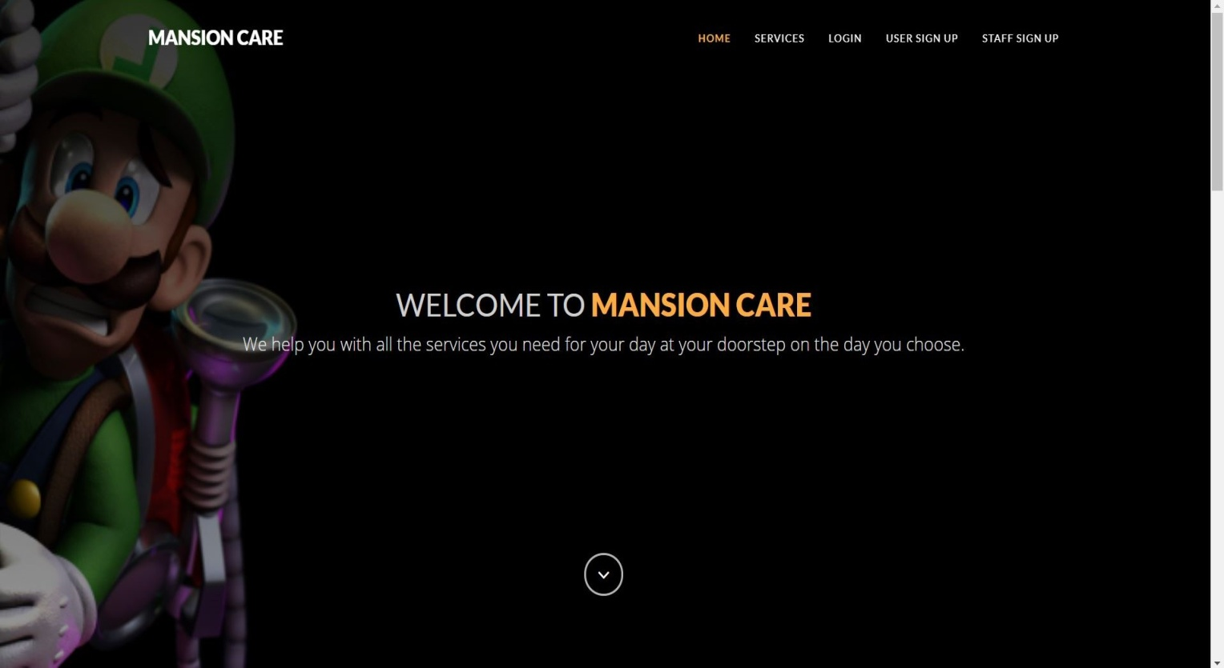

**Login page**

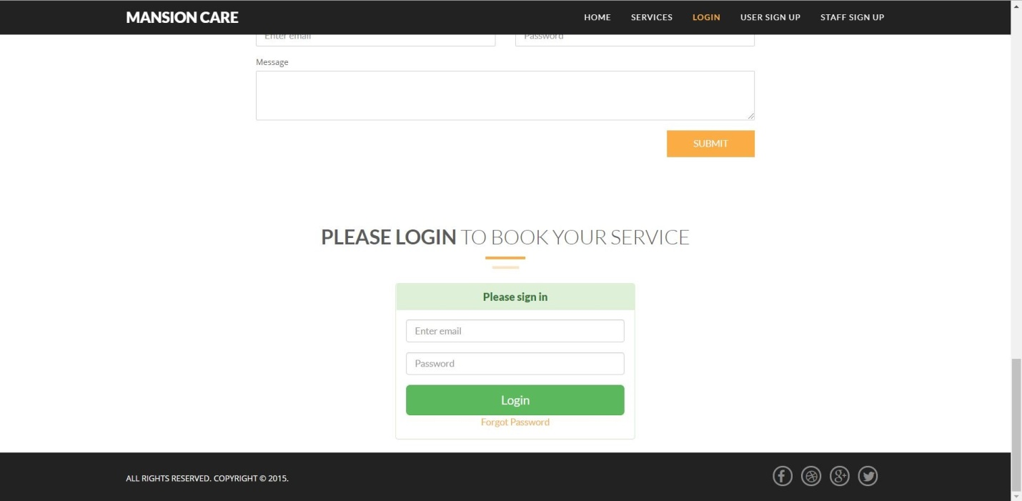

**Register page**

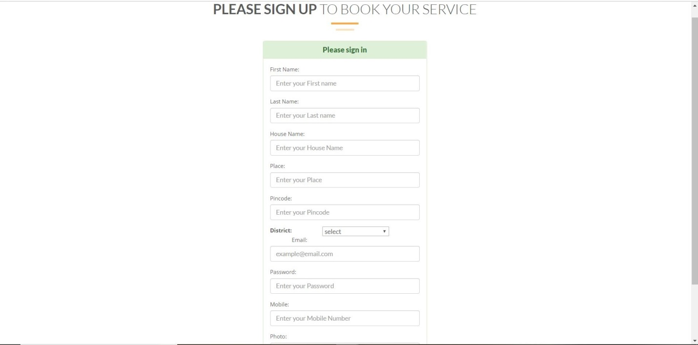

**View Employee page**

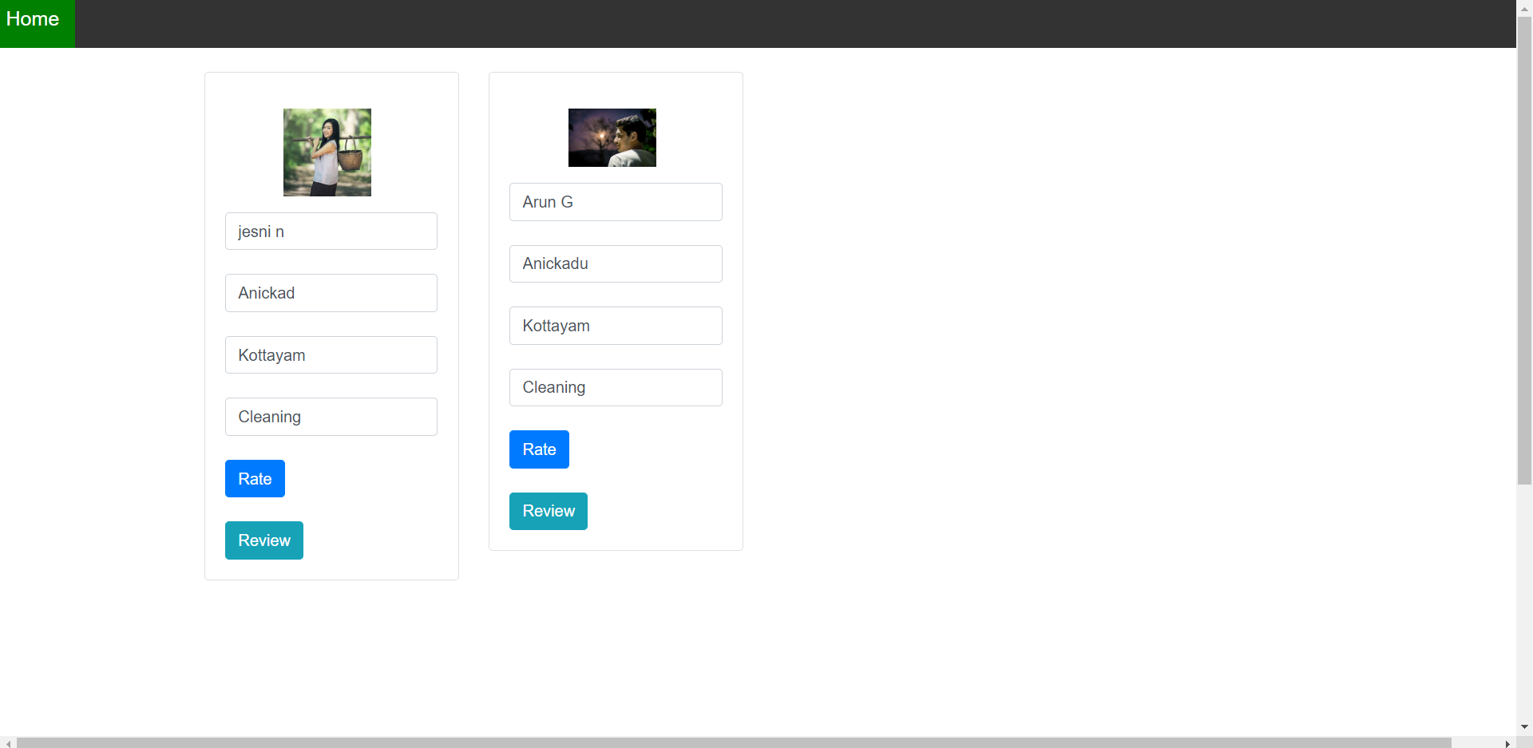

**Employee details page**

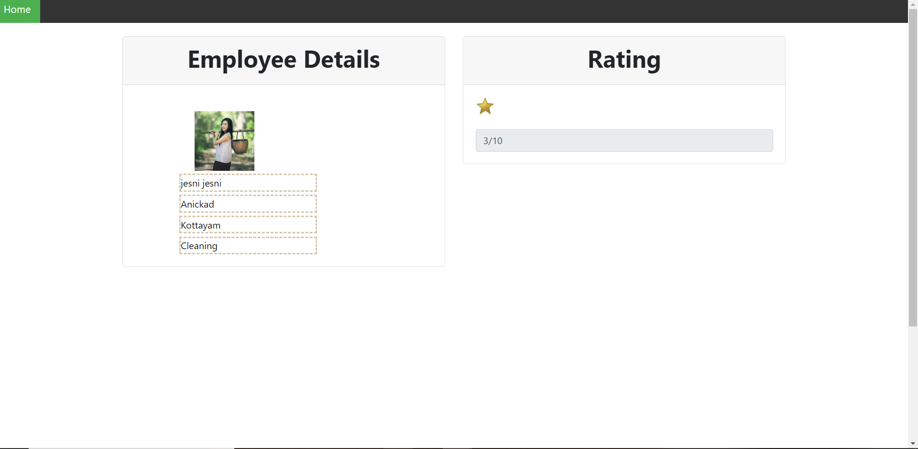

**Service booking page**

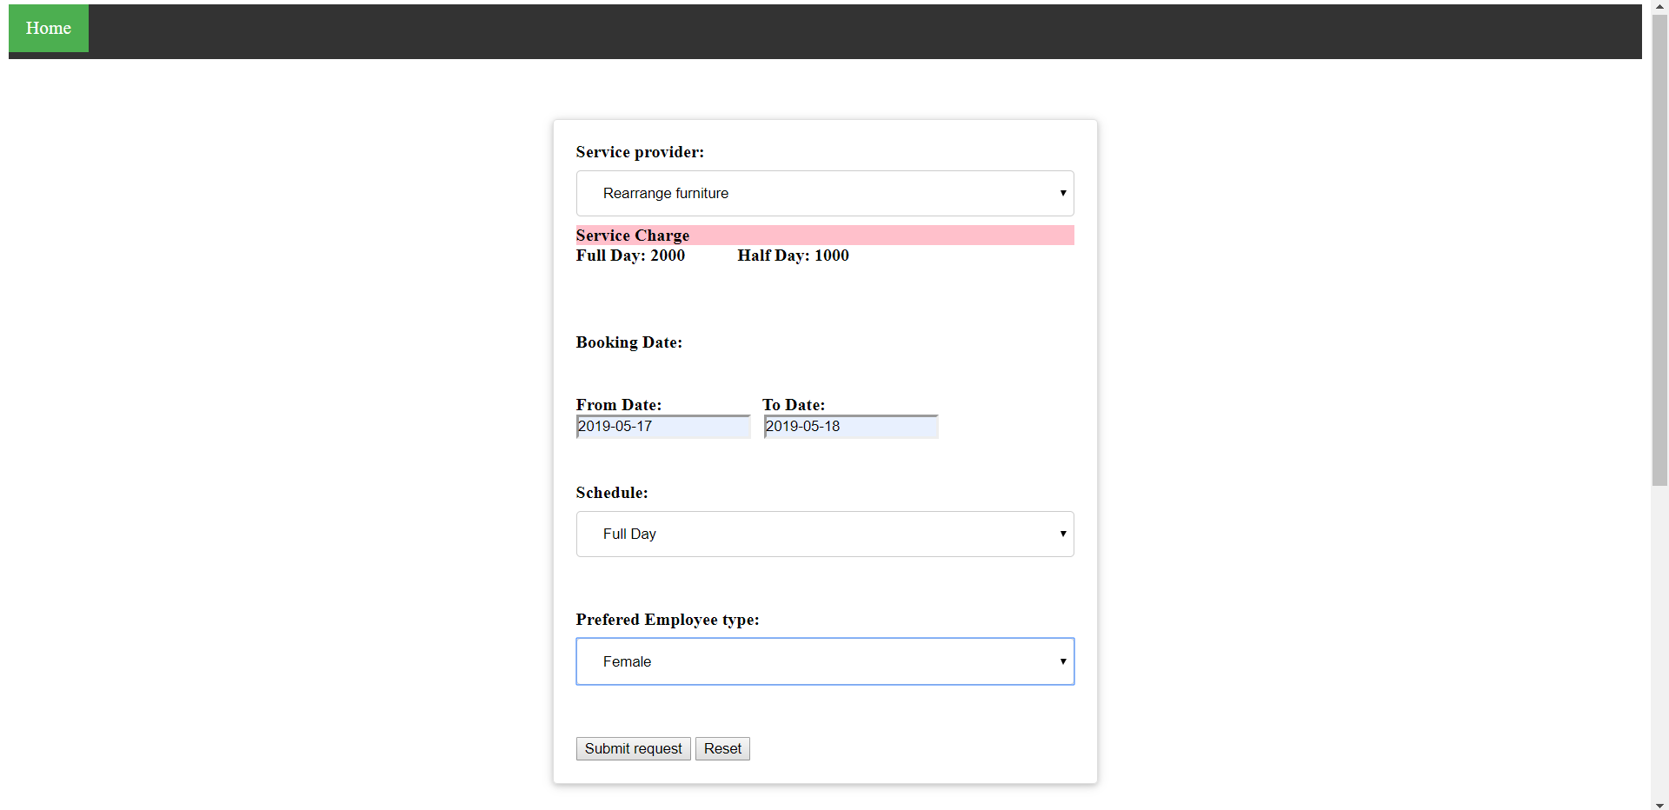

**Employee search page**

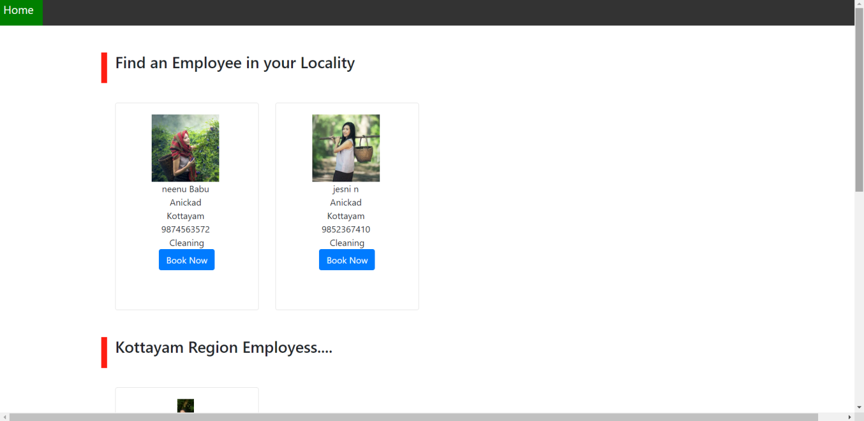

**Payment page**

